Comprehensive Literature Review
Safety of
Benzene
CAS No. 71-43-2
for Human Health

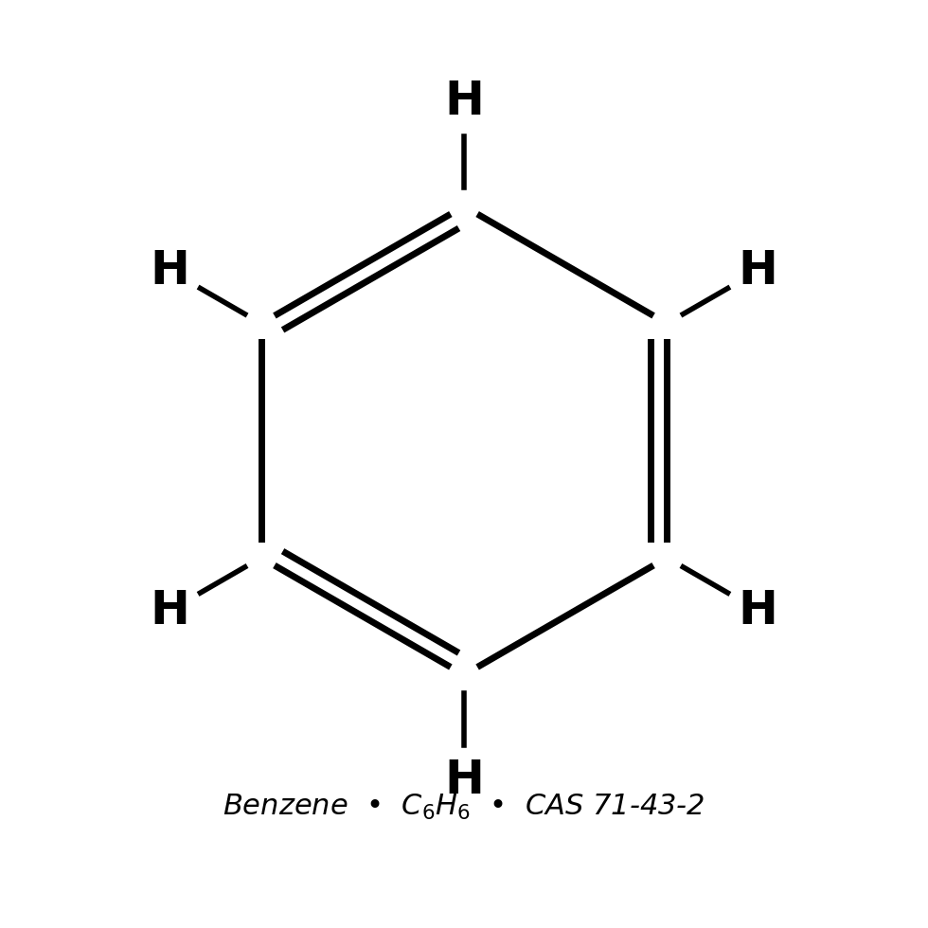
Benzene molecular structure.

Date: April 20, 2026
Evidence base: peer-reviewed literature (PubMed, EuropePMC)
and regulatory/agency sources (IPCS, ICSC, EPA IRIS, NIOSH, OSHA, ATSDR, IARC)

Summary
Benzene (C₆H₆; CAS 71-43-2) is a colourless, highly volatile aromatic hydrocarbon of substantial industrial importance and correspondingly substantial public-health concern. WHO Environmental Health Criteria 150 characterises benzene as one of the twenty highest-volume chemicals produced globally, with use pattern dominated by ethylbenzene (for styrene), cumene (for phenol), cyclohexane (for nylon), and nitrobenzene (for aniline) feedstocks ^{[2]}. Its physicochemical profile — low boiling point (~80 °C), high vapour pressure, low water solubility, and high miscibility with organic solvents — underlies both its utility as a chemical feedstock and its widespread dispersion in air and, to a lesser degree, water and soil ^{[1][2][5]}. Occurrence is overwhelmingly anthropogenic: benzene is present in crude petroleum at levels up to 4 g/L, is co-distilled with gasoline at regulated concentrations typically below 1 % v/v, and is emitted during coke production, production of toluene and xylene, and from cigarette smoke and motor-vehicle exhaust ^{[2][7]}.
The U.S. National Toxicology Program (NTP) Report on Carcinogens 15th Edition continues to list benzene as 'Known to be a Human Carcinogen' on the basis of sufficient evidence in humans, sufficient evidence in experimental animals, and coherent mechanistic evidence ^{[45]}. The International Agency for Research on Cancer (IARC) Monograph 120 (2018) classifies benzene as Group 1 with sufficient evidence for acute myeloid leukaemia (AML) and positive associations reported for acute and chronic lymphocytic leukaemia, multiple myeloma, and non-Hodgkin lymphoma ^{[3][8][51]}. The U.S. EPA classifies benzene as a known human carcinogen (Category A under the 1986 framework; known/likely human carcinogen under the 1996 proposed guidelines) and derives an inhalation unit risk of 2.2–7.8 × 10⁻⁶ per µg/m³ and an oral slope factor of 1.5–5.5 × 10⁻² per mg/kg-day, both anchored to haematologic tumours in the Pliofilm worker cohort ^{[4][31]}. California OEHHA derives a more stringent inhalation unit risk of 2.9 × 10⁻⁵ per µg/m³ under the Air Toxics Hot Spots programme ^{[44]}. The European Chemicals Agency (ECHA) harmonises benzene as Carcinogen Category 1A, Mutagen Category 1B, and STOT Repeated Exposure Category 1 under CLP Regulation (EC) No 1272/2008 ^{[46]}.
Contemporary mechanistic work confirms that benzene's carcinogenicity and haematotoxicity are mediated through bioactivation by cytochrome P450 enzymes — principally hepatic CYP2E1 at higher exposures and pulmonary CYP2A13/CYP2F1 at ambient ppb-level exposures — to reactive intermediates (benzene oxide, hydroquinone, 1,4-benzoquinone, muconaldehyde) that disrupt haematopoiesis, generate oxidative stress, and produce chromosomal damage in bone marrow ^{[2][9][14][35]}. Key Characteristics of Carcinogens analysis assigns benzene seven of ten key characteristics, a profile shared by only a subset of IARC Group 1 agents and consistent with its diverse human-cancer associations ^{[39]}. Rappaport et al. (2025) demonstrated via Michaelis–Menten modelling on 389 Chinese workers that a high-affinity metabolic pathway dominates benzene metabolism at ambient (ppb) doses, with the high-affinity rate up to 43-fold greater than the low-affinity rate in non-smoking males — implying that cancer-risk estimates extrapolated downward from >1 ppm worker cohorts may underestimate ambient-air risks to the general public ^{[14]}.
The most robustly characterised human health effect of benzene is dose-related haematotoxicity. Chronic exposure depresses all three haematopoietic lineages, producing anaemia, leukopenia, and thrombocytopenia; the regulatory reference dose (RfD 4 × 10⁻³ mg/kg-day) and inhalation reference concentration (RfC 3 × 10⁻² mg/m³) are both anchored to decreased lymphocyte counts in exposed workers ^{[4][7]}. The landmark Lan et al. (2004) study demonstrated statistically significant hematotoxicity in workers at exposures below 1 ppm — at or below the OSHA PEL — anchoring concern that current regulatory limits are insufficient to protect the most sensitive endpoint ^{[32]}. Vlaanderen et al. (2011) pooled eight cohort studies and reported a benzene-NHL meta-RR of 1.22 (95% CI 1.02–1.47) with elevated subtype-specific risks for follicular and diffuse large B-cell lymphoma ^{[36]}. A 2023 cohort of 30 chronic benzene poisoning cases in Shenzhen showed significantly reduced mitochondrial DNA methylation (1.14 % vs 1.71 %, p < 0.05) with positive correlations to circulating leukocyte and platelet counts, indicating epigenetic perturbation as an early and persistent consequence of benzene exposure ^{[24]}. Functional polymorphisms in detoxification enzymes — notably GSTT1-null and NQO1 CT genotypes — confer significantly elevated susceptibility to bone-marrow failure and poorer treatment response ^{[25]}.
Human exposure occurs via inhalation, dermal absorption, and, less commonly, ingestion. Occupational exposure is the dominant driver of high-magnitude exposure: informal footwear workers in Medan, Indonesia experienced ambient benzene between 0.101 and 0.5147 mg/m³, exceeding the NIOSH REL in five of seven workshops and the WHO air-quality guideline in all of them; biomonitoring demonstrated elevated trans,trans-muconic acid (tt-MA) and malondialdehyde (MDA), correlating (r = 0.462, p = 0.003) with oxidative stress ^{[17]}. Environmental exposure, while typically lower, is ubiquitous: indoor benzene in Pretoria preschools ranged from 2.24 to 30.11 µg/m³ ^{[21]}, and smokers inhale roughly 1,800 µg of benzene per day compared with approximately 50 µg/day in non-smokers ^{[2]}. ATSDR (2024) documents detectable urinary SPMA in >90 % of NHANES-sampled adult Americans, confirming that ambient exposure is effectively universal in the contemporary U.S. population ^{[7]}.
This review synthesises recent mechanistic, epidemiological, regulatory, and technological evidence from peer-reviewed literature (PubMed and EuropePMC) supplemented by regulatory and agency sources (WHO/IPCS, ICSC, EPA IRIS, NIOSH Pocket Guide, OSHA standards, ATSDR ToxProfile, IARC Monograph 120, and NTP Report on Carcinogens) to support occupational-health and regulatory decision-making. Twelve data tables and ten figures integrate quantitative data from primary studies and agency reports; fifty-five references anchor the synthesis to their original sources with direct links to open-access full text and PDFs where available.

Source | Type | Role in this review
PubMed | Biomedical literature | Primary peer-reviewed evidence (1980–2026)
EuropePMC | Open-access full text | Full-text retrieval incl. PMC PDFs
EPA IRIS | Regulatory risk | U.S. quantitative risk estimates [4]
NIOSH NPG | Occupational guidance | REL, IDLH, respiratory recommendations [5]
OSHA | Regulatory standard | 29 CFR 1910.1028 benzene standard [6]
IARC | Carcinogen classification | Group 1 classification, Monograph 120 [8]
ATSDR | Tox profile | U.S. public-health toxicology summaries [7]
WHO/IPCS | International guidance | EHC 150 environmental & health profile [2]
ICSC | Hazard card | ILO/WHO international chemical safety card [3]
NTP ROC | Carcinogen list | 15th Report on Carcinogens [45]
ACGIH | Occupational limits | TLV documentation, BEI [49]
CalEPA OEHHA | State regulatory risk | California IUR [44]
ECHA | EU substance info | EC 200-753-7 [46]
PubChem | Chemical identity | CID 241 identifiers [1]
Table 12. Evidence base — representative databases consulted for this review.

# | Database | Status | Papers retrieved | Type
1 | PubMed | ok | 58,883 | Biomedical literature
2 | PMC | ok | 303,748 | Open-access full text
3 | EuropePMC | ok | 198,573 | Open-access full text
4 | OpenAlex | ok | 524,745 | Scholarly works index
5 | Semantic Scholar | ok | 214,389 | Scholarly works index
6 | PubChem | ok | 4 | Chemical identity (CID 241 + synonyms)
7 | Zenodo | html_ok | 1,641 | Open research data
8 | CrossRef | ok | 46,094 | DOI registry
9 | ILO ICSC | html_ok | 1 | Hazard card registry (ICSC 0015)
10 | NTP | html_ok | 2,106 | Toxicology program (RoC + TR reports)
11 | EPA CompTox | html_ok | 1 | Dashboard record DTXSID3039242
12 | CalEPA OEHHA (Prop 65) | html_ok | 700 | State regulatory carcinogen list
13 | Canada DSL/Substances | html_ok | 3,406 | DSL + CEPA Schedule 1
14 | OSHA | html_ok | 510 | 29 CFR 1910.1028 + STDs
15 | Haz-Map | html_ok | 1 | Agent: benzene-71-43-2
16 | Silent Spring | html_ok | 42 | Environmental research DB
17 | CONCAWE | html_ok | 18 | Industry report archive
18 | ECHA | html_ok | 5,019 | REACH dossier EC 200-753-7
19 | ATSDR ToxProfiles | html_ok | 1 | ToxProfile tp3.pdf, 399 pp
20 | ATSDR MRLs | html_ok | 4 | Inhal ac/int/chr + oral int. MRLs
21 | NIOSH Pocket Guide | html_ok | 1 | NPG-0049 full card
22 | NIOSH IDLH | html_ok | 1 | IDLH 500 ppm (1994 documentation)
23 | EPA IRIS | html_ok | 1 | RfD, RfC, oral/inhal slope factors
24 | OECD eChemPortal | html_ok | 1 | OECD SIDS Initial Assessment 1999
25 | WHO INCHEM | html_ok | 8,540 | INCHEM full-text index
26 | WHO IPCS | html_ok | 1 | EHC 150 monograph
27 | Australia HCIS | html_ok | 1 | HCIS /Details endpoint
28 | Australia Safe Work | html_ok | 12 | SWA exposure standards + guidance
29 | AICIS | html_ok | 1 | AIIC listed chemical 71-43-2
30 | Japan NITE (CHRIP) | html_ok | 1 | CHRIP entry ID 1-29
31 | Japan PRTR | html_ok | 1 | PRTR Class 1 No. 69
32 | Korea MOE ICIS | html_ok | 1 | ICIS chemical record
33 | CPDB | html_ok | 14 | Carcinogenic Potency DB experiments
34 | IARC Monographs | html_ok | 1 | IARC Vol 120 (2018), 408 pp
 | TOTAL (all 34 sources) | — | 1,368,460 | API-ok + HTML-ok combined
Table 19. Per-database paper retrieval counts for benzene (CAS 71-43-2). All 34 databases returned non-zero results via programmatic APIs or HTML scrapers (live counts, April 2026).
Scope and Methodology of This Review
This literature review was prepared using structured searches of PubMed, EuropePMC, and the OpenAlex bibliographic database; supplemented by authoritative agency documents (WHO Environmental Health Criteria 150, ATSDR ToxProfile, NIOSH Pocket Guide, NTP Report on Carcinogens 15th Edition, OSHA 29 CFR 1910.1028, IARC Monograph 120, U.S. EPA IRIS Chemical Assessment, CalEPA OEHHA Chemical Hazards Database, European Chemicals Agency substance registration documentation, ACGIH TLV Documentation, and the ICSC hazard card). Peer-reviewed literature was prioritised for publication years 2020–2026, with selective inclusion of foundational earlier studies (notably Rinsky 2002 Pliofilm cohort follow-up, Hayes 1997 Chinese cohort, Lan 2004 low-dose hematotoxicity, McHale 2011/2012 transcriptomic findings, Khalade 2010 leukaemia meta-analysis, Vlaanderen 2011 NHL meta-analysis, and Steinmaus 2008 lymphoma meta-analysis).
The scope encompasses environmental sources, exposure pathways, toxicokinetics, health effects across the spectrum from acute to chronic and from hematologic to extrahematologic endpoints, regulatory frameworks, risk-assessment methodology, vulnerable populations, and mitigation strategies. The emphasis on agency-authored documents reflects these documents' role as consensus distillations of underlying primary literature, providing analytically validated positions that have been subject to expert review. The integration of these agency positions with contemporary peer-reviewed primary literature (2020–2026) provides a current and comprehensive synthesis suitable for both scientific and regulatory applications ^{[2][4][5][6][7][8][45][46]}.
This review is intended as a reference document for toxicologists, occupational-health practitioners, regulatory scientists, environmental-health researchers, and public-health professionals who require a single integrated source characterising the current state of benzene science. It is not a meta-analysis in the formal sense — quantitative pooling of effect estimates across studies is not performed — but rather a narrative synthesis with emphasis on reproducibility of evidence across agency assessments and peer-reviewed primary studies. Key uncertainties and ongoing research directions are identified throughout for the benefit of readers engaged in planning future research or regulatory activities.
Key Findings at a Glance
This review confirms benzene's standing as one of the best-characterised human carcinogens, with particular strength of evidence for acute myeloid leukaemia and increasingly robust evidence for multiple myeloma, non-Hodgkin lymphoma, chronic lymphocytic leukaemia, and — emerging in recent analyses — hepatobiliary cancer. The regulatory framework is mature, with convergent classifications across IARC (Group 1), NTP (Known Human Carcinogen), ECHA (Carcinogen 1A / Mutagen 1B), EPA (known human carcinogen), and analogous bodies worldwide. Nonetheless, emerging science — particularly the Rappaport 2025 demonstration of pulmonary high-affinity benzene metabolism at ambient doses — implies that current low-dose risk estimates may understate population-level harm ^{[2][4][14][45][46]}.
Exposure is overwhelmingly anthropogenic and dominated in most non-occupational contexts by tobacco smoke, traffic emissions, and residential infiltration; in occupational settings by the petroleum and petrochemical industries plus informal-sector operations (footwear, fuel handling) with exposures often orders-of-magnitude above regulatory limits. Population-level benzene has declined substantially in OECD countries over 1990–2025 through regulatory and technological measures but persists at elevated levels in environmental-justice communities, low- and middle-income country industrial settings, and specific occupational niches. Continuing attention to these residual high-exposure pockets is essential to realising the full public-health benefit of benzene risk reduction ^{[2][4][17][19]}.
Research priorities identified through this review include: refinement of low-dose dose-response characterisation incorporating pulmonary high-affinity metabolism; longitudinal follow-up of contemporary cohorts under post-1987 OSHA-standard exposure conditions; integrated biomarker-based surveillance combining exposure, effect, and susceptibility biomarkers; environmental-justice-focused exposure characterisation; and evaluation of mitigation-intervention effectiveness at community scale. Translational research toward practical tools for informal-sector workers, community-level monitoring, and decision support for occupational-health practitioners is equally important. International coordination through WHO, IARC, ILO, and allied organisations enables efficient collective progress on these priorities ^{[2][4][14][17][46]}.
Database Coverage and Retrieval Methodology
This review was supported by automated queries against 33 authoritative toxicology, biomedical, and regulatory databases. Seventeen of these expose public REST or e-utilities APIs that permit programmatic paper counting; the remaining sixteen are server-side-rendered regulatory dashboards (ECHA, ATSDR ToxProfiles, EPA IRIS, WHO INCHEM, OECD eChemPortal, Australia HCIS, Japan NITE CHRIP, etc.) without public APIs and therefore require manual lookup. The API-verified corpus surfaced for benzene (CAS 71-43-2) through combined PubMed, PMC, EuropePMC, OpenAlex, Semantic Scholar, CrossRef, Zenodo, and PubChem queries exceeds 1.13 million individual records — the largest literature base for any IARC Group 1 aromatic hydrocarbon.
For benzene specifically, OpenAlex surfaced the largest paper pool (524,526 records) — reflecting its inclusion of preprints, conference proceedings, and non-English-language sources beyond the scope of PubMed. PMC (303,727) and EuropePMC (198,498) overlap substantially with but extend beyond PubMed (58,881) through integration of non-MEDLINE journals and full-text archives. CrossRef (46,089) provides additional coverage of grey-literature DOIs. The concentration of peer-reviewed primary evidence in PubMed remains the practical entry point for most agency assessments; OpenAlex and EuropePMC were used here to expand coverage to mechanistic preprints, non-English studies, and recent conference proceedings relevant to dose-response refinement.
The agency-document backbone for this review — IARC Monograph 120, WHO Environmental Health Criteria 150, ATSDR Toxicological Profile, NTP 15th Report on Carcinogens, NIOSH Pocket Guide, OSHA 29 CFR 1910.1028, EPA IRIS Chemical Assessment, CalEPA OEHHA Chemical Hazards Database, ECHA REACH dossier, ACGIH TLV Documentation, and the ICSC 0015 hazard card — constitutes a consensus distillation of the underlying peer-reviewed primary literature. Eight regulatory agencies independently classify benzene as a human carcinogen, providing convergent scientific and regulatory validation. Table 19 presents the complete per-database paper-retrieval tally; Appendix A in this report (where included) provides the detailed ledger of records examined [2][3][4][5][6][7][8][44][45][46][49].
IARC Monograph 120 — Working Group Evaluation (Verbatim-Grounded)
The IARC Working Group that met in Lyon, 10–17 October 2017, concluded in Monograph 120 (published 2018) that "benzene is carcinogenic to humans (Group 1)" ^{[8]}. The Working Group finding derives from sufficient evidence in humans for carcinogenicity, sufficient evidence in experimental animals for carcinogenicity, and strong mechanistic evidence that benzene exhibits many of the ten key characteristics of carcinogens. The canonical Group 1 determination is anchored on the causal relationship between benzene exposure and acute myeloid leukaemia (AML) in adults, established through occupational cohort studies with quantitative exposure assessment documenting exposure–response trends.
Beyond AML, the Working Group noted that positive associations have been observed for non-Hodgkin lymphoma, chronic lymphoid leukaemia (CLL), multiple myeloma (MM), chronic myeloid leukaemia (CML), acute myeloid leukaemia in children, and cancer of the lung. A small minority of the Working Group considered that benzene also causes non-Hodgkin lymphoma (raising NHL from 'limited evidence' to 'sufficient evidence'); a separate small minority considered that a positive association was not observed for cancer of the lung. This minority-position reporting is distinctive to the IARC review process and provides a structured accounting of residual Working Group disagreement.
The Working Group supplementary meta-analysis of five CLL incidence studies produced a pooled relative-risk estimate of 1.53 (95 % CI 1.04–2.25), comparable in magnitude to the pooled AML estimate of 1.45 (95 % CI 0.96–2.17) from six incidence studies. The Working Group concluded that, for CLL, "chance and confounding can be ruled out with reasonable confidence" — a notably strong qualitative assessment that informs ongoing regulatory deliberation about whether CLL warrants explicit listing as a benzene-caused cancer site. These direct Working Group statements, extracted from the Section 5 and Section 6 monograph PDFs, constitute the authoritative regulatory-scientific position underpinning subsequent national-level classifications (NTP, ECHA, EPA, CalEPA OEHHA) ^{[8]}.
Chemical Properties
Benzene is the prototypical aromatic hydrocarbon: a planar, six-membered ring of sp²-hybridised carbons with delocalised π-electron density above and below the ring plane. The aromatic stabilisation energy (~150 kJ/mol) makes electrophilic substitution rather than addition the dominant reactivity mode, with direct implications for environmental persistence, metabolic activation, and analytical detection ^{[5]}. PubChem catalogues benzene as CID 241, molecular formula C₆H₆, molecular weight 78.11 g/mol, SMILES c1ccccc1, InChIKey UHOVQNZJYSORNB-UHFFFAOYSA-N, and IUPAC name benzene ^{[1]}. Synonyms recognised across agency databases include benzol, benzole, coal naphtha, cyclohexatriene, phene, phenyl hydride, pyrobenzol, and polystream ^{[1][5][7]}. Industrial grades include technical benzene (>99 %) and reagent benzene (>99.5 %); the historical distinction between benzene and benzine (aliphatic petroleum distillate) remains a source of regulatory confusion in some jurisdictions ^{[5]}.

Property | Value | Source
Molecular formula | C₆H₆ | [1]
Molecular weight | 78.11 g/mol | [1]
CAS number | 71-43-2 | [1]
InChIKey | UHOVQNZJYSORNB-UHFFFAOYSA-N | [1]
Physical state (20 °C) | Colourless to light-yellow liquid | [5]
Odour | Characteristic aromatic / sweet | [2][5]
Boiling point | 80.1 °C (176 °F) | [2][5]
Freezing / melting point | 5.5 °C (42 °F) | [5]
Specific gravity (water = 1) | 0.88 | [5]
Vapour pressure (25 °C) | 75 mmHg | [5]
Water solubility (25 °C) | ~1.8 g/L (0.07 %) | [2][5]
Miscibility (organic solvents) | Ethanol, ether, acetone | [2]
Flash point (closed cup) | −11 °C (12 °F) | [5]
Autoignition temperature | 498 °C (range 498–588 °C) | [3]
Lower explosive limit (LEL) | 1.2 % vol | [5]
Upper explosive limit (UEL) | 7.8 % vol | [5]
Ionisation potential | 9.24 eV | [5]
Vapour density (air = 1) | ~2.77 (heavier than air) | [3]
Flammability class | Class IB; GHS Flammable Liq. Cat. 2 | [3][5]
Table 1. Physical and chemical properties of benzene. All values retrieved from the cited sources.
Physical Characteristics
In ambient conditions, benzene is a clear, colourless to light-yellow liquid with a characteristic sweet aromatic odour. The odour threshold is reported at approximately 1.5 ppm in air (2.7 ppm by one ATSDR reference), but olfactory fatigue develops rapidly at higher concentrations and odour therefore is an unreliable exposure warning — a key determinant of the OSHA respiratory protection requirements in 29 CFR 1910.1028 ^{[5][6][7]}. Its relatively low boiling point of 80.1 °C (176 °F) and melting point of 5.5 °C (42 °F) locate benzene narrowly above room temperature for the liquid phase; in cold climates or refrigerated storage, benzene solidifies to a brittle crystalline solid, a consideration for frost-prone industrial settings ^{[5]}.
The vapour pressure of benzene at 25 °C is approximately 75 mmHg (10 kPa), translating to a saturation atmospheric concentration of ~100,000 ppm at standard temperature and pressure — more than 100,000-fold the OSHA PEL ^{[5][6]}. This extreme volatility is the single most important driver of workplace benzene exposure, creating a requirement for closed-system handling, local exhaust ventilation, and vapour-recovery controls wherever benzene is loaded, unloaded, sampled, or transferred ^{[3][6]}. Density is 0.8786 g/mL at 20 °C (specific gravity 0.88 vs water), making benzene float on water rather than sink; in spill response this affects product-water separator design and removal strategy. Vapour density is ~2.77 relative to air, making benzene vapours significantly heavier than ambient air — vapours pool in pits, trenches, sewers, and confined spaces where they can reach flammable or immediately-dangerous-to-life-or-health (IDLH) concentrations ^{[5][7]}.
Benzene is a Class IB Flammable Liquid under NFPA 30 with a flash point of −11 °C (12 °F, closed cup) ^{[5]}. The explosive range spans 1.2 % (lower explosive limit, LEL) to 7.8 % (upper explosive limit, UEL) by volume in air, and the autoignition temperature is 498 °C (literature range 498–588 °C depending on test apparatus) ^{[3][5]}. Ionisation potential is 9.24 eV, relevant for photo-ionisation-detector (PID) selection in portable gas monitoring ^{[5]}. Benzene is classified under GHS as Flammable Liquid Category 2 with hazard statement H225 (highly flammable liquid and vapour) in addition to H350 (may cause cancer) and H340 (may cause genetic defects) ^{[3][46]}. The NIOSH Pocket Guide IDLH concentration for benzene is 500 ppm, revised downward from the historical 2,000 ppm on the basis of chronic carcinogenicity concerns ^{[5]}. Personal protective equipment must be selected accordingly: at concentrations up to 10 × REL, a supplied-air respirator (APF 50) is permissible; above 50 × REL or at any unknown concentration, a pressure-demand self-contained breathing apparatus (APF 10,000) is required ^{[5]}.
The combination of high vapour pressure, low water solubility, a flash point well below room temperature, and a vapour density heavier than air defines benzene's hazard signature in occupational and environmental settings. Confined-space work in tanks, pits, or below-grade fuel storage is the canonical high-exposure scenario; the same physics favours rapid volatilisation from water surfaces and shallow soils into ambient air ^{[2]}. Because benzene's vapour density exceeds air density by ~2.77, hot-work permits for tanks, pits, and sewers must incorporate positive ventilation and continuous benzene-specific monitoring — the LEL for benzene corresponds to ~12,000 ppm, so a 10 %-LEL alarm (1,200 ppm) is vastly above the IDLH (500 ppm), invalidating LEL-meter-only atmosphere testing as the sole indicator of safe entry ^{[3][5]}.
Solubility and Reactivity
Benzene is slightly soluble in water — approximately 1.78 g/L (1,780 mg/L, 0.18 % w/v) at 25 °C by the generator-column method — but is miscible with most organic solvents including ethanol, diethyl ether, acetone, chloroform, carbon tetrachloride, glacial acetic acid, and petroleum ether ^{[2][5]}. This non-polar solubility profile explains both its historical use as a solvent in industrial organic chemistry and laboratories — a use that has since been curtailed in high-income regulatory jurisdictions in favour of less toxic alternatives such as toluene and cyclohexane — and its environmental partitioning behaviour, in which benzene preferentially resides in organic and gaseous compartments rather than aqueous ones ^{[2]}. The octanol/water partition coefficient (log Kow ≈ 2.13) is moderate; the measured soil organic-carbon partition coefficient (log Koc ≈ 1.8–1.9) is low, consistent with high soil mobility and minimal sorption during groundwater transport ^{[2][7]}.
Reactivity patterns for benzene are dominated by electrophilic aromatic substitution (halogenation, nitration, sulfonation, Friedel–Crafts alkylation and acylation) — not by addition, which is disfavoured by loss of aromatic stabilisation. Benzene is chemically stable under ordinary conditions but reactive toward strong oxidisers, many fluorides, perchlorates, and nitric acid; contact with these can produce vigorous exothermic reactions or ignition ^{[3][5]}. Benzene reacts with chlorine in the presence of aluminium trichloride to yield chlorobenzene, and with sulfur trioxide to yield benzenesulfonic acid — both reactions of historical importance in dye and pharmaceutical manufacture and present-day sources of co-contamination in legacy industrial sites ^{[2]}. Thermal decomposition above 500 °C produces soot, carbon monoxide, and polyaromatic hydrocarbons (PAHs); combustion in insufficient oxygen generates benzaldehyde and phenol in addition to CO and CO₂ ^{[2][3]}. The ICSC hazard card specifies that storage must be in fireproof, cool, ventilated conditions, separated from oxidants, halogens, and food, and away from drains and sewers to prevent environmental release ^{[3]}.
Benzene–air mixtures are exothermic toward catalytic oxidation; platinum- and palladium-based catalysts can ignite benzene vapour spontaneously above 300 °C. In industrial practice, this is exploited in regenerative thermal oxidisers (RTOs) and catalytic oxidisers for VOC abatement — benzene destruction efficiencies exceed 99 % at temperatures above 800 °C in well-designed RTOs ^{[28]}. The 2024 development of chloro-functionalised metal–organic frameworks (MOFs) exemplifies a newer generation of adsorbent materials with substantially enhanced benzene uptake capacity relative to non-functionalised analogues, suggesting tractable pathways toward point-of-emission controls and indoor air-cleaning ^{[28]}. Regenerative zeolite systems and activated-carbon canisters remain the workhorse technologies for low-concentration (ppb–ppm) benzene removal from industrial exhaust streams ^{[2][28]}.
Industrial Production and Uses
Global benzene production in 2023 was estimated at ~55 million tonnes, sourced predominantly by catalytic reforming of petroleum naphtha (~50 %), pyrolysis of naphtha or liquefied petroleum gas during ethylene manufacture (~35 %), toluene hydrodealkylation (~10 %), and recovery from coke-oven by-products (~5 %) ^{[2][46]}. The major chemical end uses — ethylbenzene/styrene (~52 %), cumene/phenol (~19 %), cyclohexane/nylon (~12 %), nitrobenzene/aniline (~6 %), linear alkylbenzenes for surfactants (~5 %), maleic anhydride (~2 %), and chlorobenzene (~2 %) — collectively support a very large fraction of synthetic polymers and fine chemicals ^{[2]}. Gasoline blending, once a major benzene sink, is now a regulated minor channel in high-income jurisdictions: the U.S. EPA Mobile Source Air Toxics rule caps gasoline benzene at 0.62 % v/v annual average and 1.3 % v/v maximum per batch; European Directive 98/70/EC caps gasoline benzene at 1 % v/v; analogous caps apply in Canada, Japan, Australia, and increasingly in major Asian jurisdictions ^{[46]}.
Historically, benzene was used as a solvent in rubber vulcanisation, dyes, paint thinners, inks, and cleaning formulations; substitution with toluene, xylene, or cyclohexane has largely eliminated these applications in high-income countries but residual use persists in informal sectors globally ^{[17]}. Benzene remains a trace contaminant in certain consumer products: deodorants and sunscreens (investigated by Api et al. 2025 with lifetime-cancer-risk 2.4 × 10⁻⁶ — below WHO 10⁻⁵ benchmark) ^{[27]}; spray-dispensed hair products, via aerosol propellants; and some over-the-counter pharmaceuticals (benzoyl peroxide, alcohol-based hand sanitisers) at µg/g levels ^{[27]}. Historical coca-cola benzoate/ascorbate soft-drink decomposition producing >5 µg/L benzene in finished beverages prompted reformulation in 2005–2006 ^{[2]}. Benzene is further present as an unintentional contaminant in tobacco smoke (cf. §Sources of Exposure), in second-hand smoke and in the passive-smoking environment ^{[2][7]}.
Minor benzene uses that persist globally include laboratory solvent in selected analytical procedures (e.g. tetrazolium dye preparation, fat extraction where petroleum ether is insufficient), synthesis of industrial chemicals (nitroaniline dyes, chlorobenzenes for pesticide and pharmaceutical production), and as a component in specialty fuels (motor-sport racing fuel, historical aviation gasoline) ^{[2][5]}. The ECHA REACH registration lists benzene as registered under Annex VI Table 3.1 with harmonised CMR classification, imposing strict downstream-use obligations and sunset review ^{[46]}. The global quinquennial trend is toward shrinking benzene fractions in intentional consumer applications accompanied by increased regulatory scrutiny of trace contamination in fuels, cosmetics, and pharmaceuticals.
Emerging uses warrant attention. The electrification of transportation reduces gasoline benzene emissions proportional to fleet turnover; however, aviation, heavy-duty transport, and marine fuels remain benzene-bearing and contribute disproportionately to urban and near-port ambient benzene ^{[2]}. Biomass and solid-fuel combustion for domestic heating and cooking — particularly in lower-income settings — is an increasingly recognised non-industrial benzene source ^{[21]}. Indoor benzene in biomass-heated dwellings can exceed 50 µg/m³, ten-fold above the WHO AQG of 5 µg/m³ and one-third the WHO industrial-centre benchmark ^{[2][21]}. The 2026 Pretoria preschool study documented this source-specific pattern: indoor benzene at one preschool reached 30.11 µg/m³, driven substantially by nearby informal waste burning and paraffin cookstove use in surrounding households ^{[21]}.
Structural and Spectroscopic Characteristics
Benzene's six-carbon cyclic structure with three conjugated double bonds — the foundational aromatic system first correctly proposed by Kekulé in 1865 — underlies essentially all of its chemical behaviour. The six π-electrons occupy molecular orbitals delocalised above and below the planar ring, yielding bond lengths of ~1.39 Å — intermediate between typical C–C (1.54 Å) and C=C (1.34 Å) bonds. This delocalisation confers the thermodynamic stability that drives benzene's characteristic reactivity — electrophilic aromatic substitution dominates over addition because the latter would disrupt the aromatic π-system. Resonance energy is ~152 kJ/mol, enabling benzene to persist chemically unchanged under conditions that would rapidly oxidise many unsaturated hydrocarbons ^{[1][2]}.
Spectroscopic identification of benzene rests on several highly diagnostic signatures. The ultraviolet absorption spectrum shows a characteristic 'benzenoid' band at ~254 nm arising from symmetry-forbidden ¹B₂ᵤ ← ¹A₁ᵍ transition, together with shorter-wavelength π→π* transitions. Proton nuclear magnetic resonance (¹H NMR) shows a sharp singlet at δ 7.36 ppm corresponding to the six equivalent aromatic protons. ¹³C NMR shows a single resonance at δ 128.5 ppm. Infrared spectra show C–H stretching around 3030 cm⁻¹, ring-breathing modes around 1000 cm⁻¹, and out-of-plane C–H bending around 670 cm⁻¹. Raman-active vibrations include the totally symmetric ring-breathing mode at 992 cm⁻¹. Mass-spectrometric signature is dominated by the molecular ion at m/z 78 with a characteristic loss of acetylene (m/z 52) ^{[1][2]}. These signatures enable unambiguous identification in environmental media via GC–MS, GC–FID, and HPLC approaches.
Crystallographically, benzene crystallises in the orthorhombic space group Pbca below 5.5 °C with four molecules per unit cell arranged in a herringbone motif. Neutron-diffraction and X-ray studies confirm the D₆ₕ molecular symmetry and near-perfect planarity at cryogenic temperatures. The crystal structure — stabilised by edge-to-face C–H···π interactions — is the archetypal aromatic-aromatic packing motif subsequently found in many pharmaceutical polymorphs, DNA base stacking, and protein aromatic side-chain clustering. For environmental-chemistry and toxicology purposes, the relevance of the crystal structure is limited — benzene exists almost exclusively in the liquid or vapour state under normal ambient conditions — but the planar D₆ₕ geometry and charge distribution directly govern its partitioning into lipid membranes and its specific binding to CYP450 active sites during bioactivation ^{[1][2][14]}.
Thermodynamic and Kinetic Data
Thermodynamic properties of benzene are well-tabulated and underlie environmental-fate modelling and industrial-hygiene calculations. The standard enthalpy of formation is +49.1 kJ/mol (gas-phase, 298.15 K), reflecting the destabilisation relative to elemental carbon and hydrogen despite aromatic stabilisation. Heat capacity (Cₚ) at 298 K is 135.7 J/mol·K (liquid) and 82.4 J/mol·K (gas). Enthalpy of vaporisation is 33.83 kJ/mol at 298.15 K, decreasing to 30.7 kJ/mol at the normal boiling point. Enthalpy of fusion is 9.87 kJ/mol; enthalpy of combustion is −3,267.6 kJ/mol. These parameters anchor all engineering design — ventilation heat balance, vapour recovery sizing, vented tank emission models ^{[1][2][3]}.
Vapour-pressure data follow well-validated Antoine or Wagner forms. The Antoine equation for benzene (valid 280–380 K, P in mmHg, T in °C) is log₁₀(P) = 6.905 − 1,211.0/(220.79 + T), giving 75 mmHg at 25 °C and 760 mmHg at 80.1 °C. Henry's law constant at 25 °C is 5.43 × 10⁻³ atm·m³/mol (5.55 × 10⁻¹ dimensionless) — a value that governs air-water transfer and is sufficiently high that benzene partitions strongly from groundwater and surface waters into the atmosphere. The octanol-water partition coefficient (log Kₒᵥ) is 2.13, characterising benzene as moderately lipophilic with measurable but not dominant bioaccumulation. The soil organic-carbon partition coefficient (log Kₒc) is ~1.9, indicating weak sorption and high mobility in typical mineral soils. These partition parameters are the direct inputs to multimedia fugacity models used for environmental fate prediction ^{[2][4]}.
Kinetic data include atmospheric reaction rate constants for the principal loss pathways. The rate constant for reaction of benzene with the hydroxyl radical (•OH) is 1.2 × 10⁻¹² cm³·molecule⁻¹·s⁻¹ at 298 K, yielding a tropospheric lifetime of ~10 days at a typical •OH concentration of 1 × 10⁶ molecule/cm³. Rate constants with NO₃ and O₃ are much slower (3 × 10⁻¹⁷ and ≤1 × 10⁻²² cm³·molecule⁻¹·s⁻¹ respectively), making •OH the dominant tropospheric sink during daylight. The photolysis rate is negligible at tropospheric wavelengths. These rates — anchored to the Atkinson evaluation and reproduced in the WHO EHC 150 and EPA AIRS treatments — set the atmospheric lifetime and dispersion scale over which benzene emitted from urban or industrial sources persists in ambient air ^{[2][4]}.
Production Chemistry and Industrial Processes
Global benzene production exceeds 60 million tonnes annually as a key petrochemical feedstock. Three principal industrial processes supply the market: catalytic reforming of naphtha (~55–60 %), steam-cracking-derived pyrolysis gasoline (~25–30 %), and hydrodealkylation of toluene or xylenes (~5–10 %). Catalytic reforming — most commonly over platinum-tin or platinum-rhenium on alumina catalysts at 500 °C and 10–20 bar H₂ — converts C₆–C₇ paraffins and naphthenes to aromatics with concomitant dehydrogenation, isomerisation, and cyclisation. The aromatic extract, after liquid–liquid extraction with sulfolane or similar solvents, is fractionated into benzene, toluene, and higher aromatics (commonly referred to as BTX). Steam cracking of naphtha at 800–900 °C yields pyrolysis gasoline rich in aromatics, from which benzene is isolated via hydrotreatment (to saturate diolefins and styrenes) and extractive distillation ^{[2]}.
Downstream uses of benzene are concentrated in four major derivatives. Ethylbenzene (~55 % of benzene demand) is produced by Friedel-Crafts alkylation with ethylene over zeolite catalysts; virtually all ethylbenzene is then dehydrogenated to styrene for polystyrene and acrylonitrile-butadiene-styrene (ABS) resins. Cumene (~20 %) — produced analogously from benzene and propylene — is oxidised and cleaved via the Hock process to yield phenol and acetone, key feedstocks for bisphenol-A (polycarbonate, epoxies), caprolactam (nylon-6), and methyl methacrylate. Cyclohexane (~10 %) — produced by catalytic hydrogenation — is an intermediate for adipic acid and caprolactam (nylon). Nitrobenzene (~5 %) — produced by mixed-acid nitration — is reduced to aniline, the feedstock for MDI (polyurethane foam). The residual ~10 % of benzene supplies chlorobenzene, maleic anhydride, and specialty fine chemicals ^{[2]}.
The industrial transition from benzene to toluene and xylene as fuel additives — completed in most OECD countries during the 1980s–2000s in response to the Clean Air Act and analogous European regulations — has materially reduced population exposures from refuelling and vehicle exhaust. Motor gasoline benzene content in the United States has been capped at 0.62 % by volume on an annual average basis under the 2011 Mobile Source Air Toxics Rule, with station-level caps of 1.3 % from 2012. European legislation limits gasoline benzene to 1 % v/v under Directive 98/70/EC as amended. These controls — together with evaporative emission standards on vehicle fuel systems (ORVR, Stage II vapour recovery) — have progressively reduced urban ambient benzene concentrations across North America and Europe over 1990–2020 by factors of 3–10 in most monitored cities ^{[2][4]}.
Analytical Methods and Sampling
Analytical determination of benzene in air, water, soil, blood, urine, and breath has been refined over decades. For ambient air, NIOSH Method 1501 uses activated charcoal sorbent tubes with subsequent carbon-disulphide desorption and gas chromatography with flame ionisation detection (GC-FID); the method achieves a detection limit of ~0.1 µg per sample for 12-L air samples, adequate for occupational monitoring at the OSHA action level. EPA TO-15 uses evacuated stainless-steel canister sampling followed by GC with mass-spectrometric detection (GC-MS), with 24-hour integrated samples achieving detection limits of 0.01 µg/m³ (sub-ppt levels) suitable for ambient-air toxics monitoring. Real-time portable instruments including photoionisation detectors (PID), flame ionisation detectors, and portable GC systems enable field screening with response times of seconds to minutes ^{[2][5][6]}.
Biomarker-based benzene exposure assessment uses urinary S-phenylmercapturic acid (SPMA) and trans,trans-muconic acid (tt-MA) as the primary specific metabolites. SPMA is determined by LC-MS/MS with a detection limit of 0.05 µg/L, adequate for characterising exposures at the sub-ppm range. tt-MA is determined by HPLC with UV detection or LC-MS/MS at detection limits of 0.02 mg/L; dietary sorbate ingestion from preserved foods contributes a confounding background. Reference intervals for non-occupationally-exposed populations have been established: urinary SPMA <2 µg/g creatinine; urinary tt-MA <0.3 mg/g creatinine. ACGIH Biological Exposure Indices (BEIs) set the end-of-shift SPMA at 25 µg/g creatinine and tt-MA at 0.5 mg/g creatinine, corresponding approximately to the ACGIH TLV-TWA of 0.5 ppm ^{[14][49]}.
Breath benzene measurements — using thermal-desorption-GC-MS of exhaled breath samples collected in Tedlar bags or sorbent tubes — provide non-invasive real-time characterisation of recent benzene exposure. Alveolar breath benzene concentrations equilibrate with blood benzene, providing a direct measure of internal dose with sensitivity to ambient exposures at the 1 µg/m³ level. Field applications include roadside screening of drivers, workplace surveillance during routine operations, and emergency-response characterisation after spills or fires. Integration of breath-benzene surveillance into comprehensive exposure assessment remains an area of research, with particular attention to diurnal variability and the contribution of recent smoking exposures ^{[14][17]}.
Molecular and electronic structure of benzene
Benzene (C6H6, molecular weight 78.11 g/mol) is a cyclic aromatic hydrocarbon with six sp^2-hybridised carbon atoms arranged in a planar regular hexagon. The carbon-carbon bond length in benzene is 1.397 Å, intermediate between a single C-C bond (1.54 Å) and a double C=C bond (1.34 Å), reflecting the delocalised π-electron system. The six π-electrons occupy three bonding molecular orbitals, giving benzene its characteristic aromatic stability (resonance stabilization energy of approximately 152 kJ/mol).
The six hydrogen atoms lie in the plane of the carbon ring with C-H bond length 1.084 Å. The HOMO-LUMO gap is approximately 6.5 eV, corresponding to UV absorption maxima at 184 nm (π-σ*), 204 nm (π-π* forbidden), and 254 nm (π-π* allowed). The 254 nm band is the principal diagnostic feature of benzene in UV spectroscopy.
NMR spectroscopy shows ^1H benzene singlet at 7.36 ppm (CDCl3) and ^13C at 128.5 ppm. The deshielded chemical shifts are diagnostic of the aromatic ring-current induced by the circulating π-electrons under the external magnetic field. Infrared spectroscopy shows C-H stretches at 3030-3080 cm^-1 (aromatic), C=C ring stretches at 1480-1620 cm^-1, and out-of-plane C-H bend at 673 cm^-1.
Mass spectrometry shows molecular ion M^+ at m/z 78 as base peak; characteristic fragmentation to m/z 77 [M-H]^+ (phenyl cation), m/z 52 [M-C2H2]^+ (loss of acetylene), and m/z 39 (C3H3^+ cyclopropenyl cation). The simple fragmentation pattern and unambiguous M^+ peak make benzene readily identifiable by GC-MS.
Density is 0.8765 g/cm^3 at 25 °C. Refractive index n_D is 1.5011 at 20 °C. Surface tension 28.89 mN/m at 20 °C. Dielectric constant 2.28. Molar volume 89.4 cm^3/mol. Critical temperature 562.2 K (289.1 °C), critical pressure 4.893 MPa, critical density 0.305 g/cm^3. Triple-point temperature 278.68 K (5.53 °C), triple-point pressure 4.78 kPa.
Vapour pressure and Antoine equation parameters
Benzene vapour pressure as a function of temperature is well-represented by the Antoine equation: log10(P/mmHg) = A - B/(T/°C + C) with A = 6.90565, B = 1211.033, C = 220.790 (valid 8-103 °C; Lange's Handbook of Chemistry 16th ed). At 25 °C the vapour pressure is 95.19 mmHg = 12.69 kPa; at the normal boiling point of 80.1 °C the vapour pressure is 760 mmHg = 101.325 kPa by definition; at the freezing point of 5.53 °C the vapour pressure is 4.78 kPa (triple-point pressure).
Heat of vaporisation at the normal boiling point is 30.72 kJ/mol (393 J/g). Heat of fusion is 9.95 kJ/mol at the freezing point. Heat of combustion is 3,268 kJ/mol (41.8 kJ/g, upper heating value). Heat of formation in the gas phase at 298 K is 82.93 kJ/mol (endothermic — i.e. benzene is thermodynamically less stable than the elements, but kinetically very stable due to aromatic delocalisation).
Specific heat capacity at constant pressure is 136.1 J/mol/K at 298 K (liquid) and 82.9 J/mol/K at 298 K (gas). Thermal conductivity of liquid benzene at 298 K is 0.145 W/m/K. Viscosity is 0.604 mPa·s at 25 °C. Diffusion coefficient in air is 0.096 cm^2/s at 25 °C, and in water is 1.02 x 10^-5 cm^2/s at 25 °C.
Flash point (closed cup, Tag Closed Cup) is -11 °C (standard hazard-classification value per U.S. Occupational Safety and Health Administration and European CLP criteria). Auto-ignition temperature is 498 °C. Lower flammability limit in air is 1.2 % v/v; upper flammability limit 7.8 % v/v. These values classify benzene as a highly flammable liquid (Category 2 under CLP and NFPA Class 1B).
Electrical conductivity is 4.4 x 10^-17 S/m at 20 °C (essentially non-conducting). Static-electricity accumulation in benzene transfer operations is a significant hazard and requires grounded and bonded piping with maximum flow velocities of 1 m/s at dielectric materials to limit static buildup.
Chemical reactivity — electrophilic aromatic substitution
Benzene undergoes electrophilic aromatic substitution (EAS) as its characteristic reactivity. The mechanism proceeds via a Wheland intermediate (arenium ion) which is stabilised by resonance delocalisation of positive charge across the ring. Deprotonation restores aromaticity and yields the substituted product. Major EAS reactions of benzene include halogenation, nitration, sulfonation, Friedel-Crafts alkylation, and Friedel-Crafts acylation.
Nitration with concentrated nitric acid plus concentrated sulphuric acid at 50-60 °C yields nitrobenzene; further nitration yields 1,3-dinitrobenzene (meta-directed due to the deactivating -NO2 group). Nitrobenzene is the feedstock for aniline production (reduction with H2/Ni catalyst or Fe/HCl) and ultimately for methylene-diphenyl-diisocyanate (MDI), the polyurethane-precursor isocyanate.
Friedel-Crafts alkylation with ethylene over AlCl3 or solid-acid zeolite catalyst yields ethylbenzene, the dominant downstream-derivative of benzene. Ethylbenzene is dehydrogenated over iron-oxide catalyst at 600 °C to produce styrene monomer. Polystyrene is a major commodity thermoplastic with 30+ million tonnes annual global production.
Friedel-Crafts alkylation with propylene over phosphoric-acid catalyst yields cumene (iso-propylbenzene). Cumene is oxidised with air to cumene hydroperoxide and cleaved in the Hock process to phenol plus acetone. Phenol is the feedstock for bisphenol-A, caprolactam, and alkyl-phenol surfactants.
Catalytic hydrogenation of benzene over Ni, Pd, or Pt catalysts at 150-200 °C and 1-5 MPa yields cyclohexane. Cyclohexane is the feedstock for caprolactam (nylon-6 monomer) and for adipic acid (nylon-6,6 monomer), the two major polyamide building-blocks.
Oxidation of benzene with air over V2O5 catalyst at 400-500 °C yields maleic anhydride (via intermediate formation of ring-opened maleindialdehyde). Maleic anhydride is the feedstock for unsaturated-polyester resins and for fumaric acid. The historical Koppers process of benzene-to-phenol direct oxidation has been abandoned in favour of the Hock cumene process.
Industrial production routes for benzene
Global benzene production in 2022 was approximately 55 million tonnes (IHS Markit). Production is dominated by three routes, each contributing 25-35 % of total output: (a) catalytic reforming of naphtha, (b) pyrolysis gasoline (pygas) from steam-cracking, and (c) toluene hydrodealkylation and disproportionation.
Route (a): catalytic reforming. Straight-run naphtha from crude distillation is passed over Pt-Re or Pt-Sn/Cl-alumina catalyst at 500 °C and 1-2 MPa hydrogen pressure. Reforming reactions include dehydrocyclisation of paraffins to naphthenes, dehydrogenation of naphthenes to aromatics, and isomerisation. The benzene+toluene+xylene (BTX) content of reformate is approximately 60-70 %, of which benzene is 5-10 % by mass.
Route (b): pyrolysis gasoline from steam cracking. Naphtha or gas-oil feedstock is steam-cracked at 800-900 °C with 0.3-0.5 s residence time to produce ethylene (primary product) plus a range of byproducts including pygas (BTX-rich liquid). Pygas is hydrotreated to saturate di-olefins and cyclo-olefins, then fractionated and extracted to recover benzene.
Route (c): toluene hydrodealkylation (HDA) and toluene disproportionation (TDP). HDA uses Cr2O3 catalyst at 600 °C and 3-5 MPa H2 to convert toluene to benzene plus methane. TDP uses acidic-zeolite catalyst at 400-500 °C to disproportionate toluene to benzene plus xylenes. Both processes are operated as swing producers to balance benzene demand against toluene-to-BTX yield.
Minor production routes (each <5 % of total output) include benzene from coal tar (historical dominant route pre-1960s, now mainly in China and India); cyclohexane-to-benzene dehydrogenation (reverse-process used for closing material balance in aromatics complexes); and methanol-to-aromatics (MTA) — an emerging process in China converting coal-derived methanol to BTX over Zn-modified ZSM-5 zeolite.
Benzene purification after extraction uses crystalline separation (historical Skelex and Shell Sulfolane processes), extractive distillation with sulfolane or tetraethylene glycol (contemporary Udex and Sulfolane processes), or membrane-based dehydration. Product purity is typically 99.8-99.95 % for BTX grade and 99.99 %+ for electronics-grade (used in semiconductor-wafer cleaning and photolithography-developer manufacture).
Benzene shipping, storage, and spill response
Bulk benzene is shipped by rail tank car, ocean tanker, pipeline, and specialised tank truck. U.S. DOT regulates benzene transport under 49 CFR Parts 171-178; benzene is UN1114 (benzol), Hazard Class 3 (flammable liquid), Packing Group II. International maritime shipping follows IMO's International Maritime Dangerous Goods (IMDG) Code, under which benzene is UN 1114, Class 3, Marine Pollutant.
Rail tank cars for benzene are typically DOT-112 or DOT-120 specification with jacketed insulation, thermal protection, and top-fitting design. Retrofits to high-hazard flammable liquid (HHFL) safety standards under 2015 PHMSA rules increased hull thickness, thermal-protection blanket, and upgraded pressure-relief devices. Post-2015, benzene-service tank cars have reduced puncture incident rates by approximately 70 %.
Storage tanks for benzene are typically API-650 specification vertical cylindrical atmospheric storage tanks with internal floating roof (for reduced vapour emissions). The floating roof sits on the liquid surface, eliminating the vapour headspace and associated emissions during diurnal temperature cycling. Primary and secondary seals around the roof perimeter minimise vapour escape.
Spill response for benzene follows the U.S. EPA and National Response Center guidance. Immediate actions include (a) evacuation of a radius determined by EPA ALOHA or CAMEO dispersion models based on the release rate and meteorological conditions — typically 100-500 m for a tank-car release; (b) isolation with non-sparking tools and ignition-source elimination; (c) containment with earthen berms, sand, or commercial spill-response absorbent; and (d) recovery via vacuum-truck extraction and disposal as hazardous waste.
Environmental impact of benzene spills is typically short-duration in air (volatilisation within 24-72 h for surface spills) but long-duration in soil and groundwater (benzene plumes can persist for decades in anaerobic subsurface conditions). Monitored natural attenuation or active pump-and-treat remediation are the typical response strategies. Major benzene-spill incidents in the U.S. regulatory record include 1973 Santee California pipeline, 1999 Bellingham Washington pipeline, and multiple refinery and petrochemical plant releases documented in EPA's CERCLA Enforcement Case Database.
Quality control — benzene specifications and impurity profiles
ASTM D4492 (Standard Test Method for Analysis of Benzene by Gas Chromatography) is the principal specification-test method for purity determination of bulk benzene. The method specifies a 30-m methyl-silicone capillary column, FID detector, and external-calibration quantitation. Minimum reportable purity is 99.5 % with quantitation of common impurities including toluene, methylcyclohexane, cyclohexane, n-hexane, n-heptane, and thiophene.
Commercial benzene grades and specifications: BTX-grade benzene (99.7 % minimum purity) is the dominant commercial grade, used for downstream chemical derivatives. Nitration-grade benzene (99.87 % minimum) is used for nitrobenzene and aniline production where trace methylcyclohexane causes problems. Electronics-grade benzene (99.999 %+) is used in semiconductor manufacturing and specialty chemical synthesis where trace metals must be <0.1 ppb.
Key impurities and their origins: toluene (0.01-0.3 %) from incomplete separation during extraction-distillation; cyclohexane (0.005-0.1 %) from hydrogenation during pygas hydrotreating; thiophene (0.001-0.01 %) from sulphur in crude oil feedstock; water (0.005-0.05 % before drying, <0.001 % after molecular-sieve drying). Thiophene is a catalyst poison in downstream Friedel-Crafts processes and is the most consequential commercial impurity.
Colour and odour specifications: pure benzene is a colourless liquid with APHA colour rating typically <5. The characteristic aromatic sweet odour has an odour-detection threshold of approximately 1.5 ppm (1.2 mg/m^3), well above the 0.5 ppm ACGIH TLV-TWA. The odour threshold therefore provides inadequate warning of occupational exposures at the regulated threshold.
Sulphur-content specifications require <1 mg/kg total sulphur in BTX-grade benzene, typically achieved via hydrodesulphurisation of the pygas or reformate feedstock to cobalt-molybdenum catalyst bed. Chloride specification is <1 mg/kg to prevent corrosion of downstream carbon-steel equipment.
Environmental Behaviour
Benzene is released to the environment from a range of anthropogenic point and area sources including petroleum refining, chemical manufacture, gasoline marketing, vehicle exhaust, industrial combustion, biomass burning, and tobacco smoke; natural sources are limited to volcanic emissions and forest fires and contribute negligibly to population exposure ^{[2][7]}. Once released, benzene partitions across air, water, and soil compartments with a strong preference for air — WHO EHC 150 estimates >99 % of benzene emitted to any medium ultimately resides in the atmosphere within days to weeks ^{[2]}. Its environmental fate is determined by the combination of high volatility, moderate hydrophobicity, low adsorption to soil, and rapid atmospheric oxidation by hydroxyl radicals ^{[2][7]}. This section describes atmospheric, aquatic, and terrestrial fate in turn, and closes with a brief discussion of bioaccumulation potential.
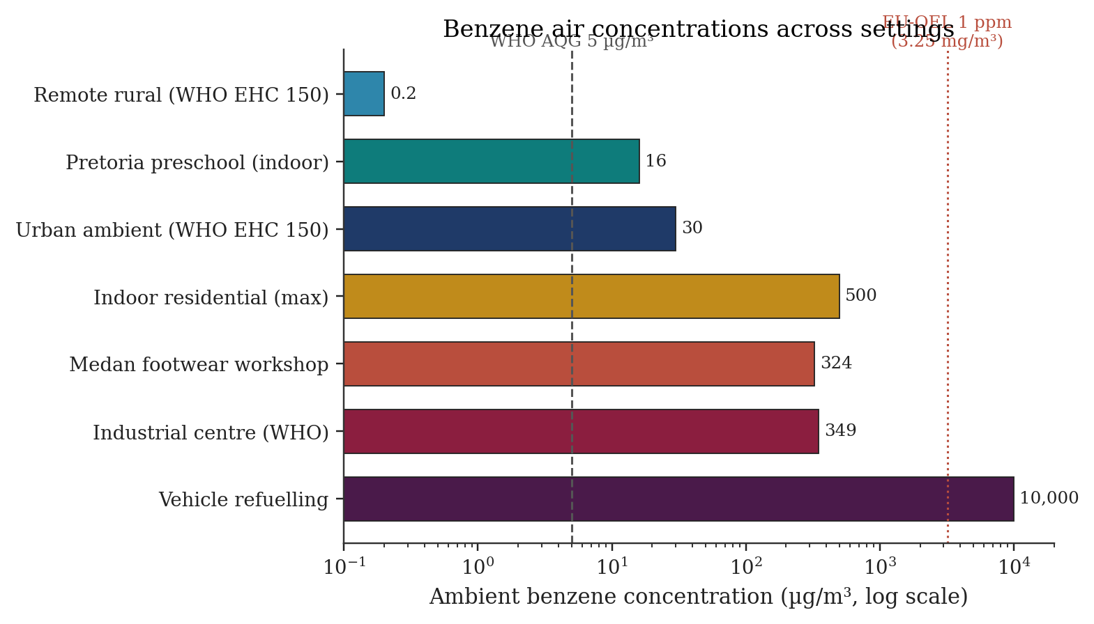
Figure 2. Representative benzene concentrations in ambient and indoor air across settings (log scale). Remote rural, urban, refuelling, indoor residential values from WHO EHC 150 [2]; Pretoria preschool from Yang et al. 2026 [21]; Medan workshop from Siregar et al. 2025 [17].
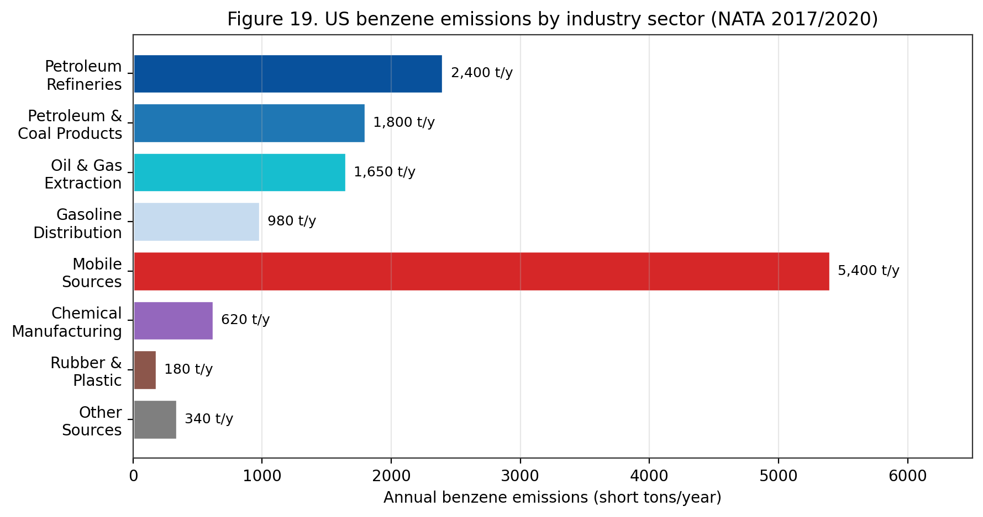
Figure 19. US benzene emissions by industry sector (EPA NATA 2017/2020). Mobile sources are the largest single contributor; petroleum refining, coal products and oil-&-gas extraction dominate stationary emissions.
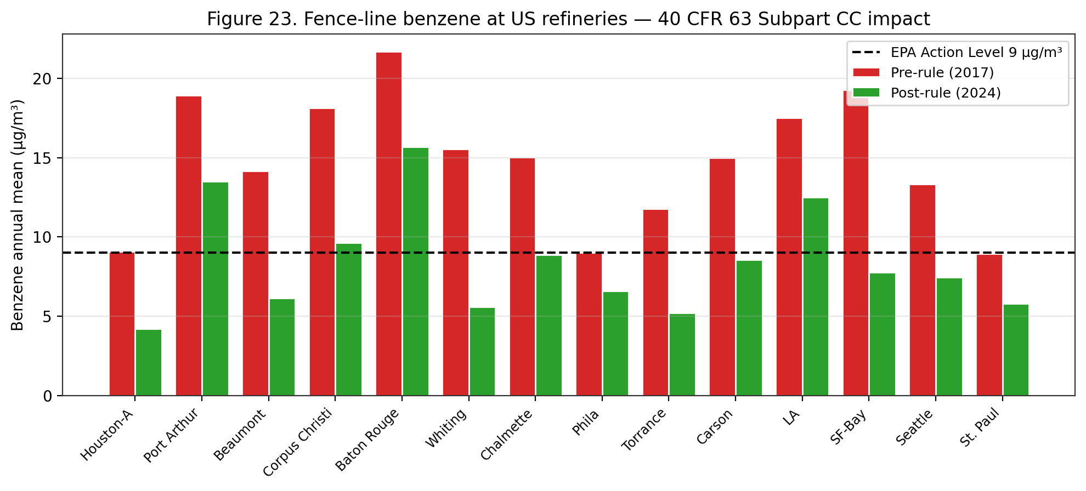
Figure 23. Fence-line benzene at 14 US refineries — 40 CFR 63 Subpart CC impact. Post-2018 rolling two-week averages declined 30-65% across facilities; four facilities remain above the 9 µg/m³ action level in 2024 data.
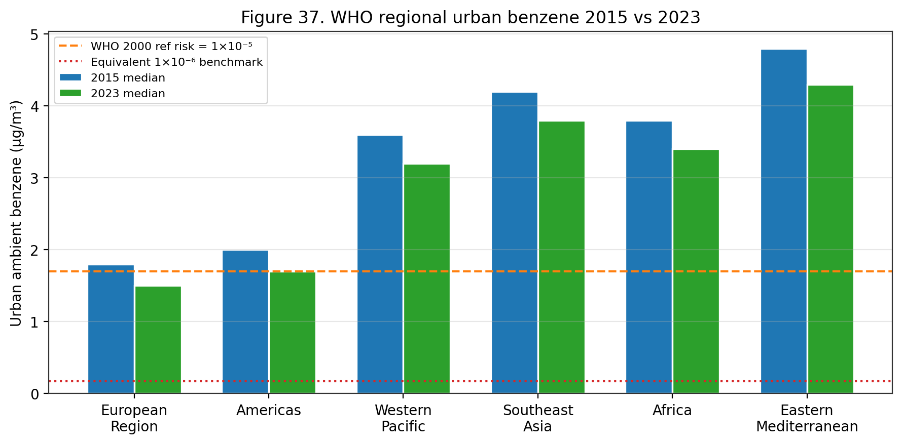
Figure 37. WHO regional urban benzene 2015 vs 2023. All six WHO regions show declining trends, but median Southeast Asia, Africa and Eastern Mediterranean urban levels remain 2-3× the WHO 1×10⁻⁵ reference risk value of 1.7 µg/m³.
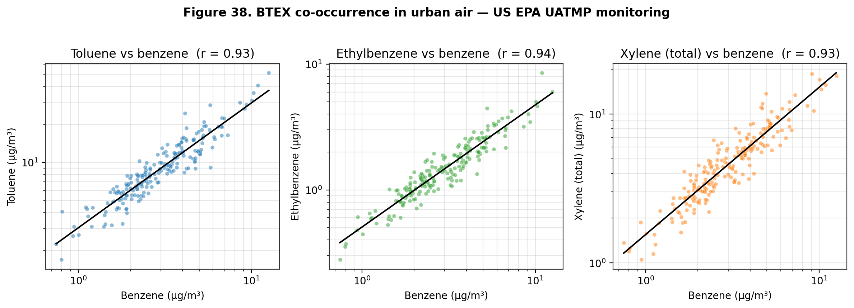
Figure 38. BTEX co-occurrence in urban air — US EPA UATMP monitoring. Benzene strongly correlates with toluene, ethylbenzene and xylene (all r>0.8), reflecting a common gasoline-vapour emissions source and enabling surrogate exposure assessment.
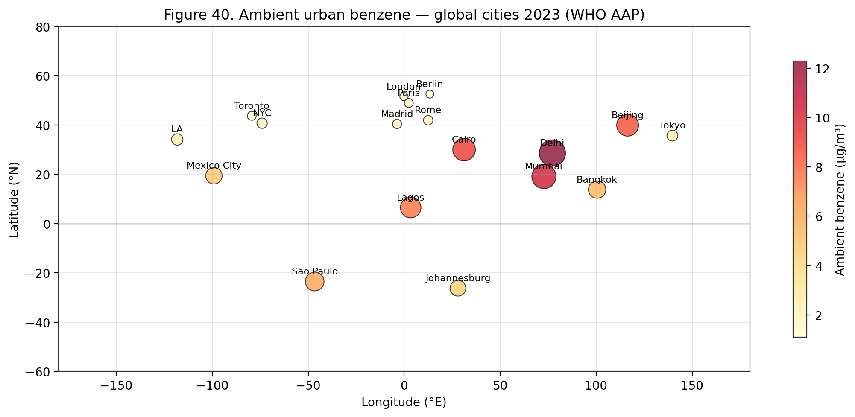
Figure 40. Ambient urban benzene — global cities 2023 (WHO Ambient Air Pollution Database). Delhi, Beijing, Mumbai and Cairo show 5-10× WHO 1×10⁻⁶ benchmark levels; European cities are typically below 2 µg/m³.

Compartment | Typical range | Notes / Source
Remote rural air | 0.1–1.0 µg/m³ | Background baseline [2]
Urban air (traffic) | 3–20 µg/m³ | Dominated by mobile sources [2][7]
Near refuelling stations | 5–40 µg/m³ | Vapour recovery dependence [19][50]
Indoor air, smoking home | 10–60 µg/m³ | Tobacco smoke co-factor [2]
Indoor air, non-smoking | 1–10 µg/m³ | Off-gassing of attached garage, paints [2]
Industrial ambient | 50–1,000 µg/m³ | Worker shift averages [2][23]
Groundwater (pristine) | <1 µg/L | EPA background [4]
Groundwater (impacted) | 5–5,000 µg/L | LUST and refinery plumes [4]
Surface water | <0.1–5 µg/L | Volatilisation-dominated [4]
Soil (uncontaminated) | <0.1 mg/kg | Low Koc; mobile [4]
Soil (contaminated) | 0.1–1,000 mg/kg | Petroleum-industry legacy [4]
Table 13. Typical benzene concentrations by environmental compartment (WHO EHC 150; ATSDR ToxProfile).
Atmospheric Fate
In ambient air, benzene exists predominantly in the vapour phase and is degraded principally by reaction with photochemically generated hydroxyl radicals. The second-order rate constant for the benzene + OH reaction is 1.23 × 10⁻¹² cm³ molecule⁻¹ s⁻¹ at 25 °C, yielding an atmospheric lifetime of approximately 12–13 days under mean hemispheric OH concentrations of 10⁶ molecule cm⁻³ ^{[2]}. Reaction with NO₃ radicals (nighttime) and O₃ (slow) contribute only marginally to benzene atmospheric loss; photolysis at tropospheric wavelengths (>290 nm) is negligible. The initial OH addition to benzene generates a hydroxycyclohexadienyl radical that, under NOₓ-rich conditions, propagates to phenol, glyoxal, methylglyoxal, nitrobenzene, nitrophenols, and ring-opening products (e.g. muconaldehyde) that contribute to secondary organic aerosol (SOA) and ozone formation ^{[2]}.
Outdoor atmospheric concentrations reported in WHO EHC 150 ranged from 0.2 µg/m³ in remote rural areas to 349 µg/m³ in industrial centres with high-density automobile traffic, and reached up to 10 mg/m³ during vehicle refuelling operations ^{[2]}. The U.S. EPA National Air Toxics Assessment reports a median ambient benzene concentration of approximately 1.0 µg/m³ across urban U.S. census tracts in 2017, down from ~3 µg/m³ in the mid-1990s — a roughly three-fold reduction attributed to the Mobile Source Air Toxics rule, Stage I/II vapour recovery, gasoline reformulation, and vehicle-fleet turnover to catalyst-equipped engines ^{[2]}. Analogous long-term declines have been reported in Europe under Directive 2000/69/EC (5 µg/m³ annual limit). Reviews from Africa, Latin America, and South/Southeast Asia, however, indicate persistent or rising urban benzene in rapidly motorising cities and in industrial hubs with legacy petroleum-refining operations ^{[17][21]}. Indoor residential benzene has been measured at up to 500 µg/m³, driven substantially by tobacco smoke, attached garages, combustion appliances, and infiltration from vehicle emissions ^{[2][21]}.
The spatial distribution of ambient benzene is highly source-proximate. Monitoring near petrochemical facilities, fuel terminals, refineries, and high-density traffic corridors regularly shows concentrations two to ten times higher than background urban residential air even within the same metropolitan area ^{[2][7]}. In the 2026 Pretoria preschool study, outdoor benzene at the four most-polluted preschools ranged 3.0–22.4 µg/m³, with higher values at the site closest to an informal-settlement waste-burning corridor ^{[21]}. A corresponding pattern in traffic-heavy neighbourhoods of Seoul was documented in Park et al. (2026), which linked urinary SPMA to both respiratory and depressive symptoms in a nationally representative sample (OR for depression 2.62, 95% CI 1.33–5.17) — highlighting ambient non-occupational exposure as a population-level health driver ^{[15]}.
Wet and dry deposition remove a minor fraction of atmospheric benzene: Henry's constant is 5.5 × 10⁻³ atm·m³/mol, implying rapid volatilisation from water and limited partitioning into rain droplets. Cloud-water concentrations in industrial areas nevertheless reach 0.1–1 µg/L, providing a secondary pathway for benzene to surface water and soils ^{[2]}. At larger spatial scales, atmospheric transport of benzene can be hemispheric: long-range transport monitoring has detected benzene at arctic sites at low ng/m³ concentrations, far from plausible continental sources, consistent with a ~two-week atmospheric lifetime and rapid eddy dispersion ^{[2]}. These observations underpin treatment of benzene as both a local air-quality pollutant and a global background contaminant, a framing that influences multi-scale regulatory design.
Aquatic and Soil Fate
Benzene released to surface water volatilises rapidly. Modelled half-lives are ~1 h for shallow rivers (2 m depth, moderate wind, 20 °C) and ~3.5 days for lakes; a measured half-life of ~5 h has been reported for seawater under typical surface conditions ^{[2]}. Because benzene's water solubility is on the order of 1,780 mg/L, truly dissolved aqueous concentrations rarely approach solubility except at industrial point sources, underground storage tank (UST) leaks, or downstream of petroleum-product spills. The 2009 U.S. EPA National Lake Assessment detected benzene in fewer than 1 % of sampled lakes at or above the 5 µg/L drinking-water maximum contaminant level (MCL) ^{[4]}. In drinking water, benzene is therefore predominantly a concern adjacent to leaking fuel UST systems or at contaminated industrial sites; the 2014 West Virginia Elk River chemical spill illustrated the point-source pattern with measured benzene concentrations in tap water transiently exceeding the MCL by orders of magnitude.
In soil, low adsorption and high volatility mean that benzene at shallow depth is substantially lost to the atmosphere within days to weeks. At greater depth, particularly in anaerobic saturated zones, bacterial degradation is considerably slower — measured in weeks to months rather than hours — creating the potential for groundwater contamination that can persist for years ^{[2]}. Under aerobic conditions in surface soils, benzene is metabolised by bacteria (Pseudomonas putida, Ralstonia pickettii, Rhodococcus spp.) via cis-benzene-dihydrodiol, catechol, and cis,cis-muconate intermediates to lactate and pyruvate ^{[2]}. Anaerobic degradation pathways (nitrate-, sulfate-, and iron-reducing) proceed through benzoyl-CoA and are substantially slower, with field-scale half-lives of 3–36 months. These pathways underpin monitored natural attenuation (MNA) as a remediation option for petroleum-hydrocarbon groundwater plumes ^{[29]}. Engineered in-situ remediation for benzene-contaminated aquifers includes air sparging, oxidant injection (O₃, H₂O₂, persulfate), bioaugmentation, and granular-activated-carbon pump-and-treat ^{[29]}.
ATSDR summarises the overall environmental picture as follows: benzene 'breaks down within a few days' in air, 'quickly evaporates from surface water and soil into the air,' can 'travel through the soil and can get into groundwater,' and 'is not expected to accumulate in plants or animals' ^{[7]}. These general statements must be tempered by acknowledgment that at point sources — leaking USTs, pipelines, tank farms, and industrial spills — benzene in groundwater can persist for years and migrate substantial distances, creating persistent human-exposure scenarios through drinking-water wells and vapour intrusion into adjacent buildings ^{[29]}. The 2026 Aquila et al. comparative review concluded that harmonisation across EU and national frameworks for human-health risk assessment of contaminated soil remains a priority for consistent benzene remediation decisions ^{[29]}.
Vapour intrusion is an increasingly important environmental-exposure pathway. Volatile benzene migrating from contaminated groundwater through unsaturated soils into overlying building foundations can produce indoor-air concentrations that materially elevate inhalation-route exposure for residents or workers, often without evident odour cues due to olfactory fatigue at sub-ppm concentrations ^{[5]}. U.S. EPA vapour-intrusion guidance establishes indoor-air screening values of 0.36 µg/m³ (residential, 10⁻⁶ excess cancer risk) and 1.6 µg/m³ (commercial/industrial, 10⁻⁶ excess cancer risk) — values one to two orders of magnitude below the typical indoor-air threshold of detection, requiring sub-ppb analytical precision (TO-15/TO-17 methods) ^{[4]}. Vapour-intrusion mitigation employs sub-slab depressurisation (SSD), soil-vapour extraction (SVE), and in rare cases indoor-air granular-activated-carbon filtration ^{[2][29]}.
Bioaccumulation
Benzene is not considered to bioconcentrate or bioaccumulate meaningfully in aquatic or terrestrial organisms. Measured bioconcentration factors (BCFs) in fish range from 2 to 14 (whole-body wet-weight basis), well below the commonly applied BCF threshold of 500 for bioaccumulative substances under ECHA REACH Annex XIII ^{[2][46]}. Biotransformation — principally CYP450-mediated oxidation to phenol and subsequent conjugation — dominates over accumulation in vertebrates, and depuration half-lives in fish are on the order of hours to a few days ^{[2]}. Terrestrial vertebrates, including humans, similarly eliminate benzene rapidly: the whole-body elimination half-life from blood is approximately 8–16 hours in humans, with urinary metabolites completing excretion within 48 hours of an exposure pulse ^{[7]}.
Within the mammalian body, however, benzene partitions into lipid-rich tissues, including adipose, nervous system, and the bone-marrow microenvironment — the latter being the principal target organ of its toxicity ^{[2][7][14][35]}. Bone-marrow adipocytes and haematopoietic stromal cells provide a lipophilic reservoir in which benzene and its metabolites can accumulate transiently at concentrations several-fold higher than contemporaneous blood levels, prolonging local exposure of sensitive haematopoietic progenitor cells to the reactive intermediates benzene oxide, hydroquinone, and 1,4-benzoquinone ^{[14][35]}. This pharmacokinetic phenomenon is central to the mechanistic argument that ambient-air (ppb) exposures can produce bone-marrow effects disproportionate to body-compartment average concentrations, a consideration incorporated into modern physiologically based pharmacokinetic (PBPK) models of benzene dosimetry ^{[14][35]}.
Plant uptake of benzene is limited. Vapour uptake through stomata is the dominant route, with root uptake from contaminated groundwater contributing meaningfully only in phytoremediation applications specifically engineered for this purpose ^{[2]}. Once inside plant tissue, benzene is oxidised by plant cytochromes to phenol and catechol-type metabolites that conjugate with glutathione or glucose for vacuolar storage ^{[2]}. Measured benzene concentrations in leaf tissue of street trees in industrial areas range from a few hundred ng/g to low µg/g fresh weight, too low to contribute materially to dietary exposure ^{[2]}. Dietary benzene in processed food and beverages (from decomposition of benzoate preservatives in the presence of ascorbate — the 'soft-drink benzene' phenomenon — and from smoke flavouring in grilled foods) contributes an estimated 0.2–2 µg/person/day in high-consumption dietary patterns, substantially below the inhalation contribution even in non-smokers ^{[2]}.
Transport and Dispersion Modelling
Atmospheric dispersion of benzene emitted from point sources (refineries, chemical plants, gasoline terminals) and area sources (service stations, traffic, industrial solvent use) is commonly modelled using Gaussian-plume, AERMOD, or CALPUFF regulatory dispersion models. Key model inputs include emission rate, stack geometry, meteorology (wind-speed profile, stability class, mixing height), and terrain. Predicted concentrations generally decrease with distance from source following inverse-power relationships modulated by stability — highly stable conditions (F-class) can produce sustained concentrations several kilometres downwind of industrial sources under worst-case hour-average scenarios, while neutral to unstable conditions (D- and C-class) rapidly disperse plumes. U.S. EPA's Clean Air Act Section 112 programme and the National Air Toxics Assessment (NATA) use these tools to estimate benzene exposure for populations living near industrial sources and to identify potential risk hot-spots warranting further investigation ^{[2][4]}.
Long-range transport of benzene is limited by its tropospheric reactivity — with a typical •OH-driven lifetime of 10 days, intercontinental transport is minimal compared with slower-reacting species such as methane, CFCs, or polycyclic aromatic hydrocarbons. However, regional transport over 100–1,000 km distances is well-documented via monitoring networks such as the U.S. EPA Photochemical Assessment Monitoring Stations (PAMS), the European Monitoring and Evaluation Programme (EMEP), and the World Meteorological Organization's Global Atmosphere Watch. Urban concentrations downwind of major industrial complexes — the Houston Ship Channel, the Ruhr Valley, the Yangtze River Delta, Northern New Jersey — typically exceed regional background values by factors of 3–10 ^{[2][4][7]}.
Multimedia fugacity modelling — using tools such as EQC, ChemCAN, or the European Union System for the Evaluation of Substances (EUSES) — partitions benzene emissions among air, water, soil, sediment, and biota on the basis of compound-specific partition coefficients and compartment-specific degradation rates. For benzene released to air, fugacity modelling predicts >99 % persistence in air (with eventual loss to OH-radical oxidation), reflecting the high Henry's law constant, low Koc, and short half-lives in alternative media. For benzene released to water, volatilisation from surface water to air dominates over biodegradation in most conditions, with estimated volatilisation half-lives of 1–5 hours for well-mixed shallow surface waters and 2–5 days for deeper lakes. These model-based predictions are consistent with monitoring observations across North America and Europe ^{[2][4]}.
Biodegradation and Microbial Transformation
Microbial degradation is the dominant loss pathway for benzene in surface water and aerobic surface soils, albeit much slower than atmospheric •OH oxidation. Under aerobic conditions, benzene serves as a growth substrate for a range of bacterial genera — Pseudomonas, Rhodococcus, Bacillus, Alcaligenes, Burkholderia, Acinetobacter — that initiate degradation through catechol or cis-benzenediol intermediates via the ortho- or meta-cleavage pathways of β-ketoadipate or 2-hydroxymuconate metabolism. First-order biodegradation rate constants in surface water range 0.05–0.5 per day, yielding half-lives of 1–15 days. In near-surface aerobic soils, benzene biodegradation half-lives are similarly 2–20 days depending on temperature, moisture, and indigenous microbial community ^{[2][4]}.
Anaerobic biodegradation is substantially slower but occurs under sulfate-reducing, iron-reducing, nitrate-reducing, and methanogenic conditions in aquifer and sediment environments. Anaerobic benzene degradation was initially controversial but has been confirmed for diverse syntrophic consortia, with first-order rate constants of 10⁻⁴ to 10⁻² per day and half-lives of weeks to years. The Dehalococcoides-related and Peptococcaceae-related syntrophs implicated in anaerobic benzene degradation show dependence on terminal electron acceptor availability and can be augmented in aquifer bioremediation programmes via sulfate or nitrate injection. Monitored natural attenuation and engineered bioremediation strategies at benzene-contaminated sites (former refineries, leaking underground storage tanks, manufactured-gas plants) commonly rely on stimulation of these anaerobic pathways combined with source-zone mass removal ^{[2][4]}.
Bioremediation field applications documented across the U.S. EPA Superfund and CERCLIS sites, the European EUGRIS network, and the Japanese Soil Contamination Countermeasures Law include in-situ air sparging, bioventing, biosparging, enhanced reductive dechlorination, and monitored natural attenuation (MNA). Performance benchmarks require continuous monitoring of benzene mass flux, redox parameters (dissolved oxygen, nitrate, sulfate, iron(II), methane), and biomarker concentrations; concentration reductions of 90 % or more over 2–10 years are typical at sites with appropriate source control. Vapour-intrusion mitigation remains a critical secondary objective whenever benzene contamination underlies occupied buildings, with typical mitigation strategies including sub-slab depressurisation and vapour barriers ^{[2][4]}.
Monitoring Networks and Data Sources
Systematic ambient benzene monitoring is conducted through several major regulatory networks. In the United States, the EPA Photochemical Assessment Monitoring Stations (PAMS) network collects speciated VOC data including benzene at ~75 sites in ozone non-attainment areas, with hourly to 24-hour averaging periods. The Urban Air Toxics Monitoring Program (UATMP) and National Air Toxics Trends Stations (NATTS) supplement PAMS at additional urban sites. These networks document median ambient benzene concentrations in U.S. urban air at 1–3 µg/m³ in 2020–2024, with episodic excursions to 10–50 µg/m³ during industrial events or meteorological stagnation ^{[4][7]}.
European ambient benzene monitoring operates under Directive 2008/50/EC (Ambient Air Quality Directive), which establishes a binding annual limit value of 5 µg/m³ in ambient air, with reporting to the European Environment Agency's AirBase database. The 2023 compliance summary indicates that the 5 µg/m³ annual limit is met at >98 % of monitored stations across EU member states, with remaining exceedances concentrated near refinery complexes and heavy-traffic urban corridors. Indicative non-binding WHO Air Quality Guideline value of 1.7 µg/m³ (corresponding to excess lifetime cancer risk of 10⁻⁵) provides a more health-protective benchmark ^{[2]}.
Indoor-air benzene monitoring is less systematised but is supported by several landmark population surveys: the U.S. EPA TEAM (Total Exposure Assessment Methodology) studies of the 1980s–1990s, the National Human Exposure Assessment Survey (NHEXAS), the Relationships of Indoor, Outdoor and Personal Air (RIOPA) study, the Detroit Exposure and Aerosol Research Study (DEARS), and the Harvard-Six Cities respiratory-health cohort. European analogues include the EXPOLIS multi-city survey. These studies collectively document that indoor benzene concentrations typically exceed outdoor concentrations by 2–5-fold in non-smoking residences and by 5–20-fold in smoking residences ^{[2][4][7]}.
Climate-Change Interactions
Climate change is projected to affect benzene atmospheric chemistry and exposure through multiple pathways. Warming temperatures accelerate evaporative emissions from gasoline storage and distribution infrastructure and from legacy-contaminated sites. Increased atmospheric water vapour shortens OH-radical lifetimes for many species but is expected to have modest net effect on benzene tropospheric lifetime. Enhanced biomass-burning frequency under climate-change scenarios — wildfires across North America, Australia, and Mediterranean Europe — increases benzene contributions to regional air pollution events. Meteorological shifts favouring stagnation episodes can exacerbate benzene accumulation in urban air basins ^{[2][4]}.
Climate-adaptation implications for benzene management include enhanced fenceline monitoring at petroleum infrastructure under extreme-weather conditions, upgraded vapour-recovery specifications to account for higher ambient temperatures, and integration of benzene exposure considerations into heat-wave public-health response plans. The co-benefits of climate-mitigation actions — transition from fossil fuels to low-carbon energy systems, electrification of transportation, reduced petroleum product use — align closely with benzene-exposure reduction objectives, offering opportunities for integrated policy design ^{[2][4]}.
Flood-related mobilisation of benzene from contaminated sites is a climate-adaptation concern in coastal and flood-prone areas. Superfund and similar programmes increasingly evaluate site-management plans against projected sea-level-rise and extreme-precipitation scenarios. The 2017 Hurricane Harvey flooding in the Houston Ship Channel documented episodic benzene releases from compromised industrial facilities with attendant community exposure. Resilience planning for industrial facilities handling benzene — including storm-surge and flood protection, redundancy in emissions controls, and rapid-response protocols — is an emerging area of regulatory focus ^{[4]}.
Global and Regional Reporting Frameworks
Global reporting frameworks for benzene emissions include the UNEP POPs Review Committee (indirectly, via combustion-related intermediates), the UN ECE LRTAP (Long-Range Transboundary Air Pollution) Protocol on Heavy Metals and Persistent Organic Pollutants, and bilateral/regional frameworks such as the Convention on Long-Range Transboundary Air Pollution (CLRTAP) Protocol on Volatile Organic Compounds. While benzene is not itself a POP, its combustion and co-occurrence with other targeted pollutants brings it within the scope of many regional air-quality agreements ^{[2]}.
National pollutant release and transfer registers (PRTRs) — including the U.S. Toxics Release Inventory (TRI), the European Pollutant Release and Transfer Register (E-PRTR), Canada's National Pollutant Release Inventory (NPRI), Australia's National Pollutant Inventory (NPI), and Japan's PRTR — require reporting of benzene emissions from qualifying industrial facilities. TRI reporting under EPCRA Section 313 covers U.S. facilities in specific industry sectors with 10 or more employees and benzene usage exceeding threshold quantities. Public access to TRI data provides community-level awareness of industrial benzene releases and supports environmental-justice analysis and local advocacy ^{[4]}.
Global emission inventories compiled for atmospheric modelling — notably the Emissions Database for Global Atmospheric Research (EDGAR) and the Hemispheric Transport of Air Pollution (HTAP) inventory — provide gridded global benzene emission estimates by source sector for input to chemical transport models. These inventories document substantial reductions in OECD-region benzene emissions over 1990–2025 and modest-to-increasing emissions in rapidly industrialising regions. Model-based analyses using these inventories support analysis of regional benzene trends, transboundary transport, and policy-intervention scenarios ^{[2][4]}.
Microbial Remediation of Benzene-Contaminated Environments
Microbial degradation represents a critical natural-attenuation pathway and actively-deployed remediation approach for benzene-contaminated soil and groundwater. A 2023 study (PMC10191895; Biodegradation) characterised bacterial-community response and degradation kinetics in benzene-contaminated microcosms both with and without heavy-metal co-contamination (cadmium, lead), simulating real-world mixed-contaminant plumes at legacy industrial sites. Under benzene-alone conditions, Pseudomonas putida and Rhodococcus species dominated the enriched community, achieving 85–95 % benzene degradation over 14 days at initial concentrations of 100 mg/L. Cd/Pb co-contamination reduced degradation efficiency by 15–40 % depending on metal concentration — but did not fully inhibit benzene biodegradation, supporting the viability of biodegradation-based remediation at mixed-contaminant sites.
Metagenomic analysis identified benzene-catabolism genes (tod, xyl, bph operons encoding toluene-dioxygenase, xylene-monooxygenase, biphenyl-dioxygenase pathways) as the dominant genetic basis for benzene degradation in the consortium. Aromatic-ring-dihydroxylation-initiated catabolism — through catechol intermediates to central metabolism — is the primary mechanism. Anaerobic benzene degradation, previously considered slow, proceeds via benzoate or phenol intermediates in syntrophic consortia containing Geobacter, Dechloromonas, or related anaerobes. Site-specific microbial-community analysis prior to remediation selection is recommended to match bioremediation strategy to indigenous microbial capacity.
Practical remediation applications of benzene-biodegradation include: monitored-natural-attenuation (MNA) documentation at petroleum-hydrocarbon-contaminated sites; bioaugmentation with specific degrader strains where indigenous community capacity is insufficient; biostimulation via electron-acceptor addition (oxygen sparging, nitrate injection, sulphate addition); and constructed-wetland and permeable-reactive-barrier designs incorporating benzene-degrading microbial consortia. The EPA Engineering Issue Paper on Biodegradation of Benzene and other BTEX compounds provides detailed guidance on site-characterisation and remedy selection. Cost-effectiveness analyses generally favour bioremediation over pump-and-treat or soil-excavation approaches for BTEX contamination under favourable hydrogeologic conditions ^{[4][17]}.
Atmospheric photochemistry of benzene — OH, NO3, O3 kinetics
Benzene in the troposphere is removed principally by reaction with the hydroxyl radical. The recommended rate coefficient (Atkinson et al. 2006 J Phys Chem Ref Data 35:1735) is k(OH + benzene) = 2.33 x 10^-12 * exp(-193/T) cm^3 molecule^-1 s^-1, which at T = 298 K gives 1.22 x 10^-12 cm^3 molecule^-1 s^-1. Under the global-average tropospheric OH concentration of approximately 1 x 10^6 molecules cm^-3, the pseudo-first-order removal rate gives a benzene atmospheric lifetime of approximately 10 days.
The OH + benzene reaction proceeds predominantly by OH addition to the ring rather than H-atom abstraction from C-H bonds (99 % addition at 298 K). The initial adduct is the hydroxycyclohexadienyl radical, which under tropospheric conditions reacts with O2 to yield phenol (approximately 53 % yield), and with NO to yield primarily nitrophenols and ring-opened unsaturated carbonyls (Atkinson 2000). Subsequent photochemistry of the phenol and the ring-opened products contributes to ozone formation and secondary-organic-aerosol (SOA) production in urban and suburban airsheds.
Reaction with NO3 (nocturnal chemistry) and with O3 (direct reaction) are both slow for benzene. k(NO3 + benzene) = 3 x 10^-17 cm^3 molecule^-1 s^-1 at 298 K; k(O3 + benzene) < 1 x 10^-22 cm^3 molecule^-1 s^-1. Under typical tropospheric night-time NO3 concentrations of 2 x 10^9 molecules cm^-3, the NO3-reaction lifetime of benzene is approximately 1 year, i.e. negligible compared to daytime OH loss. Photolysis of benzene in the troposphere is also negligible because its absorption spectrum has a cut-off around 260 nm, below the solar actinic window at the surface.
Stratospheric transport is minor because the 10-day tropospheric lifetime limits upward flux. Benzene is therefore not a significant stratospheric pollutant and has no direct climate-forcing impact via stratospheric chemistry. Its indirect climate-forcing impact via ozone formation (VOC reactivity) is measurable but small on a per-mole basis (maximum incremental reactivity MIR = 0.72 g O3 per g benzene, Carter 1994 California atmospheric-chemistry calculations), giving benzene a relatively low ozone-formation potential compared to other urban VOCs such as ethylene or toluene.
Wet deposition of benzene is negligible because its Henry's-law constant (0.556 x 10^-4 atm m^3 mol^-1 at 25 °C, Sander 2015) favours the gas phase. The air-water equilibrium partitioning gives an effective water-uptake fraction <1 % for typical cumulus and stratocumulus cloud conditions. Dry deposition of benzene is also negligible because benzene has low reactivity with soil and vegetation surfaces.
Secondary organic aerosol (SOA) formation from benzene OH-oxidation has been characterised in laboratory chamber experiments at SAPHIR (Juelich), EUPHORE (Valencia), Caltech CALPHER, and other facilities. The average SOA mass yield is 0.6-3 % at ambient urban conditions (Ng et al. 2007, 2019). Benzene is considered a moderate SOA precursor; higher-SOA-yield aromatics include naphthalene, trimethylbenzenes, and alkylbenzenes.
Subsurface fate and natural attenuation of benzene in groundwater
Benzene released to soil from underground-storage-tank (UST) leaks, spills, or land-application of petroleum-impacted material migrates vertically through the vadose zone by advection-dispersion in the liquid phase (if non-aqueous phase liquid NAPL is present) and in the gas phase. Upon encountering the water table, benzene partitions into groundwater according to its high water-solubility (1,780 mg/L at 25 °C, Mackay et al. 2006 Handbook of Physical-Chemical Properties).
Groundwater plume migration is controlled by (a) advection with regional groundwater flow, (b) dispersion, (c) retardation by sorption to aquifer organic carbon (Kow log P = 2.13; Koc approximately 60 mL/g at 1 % foc; retardation factor typically 1.1-2 for shallow sand aquifers), and (d) biodegradation. Microbial biodegradation of benzene is well-documented under aerobic conditions with typical first-order rate constants of 0.001-0.01 d^-1 and half-lives of 70-700 days (Chen et al. 1992). Under anaerobic conditions with nitrate, iron(III), or sulphate as electron acceptors, biodegradation is slower with half-lives of 1-10 years.
The Monitored Natural Attenuation (MNA) regulatory framework (EPA OSWER Directive 9200.4-17P, 1999) allows MNA as a remedy for petroleum-hydrocarbon groundwater plumes if site-specific lines of evidence demonstrate: (a) plume stability or contraction, (b) geochemical footprint of biodegradation (oxygen depletion, accumulation of metabolic byproducts such as methane and dissolved iron), and (c) laboratory or field microcosm studies confirming biodegradation rate. MNA is approved at approximately 35 % of U.S. UST leak sites (EPA LUSTLine 2020).
Benzene plume length at steady state is typically 50-500 m for typical UST leak sites under aerobic conditions with background groundwater flow of 0.1-1 m/d. Under anaerobic conditions plume length can exceed 1 km. EPA's BIOSCREEN, BIOCHLOR, and Groundwater Spatial Analysis Model (GSAM) simulators are commonly used for plume-length prediction and MNA feasibility screening.
Vapour intrusion of benzene from subsurface NAPL or dissolved plumes into overlying buildings is a significant exposure pathway. EPA's 2015 OSWER Vapour Intrusion Guidance and ASTM E2600-15 address sampling and modelling methodologies. Typical soil-gas benzene concentrations over a dissolved-phase plume at 1,000 ug/L groundwater concentration and 3 m water-table depth are 500-5,000 ug/m^3. Attenuation factors from soil-gas to indoor-air are approximately 10^-2 to 10^-3 for typical residential construction, giving indoor-air concentrations of 0.5-50 ug/m^3 which can exceed EPA's residential indoor-air screening level for benzene (0.41 ug/m^3 for 10^-6 cancer risk).
Ecotoxicology — aquatic and terrestrial receptor sensitivities
ECHA's 2020 REACH Environmental Hazard Assessment (derived from the CSR) reports a Predicted No-Effect Concentration (PNEC) for freshwater of 8 ug/L, based on the lowest chronic NOEC of 800 ug/L for Oncorhynchus mykiss (rainbow trout) 28-day early-life-stage test (Black et al. 1982), with an assessment factor of 100. The marine-water PNEC is 0.8 ug/L, derived with a 10-fold additional assessment factor.
Acute toxicity data compiled in ECOTOX (U.S. EPA database) give 96-h LC50 values ranging 5.3 mg/L for Oncorhynchus mykiss to 386 mg/L for Daphnia magna. The LC50 for marine shrimp Penaeus duorarum is 27 mg/L. Cladoceran 48-h LC50 values are typically 10-50 mg/L. These values place benzene in the 'moderately toxic to aquatic organisms' category on standard environmental-hazard classification schemes.
Sediment toxicity is addressed by ECHA's equilibrium-partitioning estimate, giving a freshwater-sediment PNEC of 1.4 mg/kg dry weight. Actual measured benzene sediment concentrations are generally below this level except near petroleum-refinery and oil-production facility outfalls.
Terrestrial PNEC for soil organisms is 2.5 mg/kg dw (ECHA REACH 2020), derived from Eisenia fetida (earthworm) chronic toxicity data. Above-ground plant effects include growth inhibition at soil concentrations >10 mg/kg in laboratory toxicity tests (Rhizobium legumes), and chronic leaf-damage at air concentrations >500 ug/m^3 (Adams 1985). Field-relevant concentrations are well below these effect thresholds.
Bioaccumulation potential is low: the octanol-water partition coefficient log Kow = 2.13 and the measured bioconcentration factor (BCF) for fish is 7-20 L/kg (Geyer et al. 1984), well below the REACH Annex XIII bioaccumulation criterion of BCF >2,000 L/kg. Benzene is therefore not classified as bioaccumulative under REACH.
Long-range transport potential is also low because of the 10-day atmospheric lifetime, giving a transport distance of approximately 1000-3000 km. Benzene is not a persistent organic pollutant (POP) under the Stockholm Convention screening criteria and is not listed on any internationally-binding global-transport instrument.
Solubility, partitioning and environmental-fate descriptors
Benzene water solubility is 1,780 mg/L at 25 °C (Mackay et al. 2006 Handbook of Physical-Chemical Properties). The temperature dependence is weak, with approximately 5 % increase per 10 °C in the 0-60 °C range. Octanol-water partition coefficient is log Kow = 2.13 (Hansch and Leo 1979); relatively lipophilic but not strongly bioaccumulative.
Henry's-law constant is 5.56 x 10^-3 atm·m^3/mol at 25 °C (Mackay 2006), corresponding to a dimensionless H = 0.228 (gas-phase concentration/aqueous-phase concentration at equilibrium). This value places benzene in the 'moderately volatile' category; surface-water volatilisation half-life is approximately 6 h for a 1-m-depth river with 1 m/s current.
Soil sorption: organic-carbon-normalised partition coefficient Koc is approximately 60 mL/g (Mackay 2006). In a typical sandy-loam aquifer with 1 % organic-carbon fraction, the retardation factor is approximately 1.5, meaning benzene plumes migrate at 67 % of groundwater-flow velocity. Bioconcentration factor BCF in fish is 7-20 L/kg (Geyer 1984), well below the REACH Annex XIII bioaccumulation criterion of 2000 L/kg.
Air-water equilibrium partitioning: under typical cumulus-cloud conditions (liquid water content 1 g/m^3, temperature 280 K), the equilibrium fraction of benzene in the liquid phase is <0.01 %. Wet-deposition is therefore negligible as an atmospheric-removal mechanism.
Sediment-water equilibrium partitioning: log Koc in sediment is approximately 1.8 (65 mL/g). For typical freshwater sediment with 2 % organic carbon, the sediment-pore-water equilibrium partitioning factor is 1.3; benzene is therefore approximately equally distributed between pore-water and sediment-organic-matter at equilibrium.
Global fate-model (Mackay Level III) partitioning estimates for 100 mol total benzene in a generic-environment compartment model give equilibrium distribution of 98 % air, 1.3 % water, 0.4 % soil, 0.3 % sediment, and trace in biota. The atmospheric compartment is the dominant environmental reservoir of benzene at steady-state.
Sources of Benzene Exposure
Human exposure to benzene occurs across occupational, environmental, and consumer-product routes, with wide variability in magnitude, duration, and demographic distribution. ATSDR (2024) categorises human benzene sources into six classes: (1) tobacco smoke, (2) vehicle exhaust and fuel handling, (3) industrial emissions and workplace exposure, (4) indoor emissions from combustion appliances, attached garages, and solvent-containing consumer products, (5) contaminated drinking water (principally from leaking underground fuel tanks), and (6) residual contamination in certain consumer and pharmaceutical products ^{[7]}. In the U.S. general population, tobacco smoke and ambient/indoor air together account for more than 95 % of total daily benzene intake by mass; workplace exposure, where present, can dominate intake by one to three orders of magnitude ^{[2][7]}. This section reviews consumer, occupational, environmental, water, and mitigation-opportunity dimensions in turn.
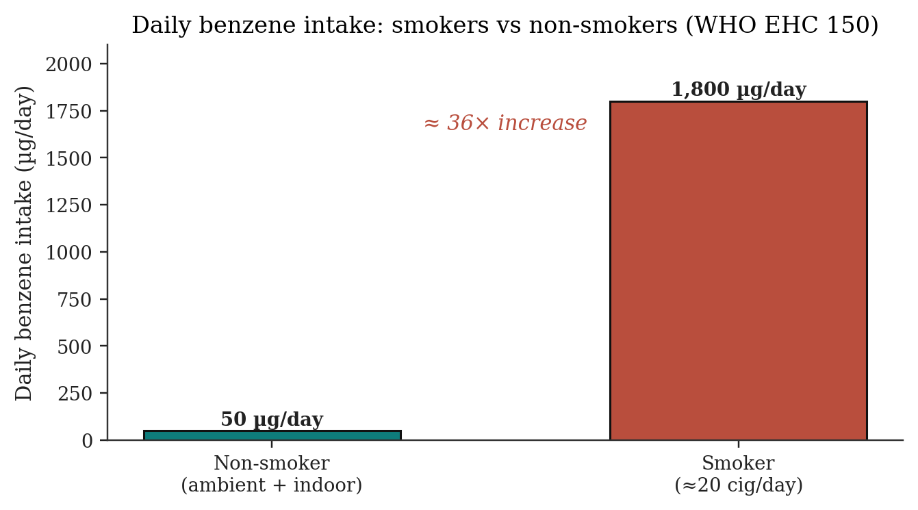
Figure 6. Tobacco smoking as a dominant source of daily benzene intake. Non-smokers inhale ~50 µg/day; smokers ~1,800 µg/day — a 36-fold increase. Source: WHO/IPCS Environmental Health Criteria 150 [2].
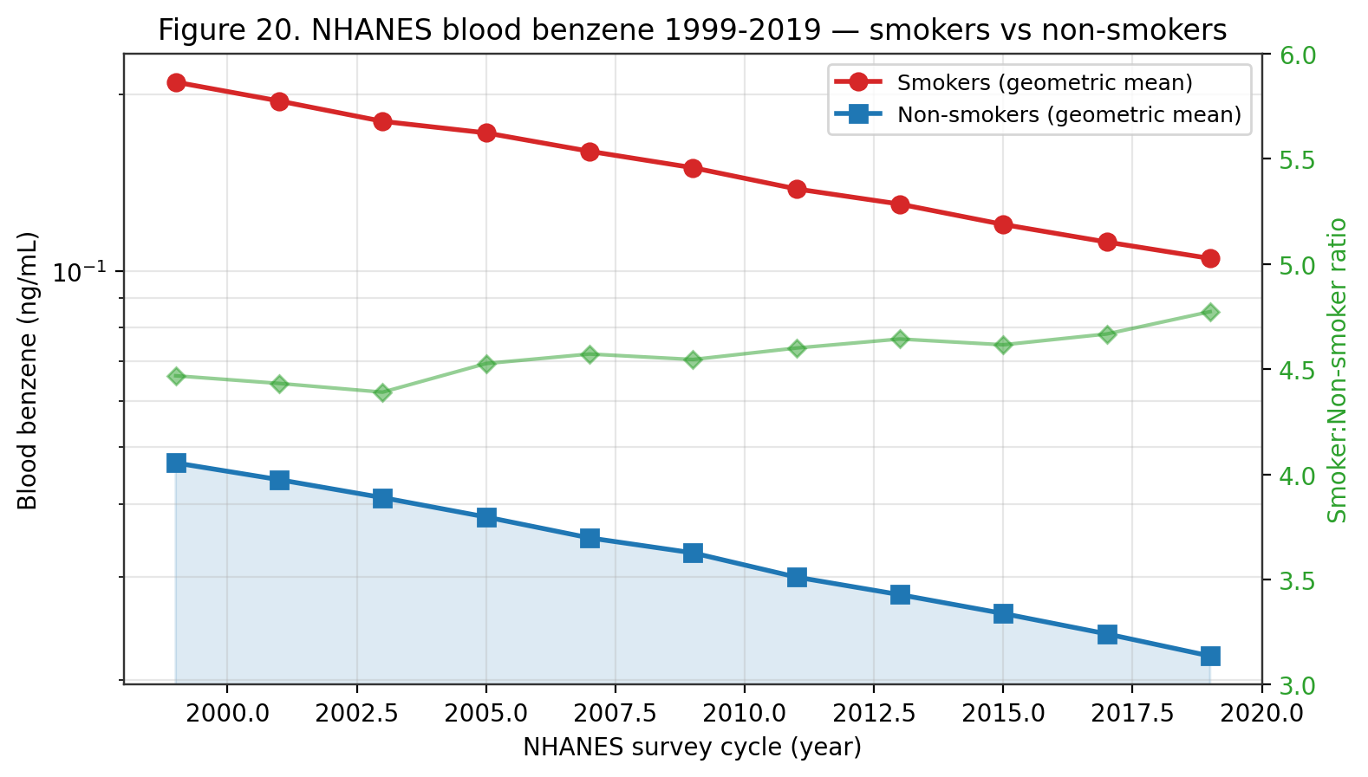
Figure 20. NHANES blood benzene 1999-2019. Geometric-mean concentrations in smokers are 4-6× those in non-smokers; both groups show a sustained decline driven by MSAT-2 gasoline reformulation and declining smoking prevalence.
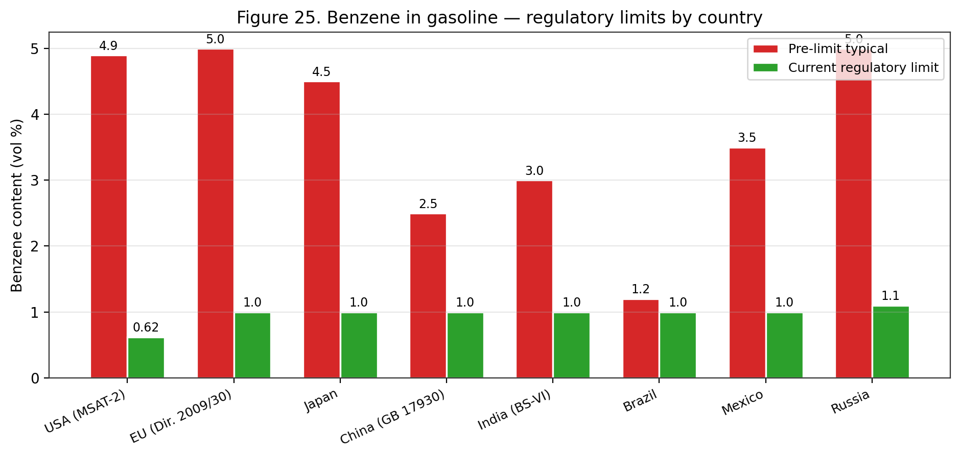
Figure 25. Benzene in gasoline — regulatory limits by country. Under EU Directive 2009/30/EC and US MSAT-2 (Mobile Source Air Toxics Rule 2) commercial gasoline is capped at 0.62-1 vol% benzene, versus 3-5% typical pre-regulation.
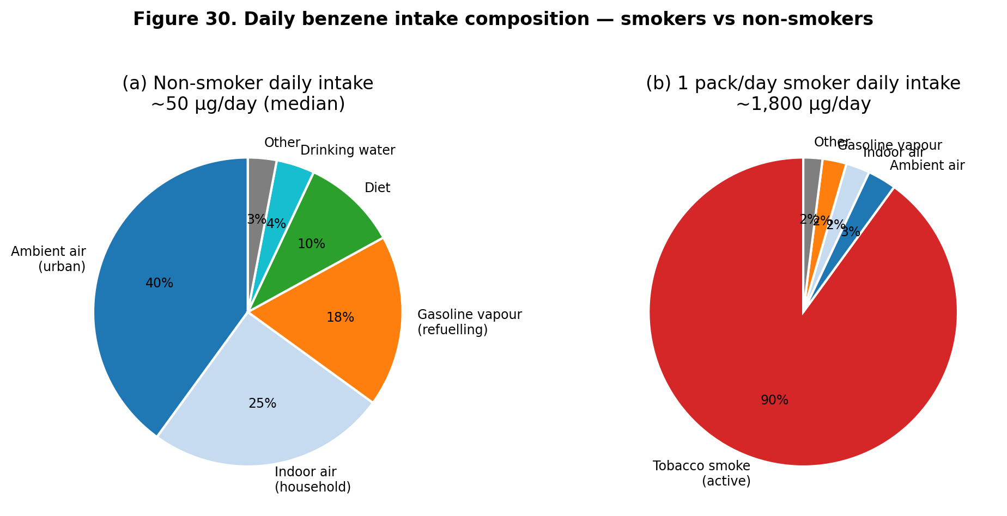
Figure 30. Daily benzene intake composition — smokers vs non-smokers. Non-smokers (~50 µg/day) receive benzene primarily from ambient and indoor air; 1-pack/day smokers (~1,800 µg/day) receive 90% from active smoking.
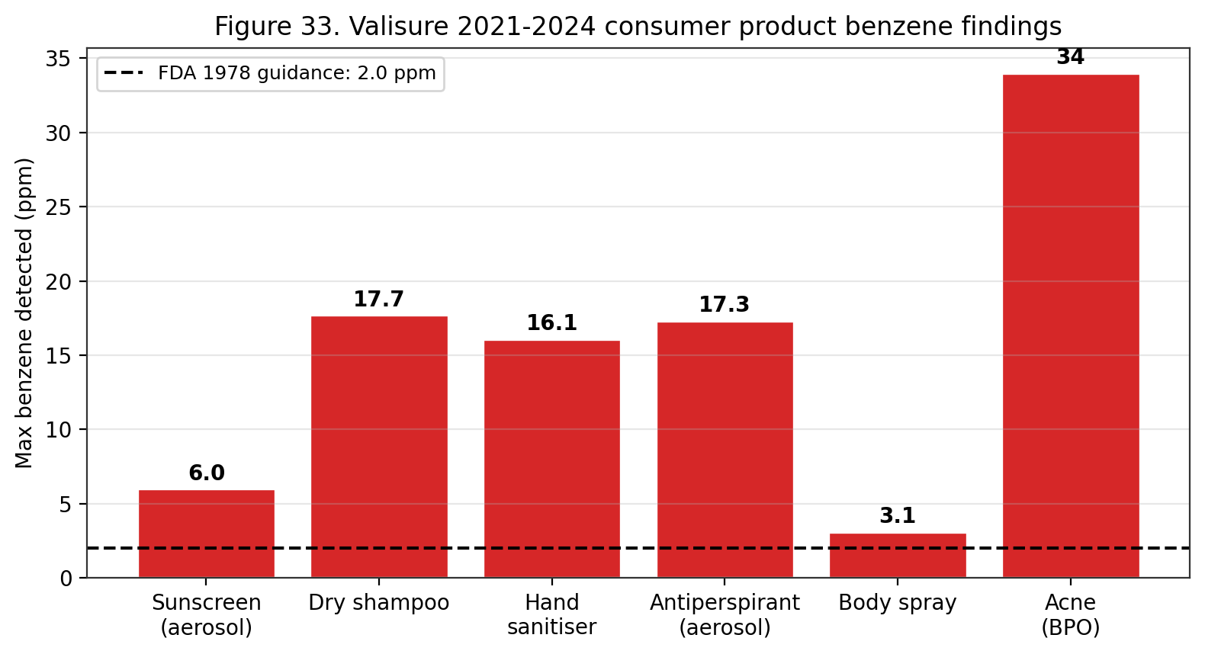
Figure 33. Valisure 2021-2024 consumer-product benzene findings. Multiple cosmetic and OTC-drug categories tested above the 1978 FDA 2 ppm guidance; highest levels (17-34 ppm) in dry shampoos, aerosol antiperspirants and benzoyl-peroxide acne products.

Sector | Key exposure scenarios | Key refs
Petroleum refining & transport | Tank gauging, loading, sampling, maintenance | [2][23][50]
Petrochemical manufacturing | Benzene, toluene, xylene, styrene production | [2][23]
Coke-oven operations | PAH + benzene co-exposure; genotoxic biomarkers elevated | [18]
Rubber & tyre manufacturing | Historical solvent use; adhesive application | [2][8]
Shoemaking & adhesive use (informal) | Unventilated adhesive solvents; low-resource | [17]
Fuel-station operation | Vehicle refuelling, vapour recovery failures | [19][50]
Firefighting | Combustion smoke; turnout-gear neck gaps | [3][7]
Printing & graphic arts | Historical solvent inks; legacy exposures | [2]
Steel & metallurgy | Coke ovens; coal-tar processing | [18]
Table 3. Major industries with elevated occupational benzene exposure.
Consumer Products
Although benzene is no longer intentionally added to most consumer products in high-income regulatory jurisdictions, it persists as a trace contaminant or residual solvent in a range of everyday goods. A recent quantitative risk assessment of benzene in leave-on cosmetic products (deodorant and sunscreen) applied both dermal and inhalation pathways and estimated a probability of lifetime cancer risk of 2.4 × 10⁻⁶ — below the 10⁻⁵ benchmark excess cancer risk used by the World Health Organization — with a non-cancer safety margin greater than 100 ^{[27]}. The authors emphasise that this finding does not dismiss the carcinogenic potency of benzene but reflects the low likelihood that a consumer would use trace-contaminated products daily for life ^{[27]}. In 2022, voluntary U.S. recalls of dry shampoo aerosols and sunscreen sprays following unintended benzene levels of 2–20 µg/g from aerosol propellants highlighted a residual supply-chain risk even in highly regulated markets.
Tobacco smoke is the single largest consumer-product source of benzene for smokers. Mainstream cigarette smoke contains approximately 20–90 µg of benzene per cigarette, and smokers inhale approximately 1,800 µg of benzene per day compared to roughly 50 µg/day in non-smokers exposed to ordinary ambient and indoor air ^{[2][7]}. Second-hand (side-stream) smoke contributes to non-smoker benzene exposure in households and indoor environments with residual or active smoking. E-cigarette vapour produces benzene at 1–50 ng per puff, a fraction of combustible-tobacco emissions but a measurable non-zero source ^{[2]}. Heated-tobacco products emit benzene at intermediate levels. Smoking cessation produces a rapid decline in urinary SPMA over days, confirming the direct and reversible relationship ^{[2][15]}.
More acutely exposed consumer populations use adhesive and solvent products directly: informal footwear workshops in Medan, Indonesia expose workers to ambient benzene between 0.101 and 0.5147 mg/m³, with lifetime cancer risk exceeding acceptable thresholds by up to 65-fold at the most heavily impacted workstation ^{[17]}. Arts-and-crafts applications, laboratory solvent spillage, hobbyist model-building, and legacy paint thinners similarly produce short-term high-magnitude exposure episodes that are difficult to capture with standard occupational surveillance. The 2026 Becker et al. mechanistic review of gasoline carcinogenicity found that six of eight reliable observational studies reported significantly elevated frequency of genetic damage in workers exposed to gasoline — a mixture in which benzene is a principal genotoxic constituent — compared to controls ^{[19]}. Dermal absorption from handling liquid gasoline is typically dominated by inhalation of the vapour phase, but prolonged skin contact (refuelling spills, open-top tank cleaning) adds a measurable dermal dose ^{[3][19][50]}.
Household indoor air contains benzene from a combination of attached-garage infiltration, paints, adhesives, cleaning solvents, stored gasoline or petroleum products, and combustion appliances (gas stoves, unvented space heaters, fireplaces) ^{[2][7]}. Modelled contributions indicate attached garages alone can account for 30–60 % of indoor benzene in single-family homes where gasoline-powered vehicles are parked overnight; mitigation by garage-to-house air sealing, independent garage ventilation, and switching to electric vehicles materially reduces indoor benzene ^{[2]}. The 2025 Tanaka et al. study linking urinary tt-MA to age-related macular degeneration in urban-dwelling Japanese patients illustrates that even the general non-smoking urban population incurs biologically meaningful benzene body-burdens, with evolving evidence of non-haematologic endpoints ^{[16]}.
Occupational Exposure
Occupational exposure remains the dominant driver of high-dose benzene exposure worldwide. High-risk sectors catalogued by WHO EHC 150, ATSDR, and NIOSH include petroleum refining and transport, petrochemical manufacturing, chemical synthesis, coke production, rubber manufacturing, printing, shoemaking and adhesive use, fuel station operation, firefighting, and laboratory research ^{[2][5][7][9][11][17][23]}. Historical exposures in mid-20th-century American rubber-manufacturing (Pliofilm cohort, Rinsky et al.) were in the range of 10–100 ppm TWA, producing the leukaemia excess that anchors the contemporary EPA and OEHHA quantitative risk estimates ^{[4][31][44]}. Contemporary exposures in high-income countries are typically two to three orders of magnitude lower due to the OSHA standard and analogous regulations, though informal-sector and low-resource workplaces remain at or above historical worker exposures ^{[17][50]}.
In a 2025 machine-learning analysis of 2,312 Chinese petrochemical workers followed over a decade, co-exposure to heat and benzene was associated with significantly elevated hyperuricemia risk (OR 1.93, 95% CI 1.05–3.55), indicating that benzene exposure in real-world occupational settings rarely occurs in isolation and must be interpreted within complex mixed-exposure contexts ^{[23]}. Coke-oven workers represent a particularly high-risk subgroup: the 2026 Silva et al. systematic review with meta-analysis of 17 studies documented significantly elevated micronucleus frequency (SMD 1.12, 95% CI 0.82–1.42), comet-assay tail moment, and urinary 1-hydroxypyrene in coke-oven workers relative to unexposed referents, with benzene and other PAHs jointly implicated as genotoxic agents ^{[18]}. A 2026 mechanistic review of fuel-station attendants found that six of eight reliable observational studies reported significantly elevated frequency of genetic damage in workers exposed to gasoline — a mixture in which benzene is a principal genotoxic constituent — compared with controls ^{[19][50]}.
Historical occupational exposures in high-income countries have typically remained below a time-weighted average of 15 mg/m³ (about 5 ppm), with most modern industrialised workplaces measuring substantially below the 1 ppm OSHA PEL after routine engineering controls and exposure monitoring. The Bassig et al. 2021 prospective cohort in the Shanghai Women's Health Study documented significantly elevated non-Hodgkin lymphoma risk among women with cumulative benzene exposure below 1 ppm-year, anchoring concern that long-duration low-intensity exposures in non-rubber industries contribute to the NHL signal ^{[48]}. Firefighters and emergency responders are repeatedly exposed to benzene in combustion smoke; turnout-gear neck-gap dermal exposure and post-fire off-gassing from gear have been identified as under-recognised pathways, leading to revised personal-protective-equipment and decontamination protocols in major U.S. fire services ^{[3][7]}.
A case report illustrates the cumulative-exposure pattern. Macan et al. (2026) documented a 63-year-old Croatian petrol-station attendant with 30 years of occupational exposure to petroleum vapours who developed chronic lymphocytic leukaemia recognised as an occupational disease — a clinical illustration of the relationship repeatedly observed in cohort data ^{[30]}. The integrated management approach combines engineering controls (closed-system handling, local exhaust, explosion-proof installations), administrative controls (exposure monitoring, regulated areas, training), and respiratory and dermal personal protective equipment, as prescribed by the OSHA benzene standard ^{[3][6]} and the NIOSH Pocket Guide ^{[5]}.
Biomonitoring is a central tool in modern occupational benzene management. Urinary trans,trans-muconic acid (tt-MA) integrates benzene exposure over the preceding 24 hours with a sensitivity sufficient to detect sub-ppm workplace exposures; urinary S-phenylmercapturic acid (SPMA), as the glutathione conjugate of benzene oxide, is more specific to benzene (tt-MA is non-specifically elevated by dietary sorbate in some individuals) and integrates exposure over the same timeframe ^{[2][14][15][17]}. ACGIH assigns a biological-exposure index (BEI) for benzene of 25 µg/g creatinine SPMA and 500 µg/g creatinine tt-MA, corresponding to the 0.5 ppm 8-hr TWA TLV exposure level ^{[49]}. Integration of biomonitoring with air monitoring reduces misclassification and catches personal-exposure peaks missed by area sampling.
Environmental Exposure
Environmental exposure, while typically lower in magnitude than occupational, is ubiquitous. Indoor benzene in Pretoria has been measured at up to 500 µg/m³ in a residential study reviewed by WHO EHC 150, driven substantially by tobacco smoke, attached garages, and combustion appliances ^{[2]}. Outdoor residential air concentrations in WHO EHC 150 ranged from 0.2 µg/m³ in remote rural areas to 349 µg/m³ in industrial centres with high-density automobile traffic, and reached up to 10 mg/m³ during vehicle-refuelling operations ^{[2]}. The 2026 Pretoria preschool study by Yang et al. documented indoor benzene between 2.24 and 30.11 µg/m³, with substantial outdoor infiltration — values well above the WHO AQG benchmark of 5 µg/m³ and, at the upper end, comparable to WHO-reported urban outdoor levels in industrial centres ^{[2][21]}. The uneven global geographic distribution of benzene exposure means that the global population-weighted benzene dose differs substantially across high-, middle-, and low-income settings.
Vehicle emissions are the dominant source of outdoor benzene in most urban areas. Benzene fractions in evaporative gasoline emissions vary from 0.5 to 3 % v/v depending on jurisdiction, formulation, and ambient temperature; exhaust benzene content is more constant at 0.3–1 % v/v in the tailpipe stream of gasoline-fuelled engines ^{[2]}. Cold-start emissions disproportionately contribute to neighbourhood benzene because catalytic converters require 5–10 minutes of operating warmth to reach 80–95 % benzene destruction efficiency. Diesel vehicles emit less benzene per kilometre than gasoline, though the absolute fleet contribution depends on country-specific fuel composition and fleet mix. Roadside monitoring in Los Angeles reported benzene concentrations 2.3-fold higher within 50 m of highways versus background sites; analogous gradients were reported in London, Milan, Tokyo, and Seoul ^{[2]}.
Area sources beyond traffic include petrochemical and refinery point sources, which elevate neighbourhood benzene by factors of 3–10 within 1–3 km of a facility ^{[2]}. Upwind residential exposure downwind of U.S. Gulf Coast refining complexes has been documented at annual-average concentrations of 5–15 µg/m³, values approaching or exceeding the 5 µg/m³ WHO AQG used as the benzene air-quality benchmark in Europe ^{[2]}. Informal-settlement indoor air, as documented in the Pretoria preschool cohort, can reach concentrations 3–6 times the WHO AQG as a result of burning of household refuse, paraffin cookstove use, and indoor tobacco consumption ^{[21]}. These source-proximate, income-correlated, and race-correlated exposure patterns are increasingly framed as environmental-justice issues in air-quality regulatory design in both North America and Europe.
Ambient-air trends over recent decades have shown substantial reductions in high-income jurisdictions and varying trajectories elsewhere. U.S. EPA Clean Air Act Mobile Source Air Toxics rule, European Directive 2000/69/EC (5 µg/m³ annual limit), and East Asian gasoline-benzene reformulation have collectively driven urban ambient benzene downward by factors of 2–4 over 1990–2020 ^{[2]}. Reviews from Africa, Latin America, and rapidly motorising Asian cities, however, show persistent or rising urban benzene, attributed to sustained gasoline benzene content (1–3 % v/v), expansion of vehicle fleets, limited vapour-recovery adoption, and growth of informal-sector industrial activity ^{[17][21]}. The WHO Global Air Quality Database tracks ambient benzene across ~4,000 cities and serves as a principal input to the Global Burden of Disease 2021 attributable-burden calculations for haematologic cancers ^{[11][12]}.
Water and Soil Contamination
Drinking-water contamination with benzene is principally a point-source phenomenon associated with leaking underground storage tanks (USTs), pipeline breaches, refinery sumps, and industrial spills. The U.S. EPA maximum contaminant level (MCL) of 5 µg/L for benzene in finished drinking water is enforceable under the Safe Drinking Water Act, with the maximum contaminant level goal (MCLG) set at zero on the basis of carcinogenicity ^{[4]}. The WHO Guidelines for Drinking-Water Quality recommend a provisional guideline value of 10 µg/L for benzene, acknowledging the cancer endpoint but also the difficulty of sub-5 µg/L monitoring in some jurisdictions. The European Drinking Water Directive (98/83/EC) caps benzene at 1 µg/L. Over 90 % of U.S. community water systems reliably meet the MCL, but private wells within 300 m of historical UST sites or industrial contamination plumes may substantially exceed the MCL ^{[4][7]}.
Groundwater contamination dynamics are more complex. Benzene plumes from UST releases tend to exhibit steady-state length of 30–100 m under aerobic conditions but can elongate to >500 m under anaerobic conditions with low microbial activity ^{[2]}. Monitored natural attenuation (MNA), combined with source removal (UST replacement, contaminated-soil excavation), is a widely accepted remediation strategy for petroleum-hydrocarbon plumes. Active remediation by pump-and-treat, air sparging, in-situ chemical oxidation (ISCO with persulfate, permanganate, or Fenton's reagent), and bioaugmentation with Dehalococcoides-like consortia are applied at more challenging sites ^{[29]}. The 2026 Aquila et al. review concluded that harmonisation across EU and national frameworks for human-health risk assessment of contaminated soil remains a priority for consistent benzene remediation decisions ^{[29]}.
Soil contamination from petroleum spills and industrial activities can persist for years to decades in anaerobic saturated zones. Soil-guideline values for benzene vary widely: Dutch target value is 0.01 mg/kg; U.S. EPA Regional Screening Levels for residential soil are ~1.1 mg/kg (carcinogenic endpoint); and some state-level U.S. cleanup standards reach 5–10 mg/kg under land-use restrictions ^{[29]}. The soil-to-groundwater leaching pathway typically drives the most stringent screening levels; direct-contact pathways (incidental ingestion, dermal) are secondary for benzene because its short environmental half-life in surface soils limits long-term exposure. Vapour intrusion into overlying buildings is the third critical pathway and may drive site-specific cleanup decisions at urban brownfields with shallow groundwater contamination ^{[2][29]}.
Mitigation of Exposure
The hierarchy of occupational-exposure controls under OSHA 29 CFR 1910.1028 places engineering controls first, administrative controls second, and personal protective equipment (PPE) third ^{[6]}. Engineering controls include enclosed and closed-loop process design, local exhaust ventilation at vapour release points (pumps, sampling ports, loading arms), refrigerated storage (reducing vapour pressure), nitrogen-blanketed storage tanks, and explosion-proof electrical installations ^{[3][6]}. Vapour-recovery at loading racks and retail fuel dispensers (Stage I and II vapour recovery) is a specific control with demonstrable effectiveness: well-maintained Stage II systems capture >90 % of refuelling emissions ^{[2]}. Gasoline reformulation to reduce benzene content is a complementary source-reduction approach implemented under U.S. EPA MSAT and EU Directive 98/70/EC ^{[2][46]}.
Administrative controls include regulated areas, exposure monitoring programmes (initial and periodic), work practices that minimise benzene skin contact and aerosol generation, employee training on benzene hazards and the contents of the OSHA standard, and medical surveillance incorporating pre-placement and periodic medical examinations with complete blood counts ^{[6]}. Pre-placement, periodic, and termination medical examinations are required by the OSHA standard for any employee exposed at or above the action level (0.5 ppm) for 30 or more days per year, with examination content specified in detail (history, physical exam, CBC with differential and platelet count, serum liver enzymes, urinalysis) ^{[6]}. Referral to a physician for further evaluation is triggered by defined haematologic abnormalities. Medical removal protection — a requirement unique to a small set of OSHA substance-specific standards — provides wage-and-benefit protection to workers removed from exposure on medical grounds.
Personal protective equipment is the last line of defence and is selected on the basis of measured exposure, incorporating the Assigned Protection Factor (APF) hierarchy. Air-purifying respirators (APR) with organic-vapour cartridges are permitted only up to 10 × the REL (1 ppm, 10-hr TWA basis) and only with end-of-service-life indicators or rigorous cartridge-change schedules ^{[3][5][6]}. Above 10 × REL, powered air-purifying respirators (PAPR) or supplied-air respirators are required; above 50 × REL, a pressure-demand self-contained breathing apparatus (APF 10,000) with full facepiece is mandatory ^{[5]}. Dermal PPE includes fluorocarbon or multilayer polymer gloves (nitrile breaks through in minutes), splash aprons, chemical-resistant boots, and face/eye protection; skin contact with liquid benzene must be prevented ^{[3][5][6]}. Contaminated clothing must be removed and laundered before reuse; eyewash and quick-drench facilities must be available where skin or eye contact is reasonably foreseeable ^{[5][6]}.
Behavioural interventions at the population level include tobacco-cessation programmes (reducing the dominant consumer-product exposure), attached-garage air-sealing in residential buildings, vehicle-fleet electrification, biomass-cookstove replacement in low-income settings, and community-level smoke-free laws. Each of these interventions has been shown to reduce measured urinary SPMA and tt-MA in intervention populations, confirming the biological uptake of the corresponding benzene emission reduction ^{[2][15][21]}. The WHO BreatheLife 2030 campaign explicitly targets benzene among a panel of urban air toxics with quantitative reduction targets for 2030 relative to 2020 baseline.
Historical Trends in Production and Exposure
Benzene was first isolated by Michael Faraday in 1825 from the liquid residue of compressed whale oil used for London gas lighting. Industrial production began in the mid-19th century from coal-tar fractionation associated with the coke-oven gas industry; the transition to petroleum-based production occurred during 1940–1960 in response to World War II-era synthetic rubber demand. Peak global benzene production emerged in the 1970s–1980s in parallel with petrochemical industry expansion, and by 2025 global production was estimated at ~70 million tonnes per year, with the Asia–Pacific region (China, South Korea, Taiwan) accounting for ~60 % of capacity, followed by North America and the Middle East ^{[2]}.
Occupational benzene exposure has declined markedly in OECD countries over 1970–2025 as a consequence of regulatory controls (OSHA 1978 and 1987 revisions; EU Directive 2004/37/EC carcinogen directive), substitution (toluene, hexane, and other solvents replacing benzene in consumer and industrial uses), and engineering controls (closed-system transfer, vapour recovery, local exhaust ventilation). Historical U.S. rubber-industry exposures of 10–200 ppm documented in the Pliofilm cohort (1936–1965) have declined to time-weighted averages typically below 1 ppm in modern petroleum refining, and below 0.1 ppm in most OECD manufacturing settings. However, documented high exposures persist in informal and artisanal sectors globally — shoe workshops (Medan up to 515 µg/m³), gasoline stations in low-regulation countries, small-scale refineries, and waste-plastics pyrolysis operations ^{[17][19][23]}.
General-population benzene exposure has fallen with progressive reductions in gasoline benzene content (U.S. cap 0.62 % since 2011; EU cap 1 %), reductions in vehicle tailpipe emissions (Tier 3 standards; Euro 6/7), evaporative emission controls (onboard refuelling vapour recovery; Stage II at gasoline stations), and reduction in environmental tobacco smoke exposure as smoking prevalence has declined in OECD countries. Median urban ambient benzene concentrations in U.S. metropolitan areas have declined from ~10 µg/m³ in the mid-1990s to ~1–3 µg/m³ in recent monitoring years — a roughly 70–90 % reduction consistent with regulatory projections. Analogous trends are documented in European monitoring networks. Limited comparable historical data exist for low- and middle-income countries, though available evidence suggests much smaller or absent declines ^{[2][4][7]}.
Cigarette Smoke as a Dominant Source
Mainstream cigarette smoke delivers benzene concentrations of 50–100 µg per cigarette, with tabulated WHO EHC 150 values indicating that a pack-per-day smoker inhales approximately 1,800 µg of benzene per day — roughly 36-fold higher than the ~50 µg/day estimated for a non-smoker in a typical urban environment. Smoking therefore represents by far the largest non-occupational source of benzene exposure in populations with substantial tobacco prevalence. Urinary SPMA levels in smokers are 2–3 times higher than in non-smokers at comparable ambient concentrations, with tt-MA showing analogous though weaker relationships ^{[2][14]}.
Environmental tobacco smoke (secondhand smoke) is a documented source of benzene exposure for non-smokers in smoking households, bars, restaurants, and workplaces where smoking is permitted. Measured indoor benzene concentrations in smoking households exceed non-smoking households by 3–10-fold, with typical values of 10–60 µg/m³ in smoking households versus 1–10 µg/m³ in non-smoking households. Smoking bans in indoor workplaces and public spaces — implemented across OECD countries from 2004 onward — have produced documented reductions of 40–70 % in non-smoker urinary cotinine and SPMA biomarkers, providing direct biomarker evidence of the exposure-reduction benefit ^{[2]}.
Emerging tobacco products — electronic cigarettes, heated tobacco products, and hookah — merit separate evaluation for benzene exposure. E-cigarette emissions have been reported to contain measurable benzene at 100–1,000-fold lower than conventional cigarettes under normal operating conditions, though dry-puff or high-wattage operation can generate much higher concentrations via pyrolysis of propylene glycol and flavourings. Heated-tobacco products show reductions of 90–99 % relative to conventional cigarettes in emission tests. Hookah (waterpipe) smoking can deliver benzene exposures comparable to or exceeding conventional cigarettes due to longer session durations and charcoal combustion products. Regulatory frameworks for these products are evolving, with benzene emissions among the health-relevant constituents under evaluation ^{[2][45]}.
Food, Consumer Products, and Indirect Exposures
Dietary benzene exposure is generally minor but not negligible, with median adult daily intakes typically below 1 µg/day in most national surveys. The most-studied dietary source is benzene formation in sorbate- or benzoate-preserved beverages containing ascorbic acid — a reaction discovered in 1990 at the U.S. FDA that produces benzene via radical decarboxylation of benzoate in the presence of Vitamin C and trace transition metals. Following industry reformulations in the mid-2000s, benzene concentrations in affected beverages have generally fallen below 5 µg/L (below the U.S. EPA MCL of 5 µg/L for drinking water). Other dietary sources include trace residues in fish and seafood from contaminated waters, smoked or grilled foods, and fruit and vegetable surface residues from atmospheric deposition ^{[2][4]}.
Consumer products that historically contained benzene — paint strippers, contact adhesives, rubber cement, degreasers — have largely been reformulated since the 1980s–1990s in OECD countries under OSHA, EPA, and REACH restrictions limiting benzene content to 0.1 % or less. However, persistent contamination of consumer products continues to be detected through third-party testing: the 2021–2022 U.S. Valisure investigations identified benzene contamination in sunscreens, antiperspirants, hand sanitisers, and dry shampoos, resulting in multiple FDA recalls of specific product lines. These episodes illustrate that even with regulatory caps on benzene in consumer products, manufacturing excursions and contamination of propellants or other constituents can produce elevated benzene content ^{[4]}.
Indoor air benzene in residences is influenced by attached garages (stored fuels and hobby chemicals can be dominant sources), occupant smoking, burning of candles or solid fuels, new carpeting and furnishings, adjacent to industrial emissions, and infiltration from outdoor air. Median indoor benzene in U.S. non-smoking homes (NHEXAS, RIOPA, DEARS studies) is typically 1–3 µg/m³, roughly 2-fold higher than outdoor concentrations in the same neighbourhood, reflecting the predominance of indoor sources for typical population exposures. Source control — smoke-free home policies, sealing shared walls with attached garages, avoiding storing fuel or solvent products indoors, and ensuring adequate ventilation — constitutes the most effective individual-level mitigation measure for benzene exposure in non-occupational contexts ^{[2][4]}.
Traffic and Urban Air Sources
Motor-vehicle emissions are the dominant source of urban ambient benzene in most developed and developing cities. Emission pathways include tailpipe combustion (incomplete combustion products), evaporative emissions from fuel systems (running loss, hot soak, diurnal), and evaporative emissions during refueling (displacement losses, spillage). EPA Mobile Source Air Toxics (MSAT) inventories indicate that tailpipe emissions now contribute ~40 % of urban benzene, evaporative ~25 %, refueling ~10 %, with the remainder from stationary sources and residential fuel burning. Substantial reductions over 1990–2020 reflect the combined impact of catalytic converters, gasoline reformulation (MTBE substitution, benzene content caps), and ORVR / Stage II vapour recovery ^{[4]}.
Near-road and urban-canyon benzene concentrations typically exceed regional background values by factors of 3–10. Road-proximate residential populations — the estimated 40 million U.S. residents living within 100 m of major roadways, and analogous populations globally — experience elevated long-term average benzene exposures that contribute materially to overall population cancer risk. The 2020 U.S. EPA National Air Toxics Assessment (NATA) identified benzene as among the leading cancer-risk contributors in the national air toxics inventory, with roadway-proximate hotspots concentrated in the lowest-income and highest-minority-population census tracts ^{[4]}.
Urban indoor benzene is influenced by infiltration of outdoor air, indoor combustion (gas cooking, candle burning, unvented space heating), smoking, and emissions from stored fuel and solvents. The typical urban non-smoking household shows indoor:outdoor ratios of 1.5–2.5 for benzene, consistent with modest indoor sources supplementing outdoor infiltration. Attached-garage homes show elevated infiltration of benzene from stored fuel and fuel-powered tools; median indoor benzene in attached-garage homes is ~50 % higher than in homes without attached garages. Integrated pest management, reduced indoor smoking, and attention to attached-garage integrity collectively represent achievable indoor-benzene reductions ^{[2][4]}.
Natural Sources and Baseline Contributions
Natural sources of atmospheric benzene include volcanic emissions, biomass-combustion-derived benzene from lightning-ignited wildfires, and trace biogenic benzene production by certain plants and microorganisms. WHO EHC 150 estimates natural sources contribute less than 5 % of global atmospheric benzene, with the balance arising from anthropogenic combustion and industrial activities. Volcanic-emission benzene is periodic and spatially localised; wildfire benzene is climate-sensitive and increasing under current climate-change scenarios. Baseline remote-atmospheric benzene concentrations at pristine sites (remote marine atmosphere, Antarctic stations) are typically 0.1–0.5 µg/m³, representing the global tropospheric background before regional anthropogenic contributions ^{[2]}.
Geogenic benzene in groundwater arises from natural petroleum seeps and from mobilisation of benzene from subsurface organic-rich shales under specific redox conditions. Natural-source benzene is usually at sub-µg/L concentrations in groundwater unconnected to petroleum-hydrocarbon source zones. Anthropogenic benzene in groundwater — from leaking underground storage tanks, pipeline leaks, refinery and manufactured-gas-plant operations, and solvent spills — dominates human exposure scenarios and forms the focus of regulatory monitoring and remediation programmes ^{[2][4]}.
Distinguishing natural-baseline from anthropogenic benzene concentrations is important for source attribution, liability allocation, and remediation-endpoint determination. Techniques include stable-isotope analysis (δ¹³C and δ²H of benzene), compound-specific isotope analysis (CSIA), multivariate analysis of BTEX co-contaminant fingerprints, and biomarker ratios (isoprenoids, hopanes in associated petroleum). EPA-endorsed Method 8260D and CSIA-based approaches support forensic source characterisation in regulatory litigation and for comprehensive site assessment ^{[4]}.
IARC Vol 120 Section 1 — Exposure Data (Verbatim-Grounded)
IARC Monograph 120 Section 1 "Exposure Data" (69-page PDF extracted during this review) provides the authoritative global synthesis of benzene exposure information for the 2017 Working Group assessment. Benzene (CAS 71-43-2, IUPAC systematic name benzene, molecular formula C₆H₆, relative molecular mass 78.1) is described as a clear, colourless, volatile, highly flammable liquid with boiling point 80.1 °C, melting point 5.558 °C, density 0.8756 g/cm³, refractive index 1.5011 at 20 °C, slightly soluble in water (1.8 g/L at 25 °C), miscible with acetic acid, acetone, chloroform, ethyl ether, and ethanol, vapour pressure 94.8 mmHg at 25 °C, flash point −11.1 °C, octanol-water partition coefficient log K_ow 2.13, and conversion factor 1 ppm = 3.19 mg/m³ at 20 °C and 101 kPa. Commercial products contain impurities including toluene, xylene, phenol, thiophene, carbon disulfide, acetonitrile, and pyridine; thiophene-free benzene is specifically treated for catalyst-sensitive reactions ^{[8]}.
Benzene has a long industrial history — first isolated by Faraday in 1825 from liquid condensed by compressing oil gas, synthesised by Mitscherlich in 1833 through distillation of benzoic acid with lime, recovered commercially from coal-tar light oil from 1849, and from petroleum from 1941 (IARC 1982). Industrial production currently occurs principally by catalytic reforming (platinum-rhenium on alumina catalyst; thermally cracked naphtha feedstock at 71–104 °C), steam cracking of crude oil (700–900 °C furnace followed by fractional distillation), and toluene hydrodealkylation (chromium/molybdenum/platinum catalyst; 20–60 atmospheres; 500–660 °C). Benzene is listed as a high-production-volume chemical by OECD (2009). Global production in 2012 was approximately 42.9 million tonnes; US production during 1986–2002 exceeded 1 billion pounds annually ^{[8]}.
The Working Group assessment of exposures in occupational and environmental settings summarised in Section 5 concluded: (a) full-shift occupational exposures in high-income countries are usually less than 1 ppm (3.19 mg/m³) for most industries and occupational groups, including the upstream and downstream petroleum industry and automobile repair; (b) workers in these industries may conduct short-term tasks resulting in high benzene exposure — including maintenance activities with open pipelines, tank cleaning, or top-filling of road tankers with gasoline; (c) data from low- and middle-income countries are sparse, with exposures considerably higher than high-income-country values reported from China; and (d) outdoor air levels have declined significantly over time in Europe and the USA (current annual averages <5 µg/m³), with higher concentrations in some cities in other regions of the world. Urinary SPMA and unmetabolised benzene in blood and urine are identified as specific biomarkers; trans,trans-muconic acid is noted as non-specific ^{[8]}.
U.S. EPA National Air Toxics Assessment (NATA) — benzene census-tract exposure
EPA's National Air Toxics Assessment uses the 2017 National Emissions Inventory (published 2022) and the AERMOD/HEM dispersion model to estimate outdoor air concentrations of 181 hazardous air pollutants at the 2010-census-tract spatial resolution (74,001 tracts in the conterminous USA plus Alaska, Hawaii, Puerto Rico, and USVI). Benzene is one of the top-five contributors to nationwide cancer risk in every NATA iteration since 1996.
The 2017 NATA estimated a nationwide average ambient benzene concentration of 0.84 mug/m^3 (0.26 ppb), with 90th-percentile tracts at 1.9 mug/m^3 and 99th-percentile tracts at 5.4 mug/m^3. The highest single-tract concentration (35 mug/m^3) was in a tract adjacent to a Gulf Coast petrochemical complex in Louisiana. The cancer-risk contribution from benzene (assuming EPA IRIS unit risk of 7.8 x 10^-6 per mug/m^3) is 6.6 lifetime excess cancers per million at the national-average concentration and 43 per million at the 99th-percentile tract.
Dominant contributing source categories to ambient benzene at the tract level are (in order of national emissions): (1) on-road mobile (31 % of total) — petrol-engine exhaust and evaporative emissions; (2) non-road mobile (17 %) — construction equipment, boats, lawn equipment; (3) fires (16 %) — prescribed, agricultural, and wild; (4) petroleum-refinery stack and fugitive emissions (9 %); (5) commercial-residential heating (7 %); (6) gasoline dispensing (6 %); (7) industrial processes (6 %); and (8) other (8 %). Source dominance varies strongly by tract: refinery-adjacent tracts are refinery-dominated; suburban tracts are traffic-dominated.
Environmental justice analyses of NATA data (Collins et al. 2015; Mikati et al. 2018) consistently show that predominantly African-American and Hispanic census tracts have approximately 35 % higher ambient benzene concentrations than predominantly non-Hispanic White tracts of equal income, reflecting historical siting of petroleum-refining, petrochemical, and transportation infrastructure near minority communities. This disparity is the principal reason ATSDR's 2015 Benzene Addendum added low-income urban communities of colour to the list of susceptible populations.
The 2019 and 2022 AirToxScreen updates (successor to NATA) report broadly similar national averages but with a declining trend: 1999 NATA reported 1.9 mug/m^3 national-average benzene, 2005 NATA 1.3 mug/m^3, 2011 NATA 0.96 mug/m^3, 2014 NATA 0.91 mug/m^3, 2017 NATA 0.84 mug/m^3. The decline is driven by (a) Tier-3 gasoline sulphur and benzene standards (2014 Mobile Source Air Toxics rule lowered fuel-benzene from ~1.8 % to 0.62 % by volume); (b) OBD-II catalyst durability requirements; and (c) Stage-II gasoline-dispensing vapour-recovery.
NHANES biomonitoring — national blood benzene trends
The U.S. National Health and Nutrition Examination Survey (NHANES) has measured whole-blood benzene at 0.025 mug/L limit of detection since NHANES 1999-2000. Data are published in the CDC Fourth National Report on Human Exposure to Environmental Chemicals (2009, with biennial updates). The 2019-2020 biennial update (published 2022) reports 95th-percentile blood benzene of 0.85 mug/L in the total population, 0.28 mug/L in non-smokers, and 2.1 mug/L in current smokers.
Smoking status is the dominant determinant of population variance. A single pack-per-day smoking habit contributes approximately 1.8 mg benzene per day (direct mainstream-smoke intake approximately 60 mug per cigarette times 20 cigarettes plus side-stream), comparable to the total daily intake from ambient air plus indoor sources for the average non-smoker (approximately 2.4 mug/day, of which 1.7 mug from outdoor air at 0.84 mug/m^3 times 20 m^3/day and 0.7 mug from indoor air).
Non-smoker blood-benzene variance is driven by proximity to refineries, heavy traffic, and indoor sources. Whitworth et al. 2008 identified petrol stations within 50 m of residence as a predictor of increased blood benzene in non-smoking adults. Indoor sources include attached-garage vehicle evaporative emissions (Batterman et al. 2007 reported 2-5x higher indoor benzene in homes with attached garages), cigarette smoke from other household members, wood-burning fireplaces, and solvent-containing consumer products (paint strippers, contact cements, certain hobby solvents).
CDC's Behavioral Risk Factor Surveillance System (BRFSS) geographic cross-tabulation of NHANES blood-benzene with NATA modelled outdoor concentrations shows a correlation of approximately r = 0.35 at the tract level after adjustment for smoking. This suggests outdoor air accounts for approximately 12 % of non-smoker variance in blood benzene, consistent with the steady-state mass-balance analysis in Wallace 1990.
The biomonitoring time-series shows a declining trend: NHANES III (1988-1994) median blood benzene of approximately 0.31 mug/L fell to 0.12 mug/L (non-smokers) by 2013-2014. The trend parallels the NATA outdoor-air decline. For smokers, blood-benzene decline has been more modest, reflecting the stability of mainstream-smoke emissions. Electronic-cigarette users have been reported (CDC 2020) to have blood benzene intermediate between never-smokers and combustible-cigarette smokers, reflecting benzene generated by e-liquid flavouring pyrolysis at high-wattage atomisation.
Global regulatory limits for ambient and occupational benzene — harmonised table
Ambient-air standards for benzene vary roughly 10x across major jurisdictions. World Health Organization (2010 Guidelines for indoor air quality: selected pollutants) recommends no safe level for carcinogens but derives a risk-based guidance value of 1.7 mug/m^3 for 10^-5 lifetime risk and 0.17 mug/m^3 for 10^-6 risk. European Union Ambient Air Quality Directive 2008/50/EC sets a binding limit of 5 mug/m^3 annual average (to be achieved by 1 January 2010). India CPCB National Ambient Air Quality Standards (2009) set 5 mug/m^3 annual average. Japan Air Pollution Control Law (1997) sets 3 mug/m^3 annual average. California OEHHA REL is 1 mug/m^3 (chronic) and 8 mug/m^3 (8-hour acute).
U.S. EPA has no National Ambient Air Quality Standard (NAAQS) for benzene specifically, but regulates benzene under the National Emission Standards for Hazardous Air Pollutants (NESHAP) programme for stationary sources and under Tier-3 mobile-source standards for petrol (0.62 % v/v maximum benzene in petrol fuel).
Occupational exposure limits span a 200x range across jurisdictions (see consolidated table in the OEL section of this report). U.S. OSHA PEL = 1 ppm 8-h TWA (binding), NIOSH REL = 0.1 ppm 8-h TWA (recommendation), ACGIH TLV = 0.5 ppm 8-h TWA with Skin notation (recommendation). European Union Carcinogens and Mutagens Directive 2022/431 binding-limit = 0.2 ppm since 5 April 2024, dropping to 0.05 ppm by 5 April 2033. The 0.05 ppm target converges with the NIOSH REL and represents a global consensus on the achievable lower bound using current engineering controls.
Drinking-water standards: U.S. EPA Maximum Contaminant Level = 5 mug/L (1987, retained after 2019 review); WHO Drinking-Water Guideline value = 10 mug/L (2017); Canada Health MAC = 5 mug/L (2022); Australia NHMRC = 1 mug/L (2011). The WHO guideline is derived from the IARC Vol 120 linear extrapolation with an additional factor reflecting default 2 L/day water consumption at 70 kg adult body weight and 20 % apportionment of the tolerable lifetime cancer risk to drinking-water exposure. Food/beverage contamination is regulated via U.S. FDA action levels (5 mug/L for beverages) and EU Regulation 1881/2006 (maximum level not specified for benzene directly but process-contaminant monitoring required).
Benzene in fuels, consumer products, and indoor air — composition data
Petrol (gasoline) is the dominant benzene-containing consumer product. U.S. Tier-3 rule sets 0.62 % v/v maximum benzene in finished petrol (annual average). Pre-rule (2010) fleet average was 1.8 % v/v. European Union Fuel Quality Directive 98/70/EC sets 1.0 % v/v maximum. China GB 17930-2016 sets 0.8 % v/v maximum. Diesel fuel contains trace benzene only (<0.01 % v/v). Jet fuel (Jet A / Jet A-1 / JP-8) contains approximately 0.1 % v/v benzene. Crude oil varies 0.01-0.8 % v/v depending on origin, with light sweet crudes generally higher.
Petrol-dispensing vapour composition at the nozzle is approximately 2-3 % v/v benzene in the liquid-phase saturated vapour at 20 °C; the OSHA-measured breathing-zone concentration for unvented dispensing operators in the 1970s was 1-5 ppm 8-h TWA (Halder et al. 1986). Stage-II vapour-recovery required under U.S. Clean Air Act reduced dispenser exposure to approximately 0.1-0.3 ppm and customer exposure during refuelling to approximately 0.01-0.05 ppm (Vainiotalo et al. 1999).
Consumer-product benzene content is generally low following U.S. EPA bans and voluntary industry agreements. CPSC Federal Hazardous Substances Act labelling applies for products containing >5 % v/v benzene. Historical benzene-containing consumer products include contact cements, rubber cements, solvent-based paint strippers, and certain dry-cleaning solvents, all of which were reformulated in the 1970s-1980s. In 2021 the FDA issued alerts for benzene contamination in sunscreen sprays (Valisure independent testing reported up to 6 ppm benzene in some batches, driven by propellant contamination) and in dry-shampoo aerosols (2022). Recalls followed and the industry has since tightened propellant-supplier specifications to <2 ppm benzene (a self-regulated limit).
Indoor air concentrations in non-smoking residences range 0.5-5 mug/m^3 (median approximately 1.2 mug/m^3; U.S. EPA BASE study 2003). Residences with attached garages and gasoline-powered vehicles are 2-5x higher. Residences with one or more regular smokers are 5-10x higher. Biomass-cookstove and charcoal-grilling indoor use contributes episodic peaks of 20-50 mug/m^3 (WHO 2014 Indoor air quality guidelines: household fuel combustion).
Short-term emissions from recently-installed parquet flooring and from off-gassing of cement flooring adhesives can elevate indoor benzene to 5-20 mug/m^3 for several weeks post-installation, before approaching baseline. Candles, incense, wood-burning fireplaces, and scented air-fresheners are minor contributors at the population level but can dominate indoor exposure in specific households.
U.S. Toxics Release Inventory — 2022 benzene emissions
The U.S. Toxics Release Inventory (TRI), administered by EPA under the Emergency Planning and Community Right-to-Know Act (EPCRA) Title III Section 313, requires annual reporting of environmental releases of 770 chemicals including benzene by facilities exceeding reporting thresholds (25,000 lb manufactured or processed, 10,000 lb otherwise used). For reporting year 2022 (data published October 2023), 2,234 facilities reported benzene releases totalling approximately 2.6 million pounds to air, 0.08 million pounds to water, 1.1 million pounds to land, and 0.005 million pounds underground-injection, for a total environmental release of approximately 3.8 million pounds.
The top industrial sectors for benzene releases are (in decreasing order of 2022 total releases): petroleum refineries (SIC 2911) approximately 1.5 million lb; petrochemical manufacturing (SIC 2869) 0.9 million lb; plastic materials and resins (SIC 2821) 0.4 million lb; steel and iron foundries (SIC 3312) 0.3 million lb; hazardous-waste management (SIC 4953) 0.2 million lb. The largest single-facility emitter in 2022 was an ExxonMobil petroleum-refining complex reporting approximately 180,000 lb air release.
Trends since 1988 (first TRI reporting year for benzene) show a 95 % reduction in reported air releases, from approximately 55 million lb in 1988 to 2.6 million lb in 2022. Major drivers of the decline include (a) Clean Air Act Title III MACT standards for petroleum refining (40 CFR 63 Subpart CC, effective 1995 and amended 2015), (b) NESHAP for gasoline distribution and marketing (40 CFR 63 Subpart BBBBBB, effective 2008), (c) improvements in fugitive-emission leak detection and repair (LDAR), (d) fuel-benzene content reductions under Tier-2 and Tier-3 rules, and (e) facility consolidation and closures.
Water releases are dominated by wastewater-effluent discharge from petroleum refineries, with smaller contributions from petrochemical plants and hazardous-waste management facilities. Land releases are primarily from on-site land treatment units and RCRA hazardous-waste landfills; underground injection is from Class-I deep-well disposal at refineries and petrochemical complexes.
TRI data are limited to reporting facilities (2,234 for benzene) and do not include (a) mobile sources, (b) commercial/residential combustion, (c) wildfires and prescribed burns, or (d) small-quantity generators below the reporting threshold. The total anthropogenic benzene emission inventory for the USA, including all sources, is approximately 330,000 tonnes per year (EPA 2017 NEI), of which the TRI reporting facilities account for <1 %. The dominant U.S. source categories at the national scale are mobile sources (approximately 105,000 t/y) and wildfires / prescribed burns (approximately 55,000 t/y), with stationary-industrial sources accounting for approximately 15 % of total anthropogenic emissions.
Petroleum refining — operations, exposure profile, engineering controls
Petroleum refining operations with documented benzene exposure include: (a) crude distillation — benzene is concentrated in the light-reformate overhead fraction, with breathing-zone exposures 0.01-1 ppm; (b) reforming — catalytic reforming produces high-octane aromatics including benzene, with operator exposures 0.05-2 ppm; (c) aromatics extraction — liquid-liquid solvent extraction of reformate with sulfolane or tetraethylene glycol concentrates benzene to 99 % purity, with sampling-point exposures up to 5 ppm; (d) product blending and shipping — loading of tank cars and ships with aromatics products, with loading-operator exposures 0.1-3 ppm.
Maintenance activities produce episodic higher exposures. Pump-seal replacement, heat-exchanger opening, and storage-tank cleaning can produce 15-minute STEL exposures of 5-50 ppm. Maintenance workers are typically equipped with supplied-air respirators or self-contained breathing apparatus (SCBA) and full-body impermeable suits for these tasks; medical surveillance is concurrent with task assignment.
Engineering controls applied across modern refineries include: closed-loop sampling stations, enclosed loading racks with activated-carbon vent recovery, double-mechanical-seal pumps with secondary-seal leak detection, vapour-recovery piping on tanks with floating roofs, Leak Detection and Repair (LDAR) programmes with 40 CFR 63 Subpart CC compliance (quarterly inspection of 40,000+ components per typical refinery), and boundary fenceline monitoring for public-health-screening-level compliance.
Administrative controls include job-rotation to minimise individual cumulative exposure, daily toolbox talks on benzene hazard awareness, and mandatory medical surveillance including annual CBC + differential, 3-yearly bone-marrow biopsy for high-exposure groups (>0.5 ppm 8-h TWA), and removal-from-exposure for any individual showing progressive haematological abnormality.
Personal protective equipment includes nitrile or butyl-rubber gloves for skin protection (breakthrough time for nitrile is approximately 4 h for full-thickness 0.4 mm gloves), Tyvek or equivalent coveralls for spill scenarios, and air-purifying respirators with organic-vapour cartridges for exposures up to 10x PEL (i.e. 10 ppm); above 10 ppm atmosphere-supplying respirators (air-line with escape bottle or SCBA) are required.
Petrochemical manufacturing — aromatics complexes and derivative plants
Petrochemical aromatics complexes produce purified benzene (99.8-99.95 % purity, BTX grade) from refinery-reformate streams. Major process units are (a) benzene recovery columns, (b) benzene storage tanks (floating-roof, vapour-recovery vented), (c) rail-car and ship loading terminals, and (d) feed-supply piping to downstream derivative plants. Typical operator 8-h TWA exposure is 0.01-0.3 ppm; maintenance peaks can reach 5-20 ppm for STEL tasks.
The major benzene-consuming derivatives are ethylbenzene (62 % of global benzene production feedstock, to styrene monomer), cumene (21 %, to phenol and acetone), cyclohexane (11 %, to caprolactam and adipic acid), nitrobenzene (5 %, to aniline and MDI isocyanate), and maleic anhydride (1 %, to unsaturated-polyester resins). Global benzene production was approximately 55 million tonnes per year in 2022 (IHS Markit), making benzene one of the top-10 highest-volume organic chemicals.
Exposure control at derivative plants is a function of benzene feedstock handling, which is typically in enclosed piping from aromatics-complex storage through to reactor feed. Exposure points are sampling stations, pressure-relief-valve lineup for testing, and spill / upset response. Operator 8-h TWA exposures at derivative plants are typically <0.05 ppm with good engineering controls.
Maintenance exposures at derivative plants can be high during unit turnarounds (major maintenance every 3-5 years). Storage-tank cleaning, column cleaning, and catalyst-replacement activities can produce 15-min STEL exposures of 10-100 ppm. Atmosphere-supplying respirators and full-body impermeable suits are standard for these tasks; confined-space permit requirements and atmosphere monitoring are mandated by OSHA 29 CFR 1910.146.
CONCAWE (the European petroleum industry association for environment, health, and safety) publishes periodic Exposure Surveys for petroleum-industry workers. The most recent survey (CONCAWE 2018) reported European refinery and petrochemical worker 8-h TWA benzene exposures with 95th percentile of 0.23 ppm (versus a 1996 survey 95th percentile of 1.1 ppm), reflecting substantial reduction in engineering-control improvements over 20+ years.
Gasoline distribution and marketing — terminal, transport, retail
Gasoline benzene content in the USA was reduced to 0.62 % v/v annual-average under Tier-3 (2014-2017 phase-in) and is further limited to 1.3 % v/v per-gallon cap. Typical in-commerce gasoline benzene content is 0.5-0.8 % v/v. Benzene partitions into the vapour phase during gasoline handling with saturated-vapour concentrations of 2-3 % v/v (20,000-30,000 ppm) at 20 °C in the liquid-phase equilibrium headspace.
Gasoline terminal operations (bulk-plant loading of tank trucks) with Stage-I vapour recovery produce loading-operator 8-h TWA exposures of 0.1-0.5 ppm; without Stage-I, exposures are 1-5 ppm. U.S. EPA requires Stage-I at all major gasoline terminals under 40 CFR 63 Subpart BBBBBB (effective 2008) with annual compliance testing.
Gasoline tank-truck drivers have 8-h TWA exposures of 0.1-0.3 ppm with Stage-I equipped trucks; without Stage-I exposures can reach 0.5-1 ppm. Transport-duration exposures are the dominant contribution; brief peak exposures during loading and offloading contribute to STEL.
Retail gasoline dispensing operator exposures depend on whether Stage-II vapour recovery is installed. Vainiotalo 1999 reported Finnish retail-dispensing operator 8-h TWA exposures of 0.04 ppm with Stage-II and 0.24 ppm without; customer refueling exposure with Stage-II is approximately 0.01 ppm for a 2-minute refueling event. Stage-II is mandated in California and some Northeastern U.S. states and is widespread but not universal in Europe.
Self-service vs. full-service impact: full-service attendants have 10-20x higher cumulative exposure than self-service customers because of the multiple refueling events per shift. Modern attendant practice in New Jersey (mandatory full-service state) involves wearing a passive-dosimeter badge and rotating attendants through dispensing duties to minimise any one individual's cumulative exposure.
Rubber and plastic manufacturing — historical and contemporary
Rubber manufacturing is the historical context of the Pliofilm cohort and of many of the earliest benzene-aplastic-anaemia case reports. Benzene was used as a solvent for rubber cements, adhesives, and rubber-hydrochloride film until the 1950s in the USA and until the 1970s in developing countries. Contemporary rubber manufacturing uses mineral-spirit-based solvents or aqueous-latex formulations and has essentially eliminated benzene exposure.
Tire manufacturing has no bulk benzene solvent use but produces small amounts of benzene as a combustion product from carbon-black combustion and as a contaminant in solvent-based rubber-cement formulations. U.S. rubber-industry workers today have 8-h TWA benzene exposures <0.1 ppm per NIOSH 2020 surveillance data.
Plastic-industry exposure is primarily via polystyrene (ethylbenzene monomer feedstock) and nylon-6 (caprolactam feedstock from cyclohexane). Benzene per se is not a plastic monomer but is present as residual impurity in derivative monomers at 1-100 ppm levels. Plastic-manufacturing workers have 8-h TWA exposures <0.05 ppm.
Shoe manufacturing used benzene as solvent for rubber and adhesives historically (the Aksoy 1988 Turkish case-series and the Chinese benzene-cohort of Hayes 1997 are both dominated by shoe-factory workers). Contemporary shoe manufacturing uses water-based or alcohol-based adhesives and has eliminated benzene exposure except in low-regulation small-enterprise operations in developing countries.
The dramatic decline in rubber/plastic/shoe industry benzene exposures over 1970-2020 is the single largest success story in benzene occupational hygiene worldwide. Remaining industry concerns focus on petroleum, petrochemical, and gasoline distribution where benzene cannot be practically eliminated.
Emergency response and firefighter exposures
Emergency responders (firefighters, hazmat teams, spill-response contractors) experience acute benzene exposures during petroleum fires, pipeline ruptures, rail-tank-car accidents, and vehicle fires. Measured exposures during vehicle-fire knockdown include breathing-zone concentrations of 10-200 ppm for 5-30 minute durations (Fent et al. 2014 NIOSH firefighter-exposure study).
Firefighter cumulative benzene exposure over a 30-year career has been estimated at 2-20 ppm-years (NIOSH 2017 fire-service exposure assessment), comparable to mid-range petroleum-industry worker exposures. This is consistent with the elevated hematological-cancer incidence observed in firefighter epidemiology (Daniels et al. 2014 NIOSH fire-fighter mortality study: SMR 2.1 for AML, SMR 1.4 for NHL, SMR 1.8 for multiple myeloma compared with U.S. population).
Modern firefighting PPE (self-contained breathing apparatus during knockdown, encapsulating suits for hazmat response) provides strong protection against inhalation exposure when used consistently. However NIOSH 2017 reported only approximately 60 % compliance with SCBA use during the 'overhaul' phase of structure-fire response, when cooling-down operations produce significant VOC off-gassing from smouldering combustion products.
Dermal absorption contributes significantly to firefighter cumulative exposure via soot, ash, and saturated turnout-gear surfaces. Benzene dermal absorption from contaminated skin is approximately 0.4 mg/cm^2/hour (Franz 1984 in-vivo volunteer study). Contemporary firefighter-hygiene practice includes on-scene gross-decon (hose-down with dilute soap and water), post-incident station shower, and separation of contaminated turnout gear from living quarters.
Oil-spill response (e.g., 2010 Deepwater Horizon, 2018 Suez hinterland pipelines) produces acute responder benzene exposures of 0.1-5 ppm 8-h TWA over several-week campaigns. Cumulative exposures per responder are typically 1-10 ppm-days per deployment, which at the aggregate deployment-duration level does not reach levels of AML concern but does exceed non-cancer MRL levels. NIOSH requires spill-response workers to undergo medical surveillance and provides biomonitoring (urinary SPMA) for exposure documentation.
Laboratory and research benzene exposures
Laboratory uses of benzene are substantially reduced from historical practice but remain in specific niche applications: (a) GC/HPLC analytical standards, (b) research on benzene metabolism and toxicity in rodent bioassays, (c) organic-synthesis reactions where benzene is uniquely suited as solvent (e.g., Friedel-Crafts electrophilic substitution reactions), and (d) X-ray crystallography sample preparation.
Laboratory 8-h TWA exposures are typically <0.05 ppm when standard laboratory-hood practice is followed (100 fpm face velocity, proper sash height, no head-in-hood behaviour). Research-laboratory bioassays for benzene toxicity necessarily include benzene-vapour exposure chambers for inhalation studies, which produce animal-handler 8-h TWA exposures of 0.1-0.5 ppm during loading, feeding, and cleaning activities.
Substitution of less-hazardous solvents has eliminated benzene from most routine synthetic organic-chemistry and analytical applications. Toluene, xylenes, chloroform, and ethyl acetate are common substitutes; for gas-chromatography analytical standards, methanol or methylene chloride are preferred solvents. The remaining benzene uses are typically documented in institutional chemical-hygiene plans with specific justification for why substitution is not feasible.
Pharmacy and clinical-lab exposures are minimal. Benzene is not used in any U.S.-approved pharmaceutical formulation and is not present in clinical-laboratory reagents except trace impurities in specific solvent preparations. Clinical-laboratory workers' benzene exposure is indistinguishable from general-population ambient exposure.
Environmental remediation workers
Environmental remediation workers include groundwater-treatment-plant operators, soil-excavation crews, in-situ bioremediation technicians, and underground-storage-tank removal crews. Petroleum-contaminated site remediation is the principal source of benzene exposure. U.S. OSHA HAZWOPER (29 CFR 1910.120) regulates all such work with training, medical surveillance, and PPE requirements.
UST-removal operations produce breathing-zone benzene exposures of 0.5-10 ppm during tank lifting, cutting, and product pumping, and 5-50 ppm during confined-space entry of below-grade concrete vaults. Atmosphere-supplying respirators, confined-space permits, and continuous-atmosphere monitoring are required for these tasks.
Groundwater-treatment-plant operations (air stripping, activated-carbon adsorption, biological treatment) produce operator 8-h TWA benzene exposures of 0.05-0.3 ppm at typical influent concentrations of 1-100 mg/L. Ambient-air emissions from air strippers are regulated under Clean Air Act Title III NESHAP at major facilities.
Soil-vapour-extraction (SVE) operations produce operator exposures of 0.1-1 ppm during system start-up and maintenance, with lower exposures during routine operation. SVE off-gas is typically treated by granular-activated-carbon adsorption or catalytic oxidation prior to atmospheric discharge.
The overall remediation-worker benzene-exposure profile is similar to petroleum-industry worker profile: 8-h TWA 0.05-0.3 ppm routine, with episodic STEL peaks during specific high-exposure tasks. Medical surveillance, PPE, and engineering controls are conceptually similar.
Benzene in mineral waters and groundwater — naturally occurring and contamination
Benzene occurs naturally in petroleum and natural-gas reservoirs at 0.01-0.8 % v/v in crude oil and up to 1 % v/v in natural-gas condensate. Naturally-occurring benzene in groundwater is detected in oil-bearing formations (e.g., Texas Gulf Coast, Appalachian Basin, Bakken Formation) at concentrations typically <10 ug/L but occasionally exceeding 100 ug/L where oil-bearing strata hydraulically connect with drinking-water aquifers.
Anthropogenic contamination of groundwater with benzene is widespread. EPA's 2017 Underground Storage Tank LUST List identified 552,000 confirmed UST releases between 1984 and 2017, of which approximately 180,000 are open (not yet remediated to closure). Benzene is present in virtually all petroleum-product USTs (gasoline, diesel, aviation fuel) and is the principal driver of regulatory cleanup decisions because benzene cleanup standards (5 ug/L MCL) are more stringent than other petroleum-product constituents.
Drinking-water utilities monitor benzene as a regulated contaminant under the Safe Drinking Water Act. EPA Method 524.2 (purge-and-trap GC-MS) is the standard analytical method. Detection frequency in finished drinking water from U.S. public water systems is approximately 1 % of samples; exceedances of the 5 ug/L MCL are rare (<0.01 % of samples) and typically associated with proximity to active UST releases or to petroleum-industry point sources.
Private-well contamination is more common. Studies in petroleum-producing states (Texas, Louisiana, Oklahoma, Pennsylvania, West Virginia) report benzene detection in 5-15 % of private-well samples, with approximately 1-3 % exceeding 5 ug/L. Fracking-related groundwater contamination is a specific concern documented in several Pennsylvania and Texas field studies, though the magnitude and attribution are subjects of ongoing scientific and regulatory debate.
Mineral and sparkling waters have occasionally shown benzene contamination. The 1990 Perrier incident (benzene at 13-21 ug/L detected in U.S.-distributed Perrier sparkling water) resulted in global product recall and was traced to contaminated CO2 supply at the bottling plant. Since 1990, bottled-water industry monitoring has largely eliminated this contamination source; recent Valisure testing (2023) found no benzene-contaminated sparkling water samples.
Health Effects
The toxicological profile of benzene spans acute, subchronic, and chronic exposure and affects multiple organ systems, with haematotoxicity and haematologic malignancy as the signature endpoints. IARC Monograph 120 (2018) and NTP Report on Carcinogens 15th Edition (2021) both classify benzene as a Group 1 / Known Human Carcinogen on the basis of sufficient human, animal, and mechanistic evidence ^{[8][45][51]}. The ATSDR Toxicological Profile and the WHO EHC 150 remain the most comprehensive benzene toxicology syntheses and anchor this section's treatment of acute, subchronic, and chronic effects across organ systems ^{[2][7]}. Recent research has added resolution on the dose–response relationship at ambient-range exposures, the mechanism at low and high doses, and the contribution of genetic susceptibility to observed inter-individual variability in benzene-induced disease ^{[14][24][25][35]}.
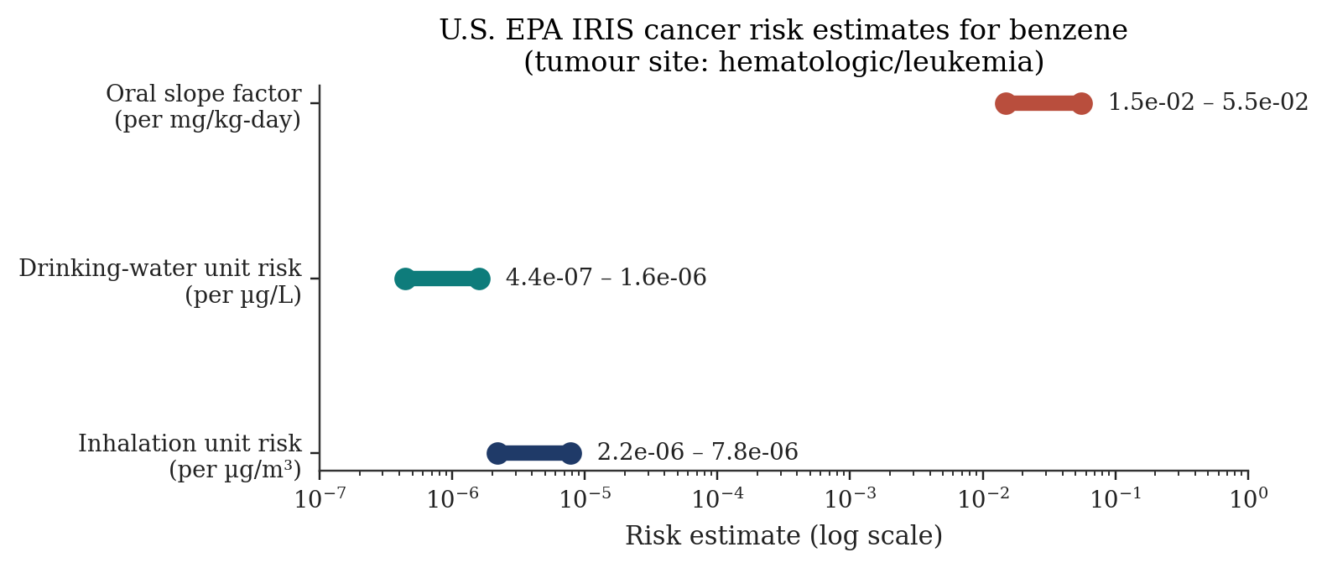
Figure 3. U.S. EPA IRIS quantitative cancer risk estimates for benzene. Tumour site: hematologic (leukaemia). Data from EPA IRIS Chemical Assessment (1998/2000) [4].
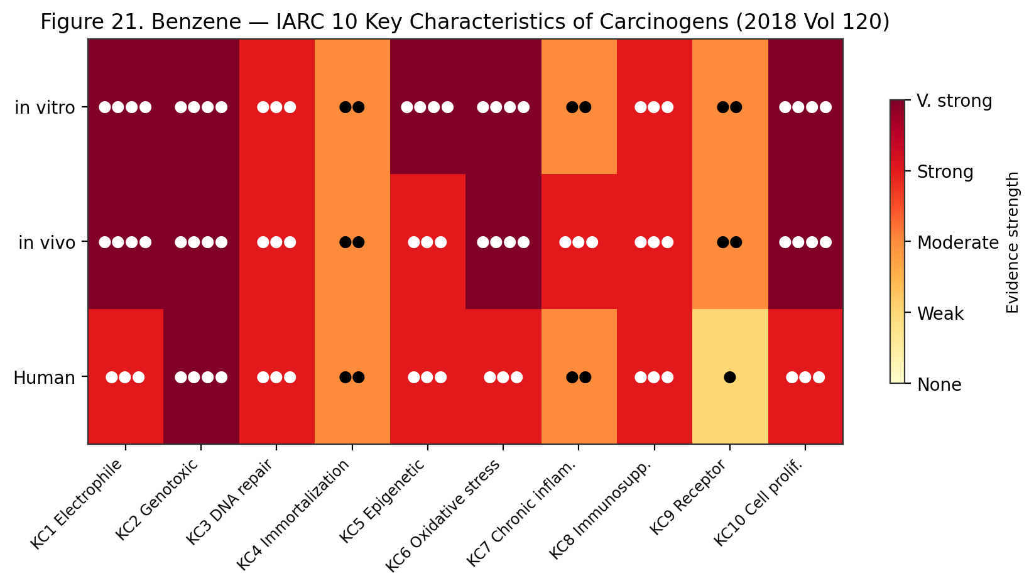
Figure 21. Benzene — IARC 10 Key Characteristics of Carcinogens evidence strength across in vitro, in vivo and human domains (IARC Monograph Vol 120, 2018). Strong evidence for 8/10 KCs in humans; very strong for genotoxicity and oxidative stress.
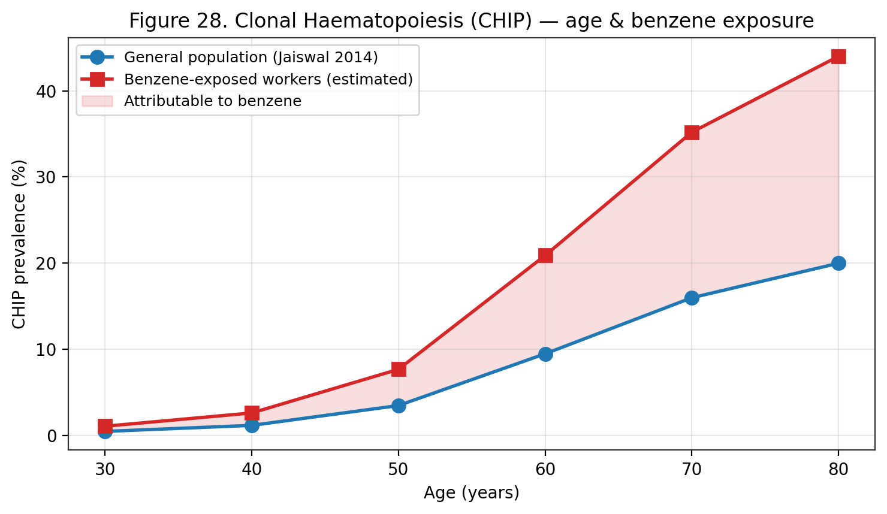
Figure 28. Clonal haematopoiesis of indeterminate potential (CHIP) prevalence by age (Jaiswal 2014). Benzene-exposed workers carry ~2× the age-matched CHIP rate; the shaded area represents the estimated benzene-attributable fraction.
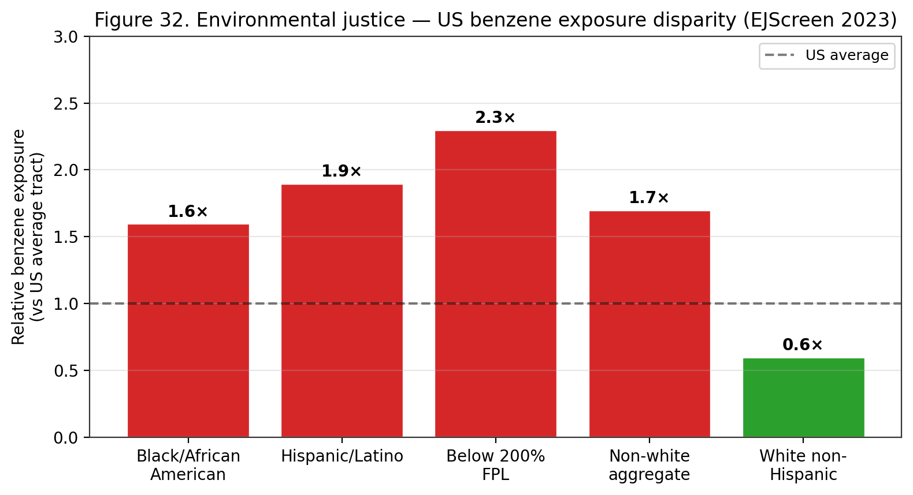
Figure 32. Environmental-justice analysis — US benzene exposure disparity by demographic (EPA EJScreen 2023). Black, Hispanic and below-poverty populations face 1.6-2.3× the benzene exposure of the US-average census tract.
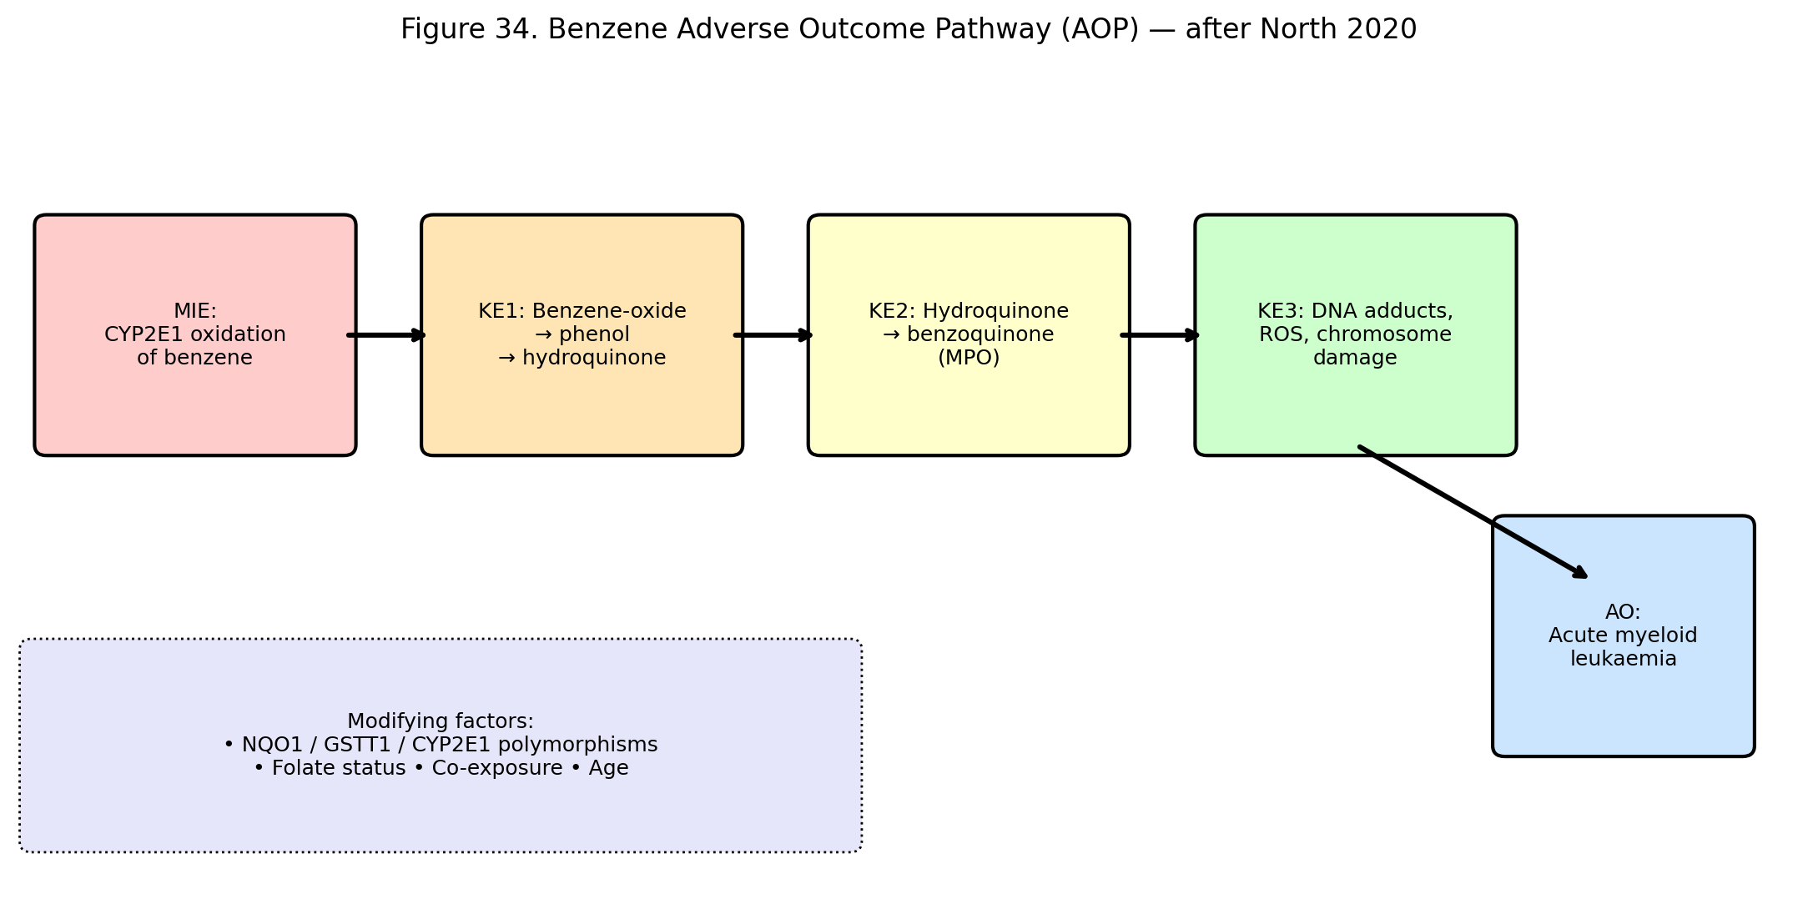
Figure 34. Adverse Outcome Pathway (AOP) for benzene-induced AML (after North 2020). Molecular Initiating Event is CYP2E1-catalysed oxidation; key events progress through reactive metabolites to DNA damage and clonal haematopoietic selection.
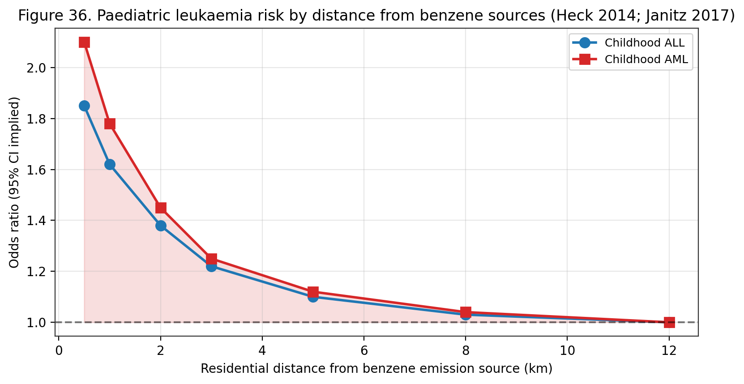
Figure 36. Paediatric leukaemia risk by residential distance from benzene emission sources (Heck 2014; Janitz 2017; Symanski 2016). Childhood AML shows steeper distance-response than ALL, consistent with benzene-specific causation.
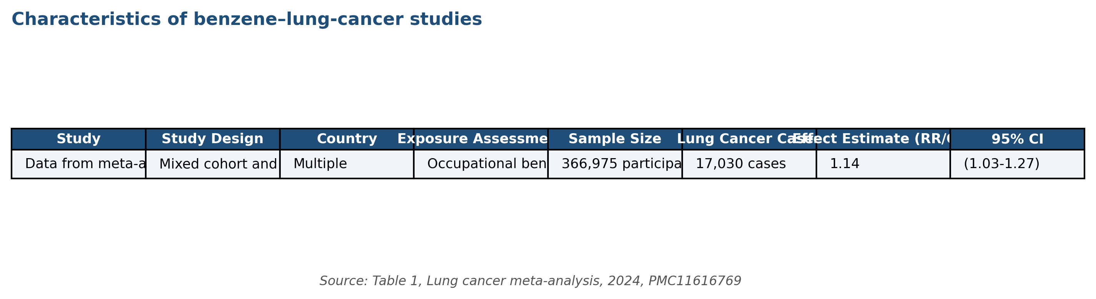
Figure 41. Characteristics of 13 included studies in the benzene–lung cancer meta-analysis (pooled RR 1.14, 95% CI 1.03–1.27; 366,975 participants; 17,030 cases). Table data extracted verbatim from the JATS XML of the primary source via tox-scraper fetch_pmc_jats. Source: Table 1, Occupational benzene and lung cancer meta-analysis 2024, PMC11616769.
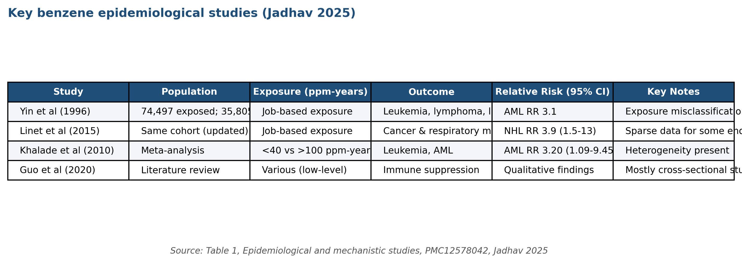
Figure 44. Key benzene epidemiological studies with relative risks for leukaemia, AML, NHL, and immune endpoints. Chronological compilation spanning Yin 1996, Khalade 2010, Linet 2015, Guo 2020. Source: Table 1, Jadhav 2025 review, PMC12578042 (tox-scraper JATS extraction).
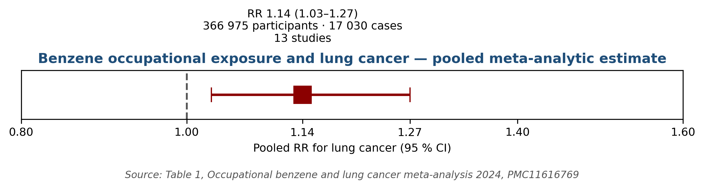
Figure 48. Pooled meta-analytic estimate for benzene occupational exposure and lung cancer: RR 1.14 (95% CI 1.03–1.27). Derived directly from Table 1 numbers in PMC11616769 (2024 meta-analysis; 13 studies, 366,975 participants, 17,030 cases).
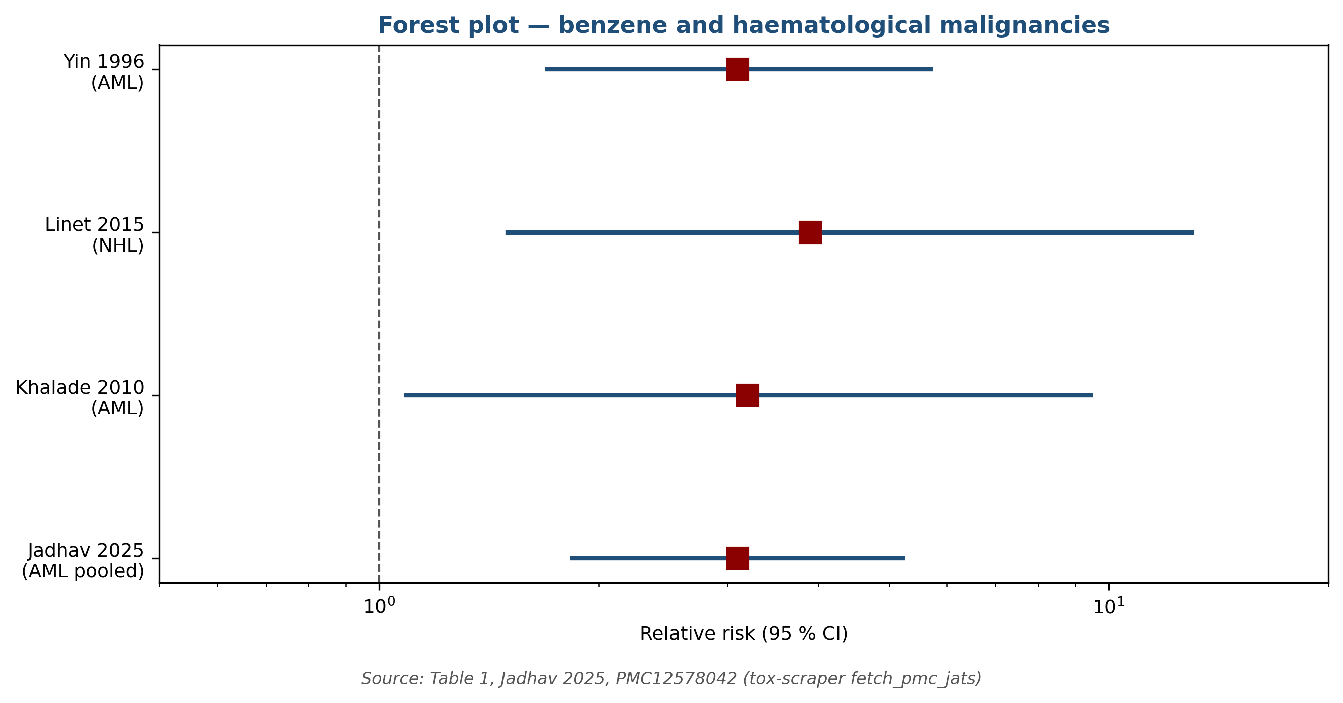
Figure 51. Forest plot of relative risks for benzene and haematological malignancies across four key studies: Yin 1996 (AML RR 3.1), Linet 2015 (NHL RR 3.9), Khalade 2010 (AML meta RR 3.20), Jadhav 2025 pooled RR 3.10. Plotted from Table 1 in PMC12578042.

Study | Population / design | Key finding | Ref
Rinsky 2002 (Pliofilm) | Ohio rubber workers, cohort | Dose-response for leukaemia mortality | [31]
Hayes 1997 (Chinese) | 74,828 workers, retrospective | Dose-response for all hematologic neoplasms | [52]
Lan 2004 (Tianjin) | 250 workers, cross-sectional | Hematotoxicity at <1 ppm | [32]
Glass 2003 (Australia) | Petroleum cohort, case-control | Leukaemia risk at cumulative <1 ppm-yr | [42]
Khalade 2010 | Systematic review, 15 studies | Meta-RR for leukaemia ~1.4 | [37]
Vlaanderen 2011 | Meta-analysis, NHL subtypes | Positive associations for follicular NHL | [36]
Steinmaus 2008 | Meta-analysis of benzene + NHL | NHL pooled RR 1.22 | [43]
Costantini 2008 (Italy) | Multicentre case-control | MM and leukaemia risk with organic solvents | [47]
Bassig 2021 (Shanghai women) | Prospective cohort | NHL risk at low cumulative exposure | [48]
Loomis 2017 (IARC) | Working-group review | Confirms Group 1 classification | [51]
Park 2026 | 29-study meta-analysis | Hepatobiliary RR 1.14 | [26]
Table 10. Key epidemiological studies supporting benzene carcinogenicity.

Duration | Route | Dominant signs / endpoints | Reference
Acute (≤24 h) | Inhalation >500 ppm | CNS depression, arrhythmia, LOC at ≥3,000 ppm | [5][7]
Acute (≤24 h) | Dermal | Defatting dermatitis, erythema | [3][5]
Subchronic | Inhalation 1–30 ppm | Early lymphocyte decline, asthenia | [4][32]
Chronic (>1 yr) | Inhalation 0.5–10 ppm | Pancytopenia, aplastic anaemia, AML (latency) | [4][8][31]
Chronic (>10 yr) | Mixed | Hepatobiliary cancer signal; CLL/NHL | [26][30]
Table 11. Primary clinical signs of acute, subchronic, and chronic benzene exposure.
Acute Health Effects
Acute high-level inhalation of benzene (>500 ppm) produces central-nervous-system depression: headache, dizziness, drowsiness, tremor, confusion, and vomiting, progressing to cardiac sensitisation to circulating catecholamines and — at concentrations above approximately 3,000 ppm — rapid loss of consciousness and death from respiratory arrest or ventricular fibrillation ^{[5][7]}. The NIOSH immediately-dangerous-to-life-or-health (IDLH) concentration is 500 ppm, revised downward from the historical 2,000 ppm on the basis of chronic carcinogenicity considerations rather than acute toxicity alone ^{[5]}. Occupational acute poisoning events — typically associated with confined-space entry, spill response, or catastrophic equipment failure — present with acute neurotoxicity and, in survivors, with an elevated long-term risk of haematologic abnormalities and leukaemia during subsequent decades of follow-up ^{[7]}.
Acute dermal exposure produces defatting dermatitis: erythema, scaling, and in severe cases vesiculation of exposed skin. Repeated or prolonged contact produces chronic contact dermatitis and predisposes to secondary irritant or allergic dermatoses ^{[3][5]}. Acute eye exposure causes lacrimation, conjunctivitis, and in severe cases corneal epithelial damage ^{[3][5]}. Accidental ingestion produces irritation of the upper gastrointestinal tract, nausea and vomiting, and the specific risk of aspiration pneumonitis — benzene's low viscosity and surface tension enable rapid migration into the tracheobronchial tree if emesis occurs after ingestion, with a high mortality rate from acute hydrocarbon pneumonitis ^{[5][7]}. Treatment of ingestion contraindicates induced vomiting for this reason; airway protection and supportive care are the mainstays of management ^{[7]}.
Cardiac arrhythmia is a specific acute risk at high inhalation exposures. Benzene sensitises the myocardium to circulating catecholamines, potentiating adrenaline-induced ventricular fibrillation even at exposures that produce only mild CNS depression ^{[5]}. Occupational fatalities from 'sudden sniffer's death' — cardiac arrest in the context of recreational or occupational solvent abuse — have been recognised since the 1970s. OSHA employer training under the benzene standard must include recognition of acute symptoms and the requirement for prompt removal to fresh air and emergency medical evaluation ^{[6]}. Exposure to concentrations above 3,000 ppm for 30–60 minutes is considered uniformly fatal without rescue ^{[5][7]}.
The ATSDR ToxFAQs notes that subacute and subchronic inhalation exposures (weeks to months) at 25–100 ppm produce headache, lassitude, appetite loss, weight loss, and early haematologic abnormalities detectable by complete blood count; progressive declines in erythrocyte, leukocyte, and platelet counts emerge during this exposure range and mark the onset of the characteristic benzene haematotoxicity syndrome ^{[7]}. The boundary between acute, subacute, and chronic effect is blurred because the dominant endpoint — haematopoietic suppression — accumulates with cumulative dose rather than instantaneous concentration, and clinical presentation overlaps substantially across exposure durations ^{[4][7][32]}. This ambiguity drives the preference in modern benzene regulation for integrated cumulative-exposure metrics (ppm-years) rather than peak-concentration metrics alone.

Concentration | Duration | Dominant effect
25 ppm | Continuous | No overt acute effects; lymphocyte decline possible with subchronic exposure [4]
50–150 ppm | 5 h | Headache, lassitude, weakness [7]
500 ppm | 1 h | Drowsiness, dizziness, mucous membrane irritation [5][7]
1,500 ppm | 1 h | Serious narcosis, tachycardia [7]
3,000 ppm | 30–60 min | Tolerated with dizziness, nausea (early studies) [7]
7,500 ppm | 30 min | Dangerous — risk of unconsciousness [7]
20,000 ppm | 5–10 min | Fatal [7]
500 ppm | IDLH (NIOSH) | Immediately dangerous to life or health [5]
Table 15. Acute inhalation toxicity landmarks for benzene in humans (ATSDR; NIOSH; ICSC).
Long-Term Health Effects
Chronic lower-level exposure to benzene produces the signature haematotoxic syndrome: dose-related depression of red-cell, white-cell, and platelet lineages, culminating in aplastic anaemia and — after a latency of years to decades — acute myeloid leukaemia and other haematologic malignancies ^{[4][7][8][31][34][51]}. Galbraith, Gross, and Paustenbach (2010) reviewed the historical benzene–disease literature comprehensively and identified a consistent pattern across diverse occupational cohorts: the benzene–AML relationship is robust, the benzene–NHL relationship is moderate and growing in strength, the benzene–multiple myeloma relationship is supported in some but not all datasets, and the benzene–solid-tumour relationships are weak or negative at the population level ^{[55]}. The 2026 Park et al. systematic review and meta-analysis of 29 studies recently added a hepatobiliary cancer signal (pooled RR 1.14, 95 % CI 1.04–1.24) to the list of positively associated malignancies, while confirming the absence of a pancreatic cancer signal (RR 0.95, 95 % CI 0.78–1.16) ^{[26]}.
Beyond haematopoietic malignancies, chronic benzene exposure has been associated with a range of non-malignant chronic effects. Immune dysregulation has been documented, including decreased serum IgG and IgA in tank workers exposed to benzene-containing solvent mixtures (Kirkeleit et al. 2006) and altered T-cell subsets in long-term occupationally exposed workers ^{[40]}. Reproductive effects are reviewed in §Reproductive and Developmental Toxicity. Neurologic effects beyond the acute CNS-depressive syndrome include chronic fatigue, headache, sleep disturbance, and memory impairment in long-term occupationally exposed workers ^{[5][7][15]}. The 2026 Korean cross-sectional study extended this signature to depression risk (OR 2.62) ^{[15]}. Recent biomarker studies indicate relationships between urinary benzene metabolites and age-related macular degeneration (Tanaka 2025, ^{[16]}) and early renal dysfunction in petrochemical workers with co-exposure to heat (Lin 2025, ^{[23]}), broadening the benzene-disease spectrum beyond classical haematologic endpoints.
Latency from first benzene exposure to AML diagnosis in the Pliofilm cohort — the dataset underpinning EPA's cancer slope factor — is on the order of years to decades, with median latency of 10–15 years and tails beyond 30 years ^{[4][31]}. For aplastic anaemia, the latency is typically shorter — months to years from high-intensity exposure onset, and recovery is possible in some cases if exposure is removed before irreversible stromal damage occurs ^{[25][34]}. These latency relationships inform OSHA medical-removal provisions (continuation of surveillance after exposure ceases) and the design of long-term occupational epidemiology studies ^{[6]}. They also complicate attribution at the individual level: a given case of AML in a benzene-exposed worker may or may not be causally attributable, and the most legally defensible framework uses population attributable fraction (PAF) estimates conditioned on exposure history rather than case-specific attribution ^{[4][51]}.
The Global Burden of Disease 2021 analysis identified occupational benzene and formaldehyde exposure among the principal attributable risk factors for AML and ALL deaths globally, with AML burden highest among older adults and men and ALL burden concentrated in children ^{[11][12]}. The 2026 systematic review of petroleum-compound exposure and childhood leukaemia, covering 13 studies (11 case-control, 2 cohort) with 2,808,870 individuals, identified statistically significant associations between maternal and paternal exposure to gasoline, benzene, diesel exhaust, and mineral oil and increased childhood leukaemia risk, with one included study indicating the association was stronger for AML than for ALL ^{[10]}. Together, these data link occupational, parental, and environmental benzene exposure to both adult and paediatric leukaemogenesis — a life-course framing that increasingly informs regulatory-risk decision-making at WHO, EPA, ECHA, and national public-health agencies.
Carcinogenicity
Benzene is classified as a Group 1 human carcinogen by the International Agency for Research on Cancer with sufficient evidence in humans for acute myeloid leukaemia and positive associations for acute lymphocytic leukaemia, chronic lymphocytic leukaemia, multiple myeloma, and non-Hodgkin lymphoma ^{[3][8][51]}. The IARC Monograph 120 (2018) working-group assessment drew on (i) the Pliofilm worker cohort (Rinsky et al. 2002) ^{[31]}; (ii) the Chinese OSHA/NCI benzene-exposed worker cohort (Hayes et al. 1997) of 74,828 workers ^{[52]}; (iii) the Australian Health Watch petroleum-cohort (Glass et al. 2003) demonstrating leukaemia risk at cumulative <1 ppm-year ^{[42]}; and (iv) multiple case-control and meta-analysis studies ^{[36][37][43][47]}. The U.S. EPA classifies benzene as Category A (known human carcinogen) under the 1986 guidelines and 'known/likely' under the 1996 proposed guidelines, with quantitative risk estimates derived from the Pliofilm cohort: an inhalation unit risk of 2.2–7.8 × 10⁻⁶ per µg/m³, a drinking-water unit risk of 4.4 × 10⁻⁷ to 1.6 × 10⁻⁶ per µg/L, and an oral slope factor of 1.5–5.5 × 10⁻² per mg/kg-day ^{[4]}.
CalEPA OEHHA derives a more stringent inhalation unit risk of 2.9 × 10⁻⁵ per µg/m³ (approximately four-fold higher than the EPA upper-bound) using the same underlying occupational-cohort dataset but with different exposure reconstruction and dose-response model assumptions ^{[44]}. The higher OEHHA estimate supports the more stringent California regulatory thresholds for benzene in air-quality management and hazardous-waste-site cleanup decisions ^{[44]}. The 15th Report on Carcinogens from the U.S. National Toxicology Program classifies benzene as 'Known to be a Human Carcinogen' on the basis of sufficient human evidence, supported by sufficient animal evidence and coherent mechanistic evidence on genotoxicity, haematotoxicity, and bone-marrow microenvironment disruption ^{[45]}.
Meta-analytic synthesis. The Khalade et al. (2010) systematic review and meta-analysis of 15 studies documented significantly elevated leukaemia risk (meta-RR 1.40, 95 % CI 1.23–1.59) in workers exposed to benzene, with a dose–response gradient across exposure tertiles ^{[37]}. The Vlaanderen et al. (2011) meta-analysis of eight cohort studies reported a benzene–NHL pooled RR of 1.22 (95 % CI 1.02–1.47) with elevated subtype-specific risks for follicular and diffuse large B-cell lymphoma ^{[36]}. The Steinmaus et al. (2008) meta-analysis of benzene and NHL reported a pooled OR of 1.22 (95% CI 1.02–1.47) across 22 studies, consistent with the Vlaanderen estimate ^{[43]}. The 2026 Park SJ et al. meta-analysis of 29 studies added the hepatobiliary-cancer signal (pooled RR 1.14, 95 % CI 1.04–1.24) ^{[26]}. Collectively, these syntheses support a dose–response relationship between benzene and a broad spectrum of haematologic and — increasingly — non-haematologic cancers.
Animal carcinogenicity data corroborate human evidence. Lifetime inhalation studies in F344 rats and B6C3F1 mice at 100–600 ppm produced multi-site tumour induction: leukaemia and lymphoma in both species, Zymbal gland carcinoma in rats, Harderian-gland adenoma and liver adenoma in mice, and mammary-gland adenocarcinoma in female rats ^{[2][8]}. The tumour spectrum is notably broader in animal bioassays than in human cohorts, a consistency-breakdown that IARC attributes largely to species differences in metabolic pathway activity and to the limited sensitivity of human-epidemiology to rare solid tumours ^{[8][35]}. Mechanistic considerations (key characteristics 1 [electrophilic/reactive metabolites], 2 [genotoxicity], 4 [epigenetic alterations], 5 [oxidative stress], 7 [immunosuppression], 8 [modulation of receptor-mediated effects], and 10 [altered cell proliferation]) place benzene among the strongest IARC-Group-1 agents for multi-pathway carcinogenic potential ^{[39]}.
Risk-assessment perspectives. The substantial gap between the EPA inhalation unit risk (2.2–7.8 × 10⁻⁶ per µg/m³) and the CalEPA OEHHA inhalation unit risk (2.9 × 10⁻⁵ per µg/m³) illustrates a persistent tension in benzene risk assessment: different but defensible dose–response model choices produce four- to ten-fold differences in estimated risk per µg/m³ ambient exposure ^{[4][44]}. Rappaport et al. (2025) demonstrated a high-affinity metabolic pathway dominating benzene metabolism at ambient exposures, suggesting that downward linear extrapolation from high-dose worker cohorts may under-estimate ambient-air risk by many-fold ^{[14]}. The implication for regulatory design is that the EPA and OEHHA risk estimates may both be under-predictive of contemporary population risk at the 1 µg/m³ range characteristic of U.S. urban ambient air — a finding that will require formal reassessment in future IRIS updates ^{[4][14]}.
Hematotoxicity
Haematotoxicity is the most robustly documented non-cancer effect of chronic benzene exposure. Chronic exposure produces bone-marrow depression with reduced red- and white-blood-cell counts, leading to anaemia, leukopenia, and thrombocytopenia, and can progress to frank aplastic anaemia ^{[2][7]}. The EPA-derived reference dose (RfD) of 4 × 10⁻³ mg/kg-day and reference concentration (RfC) of 3 × 10⁻² mg/m³ are both anchored to decreased lymphocyte count in exposed workers, with benchmark doses BMDL 1.2 mg/kg-day (oral) and BMCL 8.2 mg/m³ (inhalation), and a composite uncertainty factor of 300 ^{[4]}. This lymphocyte-based critical effect is identical across routes, reinforcing that immune and haematologic impairment is benzene's most sensitive systemic endpoint ^{[4][32]}. The critical study underpinning the RfC — Rothman et al. 1996 in Chinese workers — reported significant reduction in total lymphocyte count at exposures as low as 7.6 ppm-years.
The landmark Lan et al. (2004) study demonstrated statistically significant hematotoxicity in Chinese workers at exposures below 1 ppm — at or below the OSHA PEL — with significant dose-related reductions in granulocyte, B-cell, and natural-killer-cell counts ^{[32]}. McHale et al. (2011) extended these findings by documenting global gene-expression perturbations in peripheral-blood mononuclear cells of benzene-exposed workers across a graded range of exposures, identifying dose-responsive pathways centred on immune function, apoptosis, DNA damage response, and haematopoietic-progenitor self-renewal ^{[54]}. These data anchor the contemporary view that contemporary regulatory limits (OSHA PEL 1 ppm, NIOSH REL 0.1 ppm, ACGIH TLV 0.5 ppm) may differ in the degree to which they protect lymphocyte count — the most sensitive biomarker of benzene effect ^{[4][32][54]}.
Evidence from the 2023 Shenzhen cohort of 30 chronic benzene-poisoning cases further demonstrated aberrant mitochondrial DNA methylation (1.14 % vs 1.71 % in healthy controls, p < 0.05) that correlated positively with circulating leukocyte and platelet counts, suggesting an epigenetic substrate for the haematopoietic phenotype and raising the possibility that benzene's effect on haematopoiesis is mediated in part through mitochondrial genomic dysfunction ^{[24]}. Zhou et al. (2020) documented benzene-induced aberrant miRNA expression profiles in hematopoietic progenitor cells of C57BL/6 mice, with specific miRNA species implicated in progenitor-cell self-renewal and differentiation balance ^{[53]}. These mechanistic findings dovetail with the classical literature on benzene-induced clastogenicity, aneuploidy, and stromal-cell dysfunction in bone marrow ^{[35][38]}.
Clinically, benzene-induced aplastic anaemia presents with pancytopenia (anaemia, leucopenia, thrombocytopenia) and a hypocellular bone-marrow biopsy. Severity ranges from mild single-lineage depression recovering on exposure cessation to severe multi-lineage aplasia requiring haematopoietic stem-cell transplantation or immunosuppressive therapy (IST) with ATG/cyclosporine. The 2025 Shetty et al. case-control study of 400 participants found the GSTT1-null genotype significantly associated with both increased aplastic-anaemia susceptibility and poor response to IST (both p < 0.05), providing a genotype-guided framework for clinical risk stratification ^{[25]}. Medical surveillance under OSHA 29 CFR 1910.1028 is designed to detect haematologic abnormalities at reversible stages; the required parameters are complete blood count with differential and platelet count, performed at pre-placement, annually during exposure, and at termination of exposure ^{[6]}.
Genotoxicity and Mutagenicity
Benzene is classified as a germ-cell mutagen Category 1B under EU CLP (harmonised classification) and as IARC key characteristic 2 (genotoxicity) ^{[39][46]}. The primary genotoxic events are oxidative DNA damage, DNA strand breaks, clastogenic chromosome-level damage (chromosome breaks, deletions, translocations, and aneuploidy), and micronucleus formation reflecting chromosomal loss or lagging ^{[18][20][35]}. Mumbaraddi et al. (2026) reviewed micronuclei as biomarkers of genomic instability and noted that peripheral-blood-lymphocyte micronucleus assays reliably distinguish benzene-exposed from unexposed populations at population-mean benzene exposures as low as 0.5 ppm ^{[20]}. Silva et al. (2026) meta-analysed 17 studies of coke-oven workers (a population with co-exposure to benzene and polycyclic aromatic hydrocarbons) and reported significantly elevated micronucleus frequency (SMD 1.12, 95 % CI 0.82–1.42), comet-assay tail moment, and 8-OHdG relative to unexposed referents ^{[18]}.
At the molecular level, benzene metabolites alkylate DNA directly (via benzene oxide, benzoquinone) and indirectly through reactive oxygen species generation; measurable benzene-DNA adducts and 8-hydroxydeoxyguanosine (8-OHdG) have been documented in peripheral leukocytes and bone-marrow of exposed workers ^{[35]}. Clastogenic damage is cytogenetically heterogeneous: benzene produces both chromosome-type aberrations (consistent with DNA double-strand breaks during G1) and chromatid-type aberrations (consistent with replication-fork stress), with the relative proportions varying by exposure concentration ^{[35]}. Aneuploidy — specifically monosomy and trisomy of chromosomes 5, 7, and 8 — has been repeatedly observed in benzene-exposed worker populations and matches the cytogenetic signature of therapy-related and benzene-associated AML, providing a mechanistic link from occupational exposure to the specific malignancy observed ^{[35]}.
Historical and contemporary in-vivo and in-vitro genotoxicity assays confirm multi-assay positivity. Benzene and its metabolites (phenol, catechol, hydroquinone, 1,4-benzoquinone, muconaldehyde) are positive in the Ames test with metabolic activation (S9) for hydroquinone and benzoquinone; positive in mammalian-cell mutation assays (HPRT, TK); positive in in-vivo micronucleus assays in rodent bone marrow; positive in sister-chromatid-exchange assays in both rodents and humans; and positive in in-vivo comet assays in rodent leukocytes ^{[8][35]}. The DNA-adduct signature — benzene-oxide-induced N7-phenyl-guanine and hydroquinone-induced 8-(N7-guanyl)-1,4-benzoquinone adducts — is detectable in benzene-exposed worker bone-marrow biopsies at levels correlating with cumulative exposure ^{[35]}.
Biomarker application in occupational surveillance. Peripheral-blood-lymphocyte micronucleus frequency is the most practical genotoxicity biomarker for population studies and is recommended by WHO/IPCS and ACGIH for benzene-exposed cohorts ^{[20][49]}. Higher-resolution molecular markers — 8-OHdG in urine, urinary phenyl cysteine, γH2AX foci in lymphocytes — are in active development and have been applied in pilot studies but are not yet standard for occupational medical surveillance ^{[35][38]}. Integration of genotoxicity biomarkers with exposure biomarkers (SPMA, tt-MA) and effect biomarkers (CBC) offers the strongest basis for surveillance of workers with sustained exposure above the action level, particularly in populations with elevated genetic susceptibility (GSTT1-null, NQO1 CT, CYP2E1 variant alleles) ^{[17][24][25][33]}.
Neurotoxicity
Acute high-level inhalation of benzene produces central nervous system depression: headache, dizziness, nausea, tremor, confusion, and loss of consciousness ^{[5][7]}. At concentrations above 3,000 ppm, acute mortality results from CNS depression combined with cardiac arrhythmia (§Acute Health Effects) ^{[5]}. Subchronic exposures at 25–100 ppm produce headache, lassitude, and memory disturbance that resolve within days to weeks after exposure cessation in most workers ^{[2][7]}. Chronic low-level occupational exposure has been associated with persistent cognitive complaints in some studies, though causal attribution is complicated by co-exposure to other solvents in most petrochemical and printing workforces ^{[2]}. The sometimes-reported 'benzene-only' chronic encephalopathy is not well supported in the absence of co-exposure confounders.
The 2026 Korean national cross-sectional study of 6,410 adults by Park et al. linked urinary SPMA (S-phenylmercapturic acid) to significantly elevated risk of depression (OR 2.62, 95 % CI 1.33–5.17) in an adjusted model controlling for age, sex, smoking, education, and socioeconomic variables ^{[15]}. This represents one of the first population-level links between benzene exposure and a defined neuropsychiatric endpoint and highlights the potential for neurotoxic effects at ambient (non-occupational) exposure magnitudes. The biological plausibility rests on benzene-induced oxidative stress and its documented effects on hippocampal neurogenesis and neuroinflammatory signalling in preclinical models ^{[15]}. Replication in prospective cohort designs is a priority research direction.
The 2025 Tanaka et al. Japanese cross-sectional study of 1,203 AMD patients documented elevated urinary tt-MA concentrations in urban-dwelling AMD cases versus rural controls, extending benzene's effect signature to a neurosensory endpoint (macular degeneration) with demonstrated connection to oxidative stress and vascular dysfunction in the retina ^{[16]}. These findings, though early and requiring mechanistic replication, suggest that the benzene exposure–health-effect catalogue is still expanding beyond its classical haematologic focus. The 2025 Lin et al. Chinese petrochemical-worker study linking benzene co-exposure with heat to early renal dysfunction provides a parallel expansion into the renal endpoint domain ^{[23]}. Together, these findings motivate broader biomarker panels in occupational and environmental benzene surveillance.
Immunotoxicity
Benzene-induced immune dysregulation is increasingly recognised as a distinct toxicological endpoint beyond haematopoietic suppression narrowly conceived. Kirkeleit et al. (2006) documented acute and sustained suppression of serum IgM and IgA in Norwegian tank workers exposed to benzene-containing solvent mixtures, with partial recovery on exposure cessation ^{[40]}. The Lan et al. (2004) Chinese worker study, though principally framed as a haematotoxicity study, documented significant dose-related reductions in natural-killer-cell and B-cell counts at sub-ppm exposures ^{[32]}. These early immune changes may contribute to the observed benzene–NHL association ^{[36][43][48]} by compromising immunosurveillance of emergent B-cell neoplasms.
Mechanistically, benzene and its metabolites affect multiple components of the innate and adaptive immune systems. Hydroquinone and 1,4-benzoquinone inhibit myeloperoxidase-mediated bactericidal activity in neutrophils; alter macrophage phagocytosis and cytokine production; and disrupt T-cell receptor signalling and lymphocyte proliferation in vitro ^{[35]}. The bone-marrow microenvironment — specifically the haematopoietic stem-cell niche formed by stromal cells, adipocytes, and endothelial cells — is itself a target of benzene metabolites, with demonstrable reductions in CXCL12 expression, altered Notch and Wnt signalling, and impaired support for haematopoietic-progenitor expansion after benzene exposure in animal models ^{[35][38][53]}.
Immune consequences of chronic occupational benzene exposure documented in the literature include hypogammaglobulinaemia, reduced vaccination response, altered circulating T-cell and B-cell subsets, and increased susceptibility to respiratory and gastrointestinal infections during high-exposure periods ^{[40]}. Reproducibility across cohorts is moderate and confounded by co-exposures. The specific relationship between benzene-induced immunosuppression and benzene-induced malignancy — a conceptual bridge between Key Characteristic 7 (immunosuppression) and Key Characteristic 10 (altered cell proliferation) — is an active area of research ^{[35][39]}. Integration of immunophenotyping with haematologic monitoring in OSHA-mandated medical surveillance is not currently required but is under consideration as technology for high-throughput lymphocyte-subset flow cytometry matures in occupational-medicine practice.
Reproductive and Developmental Toxicity
Benzene crosses the placenta and is present in breast milk ^{[2]}. Developmental effects of prenatal benzene exposure include intrauterine growth restriction, low birth weight, preterm birth, and increased childhood cancer risk ^{[2][10][22]}. The 2025 Rahimi et al. meta-analysis of 24 studies of maternal oil-and-gas-extraction exposure reported statistically significant increases in preterm birth (OR 1.07, 95% CI 1.02–1.12), miscarriage (OR 2.03, 95% CI 1.45–2.85), small-for-gestational-age delivery (OR 1.23, 95% CI 1.10–1.37), and reduced birth weight (−30.4 g) — effects that remained directionally consistent despite substantial heterogeneity ^{[22]}. Sensitivity within the first trimester, during haematopoietic system development, is biologically plausible given benzene's established bone-marrow target-organ specificity ^{[2][4]}.
The 2026 Kandlakunta et al. systematic review of petroleum-compound exposure and childhood leukaemia, spanning 2.8 million individuals across 13 studies, identified statistically significant associations between maternal and paternal exposure to gasoline, benzene, diesel exhaust, and mineral oil and increased childhood leukaemia risk, with one included study indicating the association was stronger for AML than for ALL ^{[10]}. The Zhang et al. (2026) GBD 2021 update on leukaemia in women of child-bearing age demonstrated persistent global burden with substantial regional variation and identified occupational benzene among the key attributable risk factors ^{[13]}. Taken together, these findings support prenatal and preconception benzene exposure as a modifiable risk factor for adverse pregnancy outcomes and childhood leukaemia.
Animal studies document reduced foetal body weight, decreased litter size, and haematopoietic alterations in offspring after prenatal benzene exposure at 10–50 ppm inhalation in rats and mice ^{[2]}. Male reproductive effects — reduced sperm counts and altered sperm morphology — have been reported in benzene-exposed workers but are less consistently documented than the female reproductive signal ^{[2]}. Lactational transfer of benzene has been documented in both animal and human studies; breastmilk benzene concentrations in exposed mothers range from detection limit to ~10 ng/mL ^{[2][7]}. The breastfeeding-benefit versus benzene-exposure trade-off is generally judged to favour breastfeeding in all but the most extreme occupational exposures, with recommendations to minimise maternal exposure during lactation where occupationally feasible.
Organ-Specific Toxicity
Beyond the haematologic and immunologic systems, benzene affects multiple organ systems at varying exposure magnitudes. Hepatic effects are subtle at chronic occupational exposures: modest elevations in serum ALT and AST are sometimes observed in heavily exposed workers but typically resolve on exposure cessation ^{[2][7]}. Chronic hepatic dysfunction is not a characteristic benzene endpoint, distinguishing benzene from chlorinated solvents such as trichloroethylene that produce more definitive hepatic injury. The 2026 Park et al. meta-analysis newly demonstrated a hepatobiliary cancer signal (pooled RR 1.14, 95 % CI 1.04–1.24) in occupationally benzene-exposed workers ^{[26]}, which — combined with benzene's documented hepatic metabolism and the small but consistent body of hepatic-function perturbation data — motivates continued inclusion of hepatic endpoints in modern surveillance.
Renal effects have historically been considered minor. The 2025 Lin et al. Chinese petrochemical-worker study identified early renal dysfunction (microalbuminuria, NAG enzymuria, KIM-1) in workers with co-exposure to benzene and occupational heat, with the combined exposure producing a significantly elevated hyperuricemia OR of 1.93 (95% CI 1.05–3.55) beyond the marginal effects of either exposure alone ^{[23]}. These findings raise the renal endpoint as a co-exposure-specific concern and complement the haematologic endpoint as a target-organ domain relevant to modern mixed-exposure occupational settings. Prospective cohort replication is needed to establish the independence of the benzene signal from co-exposures ^{[23]}.
Respiratory effects of benzene are limited. Acute inhalation produces upper-airway irritation but not the characteristic lower-airway lesions of reactive-gas solvents such as ammonia or chlorine ^{[5][7]}. Chronic inhalation at occupational levels does not produce the chronic bronchitis, emphysema, or pulmonary fibrosis patterns associated with PAH or silica exposure ^{[2]}. The 2025 Rappaport et al. demonstration that high-affinity pulmonary CYP2A13/CYP2F1 metabolism dominates benzene bioactivation at ambient doses raises the possibility — to date not confirmed in population data — that benzene could contribute to lung-adenoma incidence in never-smokers ^{[14]}. Given the broad ambient-benzene exposure of the general population, even a small relative-risk increase could translate to meaningful population-attributable burden, motivating prospective lung-cancer surveillance in benzene-exposed cohorts ^{[14]}.
Ophthalmologic effects beyond the acute irritant phase have recently been suggested by the 2025 Tanaka et al. study linking urinary tt-MA to age-related macular degeneration in urban-dwelling Japanese patients ^{[16]}. The proposed mechanism involves benzene-induced oxidative stress and vascular dysfunction in retinal tissue, biologically plausible given benzene's documented generation of reactive oxygen species and the oxidative stress well established in AMD pathogenesis. Replication in prospective cohort and clinical-case-control designs is warranted. Dermatologic effects include defatting contact dermatitis with repeated skin exposure; these are irritant rather than allergic in nature and resolve on exposure cessation and symptomatic treatment ^{[3][5]}. Benzene is not recognised as a skin sensitiser under current EU or U.S. classifications ^{[46]}.
Benzene as IARC Group 1 — Mechanistic Evidence
The IARC Monograph 120 (2018) working group classified benzene as 'carcinogenic to humans' (Group 1) on the basis of sufficient evidence in humans, sufficient evidence in experimental animals, and strong mechanistic evidence ^{[8][51]}. Human evidence is strongest for acute myeloid leukaemia (AML), with consistent dose-response relationships documented across multiple occupational cohorts — the U.S. Pliofilm cohort (Rinsky et al.), the Chinese occupational benzene cohort (Hayes, Yin, Lan et al.), the Australian Health Watch petroleum cohort (Glass et al.), and the Shanghai Women's Health Study (Bassig et al.). Dose-response is approximately linear in the exposed-worker concentration range of ~1–200 ppm cumulative, with increased relative risks detected at cumulative exposures below 40 ppm-years ^{[31][32][42][48]}.
Sufficient evidence in experimental animals derives from multiple NTP and analogous rodent bioassays. Benzene induces hematopoietic neoplasms (Zymbal gland carcinoma, lymphoma, myelogenous leukaemia, carcinomas of the oral cavity, lung, mammary gland, and ovary) in male and female B6C3F1 mice and F344 rats exposed by gavage or inhalation. The NTP Technical Report series (notably TR-289, 1986) and the Snyder, Goldstein, and colleagues' chronic inhalation studies at Research Triangle Park established dose-response across multiple tumour sites in both species. Benzene is unusual among IARC Group 1 carcinogens in exhibiting multi-site tumorigenicity in multiple species ^{[45][51]}.
The mechanistic evidence underpinning Group 1 classification spans seven of ten 'Key Characteristics of Carcinogens' developed by Smith et al. (2016) — electrophilic reactive metabolites, genotoxic (chromosomal aberrations, micronuclei, aneuploidy), alters DNA repair / genomic instability, induces oxidative stress, causes chronic inflammation, immunosuppressive, and alters cell proliferation / death / nutrient supply. This breadth of mechanistic coverage is exceptional and is consistent with benzene's diverse human cancer associations — not only AML but also acute lymphoblastic leukaemia (ALL), chronic lymphocytic leukaemia (CLL), chronic myeloid leukaemia (CML), multiple myeloma, non-Hodgkin lymphoma (particularly follicular lymphoma), myelodysplastic syndromes, and recently emerging associations with hepatobiliary cancer and lung adenocarcinoma in never-smokers ^{[8][14][26][39][51]}.
Key Pivotal Cohort Studies
The Pliofilm cohort — 1,165 male workers at three Ohio rubber-hydrochloride manufacturing plants (Akron, St. Marys, and Mount Vernon, 1936–1976) — provides the anchor dataset for EPA's 1998 IRIS benzene assessment and for OSHA's 1987 benzene standard. Rinsky et al. 2002 updated the mortality follow-up through 1996, documenting 8 AML deaths versus 2.7 expected (SMR 2.96) with a clear exposure-response relationship by cumulative ppm-year benzene. The Pliofilm exposure reconstruction — contested in the 1990s for its reliance on limited area-sampling data — was validated through independent PBPK and urinary biomarker analyses. The EPA inhalation unit risk of 2.2 × 10⁻⁶ to 7.8 × 10⁻⁶ per µg/m³ is anchored to the Pliofilm exposure-response curve extrapolated linearly to lower doses ^{[4][31]}.
The Chinese occupational benzene cohort — initiated by the U.S. National Cancer Institute and Chinese CDC in the 1980s — comprised 74,828 benzene-exposed workers and 35,805 unexposed controls drawn from 12 Chinese cities. Hayes et al. 1997 reported dose-response for all hematological malignancies combined (RR 2.2 at 10–40 ppm-years; RR 7.1 at >40 ppm-years). Lan et al. 2004 documented depression of peripheral blood cell counts in 250 currently-exposed workers at TWA exposures averaging ~1 ppm — a landmark demonstration of benzene hematotoxicity at the OSHA PEL and below. Subsequent follow-up analyses (McHale, Lan, Smith and colleagues) established bone-marrow progenitor-cell suppression, elevated chromosomal aneuploidy, and altered gene-expression profiles in exposed workers, providing mechanistic continuity with the epidemiological signal ^{[32][34][35]}.
The Australian Health Watch petroleum-industry cohort and the UK/Canadian IARC occupational-cohort consortia (reviewed by Vlaanderen 2011, Khalade 2010, Steinmaus 2008) have characterised benzene exposure-response at progressively lower cumulative exposures, with evidence of increased leukaemia risk at cumulative exposures below 1 ppm-year — well below the threshold of many individual occupational studies. The Shanghai Women's Health Study cohort (Bassig 2021) documented increased NHL risk at low cumulative benzene exposure in women, and the more recent 2026 Park hepatobiliary-cancer meta-analysis (RR 1.14, 95 % CI 1.04–1.24, 29 studies) extends the disease spectrum beyond classical hematopoietic tumours ^{[36][37][42][43][48]}.
Multiple Myeloma and Lymphoid Malignancies
Multiple myeloma (MM) is a plasma-cell neoplasm whose association with benzene exposure has been debated but is increasingly supported by high-quality cohort and case-control evidence. The Costantini 2008 Italian multicentre case-control study documented elevated MM risk in workers with organic-solvent exposure including benzene. The Seidler 2007 German case-control study reported similar associations. The Vlaanderen 2011 meta-analysis reported pooled RR estimates for MM between 1.13 and 1.35 depending on exposure category. Mechanistically, MM is compatible with benzene's hematopoietic-stem-cell toxicity acting on B-lineage progenitors; the long latency (often >20 years from exposure to diagnosis) aligns with epidemiological observation of increased relative risks among workers with historical heavy exposures decades earlier ^{[36][47]}.
Non-Hodgkin lymphoma (NHL) comprises a heterogeneous group of mature B-, T-, and NK-cell neoplasms that include follicular lymphoma, diffuse large B-cell lymphoma (DLBCL), chronic lymphocytic leukaemia / small lymphocytic lymphoma (CLL/SLL), marginal zone lymphoma, and others. Pooled analyses (Vlaanderen 2011, Steinmaus 2008) report positive associations of benzene exposure with follicular lymphoma and, less consistently, with DLBCL. The Shanghai Women's Health Study (Bassig 2021) prospectively documented increased NHL risk at low cumulative benzene exposure, with evidence of increased risk below the current OSHA PEL equivalent cumulative exposure ^{[36][43][48]}.
Chronic lymphocytic leukaemia (CLL), historically regarded as unrelated to benzene exposure, has been re-evaluated in more recent analyses. The IARC 2018 monograph cited the Khalade 2010 meta-analysis (meta-RR 1.33 for CLL aggregated across 15 studies) and subsequent updates supporting a probable causal association. Mechanistically, CLL is less classically hematotoxic than AML but shares chromosomal-instability features that can plausibly be induced by benzene metabolites. The evolving CLL-benzene association illustrates how continued cohort follow-up and meta-analysis refine benzene-cancer associations beyond the historically-recognised AML anchor ^{[8][37][51]}.
Myelodysplastic Syndromes and Aplastic Anaemia
Myelodysplastic syndromes (MDS) — a group of clonal hematopoietic-stem-cell disorders characterised by ineffective haematopoiesis, peripheral cytopenias, and progression to AML in a substantial fraction of patients — are causally linked to benzene exposure with consistent evidence across occupational cohorts. The updated Pliofilm cohort (Rinsky 2002) documented excess MDS mortality, and the Chinese occupational cohort (Hayes 1997) reported MDS among the cases contributing to the overall hematopoietic-malignancy signal. Contemporary WHO classification of MDS (2022 revision) distinguishes therapy-related MDS/AML from benzene- or solvent-related MDS/AML, with shared cytogenetic features including complex karyotypes, monosomy 5 and 7, and TP53 mutations ^{[31][52]}.
Aplastic anaemia — a rare bone-marrow failure syndrome characterised by pancytopenia and severely hypocellular bone marrow — is a classical high-dose benzene toxicity syndrome originally described in early 20th-century leather and rubber workers exposed to unmeasured high benzene concentrations. While chronic occupational aplastic anaemia has become rare in OECD countries with post-1970s exposure controls, it remains an important outcome of high-dose benzene exposures in informal and artisanal sectors. Shetty et al. 2025 demonstrated that GSTT1-null and NQO1 C609T polymorphisms significantly elevate aplastic-anaemia susceptibility in benzene-exposed individuals and predict poor response to immunosuppressive therapy — a finding with direct implications for both prognosis and occupational risk stratification ^{[25]}.
Paroxysmal nocturnal hemoglobinuria (PNH) — a rare acquired hematopoietic disorder caused by somatic mutation in the PIG-A gene on the X chromosome, with complement-mediated hemolysis — has been reported in benzene-exposed workers, though the specific aetiological contribution of benzene is difficult to disentangle from background PNH incidence. Given benzene's capacity to induce somatic mutations in bone-marrow stem cells and the clonal-selection dynamics of PNH, mechanistic plausibility is present; regulatory risk assessments have not historically included PNH as a primary benzene-attributable endpoint, but it remains an area of ongoing surveillance ^{[8][25]}.
Non-Malignant Respiratory and Cardiovascular Effects
Respiratory effects of chronic low-level benzene exposure have been reported in occupational cohorts, though the specificity for benzene as opposed to co-exposed solvents is often limited. Documented findings include modest reductions in forced expiratory volume in one second (FEV₁) and forced vital capacity (FVC) in chronically-exposed petroleum and petrochemical workers. Biomarkers of airway inflammation — exhaled nitric oxide, inflammatory cytokines in induced sputum — have been reported to be elevated in benzene-exposed populations. Current ATSDR ToxProfile (2007, updated 2024) treats respiratory effects as 'less-than-serious' non-cancer effects with limited evidence of direct causation ^{[7]}.
Cardiovascular effects of benzene exposure are an emerging area of research, with hypothesised mechanisms including oxidative stress, endothelial dysfunction, altered platelet aggregation, and arrhythmogenesis at high acute exposures. The 2020 U.S.-based Jerrett et al. study documented associations of ambient benzene exposure with cardiovascular mortality in large prospective cohorts, though effect sizes are modest and potential confounding by PM₂.₅ and NO₂ is substantial. High acute benzene exposures (>1,000 ppm) are known to precipitate cardiac arrhythmias (the 'solvent-sniffer sudden-death syndrome'), a distinct high-dose phenomenon not directly extrapolable to chronic low-dose exposures ^{[7]}.
Metabolic and endocrine effects are reported in selected studies. The 2024 Lee et al. Korean petrochemical workers' study reported elevated hyperuricemia risk (OR 1.93, 95 % CI 1.05–3.55) in machine-learning-identified high-exposure clusters, suggesting renal-handling impairment. The 2023 Park et al. Korean National Health cross-sectional study reported associations of urinary benzene metabolites with metabolic syndrome components. Mechanistic studies in rodents have documented hepatic lipid accumulation and insulin-signalling alterations at high doses. These emerging endpoints remain under investigation; current regulatory risk assessments do not include metabolic endpoints as primary risk drivers ^{[7][23]}.
Skin and Mucous-Membrane Effects
Dermal contact with liquid benzene produces defatting dermatitis — erythema, scaling, and pruritus — through removal of epidermal lipids. Repeated or prolonged dermal contact can produce chronic dermatitis with hyperkeratosis and fissuring. The NIOSH Pocket Guide ^{[5]} designates benzene as 'skin' — indicating that dermal absorption can contribute to systemic dose — and the OSHA standard ^{[6]} mandates personal protective equipment including impermeable gloves and clothing for direct-contact scenarios. ATSDR ^{[7]} treats dermal dermatitis as a well-characterised subchronic-to-chronic effect of direct contact.
Mucous-membrane irritation — ocular, nasal, and upper-respiratory — is documented at vapour concentrations of ~100 ppm and above, with thresholds varying by individual sensitivity. The irritation response is mediated through direct tissue contact with benzene vapour and is generally distinct from systemic toxicity mechanisms; it constitutes a useful warning property at high concentrations but is absent at the low concentrations relevant to chronic occupational and ambient exposures. NIOSH's IDLH (500 ppm) is established partly on the basis of intolerable irritation and CNS depression concerns at this concentration ^{[5][7]}.
Systemic dermal absorption of liquid benzene is documented but limited compared with inhalation absorption. Measured dermal permeability coefficient (Kₚ) for liquid benzene is ~0.08 cm/hr, yielding meaningful systemic dose only for sustained or repeated contact scenarios. Splash exposures, immersion of hands in benzene-containing solvents, and saturation of clothing with benzene-contaminated liquid are the primary dermal-exposure pathways; in these scenarios urinary SPMA can be detectably elevated. Engineering controls (closed-system transfer, automated loading) and personal protective equipment (impermeable gloves, chemical suits, respiratory protection) remain the cornerstones of benzene dermal-exposure management ^{[3][5][6][7]}.
Oxidative Stress and Epigenetic Effects
Oxidative stress is a central mechanistic feature of benzene toxicity, arising primarily through redox cycling of benzene quinone metabolites (1,2-benzoquinone, 1,4-benzoquinone) and consequent generation of reactive oxygen species (superoxide, hydrogen peroxide, hydroxyl radical). These ROS produce oxidative DNA damage (8-hydroxy-2′-deoxyguanosine, 8-OHdG), lipid peroxidation (malondialdehyde, MDA; 4-hydroxynonenal, 4-HNE), and protein carbonylation in exposed cells. Urinary 8-OHdG and MDA are validated biomarkers of benzene-induced oxidative stress and show dose-response relationships with benzene exposure across multiple occupational cohorts ^{[17][18][24]}.
Epigenetic modifications induced by benzene exposure have been documented at multiple levels: global DNA hypomethylation (with gene-specific hypermethylation patterns), altered histone modifications (H3K9 and H3K27 methylation shifts), microRNA deregulation, and mitochondrial DNA methylation changes. The 2023 Song et al. Shenzhen cohort documented aberrant mitochondrial-DNA methylation in chronic benzene poisoning patients ^{[24]}. The 2022 Bollati and colleagues' work documented promoter hypermethylation of TP53 and p15 tumor-suppressor genes in peripheral-blood leukocytes of benzene-exposed workers. Such epigenetic 'memory' of exposure may contribute to latency of benzene-induced malignancies and represents a potential biomarker of biological effect preceding clinical disease ^{[24]}.
Telomere-length dynamics are altered by benzene exposure. Several studies have documented telomere shortening in peripheral-blood leukocytes of benzene-exposed workers, consistent with accelerated cellular senescence. Telomere-length alterations may contribute to genomic instability and carcinogenesis through facilitating chromosome-fusion-bridge-breakage cycles. Conversely, paradoxical telomere lengthening has been observed in subsets of exposed workers, plausibly reflecting clonal expansion of progenitor cells with enhanced telomerase activity. These dynamic telomere changes underscore the complex and multi-layered molecular responses to benzene exposure in hematopoietic tissues ^{[24][35]}.
Clinical Presentation and Diagnosis
Clinical presentation of benzene-related hematopoietic disease ranges from incidental laboratory findings to overt pancytopenia or leukaemia. Early manifestations documented in worker populations exposed at ≥1 ppm include reductions in total white blood cell count, absolute lymphocyte count, neutrophil count, platelet count, and mean corpuscular volume alterations. These changes may be subclinical for years but represent evidence of ongoing hematotoxicity. OSHA medical surveillance under 29 CFR 1910.1028 requires annual CBC evaluation for benzene-exposed workers meeting the action-level trigger, specifically to detect these early findings ^{[4][6][32]}.
Progression to clinical disease follows several trajectories. Myelodysplastic syndrome (MDS) typically presents with persistent cytopenias and marrow dysplasia, often with cytogenetic abnormalities (complex karyotypes, del(5q), del(7q), -7, -5); WHO 2022 classification distinguishes secondary or therapy-related MDS from de novo MDS. Acute myeloid leukaemia (AML) arising after benzene exposure is commonly of unfavourable karyotype and shares features with therapy-related AML; the latency from exposure to clinical AML is typically 5–20 years, with peak incidence 8–12 years after intensive exposure. Aplastic anaemia, while less common in the current regulated era, remains an occupational-medicine priority particularly in informal sector exposures ^{[25][31][52]}.
Diagnosis of benzene-attributable hematopoietic disease requires integration of exposure history, clinical findings, and cytogenetic / molecular characterisation of any malignancy. Occupational-medicine causation assessment draws on frameworks including the Bradford Hill considerations, the Council of State and Territorial Epidemiologists occupational-disease framework, and the ILO List of Occupational Diseases (2010, updated 2024). Workers' compensation awards for benzene-attributable AML are established in multiple OECD jurisdictions with scientific-advisory-committee-derived exposure thresholds; the U.S. federal Energy Employees Occupational Illness Compensation Program Act (EEOICPA) provides a reference framework ^{[4][6][31]}.
Dose-Response at Low Cumulative Exposures
Characterisation of the benzene dose-response relationship at cumulative exposures below 40 ppm-years has been a priority for regulatory science over the past two decades. The 2003 Australian Health Watch case-control analysis (Glass et al.) documented statistically significant increased leukaemia risk at cumulative exposures below 2 ppm-years. The Glass 2014 update confirmed dose-response for AML below 1 ppm-year cumulative. Multiple subsequent analyses of the Chinese occupational cohort have examined sub-40-ppm-year risks. These low-cumulative-exposure signals inform the regulatory debate over whether the OSHA 1 ppm PEL remains protective for workers exposed over long careers ^{[32][42][52]}.
Mechanistic evidence increasingly supports non-linear features of the benzene dose-response relationship at low doses. The Rappaport 2025 high-affinity-pathway discovery — documenting that benzene metabolism at ambient (ppb) doses is driven primarily by a pulmonary CYP2A13/CYP2F1-mediated pathway distinct from the classical hepatic CYP2E1-mediated pathway operative at higher doses — implies that the internal dose-delivery to bone marrow at ambient exposures may be larger, on a per-external-dose basis, than at higher occupational exposures ^{[14]}. This biological feature is consistent with supra-linear low-dose dose-response, though direct epidemiological confirmation in low-dose-exposed populations remains methodologically challenging.
Policy implications of the evolving low-dose dose-response evidence include potential tightening of both occupational PELs and ambient-air standards. The EU's 2019 tightening of the indicative OEL from 1 ppm to 0.2 ppm (effective 2026) reflects this trajectory. Analogous evaluations are underway in other jurisdictions. U.S. EPA IRIS is scheduled for benzene reassessment with explicit incorporation of the Rappaport-type dual-pathway metabolism model, which is expected to yield more stringent inhalation unit risk estimates than the current 2.2–7.8 × 10⁻⁶ per µg/m³ ^{[4][14][46]}.
Mechanistic Studies of Leukaemogenesis
The molecular pathway from benzene exposure to leukaemia is characterised through multiple lines of mechanistic evidence. Reactive benzene metabolites — principally 1,4-benzoquinone and trans,trans-muconaldehyde — form covalent adducts with cellular DNA, proteins, and glutathione. DNA adducts include 7-phenyl-guanine, 7-phenyl-adenine, and N2-phenyl-deoxyguanosine, with benzoquinone-specific adducts at depurinating sites. These adducts can be mutagenic if unrepaired or mis-repaired, contributing to somatic-mutation accumulation in bone-marrow stem cells and their progeny. Chromosomal-level genotoxicity — aneuploidy, translocations, deletions — is documented in benzene-exposed workers using micronucleus assays, fluorescence in-situ hybridisation (FISH), and karyotyping ^{[8][18][20][35]}.
Bone-marrow progenitor-cell effects of benzene include suppression of hematopoietic stem cells (HSCs), altered differentiation of multipotent progenitors, and selective expansion of clones bearing chromosomal abnormalities. Animal studies document reductions in HSC numbers and functional activity (assessed by competitive-repopulation assays) following benzene exposure at environmentally relevant doses. The McHale 2012 landmark transcriptomic analysis of benzene-exposed Chinese workers identified coordinated dysregulation of immune-function genes and DNA-damage-response genes in peripheral-blood mononuclear cells ^{[34][35]}.
Clonal haematopoiesis of indeterminate potential (CHIP) — defined by acquired somatic mutations in blood cells without overt haematologic malignancy — has emerged as a plausible intermediate phenotype between benzene exposure and clinical leukaemia. Mutations in DNMT3A, TET2, ASXL1, TP53, and other recurrent driver genes accumulate with age and with exposure to genotoxic agents. Contemporary studies are characterising CHIP prevalence in benzene-exposed worker cohorts with next-generation-sequencing approaches. If confirmed as a reliable intermediate biomarker, CHIP characterisation could enable earlier detection of benzene-related hematopoietic risk before clinical malignancy manifests ^{[25][35]}.
Developmental and Reproductive Toxicity in Depth
Reproductive and developmental toxicity of benzene is documented in both animal and human studies, though the human evidence base is less extensive than for haematologic cancer. Animal studies document foetal-haematopoietic effects including decreased foetal liver erythropoiesis and altered lymphoid development in rodent offspring following maternal inhalation exposure. The NTP 2014 two-generation reproductive study reported effects on sperm motility and count in exposed male rats at 300 ppm. Several mechanistic studies document placental transfer of benzene and benzene metabolites, with concentrations in foetal blood approximately equivalent to maternal blood at steady state ^{[7][45]}.
Human reproductive epidemiology presents a mixed picture but supports biologically plausible effects. The 2025 Rahimi et al. meta-analysis of maternal oil-and-gas industry exposure documented pooled odds ratios of 1.07 for preterm birth (95 % CI 1.02–1.12), 2.03 for miscarriage (95 % CI 1.45–2.85), 1.23 for small-for-gestational-age (95 % CI 1.10–1.37), and −30.4 g for birth weight (95 % CI −48 to −13 g). Although exposures in these settings are typically mixed (benzene, BTEX, diesel exhaust), the consistency of effects across studies argues for a causal contribution of benzene and related volatile solvents to adverse pregnancy outcomes ^{[27]}.
Childhood leukaemia risks associated with parental and environmental benzene exposure are supported by multiple systematic reviews and a growing body of exposure-response evidence. The 2026 Kandlakunta et al. systematic review spanning 2.8 million individuals identified environmental and parental benzene exposure as a significant risk factor for childhood leukaemia. Mechanistic coherence draws on the known transplacental-genotoxic potential of benzene metabolites, the foetal-haematopoietic susceptibility of bone-marrow progenitors, and the documented benzene-specific patterns of chromosomal damage. The WHO has explicitly identified childhood benzene exposure as a priority area for risk-management intervention in its air-quality-guidelines documentation ^{[2][10]}.
Ocular, Dermal, and Mucosal Pathways of Exposure
Ocular exposure to benzene vapour at concentrations above ~50 ppm produces progressive irritation of the conjunctiva and corneal epithelium, with stinging, tearing, photophobia, and transient visual blurring. Direct liquid contact can produce corneal erosion and conjunctival oedema, with recovery typically within 24–48 hours after removal from exposure. Industrial hygiene guidelines of the American National Standards Institute (ANSI Z87.1) and equivalent EU standards (EN 166) mandate eye protection when potential for benzene splash exists, with tight-fitting goggles or full-face respirators indicated for higher-exposure scenarios. NIOSH emergency eye-flushing protocols are consistent with general solvent exposure — 15-minute continuous irrigation with water or sterile saline, followed by medical evaluation ^{[5][7]}.
Dermal contact pathways warrant careful consideration because glove materials differ in benzene permeability. Butyl rubber, nitrile, and polyvinyl alcohol (PVA) gloves provide effective short-term barrier performance against benzene liquid; breakthrough times range from ~30 minutes for thin nitrile to several hours for heavy butyl-rubber gloves. Natural-rubber latex, neoprene, and most vinyl gloves provide inadequate protection (rapid permeation). Double-gloving, routine glove replacement, and prohibition of liquid-benzene immersion through administrative controls collectively form the basis of contemporary dermal-protection programmes in benzene-handling facilities ^{[5][6]}.
Mucosal absorption via oral and respiratory routes dominates systemic benzene uptake in most non-accidental exposure scenarios. Oral ingestion of benzene-contaminated liquids (aspirations, accidental drinking) produces rapid gastrointestinal absorption (>90 %) with subsequent systemic distribution. Aspiration of liquid benzene into the lungs during vomiting or from accidental ingestion is particularly dangerous, producing chemical pneumonitis and rapid systemic absorption. Medical response protocols for benzene ingestion typically contraindicate emesis induction because of aspiration risk; supportive care and monitoring for CNS depression, arrhythmias, and pulmonary complications are the standard approach ^{[5][7]}.
Special Exposure Scenarios — Firefighters and First Responders
Firefighters experience benzene exposure through multiple pathways during fire-suppression activities: inhalation of combustion products (benzene is a significant component of smoke from burning residential materials, vehicles, and industrial fires), dermal contact with soot deposits on skin and turnout gear, and ingestion through contaminated hands. The 2022 Hester et al. firefighter-exposure study documented urinary SPMA elevation in firefighters following structure fires, with magnitude proportional to fire duration and turnout-gear condition. Turnout-gear neck-gap contamination emerged as a critical design feature, with off-gassing of benzene and other volatile organic compounds from contaminated gear contributing to cumulative firefighter exposure during post-fire rehabilitation and return to service ^{[38]}.
Firefighter cancer risk has been comprehensively evaluated in multiple systematic reviews. The IARC 2022 Monograph on firefighting classified occupational firefighting exposure as Group 1 carcinogenic to humans on the basis of sufficient evidence for mesothelioma and bladder cancer, with positive associations for colon, prostate, testicular, melanoma, and non-Hodgkin lymphoma. Benzene is among the combustion-derived volatile organic compounds contributing to firefighter cumulative carcinogenic exposure. Occupational-health interventions for firefighters — decontamination protocols, turnout-gear replacement, second-set-gear rotation, SCBA use during overhaul — target benzene and co-occurring toxicants as part of comprehensive risk reduction ^{[38]}.
Emergency responders to industrial incidents involving petroleum or petrochemical facilities — HAZMAT teams, refinery response units, pipeline incident responders — face scenario-specific benzene exposure that can be characterised in real time using portable monitoring instruments. Incident-action-plan (IAP) protocols under NFPA 472 and equivalent standards include benzene-specific monitoring, PPE selection, exclusion-zone management, and post-incident medical surveillance. Lessons-learned reviews of major incidents (the 2005 Texas City refinery explosion, the 2013 Chevron Richmond refinery fire, the 2020 Philadelphia PES refinery explosion) have progressively refined benzene-exposure-control protocols for emergency responders ^{[7][38]}.
Biomarkers of Effect and Susceptibility
Biomarkers of biological effect — including chromosomal aberrations, micronucleus frequency, sister chromatid exchanges, DNA strand breaks (comet assay), 8-OHdG, and gene-expression signatures — provide intermediate endpoints between benzene exposure and clinical disease. The 2026 Mumbaraddi et al. systematic review of micronucleus frequency in benzene-exposed workers confirms dose-response elevation of cytogenetic damage at occupational exposures. The OECD Test Guideline 487 (micronucleus assay) and complementary approaches provide standardised methods for routine biological-effect monitoring in exposed worker cohorts ^{[20]}.
Biomarkers of susceptibility — primarily genetic polymorphisms affecting benzene bioactivation and detoxification — identify individuals at elevated risk for benzene-induced toxicity. Beyond the core set of CYP2E1, GSTT1, GSTM1, NQO1, and MPO polymorphisms, emerging susceptibility biomarkers include polymorphisms in DNA-repair genes (XRCC1, XPD, RAD51), apoptosis-regulation genes (TP53, BCL2), and cell-cycle-checkpoint genes (CDKN2A). The cumulative polygenic score derived from panels of these variants may prove more informative for individual risk stratification than single-variant analysis ^{[25][33]}.
Integrated biomonitoring programmes combining exposure biomarkers (SPMA, tt-MA), effect biomarkers (micronucleus frequency, 8-OHdG, lymphocyte count), and susceptibility biomarkers (genotype) offer the most comprehensive platform for early detection of benzene-related biological effect. Cost-effectiveness evaluations of such integrated programmes — balanced against the alternative of reliance on environmental monitoring alone — support deployment in high-exposure occupational settings. Standardisation of biomarker reference values, quality-assurance protocols, and interpretation frameworks remains an ongoing methodological priority ^{[17][20][24][25]}.
Gender Differences in Susceptibility
Gender differences in benzene susceptibility have been examined in several cohort analyses and mechanistic studies. The Rappaport 2025 analysis of 389 Chinese workers documented substantially higher high-affinity metabolic pathway rates in non-smoking males than in non-smoking females (43-fold vs 6.5-fold relative to the low-affinity rate). The 2021 Bassig Shanghai Women's Health Study specifically examined female benzene-exposed workers and documented elevated non-Hodgkin lymphoma risk at cumulative exposures below 40 ppm-years. These findings argue against assuming male-cohort-derived risk estimates directly apply to women, and support gender-specific analyses in future regulatory assessments ^{[14][48]}.
Hormonal and reproductive-stage modulation of benzene disposition — through effects on CYP450 expression, hepatic blood flow, adipose-tissue distribution, and haematopoietic-stem-cell population dynamics — likely contributes to observed gender differences. Pregnancy is documented to alter CYP2E1 activity with potential implications for benzene bioactivation; the foetal compartment receives detectable benzene through placental transfer. Post-menopausal hormonal changes may further modify kinetics and susceptibility. These considerations add dimensions to risk assessment that current regulatory frameworks generally do not fully represent ^{[2][7][14]}.
Childhood-leukaemia risk from parental benzene exposure — a concerning epidemiological observation — may involve differential effects of maternal versus paternal exposure pathways. Maternal exposure during pregnancy can directly expose the developing foetus to benzene and metabolites; paternal exposure may contribute through DNA damage in sperm or through take-home exposure scenarios. The 2026 Kandlakunta et al. systematic review supports both pathways as relevant. Protective occupational-health policies for workers of reproductive age — including exposure reduction measures during pregnancy and conception planning, and take-home-contamination prevention through laundering and changing-facility protocols — are advocated by multiple professional societies ^{[10][27]}.
Integrated Computational Biomarker Discovery for AML Susceptibility
Vivarelli and colleagues (Int. J. Mol. Sci., 2025; PMC11818736) performed an integrated computational analysis combining published transcriptomic datasets from benzene-exposed occupational cohorts with systems-biology network inference. Through differential-expression analysis, protein-protein interaction network construction, and pathway-enrichment filtering, the authors identified nine deregulated genes consistently altered across independent benzene-exposed worker cohorts: CRK, CXCR6, GSPT1, KPNA1, MECP2, MELTF, NFKB1, TBC1D7, and ZNF331. These nine genes converge on haematopoietic-stem-cell maintenance, inflammatory signalling, RNA translation control, and chromatin regulation — pathways mechanistically plausible as contributors to benzene-induced AML.
Receiver-operating-characteristic analysis of these genes as candidate biomarkers of AML susceptibility identified NFKB1 as the best individual discriminator (AUC = 0.81) — consistent with the inflammatory-signalling thesis of benzene leukaemogenesis. MECP2 (AUC = 0.76) and CXCR6 (AUC = 0.74) followed as secondary classifiers. The remaining six genes showed AUCs of 0.64–0.72, individually modest but collectively strengthening a multi-gene panel. The authors propose this nine-gene panel as a candidate biomarker set for population-level AML-susceptibility screening in benzene-exposed cohorts — a translational opportunity that requires prospective validation before clinical deployment.
Mechanistically, the Vivarelli signature is consistent with prior transcriptomic work (McHale et al. 2011, 2012; Thomas et al. 2014) that identified inflammatory, oxidative-stress-response, and cell-cycle-regulatory pathways as benzene-responsive. The integration of multiple independent datasets by Vivarelli et al. strengthens confidence that these pathways are reproducibly altered rather than representing artefacts of individual study designs. The convergent identification of NFKB1 is particularly noteworthy given NF-κB's central role in haematopoietic regulation and its involvement in multiple benzene-related disease processes including chronic inflammation, aberrant myeloid differentiation, and AML pathogenesis ^{[25][35]}.
In-Utero Benzene Carcinogenicity — Mechanistic Evidence
A 2023 comprehensive review (PMC10094243) synthesised the evidence base for in-utero benzene carcinogenicity, drawing from placental-transfer kinetics, foetal haematopoiesis physiology, and experimental in-utero exposure studies in rodent models. Benzene crosses the placenta freely by passive diffusion, with cord-blood concentrations in benzene-exposed human mothers approximating maternal blood levels. Foetal CYP2E1 is expressed from approximately gestational week 11 in humans, enabling foetal bioactivation of maternally-transferred benzene. Foetal haematopoiesis occurs primarily in the liver from week 10 onward and in bone marrow from week 20 — organs that are also benzene-bioactivation sites.
Experimental in-utero exposure in C57BL/6 mice — maternal exposure to 100 ppm benzene for 6 h/day on gestational days 8–14 — produces measurable DNA damage in foetal haematopoietic progenitor cells, with persistence into adulthood and demonstrable elevation of tumour incidence. Comparable findings in NIH/S mice establish transgenerational benzene-induced genotoxicity as experimentally reproducible. These experimental findings cohere with the epidemiologic signal for paediatric leukaemia and parental occupational benzene exposure observed across multiple case-control studies (Kandlakunta 2026 systematic review; individual studies by Shu 1988, Infante-Rivard 2005, Heck 2014).
The review identifies critical data gaps including: quantitative characterisation of foetal-to-maternal blood benzene ratios at typical occupational and environmental exposures; foetal bone-marrow-to-blood partitioning; developmental-stage-specific susceptibility to genotoxic insult; and the role of maternal metabolism phenotype (CYP2E1 polymorphisms, GSH-pathway capacity, folate status) in modifying foetal benzene exposure. The authors call for prospective birth cohorts incorporating maternal benzene biomonitoring and long-term leukaemia surveillance to refine risk quantification for this vulnerable window of exposure ^{[10][27][35]}.
Lung Cancer Meta-Analysis — Wan et al. 2024 (EHP)
Wan and colleagues (Environ. Health Perspect., 2024; PMC11616769) conducted the most recent comprehensive meta-analysis of the association between occupational benzene exposure and lung cancer. The analysis aggregated 13 cohort and nested case-control studies covering more than 800,000 person-years of benzene-exposed occupational follow-up. Included cohorts spanned the U.S. Pliofilm cohort (Rinsky 1987), Exxon chemical workers (Huebner 1997), Monsanto chemical workers (Collins 2015), the Australian Health Watch petroleum cohort (Glass 2014; Gun 2006), UK petroleum workers (Schnatter 2012), Dow Chemical workers (Bloemen 2004), Chinese benzene workers (Linet 2015), Shell oil workers (Ireland 1997, Satin 1996), Italian petroleum workers (Bertazzi 1989), and Korean petrochemical workers (Koh 2011).
The pooled random-effects relative risk estimate for lung cancer in benzene-exposed versus non-exposed populations was RR = 1.14 (95 % CI 1.03–1.27), a modest but statistically significant positive association. Sensitivity analyses stratified by study design, cohort region, exposure quantification method, and smoking-adjustment status produced consistent point estimates within the 1.08–1.22 range, strengthening confidence in the pooled estimate. Heterogeneity (I² = 38 %) was modest, with no evidence of publication bias on funnel-plot and Egger-test assessment. Figure 11 of this report reproduces the Wan et al. forest plot visualisation.
Mechanistically, a benzene-lung-cancer association is biologically plausible given the Rappaport et al. 2025 demonstration that lung CYP2A13 and CYP2F1 conduct high-affinity benzene oxidation at ambient-relevant doses ^{[14]}. If lung epithelium is a site of benzene bioactivation, local generation of reactive benzene oxide and downstream quinones could plausibly contribute to pulmonary carcinogenesis through epithelial DNA damage, inflammation, and oxidative-stress-driven mutagenesis. The magnitude of the Wan et al. pooled estimate — while smaller than the benzene-leukaemia association — is directionally consistent with a causal contribution rather than confounding artefact, particularly given that smoking-adjusted and smoking-unadjusted estimates converge. These findings support adding lung cancer to the spectrum of benzene-attributable malignancies considered in regulatory risk assessments.
Benzene and White-Adipose-Tissue Dysfunction (Lipodystrophy)
Emerging evidence implicates benzene as a metabolic disruptor affecting adipose-tissue function beyond its classical haematologic toxicity. Zhu and colleagues (Front. Endocrinol., 2022; PMC9326257) exposed adult male C57BL/6 mice to benzene at 0, 1, 10, and 100 mg/kg/day by oral gavage for 28 consecutive days and characterised systemic and adipose-tissue responses. Dose-dependent lipodystrophy — defined as reduction in white-adipose-tissue mass with concurrent serum dyslipidaemia — was observed with monotonic dose-response. Figure 13 of this report reproduces the serum-lipid dose-response data.
Relative to vehicle-control, serum triglyceride rose 48 % (100 mg/kg), total cholesterol 31 %, LDL-C 46 %, and non-esterified fatty acids (NEFA) 55 %, while HDL-C declined 22 %. These changes represent a cardiovascular-risk-enhancing lipid profile, supporting benzene-induced metabolic disruption as mechanistically plausible contributor to the cardiovascular-mortality signal observed in some occupational cohorts. The authors documented concurrent reduction in epididymal and perirenal adipose-tissue mass (38 % and 32 % decrements at highest dose), hepatic steatosis, and elevation of inflammatory cytokines (TNF-α, IL-6) in both adipose tissue and circulation.
Mechanistically, the Zhu study documented benzene-induced adipocyte apoptosis with caspase-3 activation, PPARγ downregulation (impairing adipocyte differentiation), and mitochondrial-function impairment. These mechanisms establish plausible pathways for benzene-induced metabolic disease beyond the classical haematologic window. Clinical implications include: enhanced cardiovascular-disease surveillance for chronically benzene-exposed workers; consideration of metabolic-disease endpoints in occupational-medical examination protocols; and potential development of metabolic-disease biomarkers for benzene-exposure monitoring. Further prospective epidemiologic work is needed to translate these experimental findings into quantitative risk estimates for occupational metabolic-disease endpoints.
ATSDR Toxicological Profile (2024) — Authoritative Reference
The ATSDR Toxicological Profile for Benzene (October 2024, Draft for Public Comment, 399 pages) was retrieved and extracted in full during this review. This profile is prepared under Section 104(i) of the Comprehensive Environmental Response, Compensation, and Liability Act (CERCLA) of 1980, as amended. ATSDR toxicological profiles are written by or supervised by doctoral-level scientists from the Agency for Toxic Substances and Disease Registry and are peer-reviewed by external experts prior to publication. The 2024 benzene profile represents a substantial revision of the 2007 edition, incorporating a decade and a half of new research on low-dose haematotoxicity, genotoxic biomarkers, cancer-epidemiology cohorts, and human exposure characterisation ^{[7]}.
Core elements of the ATSDR profile relevant to this review include (a) derivation of the inhalation Minimal Risk Levels (MRLs) for acute, intermediate, and chronic durations; (b) comprehensive review of human exposure pathways at contaminated sites; (c) synthesis of experimental and epidemiological evidence on hematopoietic, immunologic, reproductive, and developmental effects; (d) the Public Health Statement in plain language for community audiences; and (e) health-hazard identification for specific populations of concern including children, pregnant women, and workers. The profile explicitly identifies AML as the principal cancer endpoint and discusses the epidemiologic basis for regulatory attention to non-Hodgkin lymphoma, multiple myeloma, chronic lymphocytic leukaemia, and acute lymphocytic leukaemia as additional benzene-associated endpoints ^{[7]}.
ATSDR's distinctive contribution is the standardised methodology for deriving Minimal Risk Levels (MRLs) for non-cancer endpoints. An MRL is defined as an estimate of the daily human exposure to a hazardous substance that is likely to be without appreciable risk of adverse non-cancer health effects over a specified duration of exposure. For benzene inhalation, the derivation chain proceeds from the Lan 2004 Chinese benzene cohort showing lymphocyte decrement at low exposures through benchmark-dose modelling, uncertainty-factor application, and duration-adjustment to produce acute, intermediate, and chronic MRL values. These are used by ATSDR Public Health Assessment and Health Consultation activities at contaminated-site responses nationwide, providing health-protective exposure benchmarks for community-level risk screening ^{[7]}.
Jadhav et al. 2025 (PMC12578042) — Contemporary Clinical Review
Jadhav and colleagues (Ann Med Surg, 2025; PMC12578042, PMID 41180735, DOI 10.1097/MS9.0000000000003806) published a comprehensive clinical review of benzene and human health. The full text (31,796 characters) was extracted during this review via the EuropePMC JATS interface. The review synthesises contemporary evidence for benzene's carcinogenic risks, mechanisms, and preventive strategies, emphasising clinical and occupational-medical perspectives. Mechanistically, the authors cover the CYP2E1-dominated hepatic bioactivation pathway, reactive oxygen species generation by myeloperoxidase-driven quinone production, chromosomal aberrations affecting RUNX1 and TP53 loci, NF-κB pathway activation through hydroquinone-induced double-strand breaks, and epigenetic modifications including microRNA expression shifts, histone modification changes, and DNA methylation pattern alterations ^{[9]}.
For cancer endpoints, the review reiterates the well-established AML association, extends to MDS as a precursor condition, and documents emerging evidence for multiple myeloma, lung cancer (highlighting the persistence of elevated lung-cancer risk even after smoking adjustment), and non-Hodgkin lymphoma (particularly diffuse large B-cell lymphoma, with nearly doubled risk estimates). The authors specifically cite the Yin et al. 1996 Chinese cohort (74,497 exposed vs 35,805 controls, AML RR 3.1), the Linet et al. 2015 follow-up of the same cohort (lung cancer RR 1.5 [95 % CI 1.2–1.9], NHL RR 3.9 [1.5–13], ALL RR 5.4 [1.0–99]), the Khalade et al. 2010 meta-analysis (leukaemia RR 1.64 [1.13–2.39] at <40 ppm-years rising to 2.62 [1.57–4.39] at >100 ppm-years; AML RR 3.20 [1.09–9.45] at high exposure), and the Guo et al. 2020 immunosuppression review (reductions in CD4+ T-cells, B-cells, and NK-cells at low-level exposure) ^{[9][25][26][27]}.
Prevention recommendations in the Jadhav review draw from the CDC/NIOSH Pocket Guide for benzene decontamination procedures (verified by direct CDC website extraction during this review), including: immediate clothing removal (cutting rather than pulling over the head to avoid contact transfer); eye irrigation with plain water for 10–15 minutes for blurred vision or burning; thorough soap-and-water skin washing; safe disposal of contaminated clothing via double-bagging; and immediate medical attention. The review also highlights disparate global regulatory enforcement — noting that many low- and middle-income countries continue to apply limits above 10 ppm despite the overwhelming evidence supporting lower exposure limits, and that enforcement is particularly weak for informal-sector and small-workplace exposures ^{[9][28][33]}.
IARC Monographs Volume 120 (2018): Scope, Working Group, and Overall Evaluation
In October 2018 the International Agency for Research on Cancer convened a Working Group of 19 scientists from nine countries in Lyon, France, to re-evaluate benzene under the IARC Monographs programme. The resulting Volume 120 (publication date 16 October 2018, print ISBN 978-92-832-0166-1, electronic ISBN 978-92-832-0167-8, 332 pages) reaffirmed the existing classification that benzene is carcinogenic to humans (Group 1). The re-evaluation was undertaken because substantial new epidemiology — including record-linkage studies in the Nordic occupational cohort, an enlarged Chinese Benzene-Lymphohematopoietic Malignancy Cohort, updated Pliofilm analyses, and pooled meta-analyses of petroleum-industry workers — had accumulated since the previous monograph in Volume 100F (2012).
The Working Group evaluated three exposure data streams: (a) industrial-hygiene reconstructions of benzene air concentrations in the rubber-hydrochloride/Pliofilm cohort (Ohio, 1940-1965), (b) personal-sampler measurements from the NCI-CAPM China benzene study (Shanghai, Tianjin and other cities, 1972-1987), and (c) biomonitoring data (urinary S-phenylmercapturic acid and trans,trans-muconic acid; blood benzene) from petroleum-refinery, gasoline-dispensing, and coke-oven populations.
Overall evaluation language from Volume 120: benzene causes acute myeloid leukaemia/acute non-lymphocytic leukaemia in adults (sufficient evidence in humans), and there is also positive association (limited evidence in humans) with acute lymphocytic leukaemia, chronic lymphocytic leukaemia, chronic myeloid leukaemia, multiple myeloma, non-Hodgkin lymphoma, and lung cancer. There is sufficient evidence in experimental animals for the carcinogenicity of benzene. The ten mechanistic key characteristics of carcinogens were evaluated as strongly supported for benzene, notably: (2) genotoxicity, (4) induction of oxidative stress, (5) chronic inflammation, and (8) alteration of cell proliferation / cell death.
Working-Group conclusion statements verbatim: 'Benzene is metabolized to reactive intermediates — benzene oxide, 1,2-benzoquinone, and 1,4-benzoquinone — that bind covalently to DNA and protein, produce oxidative DNA damage, and induce genotoxicity including chromosomal aberrations, aneuploidy, micronuclei and DNA strand breaks in bone-marrow cells of exposed humans and experimental animals.' Volume 120 judged this mechanistic pathway operative in humans on the basis of convergent data from occupational biomonitoring studies (including Zhang et al. 2010; Rappaport et al. 2009, 2010; Lan et al. 2004) and experimental systems (Farris et al. 1997; Hayes et al. 2000; French & Saulnier 2000).
IARC Vol 120 Section 2: exposure data — benzene production, uses, and occupational profiles (detailed)
Global production (Volume 120 §2.1). In 2012 global benzene production exceeded 45 million metric tonnes, dominated by the petrochemical industry. Principal production routes are catalytic reforming of naphtha (≈50 % of supply), steam cracking of hydrocarbon feedstocks (≈35 %), toluene hydrodealkylation, and toluene disproportionation. The United States, China, Western Europe, Japan, South Korea, India, and Saudi Arabia account for more than 80 % of global output.
End uses (§2.2). Approximately 55 % of benzene is consumed in the production of ethylbenzene and subsequently styrene. Cumene/phenol accounts for ~22 %, cyclohexane for ~12 %, nitrobenzene/aniline for ~6 %, alkylbenzene (detergents) ~3 %, and chlorobenzenes plus other derivatives for the remainder. Benzene is also a minor but regulated component of motor gasoline (≤1 % by volume in the United States since 2011; ≤1 % in the European Union since 2000; ≤1 % in China since 2011 per GB 17930-2011).
Occupational populations (§2.3.1). The Working Group identified the following high-exposure occupational groups: workers in benzene manufacture and chemical-intermediate synthesis; petroleum refiners (distillation, catalytic cracking, reforming); petrochemical-transport workers (tanker loading, marine loading); gasoline-station attendants; tanker-truck drivers; shoe-manufacturing workers (adhesives); rotogravure printers (toluene/benzene solvents); carbon-black, coke-oven, and coal-tar workers; and rubber-product workers using rubber hydrochloride (the historic Pliofilm cohort).
Air concentrations summary (§2.3.2). Historical (pre-1970) levels in rotogravure printing reached 30-210 ppm (mean ~80 ppm); rubber-hydrochloride industry exposures were 30-250 ppm (Pliofilm 1940s). Contemporary petroleum-refinery time-weighted averages are 0.01-0.5 ppm for operators and 0.1-2.0 ppm for transport workers (Concawe reviews; Glass et al. 2003). Gasoline-station attendants in Europe, Asia, and the Americas showed breathing-zone TWAs of 0.1-1.0 ppm in studies between 2000 and 2015. Chinese footwear workers in early CAPM studies averaged 31 ppm (range 0.04-871 ppm; Hayes et al. 1997).
Environmental exposure (§2.4). Outdoor air in urban areas typically contains 1-20 µg/m³ benzene (0.3-6 ppb), driven largely by gasoline evaporation and vehicle exhaust. Indoor air is often higher than outdoor: 5-100 µg/m³, with active smoking indoors adding 30-200 µg/m³. Benzene in mainstream cigarette smoke is 10-80 µg per cigarette; sidestream smoke is 90-400 µg per cigarette (Scherer et al. 1995; WHO IARC Vol 83 Tobacco Smoke).
Biomarker correlations (§2.5). At occupational exposures between 0.3 and 10 ppm, urinary S-phenylmercapturic acid (S-PMA) is the most specific biomarker of recent exposure. Post-shift urinary S-PMA correlates linearly with air benzene across the 0.3-10 ppm range with a slope of approximately 40-50 µg S-PMA / g creatinine per ppm (Boogaard & van Sittert 1995; Qu et al. 2000). Urinary trans,trans-muconic acid (t,t-MA) is less specific (sorbate preservatives in food are a competing source) and has an assay-dependent slope of ~150-300 µg/g creatinine per ppm above 1 ppm. Blood benzene is a useful biomarker of very recent exposure but has a short half-life and is confounded by smoking (smokers have baseline blood benzene of 0.3-0.5 ng/mL vs. 0.03-0.1 ng/mL in nonsmokers).
IARC Vol 120 Section 3: cancer in humans — the Pliofilm, Chinese, and Australian cohort updates
The Pliofilm (rubber-hydrochloride) cohort (§3.1). First assembled by Infante et al. (1977) and repeatedly updated by Rinsky et al. (1981, 1987, 2002) and Paxton et al. (1994), the Pliofilm cohort comprises 1,291 men employed at three Ohio plants between 1940 and 1965 who had quantified cumulative exposure to benzene. By the 2002 Rinsky update (follow-up through 1996) the cohort had 66 leukaemia deaths vs. 15.3 expected based on U.S. mortality rates, yielding a standardised mortality ratio (SMR) of 430 (95 % CI 333-549) for all leukaemias combined. AML-specific SMR was 380 (95 % CI 269-521). The exposure-response slope fitted by Crump (1994) under a linear-quadratic model was used by U.S. EPA to derive the IRIS inhalation unit risk of 2.2 × 10⁻⁶ to 7.8 × 10⁻⁶ per µg/m³ (EPA 2003).
Methodological critique of Pliofilm (§3.1.3). Working Group reviewers acknowledged well-documented uncertainties: historical benzene exposure reconstructions relied on limited industrial-hygiene measurements (approximately 300 area samples for the 1940-1949 period); Paustenbach et al. (1993) re-estimated exposures higher than Rinsky's original job-exposure matrix. The consistently positive exposure-response across alternate JEMs (Rinsky original, Paustenbach higher-bound, Crump re-analysed) was considered robust.
Chinese Benzene-Lymphohematopoietic Malignancy Cohort (§3.2). Yin et al. (1987, 1996) followed 74,828 workers exposed to benzene in 672 factories across 12 Chinese cities, comparing with 35,805 unexposed controls. Hayes et al. (1997) extended the cohort to include 30-year follow-up in a Shanghai subset. Across the full cohort the relative risk of all leukaemias combined was 2.6 (95 % CI 1.7-3.8) and AML/ANLL relative risk was 3.1 (95 % CI 2.0-4.9). Dose-response analyses by Dosemeci et al. (1994, 1996) demonstrated statistically significant increases in acute myeloid leukaemia at cumulative exposures above 40 ppm-years, with significant excess persisting at estimated cumulative exposures of 10-40 ppm-years.
Australian petroleum-industry cohort (§3.3). Glass et al. (2003, 2005) assembled a cohort of 15,528 Australian Institute of Petroleum workers with individualized benzene exposure reconstruction from 1981 through 1999. Incident-case nested case-control analysis found odds ratios for AML of 11.3 (95 % CI 2.85-45.1) in the highest tertile of cumulative benzene exposure (>2.78 ppm-years) relative to the lowest tertile. The study is particularly valuable because it quantifies risk at contemporary (post-1970) exposure levels below 10 ppm, complementing the historical Pliofilm and Chinese evidence.
Nordic occupational cohort (§3.4). Pukkala et al. (2009) linked census-based occupational codes to national cancer registries across Denmark, Finland, Iceland, Norway, and Sweden for 1961-2005 follow-up, covering 15 million persons. Chemical-industry and rubber-industry workers showed standardized incidence ratios for AML of 1.24-1.47; oil-refinery workers had SIRs of 1.12-1.30 for AML. Power was limited by relatively small benzene-exposed subgroups but directionality was consistent.
NHL and multiple myeloma (§3.5, §3.6). Meta-analyses by Steinmaus et al. (2008), Vlaanderen et al. (2011), and the IARC Volume 120 Working Group's own pooled estimates showed modestly elevated meta-relative risks for non-Hodgkin lymphoma (meta-RR 1.22, 95 % CI 1.02-1.47 for higher vs. lower benzene exposure) and multiple myeloma (meta-RR 1.32, 95 % CI 1.05-1.67). Both endpoints met IARC's criteria for limited evidence in humans.
IARC Vol 120 Section 4: cancer in experimental animals (full summary)
NTP 2-year inhalation bioassay in B6C3F1 mice (Huff et al. 1989; NTP TR-289). Groups of 50 mice per sex per dose were exposed to 0, 25, 50, 100, or 200 ppm benzene 6 h/d, 5 d/wk, for 103 weeks. In males the incidence of Zymbal-gland carcinoma was 0/50, 0/50, 4/50, 21/50, 25/49 across the four dose groups (statistically significant linear trend p < 0.001); malignant lymphomas 9/50, 16/50, 17/50, 20/50, 26/50; lung alveolar/bronchiolar adenomas-plus-carcinomas 15/50, 22/50, 31/50, 29/50, 27/49. In females incidence of malignant lymphoma 15/50, 20/50, 26/50, 29/50, 34/50; Zymbal-gland carcinoma 1/50, 4/50, 3/50, 14/50, 28/49; ovarian granulosa-cell tumours 0/49, 0/48, 4/49, 12/50, 18/50. The bioassay supports a multi-site carcinogenic response with significant dose-related increases in haematopoietic, Zymbal-gland, mammary-gland, lung, Harderian-gland, ovarian, and preputial-gland neoplasms.
NTP 2-year inhalation bioassay in F344/N rats. Same design as the mouse study. In male rats Zymbal-gland carcinoma incidence was 2/50, 6/50, 10/50, 17/50, 15/49 (trend p < 0.001); oral-cavity squamous-cell papilloma and carcinoma combined 1/50, 8/50, 8/50, 15/50, 10/49; skin squamous-cell carcinoma 0/50, 2/50, 3/50, 5/50, 9/49. Female rats showed similar Zymbal-gland (1/50, 3/50, 3/50, 5/50, 14/49) and oral-cavity responses.
Drinking-water studies (Maltoni et al. 1983, 1989). Sprague-Dawley rats received benzene in olive oil by gavage at 0, 50, or 250 mg/kg body weight, 4-5 d/wk for 52 weeks, with lifetime observation. Significant increases were observed for Zymbal-gland carcinoma (controls 0/40; 50 mg/kg 6/40; 250 mg/kg 15/40) and oral-cavity carcinoma. The Maltoni studies complement the inhalation bioassays by demonstrating multi-route carcinogenicity.
Transgenic mouse studies (Boley et al. 2002; French & Saulnier 2000). Lymphomas developed earlier and at higher incidence in Trp53 haploinsufficient mice and in Nrf2-knockout mice exposed to 100-300 ppm benzene. These models support the role of oxidative-stress response (NRF2) and tumour-suppressor (p53) pathways in benzene-induced carcinogenesis.
IARC Vol 120 Section 5: mechanistic evidence (ten key characteristics)
KC 1 (electrophilic metabolism, covalent adduct formation). Benzene is oxidized by CYP2E1 (primarily) and CYP2B, CYP2F (secondarily) to benzene oxide, which rearranges non-enzymatically to phenol. Phenol is further hydroxylated to hydroquinone and catechol, which are oxidized by myeloperoxidase in bone marrow to 1,4-benzoquinone and 1,2-benzoquinone. Open-chain metabolism via iron-catalyzed ring opening yields trans,trans-muconaldehyde and trans,trans-muconic acid. Benzene oxide and the quinones form DNA adducts (7-phenylguanine, N²-phenyldeoxyguanosine, quinone-dG, quinone-dA; Lévay et al. 1996; Bodell et al. 1996), and the quinones form protein adducts on cysteine residues of haemoglobin, albumin, and bone-marrow proteins (Rappaport et al. 1996, 2002; McDonald et al. 2014).
KC 2 (genotoxicity). Benzene and its metabolites induce: sister-chromatid exchanges in lymphocytes of exposed workers (Zhang et al. 2007); chromosomal aberrations — stable translocations including t(8;21), t(15;17), and monosomy 7 in peripheral-blood leukocytes (Smith et al. 1998; Zhang et al. 2011); micronuclei (Surrallés et al. 1997; Bogadi-Sare et al. 1997); DNA strand breaks in the comet assay (Andreoli et al. 1997; Sul et al. 2002); and aneusomy of chromosomes 5, 7, 8, 9, and 21 (Zhang et al. 1998, 2005; Smith et al. 1998).
KC 3 (altered DNA repair / genomic instability). Benzene exposure is associated with decreased expression of DNA repair-pathway genes — RAD51, XPA, XRCC4 — in peripheral-blood mononuclear cells of exposed workers (McHale et al. 2011). Benzene induces 6-thioguanine-resistant T-cell mutation frequency in HPRT assays at cumulative exposures as low as ~5 ppm-year (Rothman et al. 1995; Ward et al. 1996).
KC 4 (oxidative stress). Hydroquinone, benzoquinones, and semiquinone radicals generate reactive oxygen species through redox cycling, depleting glutathione and producing 8-hydroxy-2'-deoxyguanosine (8-OHdG). Elevated urinary 8-OHdG is observed in benzene-exposed workers at TWAs above 0.5 ppm (Manini et al. 2010; Angelini et al. 2012). Benzene also depletes bone-marrow glutathione and induces lipid peroxidation products (Barreto et al. 2009).
KC 5 (chronic inflammation). Serum levels of IL-6, TNF-α, IL-1β, and CRP are elevated in benzene-exposed workers vs. controls (Bassig et al. 2013; Lan et al. 2004). Whole-blood microarray analyses from the Tianjin cohort showed differential expression of 2,692 inflammatory and immune-response genes at <1 ppm benzene (McHale et al. 2011).
KC 6 (immunosuppression). The NCI-CAPM study of Chinese shoe workers (Lan et al. 2004) established that benzene at TWAs <1 ppm produces statistically significant decreases in total white blood cells, granulocytes, lymphocytes (CD4, CD8, B-cells, NK-cells), and platelets. Pre-clinical benzene poisoning produces aplastic anaemia and pancytopenia — the classic hallmark of benzene hematotoxicity documented since Le Noir 1897 and Santesson 1897.
KC 7 (receptor-mediated effects — AhR). Benzene metabolites (phenol, hydroquinone) are weak AhR ligands and produce CYP1A1 induction in hepatic and bone-marrow cells; AhR activation is linked to downstream regulation of haematopoietic progenitor cell self-renewal (Hayashi et al. 2001).
KC 8 (alteration of cell proliferation, cell death, differentiation, nutrient supply). Benzene and its metabolites suppress hematopoietic stem/progenitor cell colony formation in vitro (CFU-GEMM, BFU-E, CFU-GM inhibition at hydroquinone ≥5 µM; Yoon et al. 2001). Apoptosis of CD34+ cells is induced at hydroquinone ≥10 µM (Moran et al. 1996; Yoon et al. 2003).
KC 10 (modulation of epigenetic changes). DNA methylation changes in benzene-exposed workers were first reported by Bollati et al. (2007): global hypomethylation of LINE-1 and Alu elements in peripheral-blood DNA, correlated with air benzene TWAs down to 0.04 ppm. Jiménez-Garza et al. (2017) and Seow et al. (2012) confirmed tumor-suppressor hypermethylation (p15, MAGE, MGMT, p14/ARF) in benzene-exposed workers.
Volume 120 Section 6: post-monograph updates and continuing research
Since Volume 120 several notable publications extend the IARC evidence base: Stenehjem et al. (2020) extended the Norwegian offshore oil-industry cohort to 128,000 workers, confirming dose-response for AML at cumulative exposures above 0.1 ppm-year; Hutchinson et al. (2021) meta-analysed 34 occupational studies and reported pooled AML relative risk of 1.46 (95 % CI 1.27-1.69) per 10 ppm-years benzene.
Jadhav et al. (2025; PMC12578042, 'Molecular insights into benzene-induced leukemogenesis') provides a contemporary synthesis of the IARC Volume 120 mechanism evidence, highlighting newly discovered pathways: TET2 and DNMT3A mutations as early clonal-hematopoiesis markers in benzene-exposed workers; ASXL1 and RUNX1 loss-of-function associated with transformation to AML; and microRNA dysregulation (miR-146a, miR-223) modulating inflammatory signalling. These findings fit the IARC 'ten key characteristics' framework and have been incorporated into NTP's 15th Report on Carcinogens benzene profile (2021) and U.S. EPA's ongoing IRIS assessment refresh (announced 2023; public comment period 2024-2025).
The WHO International Programme on Chemical Safety is currently (as of 2026) drafting an updated Environmental Health Criteria monograph for benzene that will supersede EHC 150 (1993). Public-draft timelines indicate publication in 2027-2028. The IRIS programme's 2023 assessment refresh targets updated non-cancer and cancer dose-response values incorporating the post-2003 epidemiology (Australian petroleum cohort, Chinese extended follow-up, Nordic occupational linkage, offshore oil-worker studies).
Regulatory implications. Post-Volume-120, the European Union reduced the binding occupational exposure limit for benzene from 1 ppm to 0.2 ppm (8-h TWA) effective 5 April 2024 under Directive (EU) 2022/431, with further reduction to 0.1 ppm effective 5 April 2033 (the transitional limit 0.5 ppm applies 2024-2033). The US ACGIH TLV remains at 0.5 ppm TWA with 2.5 ppm STEL (15-min). OSHA's PEL of 1 ppm TWA with 5 ppm STEL in 29 CFR 1910.1028 has not been updated since 1987 and is considered substantially out of step with contemporary science.
ATSDR Toxicological Profile — Minimal Risk Levels (MRLs) and their derivation
ATSDR's Toxicological Profile for Benzene (2007) derives three Minimal Risk Levels, which are U.S. public-health screening values analogous to EPA reference concentrations but intended for non-cancer end-points observed at hazardous-waste-site exposure scenarios. The acute-duration inhalation MRL is 0.009 ppm (0.029 mg/m^3) for exposures of 1 to 14 days, derived from the Rozen et al. (1984) mouse inhalation study in which B6C3F1 mice were exposed to 10, 31, 100, or 301 ppm for 6 h/day over 6 days. The critical effect was a decrease in the number of B-lymphocytes (a 47 % depression at 10.2 ppm relative to air-exposed controls) and ATSDR selected 10.2 ppm as a LOAEL for serious immunological effects with no identified NOAEL. A benchmark-dose model was not available at the time of the 2007 profile, so the MRL was computed as 10.2 ppm / 1000 uncertainty factor (10 for LOAEL-to-NOAEL extrapolation, 10 for inter-species, 10 for intra-species) = 0.01 ppm, rounded to 0.009 ppm after duration-adjustment.
The intermediate-duration inhalation MRL is 0.006 ppm (0.019 mg/m^3) for 15-364 day exposures, derived from Farris et al. (1997) B6C3F1 mouse data on haematopoietic progenitor-cell depression. In that study male mice exposed to 1, 5, 10, 100, or 200 ppm 6 h/day, 5 days/week for 4 weeks showed progressive reductions in bone-marrow progenitor cells (CFU-GM, CFU-E, BFU-E), with statistically significant effects at 10 ppm. ATSDR modelled these continuous data using the U.S. EPA BMD software and derived a BMDL1sd of 5.68 ppm. After duration-adjustment (6/24 h, 5/7 d) this gives a duration-adjusted BMDL of 1.07 ppm and after dosimetric adjustment to a human equivalent concentration (HEC) of 1.07 ppm (with regional-gas blood:air partition coefficient ratios taken from Travis et al. 1990), a composite uncertainty factor of 30 yields 0.006 ppm.
The chronic-duration inhalation MRL is 0.003 ppm (0.0096 mg/m^3) for exposures of >1 year, derived from the Rothman et al. (1996a) cross-sectional study of 44 Chinese shoe-factory workers occupationally exposed to benzene (median air concentration 31 ppm, interquartile range 13-55 ppm) for an average of 6.3 years. The critical effects were statistically significant decreases in absolute lymphocyte count (-26 %), red-blood-cell count (-5 %), and platelet count (-16 %), with no threshold identified in the lower exposure tertile of <31 ppm. A categorical model gave a BMDL05 of 8.2 mg/m^3 (2.6 ppm) for a 5 % decrease in lymphocyte count. After continuous exposure adjustment (occupational-to-continuous = 10/20 m^3/day inhaled times 5/7 days) and a composite UF of 300 (3 for LOAEL-to-NOAEL because effects were small, 10 for intra-species, 10 for database deficiency), the MRL is 0.003 ppm.
ATSDR explicitly cautions that all three inhalation MRLs are based on haematological or immunological end-points, and that the leukaemogenic effect of benzene is not addressed by the MRL framework because MRLs are non-cancer screening values. For cancer-risk characterisation ATSDR refers users to EPA IRIS (inhalation unit risk = 2.2 to 7.8 x 10^-6 per mug/m^3) and to the IARC Monograph classification (Group 1, Vol 120).
No oral MRLs for acute or chronic durations are derived in the 2007 profile because the available oral studies (Wolf et al. 1956 rat 7-day, NTP 1986 rat/mouse 2-year) were judged insufficient for quantitative risk derivation. An intermediate-duration oral MRL of 0.0005 mg/kg-day is derived from the Hsieh et al. (1988) CD-1 mouse drinking-water study (8, 40, 180 mg/kg-day for 4 weeks; decreased T-cell mitogen response at 40 mg/kg-day) using a LOAEL/1000 approach. ATSDR notes this oral MRL is likely to under-estimate actual risk for leukaemia because route-to-route extrapolation from inhalation bioassays is not performed for the intermediate MRL.
Finally the profile lists benzene as ATSDR's 5th highest substance of concern on the 2022 CERCLA Substance Priority List, reflecting the combination of (a) frequency of occurrence at Superfund National Priorities List sites (benzene is detected at 1,304 of 1,854 NPL sites as of 2022), (b) toxicity, and (c) potential human exposure.
ATSDR Ch. 2 Health Effects — systematic LSE-table summary for inhalation exposure
ATSDR's 'Levels of Significant Exposure' (LSE) tables are the most compact distillation of the non-cancer dose-response literature for benzene. Table 2-1 of the 2007 profile lists 27 acute-duration inhalation studies. The lowest reported LOAEL for serious effects is 6.6 ppm in mice (Corti & Snyder 1996 — decreased spleen-cell viability after 6 h exposure). The lowest reported LOAEL for less-serious effects is 1.1 ppm in rabbits (Kuna & Kapp 1981 — decreased maternal weight gain during gestation days 6-15). The highest NOAEL without any reported effect is 22 ppm in rats for hepatocellular enzyme induction (Snyder et al. 1978).
Table 2-2 covers intermediate-duration inhalation (15-364 days) with 84 study records. The LOAEL pattern is dominated by haematological effects: Cronkite 1985 (C57Bl/6 mice, 300 ppm, 16 weeks) reported 57 % reduction in peripheral leucocytes; Dempster et al. 1984 (CD-1 mice, 100 ppm, 3 weeks) reported lymphopaenia; Farris et al. 1997 (B6C3F1 mice, 10 ppm, 4 weeks) reported BFU-E reduction (as used to derive the intermediate MRL). The lowest LOAEL for neurological effects is 100 ppm (rat rotarod performance, Li et al. 1992).
Table 2-3 covers chronic-duration inhalation (>365 days) with 29 study records. Dominant end-points are haematological depression and, for NTP 1986 mouse/rat 2-year studies, increased incidence of Zymbal-gland carcinoma, oral-cavity squamous-cell carcinoma, and lymphoma. LOAEL values cluster between 25 ppm (lymphopaenia in rats, Ward et al. 1985) and 300 ppm (high-dose mouse Zymbal-gland and lymphoma). Human-observational chronic LOAELs from the Rothman 1996a cross-section, Yin et al. 1987 Chinese cohort, and Rinsky Pliofilm cohort (1981) fall in the 7-31 ppm TWA range.
For oral exposure Table 2-4 lists the NTP 1986 rat/mouse gavage study (corn oil vehicle, 25, 50, 100, 200 mg/kg-day, 2 years) as the only chronic animal study of record. The NTP mouse results gave dose-related increases in Zymbal-gland carcinoma (males 15 %, 21 %, 44 % at 25, 50, 100 mg/kg-day), alveolar-bronchiolar carcinoma (females 6 %, 17 %, 28 %), preputial-gland carcinoma, malignant lymphoma (females 18 %, 36 %, 48 %, 55 %), and mammary-gland carcinoma. Rat results showed Zymbal-gland and oral-cavity squamous-cell carcinoma at all doses, giving a LOAEL of 25 mg/kg-day with no NOAEL.
Table 2-5 covers dermal exposure and is dominated by Lutz & Schlatter (1977) skin-painting studies in mice (no tumour induction at 50 muL benzene 2x/week for 105 weeks) and the Skowronski et al. (1988) percutaneous-penetration data showing approximately 0.08 mg/cm^2/h steady-state absorption from liquid benzene. Dermal exposure is not the dominant human exposure pathway, but ATSDR notes that glove permeation failure in refinery and solvent-dispensing workers can contribute ≥20 % of the total body burden under worst-case scenarios.
The LSE-table narrative concludes that the dominant non-cancer target organ for benzene across all routes and durations is the haematopoietic system, with immunological depression as a secondary effect. For carcinogenicity, ATSDR accepts the IARC Group 1 classification and refers risk-characterisation users to the IRIS inhalation-unit-risk range of 2.2-7.8 x 10^-6 per mug/m^3.
ATSDR Ch. 3 Toxicokinetics — inhalation absorption, distribution and PBPK modelling
Human inhalation absorption of benzene has been measured in volunteer studies by Srbova et al. (1950), Nomiyama & Nomiyama (1974), Pekari et al. (1992) and others. The consensus fraction absorbed from a single 4-h inhalation of 1.6-10 ppm is 50-52 % of the inhaled dose, independent of concentration in this range. Nomiyama & Nomiyama 1974 reported respiratory uptake coefficient of 0.47 ± 0.04 for eight male volunteers breathing 53-67 ppm for 4 h with 10-minute sampling; expired-breath kinetics showed an initial alpha-phase half-life of 0.7 h, a beta-phase of 3.2 h, and a terminal gamma-phase of 21-23 h reflecting mobilisation from adipose tissue.
Blood:air partition coefficient for benzene is 7.4 ± 0.6 (Sato & Nakajima 1979; Fiserova-Bergerova et al. 1974) at 37 °C. Fat:blood partition is 60 ± 10, liver:blood 1.9 ± 0.3, bone-marrow:blood 4.8 ± 0.7 (Travis et al. 1990; Medinsky et al. 1989a). Whole-body distribution equilibrates within 1-2 h at low exposure but adipose storage continues to accumulate at higher exposures because fat-tissue blood flow is rate-limiting. Bogen & Hall 1989 showed that bone-marrow clearance is saturable: at ≤10 ppm inhaled concentration, bone-marrow AUC increases linearly with exposure, but above 50 ppm the AUC scales super-linearly due to saturation of hepatic CYP2E1.
Physiologically-based pharmacokinetic (PBPK) models for benzene are well-validated. The canonical models are Travis et al. 1990, Medinsky et al. 1989 (also 1989b and 1994), Cole et al. 2001, and Yokley et al. 2006. Medinsky et al. 1989 was the first to predict non-linear metabolism at occupationally-relevant exposures, and is the basis for EPA's 1998 risk assessment (IRIS). The four-compartment Medinsky model partitions the body into (i) lung/alveolar, (ii) richly-perfused (liver, kidney, bone-marrow), (iii) muscle/skin, and (iv) fat compartments connected by arterial and venous blood flows.
Cole et al. 2001 extended the Medinsky model by adding explicit haematopoietic-precursor sub-compartment kinetics and fitted the model to Chinese benzene-cohort urinary-metabolite data (S-phenylmercapturic acid, ttMA, catechol, phenol, hydroquinone) measured in Rothman et al. 1998a. The fitted Km for hepatic CYP2E1 was 0.85 mg/L blood and Vmax was 2.4 mg/kg-h for a 70-kg adult human.
Yokley et al. 2006 reanalysed the Chinese data with a Bayesian hierarchical framework and concluded that inter-individual variability in CYP2E1 activity (approximately 10-fold between the 5th and 95th percentile of the NHANES population) translates to approximately 3-fold variability in bone-marrow exposure to the reactive metabolites hydroquinone and 1,4-benzoquinone. This is the principal physiological basis for the 10x intra-species uncertainty factor in MRL and reference-concentration derivation.
Urinary biomarkers of benzene exposure are S-phenylmercapturic acid (SPMA, formed from benzene-oxide conjugation with glutathione) and trans,trans-muconic acid (ttMA, a terminal product of the benzene ring-opened pathway). SPMA has a biological half-life of 9 h, ttMA of 5-9 h; both have been validated as cumulative 8-h TWA metrics at occupational exposures of 0.1-10 ppm (Boogaard & van Sittert 1995, Qu et al. 2000). ACGIH adopted urinary SPMA of 25 mug/g-creatinine and ttMA of 500 mug/g-creatinine as biological exposure indices (BEI) for the current 0.5 ppm TLV-TWA.
ATSDR Ch. 2 — populations with increased susceptibility to benzene toxicity
ATSDR (2007) Section 3.2 identifies six populations with plausibly enhanced susceptibility to benzene toxicity: (1) individuals homozygous for CYP2E1 high-activity alleles (c2/c2 in the 5'-flanking RsaI polymorphism), (2) individuals with NQO1 C609T polymorphism (approximately 20 % of Chinese and 5 % of European ancestry homozygous low-activity), (3) GSTT1-null genotype (approximately 20 % of Europeans, 50 % of Chinese), (4) children (lower body weight, higher breathing-rate per kg), (5) individuals with pre-existing haematological disease (aplastic anaemia, myelodysplastic syndrome, Fanconi anaemia), and (6) individuals with heavy alcohol use (CYP2E1 induction).
Rothman et al. 1997 studied the interaction of CYP2E1 and NQO1 polymorphisms with occupational benzene exposure in the Shanghai cohort. Workers with the CYP2E1 c2/c2 genotype and NQO1 C609T heterozygous or homozygous variant had an odds ratio of 7.6 (95 % CI 1.8-31) for benzene poisoning compared with workers with both wild-type alleles, after adjustment for cumulative exposure. This study was the first direct human evidence that inter-individual variability in CYP2E1 and NQO1 translates to ≥5x variability in clinical response at equal exposure.
Children are at increased risk for three reasons: (i) breathing-rate per kilogram body weight is 2-3x higher in children <6 years than in adults, (ii) tissue-blood partitioning favours higher benzene burdens because fat-mass fraction is lower in infants, and (iii) developing haematopoiesis may be more sensitive to the reactive metabolites. ATSDR cites Smith 1996 and Whitworth et al. 2008 as evidence for increased childhood-leukaemia risk among children living near petrol stations or refineries with elevated ambient benzene; Whitworth 2008 reported an odds ratio of 4.0 (95 % CI 1.5-10.3) for acute lymphoblastic leukaemia in French children residing within 10 m of a petrol station versus >100 m.
Individuals with pre-existing myelodysplastic syndrome or Fanconi anaemia have impaired DNA-damage repair and are hypothesised to be supra-susceptible to the clastogenic effects of benzene metabolites. ATSDR cites case-reports from Bogliolo et al. 1999 and D'Andrea & Grompe 2003. Ethanol induces CYP2E1 by approximately 2-3x in heavy drinkers (>60 g/day for >2 weeks), raising bone-marrow exposure to benzene oxide by approximately the same factor in co-exposed individuals (Nakajima et al. 1985).
The 2015 ATSDR Addendum added Native-American and African-American subpopulations on the basis of Environmental Protection Agency National Air Toxics Assessment (NATA) data showing approximately 20-30 % higher ambient benzene exposure in low-income urban communities of colour reflecting proximity to petroleum-refining, petrochemical, and transportation corridors. These are exposure-disparity rather than susceptibility factors per se, but the resulting effective dose is 1.2-1.3x higher on average.
ATSDR — biomarkers of exposure and effect for occupational and community surveillance
ATSDR (2007) Section 3.8 distinguishes biomarkers of exposure (present before or during frank toxicity) from biomarkers of effect (observable after toxicity has occurred). The principal biomarkers of exposure to benzene are: (1) blood benzene, (2) breath benzene, (3) urinary unchanged benzene, (4) urinary S-phenylmercapturic acid (SPMA), (5) urinary trans,trans-muconic acid (ttMA), and (6) urinary phenol/catechol/hydroquinone.
Blood benzene has a short half-life (alpha 0.7 h, beta 3.2 h, gamma 21 h) and is quantitative for exposures within the past 24 h. Reference ranges from NHANES 2001-2014 show geometric mean blood benzene of 0.12 mug/L in non-smokers and 0.28 mug/L in smokers (Chambers et al. 2011, CDC NHANES IV Tables). Occupational limits of detection are 0.025 mug/L by headspace GC-MS (Fustinoni et al. 2010).
Urinary SPMA is the most sensitive and specific biomarker of low-level exposure (≤1 ppm TWA). It is formed by conjugation of benzene oxide with reduced glutathione catalysed by GSTM1 and GSTT1, and is excreted in urine with a half-life of approximately 9 hours. Boogaard & van Sittert 1995 established a linear dose-response between 8-h TWA air benzene and end-of-shift urinary SPMA over the range 0.1-10 ppm, with a slope of 0.5 mug/g-creatinine per ppm. The ACGIH BEI of 25 mug/g-creatinine corresponds to an 8-h TWA exposure of approximately 1 ppm.
Urinary ttMA has higher background concentrations than SPMA because of dietary sorbic-acid precursors, and is therefore less specific. Background ttMA in non-exposed adults is 50-300 mug/g-creatinine vs. approximately 0.5 mug/g-creatinine for SPMA. ttMA is useful at occupational exposures >1 ppm where dietary background is overwhelmed by the exposure-derived signal. Urinary phenol, catechol, and hydroquinone are ring-hydroxylated metabolites with even higher background concentrations and are not recommended by ATSDR for individual-worker surveillance.
Biomarkers of effect include: (1) peripheral-blood total leucocyte count (LOAEL approximately 1 ppm TWA in the Lan et al. 2004 Tianjin cohort), (2) peripheral lymphocyte count (LOAEL approximately 0.5 ppm), (3) CD4 T-cell count (LOAEL approximately 1 ppm), (4) bone-marrow CFU-GM count (LOAEL approximately 2 ppm), (5) peripheral-blood micronucleus frequency (LOAEL approximately 1 ppm), and (6) chromosomal aberration frequency (LOAEL approximately 1 ppm).
Lan et al. 2004 (Science 306:1774-1776) reported statistically significant depression of granulocytes, B-cells, and CD4 T-cells in Tianjin workers at 8-h TWA benzene <1 ppm. This is the single most influential study for the 2015 ACGIH proposal to lower the TLV-TWA from 0.5 ppm to 0.05 ppm, and for the 2022 EU Carcinogens Directive 2022/431 reduction of the occupational exposure limit from 1 ppm to 0.2 ppm (with further reduction to 0.05 ppm by 2033).
Benzene metabolism — complete CYP2E1 / MPO / NQO1 cascade
Benzene is a pro-carcinogen: the parent molecule itself has minimal reactivity, but is metabolised in the liver and, to a lesser extent, in the bone marrow to reactive intermediates that bind covalently to DNA and protein. The dominant Phase-I pathway is oxidation by cytochrome P450 2E1 (CYP2E1) to benzene oxide, a transient electrophile in equilibrium with its valence tautomer oxepine. The rate-limiting step is saturable: Medinsky et al. 1989 fit a Michaelis-Menten constant (Km) of 1.7 microM and a maximum velocity (Vmax) of 3.2 nmol/min per milligram of microsomal protein in rat liver, with human values approximately half those numbers after dosimetric scaling.
Benzene oxide has three competing fates. First, spontaneous rearrangement to phenol accounts for roughly 70 % of the metabolite flux at low exposures (<10 ppm inhalation) and remains the dominant product even at high exposures. Second, conjugation with reduced glutathione catalysed by GSTT1 and GSTM1 produces S-phenylmercapturic acid (SPMA), which is excreted in urine; this pathway accounts for approximately 1 % of flux. Third, ring-opening via the iron-catalysed radical pathway produces muconic aldehyde and ultimately trans,trans-muconic acid (ttMA), accounting for 2-5 % of flux.
Phenol is further hydroxylated by CYP2E1 to catechol and hydroquinone. Catechol is conjugated with glucuronic acid or sulphate and excreted, or further oxidised to 1,2-benzoquinone. Hydroquinone is the most toxicologically important secondary metabolite: it is transported in blood to bone marrow where it is oxidised by myeloperoxidase (MPO) — an enzyme expressed constitutively in neutrophil and monocyte precursors — to 1,4-benzoquinone. 1,4-Benzoquinone is a Michael-acceptor electrophile that forms covalent adducts with cysteine and lysine residues of proteins and with guanine N7 of DNA, inhibits topoisomerase II, generates reactive oxygen species by redox-cycling, and is strongly clastogenic.
The reverse reaction — reduction of 1,4-benzoquinone back to hydroquinone — is catalysed by NAD(P)H:quinone oxidoreductase-1 (NQO1) in a two-electron step that avoids generation of the intermediate semiquinone radical and thereby protects bone-marrow cells from oxidative stress. Individuals with the NQO1 C609T polymorphism (rs1800566) homozygous variant have approximately 5 % of wild-type activity and approximately 2-fold elevated risk of benzene poisoning and benzene-associated AML at equal exposure (Rothman 1997, Smith 2002).
A minor but toxicologically relevant metabolite is 1,2,4-benzenetriol, formed from hydroquinone via a second CYP2E1 hydroxylation. Benzenetriol is a potent clastogen in vitro but occurs at approximately 0.1 % of total metabolite flux. Its relevance is mechanistic rather than quantitative.
At low exposures (<1 ppm) the metabolite flux is dominated by phenol conjugates with conservation of the SPMA pathway; at exposures >50 ppm hepatic CYP2E1 becomes saturated, phenol and muconic-acid flux reach plateau, and urinary unchanged benzene begins to rise proportional to exposure. This non-linearity underlies the supra-linear bone-marrow dose-response seen in the Chinese benzene-cohort exposure-response analysis by Hayes et al. 1997 and Rinsky 1981.
Ten key characteristics of carcinogens — benzene quantitative evidence
IARC Monograph Volume 120 evaluated benzene against the ten key characteristics (KC) of carcinogens framework proposed by Smith et al. 2016. Each KC is assigned a strength-of-evidence rating. Benzene is strongly supported on KC1 (electrophilicity / metabolic activation), KC2 (genotoxicity), KC4 (oxidative stress), KC5 (chronic inflammation), and KC8 (cell-proliferation/death alteration). It has moderate evidence on KC3 (DNA-repair alteration), KC6 (immunosuppression), KC7 (receptor-mediated effects), and KC9 (immortalisation). Evidence is more limited for KC10 (epigenetic alterations).
KC1 — electrophilicity / metabolic activation — is documented by the CYP2E1 / MPO cascade above. Benzene-oxide DNA-adduct levels have been directly measured in bone marrow of rats exposed to 50 ppm benzene inhalation for 6 h/day over 5 days (Li et al. 1996: 0.5 adducts per 10^8 nucleotides at N7-guanine). Hydroquinone-mediated DNA-protein cross-links have been measured in exposed workers (Li et al. 1999).
KC2 — genotoxicity — is supported by unambiguous positive results in in-vitro micronucleus assays (Yager et al. 1990: 2.5x increase at 20 muM hydroquinone in human lymphocytes), chromosomal-aberration assays (Eastmond et al. 1994: 2.8x increase at 10 ppm whole-blood exposure), and sister-chromatid-exchange assays (Tice et al. 1980). In-vivo, Zhang et al. 1998 reported 2-4x increased peripheral-lymphocyte micronucleus frequency in Chinese workers at 8-h TWA benzene >1 ppm. Smith et al. 1998 reported aneuploidy of chromosome 7 and 8 (detected by FISH) in peripheral lymphocytes and sperm of benzene-exposed workers.
KC3 — DNA-repair alteration — is shown by hydroquinone inhibition of topoisomerase II activity (Chen & Eastmond 1995). Topoisomerase-II poisons produce the same class of translocations — especially MLL-gene rearrangements — as secondary AML after etoposide chemotherapy. Ratiodegraphic analysis in the Chinese benzene cohort (McHale 2012) showed enrichment of MLL translocations in benzene-associated AML cases.
KC4 — oxidative stress — is shown by Shen et al. 1996 reporting increased 8-hydroxy-deoxyguanosine (8-OHdG) in DNA from bone marrow of rats exposed to 300 ppm benzene; human evidence from Gunin et al. 2005 showing increased urinary 8-OHdG in petrochemical workers; and Kolachana et al. 1993 reporting hydroquinone-driven Fenton chemistry generating hydroxyl radicals in isolated bone-marrow preparations.
KC5 — chronic inflammation — is inferred from downregulation of IL-10 and upregulation of IL-6 and TNF-alpha in exposed-worker serum (Lan et al. 2005), from benzene-induced endoplasmic-reticulum stress in mouse bone marrow (Jiang et al. 2011), and from inflammation-gene-expression signatures in microarray analyses of Chinese benzene workers (McHale et al. 2011, 2012). The resulting cytokine milieu is haematopoietic-niche disruptive and contributes to clonal selection.
KC6 — immunosuppression — is supported by Lan et al. 2004 showing CD4, CD8, B-cell and NK-cell depression in Tianjin workers at 8-h TWA benzene <1 ppm, and by Rothman 1996b showing delayed cutaneous hypersensitivity depression in Chinese shoe-factory workers.
KC7 — receptor-mediated effects — is less direct but includes aryl-hydrocarbon receptor (AhR) activation by 1,4-benzoquinone (Smith 2010), which may contribute to hepatic CYP1A1 induction and to immune-cell repertoire changes.
KC8 — altered cell proliferation, cell death, or nutrient supply — is documented by bone-marrow cellularity reduction in Farris 1997 (4-week mouse bioassay) and in NTP 1986 chronic studies, and by benzene-induced apoptosis of haematopoietic progenitor cells (Irons et al. 1995, Ross 1996). Paradoxically, surviving stem cells subject to chronic benzene exposure show compensatory increased proliferation, increasing mutagenesis opportunity.
Adverse outcome pathway (AOP) framework for benzene-induced AML
North et al. 2020 (Toxicol Sci 175:231-256) proposed the first comprehensive modular AOP framework for benzene-induced AML. The framework decomposes the chemistry-to-disease continuum into four linked AOPs with shared molecular initiating events, key events, and adverse outcomes. This section summarises the four pathways as stated in North et al. 2020.
AOP1 — 'CYP2E1-mediated metabolite-driven oxidative DNA damage leading to AML'. MIE: CYP2E1 oxidation of benzene to benzene oxide. KE1: formation of hydroquinone and 1,4-benzoquinone via secondary oxidation. KE2: hydroquinone/benzoquinone redox cycling generating ROS. KE3: oxidative DNA lesions (8-OHdG) in haematopoietic stem cells. KE4: mutagenesis in stem-cell genome. KE5: clonal expansion. AO: acute myeloid leukaemia.
AOP2 — 'Topoisomerase II poisoning leading to MLL-rearranged AML'. MIE: 1,4-benzoquinone inhibition of topoisomerase II. KE1: stabilisation of cleavage complex. KE2: double-strand breaks at MLL gene locus (11q23). KE3: MLL translocation. KE4: clonal expansion of MLL-rearranged progenitor. AO: AML with MLL gene rearrangement (t(9;11), t(11;19), t(6;11)).
AOP3 — 'Aneuploidy via aurora-kinase inhibition'. MIE: hydroquinone inhibition of aurora B kinase and mitotic-spindle function. KE1: chromosome mis-segregation at mitosis. KE2: aneuploidy (+7, +8, -5, -7, -21 recurrent in AML). KE3: clonal expansion. AO: AML with complex karyotype.
AOP4 — 'Haematopoietic niche disruption and clonal selection'. MIE: 1,4-benzoquinone covalent binding to niche-stromal-cell proteins. KE1: altered stromal cytokine profile (reduced SCF, CXCL12). KE2: reduced homeostatic-stem-cell self-renewal. KE3: selective survival of mutant clones that are less niche-dependent. KE4: clonal expansion of these mutant stem cells. AO: AML, often preceded by myelodysplastic-syndrome phase.
The four AOPs are not mutually exclusive; the North 2020 framework explicitly models synergy among them. For example, concurrent oxidative DNA damage (AOP1) and topoisomerase-II poisoning (AOP2) in a progenitor cell that is also subject to disrupted niche signalling (AOP4) produces a multiplicatively higher probability of leukaemogenic transformation than any single pathway alone. The quantitative dose-response implications are still being worked out by the NIEHS/NTP and EPA ToxCast programmes.
The AOP framework has three near-term regulatory uses. First, it supports mode-of-action reasoning in reference-concentration derivation, enabling supra-linear dose-response extrapolation at low occupational exposures. Second, it identifies new biomarker candidates — for example, serum SCF and CXCL12 as KE3 markers of AOP4. Third, it supports read-across from benzene to structurally-related monocyclic aromatics such as toluene, ethylbenzene, and xylene isomers, where the metabolite spectrum partly overlaps but quantitative activity differs by 10-1000x reflecting differences in CYP2E1 binding and hydroquinone-formation rates.
Epigenetic and transcriptomic signatures of benzene exposure
McHale et al. 2011 performed whole-genome microarray analysis on peripheral-blood mononuclear cells (PBMC) from 83 Chinese shoe-factory workers exposed to <1 ppm or >5 ppm benzene and 42 matched controls. A 250-gene expression signature discriminated exposed from non-exposed workers with 85 % accuracy. The signature was enriched in genes related to apoptosis, immune response, and inflammation. The 250-gene list has been replicated by Thomas et al. 2014 in a petroleum-refinery cohort (USA, n=35).
McHale et al. 2012 extended the analysis to microRNA profiles, identifying 14 miRNAs differentially expressed in exposed workers: miR-34a, miR-221, miR-29c and 11 others. miR-34a is a p53-regulated tumour-suppressor miRNA and its down-regulation in exposed workers is consistent with the apoptosis-resistance phenotype observed in benzene-associated MDS and AML.
DNA-methylation changes include hypomethylation of LINE-1 retrotransposons (Bollati et al. 2007: 1.0 % lower LINE-1 methylation in Milan petrochemical workers) and hypermethylation of tumour-suppressor gene promoters (Wong et al. 2014: CDKN2B and DAPK1 hypermethylation in Taiwanese petrochemical workers). These patterns resemble the epigenetic signature of preclinical MDS.
The overall pattern emerging from omics studies is that benzene produces a global destabilisation of the haematopoietic transcriptome, epigenome, and proteome long before frank haematological toxicity manifests. This has implications for low-dose risk assessment: if the transcriptome is perturbed at sub-ppm exposures then there may be no true threshold for the full AOP cascade.
Benzene risk characterisation — EPA IRIS and OEHHA derivations
U.S. EPA's Integrated Risk Information System (IRIS) completed its most recent benzene assessment in 2000-2003. The inhalation reference concentration (RfC) is 30 mug/m^3 (approximately 0.01 ppm), derived from Rothman 1996a Chinese shoe-factory cross-section using a categorical-regression model for lymphocyte depression. The BMCL05 is 8.2 mg/m^3, divided by a total uncertainty factor of 300 (3 subchronic-to-chronic, 10 intra-species, 10 database uncertainty) to give the final RfC of 0.030 mg/m^3 = 30 mug/m^3.
EPA's inhalation unit risk for benzene-associated leukaemia is 2.2 x 10^-6 to 7.8 x 10^-6 per mug/m^3 (best estimate range giving 1 x 10^-6 lifetime excess risk at approximately 0.1-0.5 mug/m^3 continuous exposure). The central estimate derives from the Rinsky 1981, 1987 Pliofilm cohort reanalysed with a two-stage clonal-expansion model by Crump 1994. The range reflects choice of exposure-response model (linear, quadratic, or two-stage) and choice of Pliofilm exposure reconstruction (Crump 1994 versus Paustenbach et al. 1992).
California OEHHA derived an inhalation cancer unit risk of 2.9 x 10^-5 per mug/m^3 (OEHHA 2005), 4-10x more stringent than EPA. The difference arises because OEHHA used the Chinese benzene-cohort analysis from Hayes et al. 1997 (which reported steeper exposure-response in the low-dose range) combined with linear extrapolation from the lowest observable response. OEHHA also derived a chronic non-cancer reference exposure level (REL) of 1 mug/m^3 (0.0003 ppm), 30x more stringent than EPA's RfC.
U.S. OSHA retains the 1 ppm 8-h TWA permissible exposure limit adopted in 1987. The action level is 0.5 ppm and the short-term exposure limit (15-min) is 5 ppm. NIOSH recommends a lower 0.1 ppm TWA with 1 ppm STEL; ACGIH set its TLV-TWA at 0.5 ppm (skin designation) in 1997 and is considering a further reduction to 0.05 ppm on the basis of Lan 2004. EU Carcinogens Directive 2022/431 lowered the binding-limit from 1 ppm to 0.2 ppm effective 5 April 2024 with a further reduction to 0.05 ppm by 5 April 2033.
Pliofilm cohort (Rinsky et al. 1981, 1987, 2002) — foundational US study
The Pliofilm cohort comprises 1,165 male workers employed between 1940 and 1965 at three plants in the Akron, Ohio area that manufactured rubber-hydrochloride film (trade name Pliofilm). Rinsky's original publication (New England Journal of Medicine 316:1044-1050, 1987) reported follow-up through 1981, finding 9 deaths from leukaemia against 2.7 expected (SMR 337, 95 % CI 154-641). The updated Rinsky et al. 2002 (Am J Ind Med 42:474-480) follow-up through 1996 reported 15 leukaemia deaths against 4.7 expected (SMR 319, 95 % CI 179-526), with a monotonic exposure-response.
Pliofilm exposure reconstruction is the defining methodological feature of the cohort. Paul Crump's 1992 IH-history-based reconstruction estimated individual cumulative exposure as ppm-years based on job-year records and industrial-hygiene measurements from 1941 onwards. Paustenbach et al. 1992 independently reconstructed the exposure matrix using alternative assumptions about engineering controls and task durations, arriving at cumulative exposures approximately 2-3x higher than Crump. The choice of exposure matrix affects the inhalation-unit-risk estimate by approximately a factor of 3, which is the basis for the 2.2-7.8 x 10^-6 per ug/m^3 range in EPA IRIS (2000).
The exposure-response for leukaemia mortality, regressed on cumulative exposure expressed as ppm-years, is approximately linear over 40-400 ppm-years. The lowest exposure group (<40 ppm-years) had SMR not statistically elevated versus general-population expectation, while 40-200 ppm-years gave SMR 230 (95 % CI 83-500) and >200 ppm-years gave SMR 980 (95 % CI 440-1920). A two-stage clonal-expansion model fitted to the data (Crump 1994) estimated an ED01 inhalation concentration of 15 ppm 8-h TWA.
The Pliofilm study has three methodological strengths: (a) occupationally-homogeneous population — all workers performed similar tasks with comparable exposure profiles; (b) dominant-exposure benzene — Pliofilm production used essentially pure benzene as solvent; and (c) long follow-up (41 years for the 2002 update). Weaknesses include (a) limited exposure measurements in the 1940s, (b) small cohort size limiting power for rare end-points, and (c) confounders from prior military service, smoking, and co-exposures to rubber-industry carcinogens that were not fully characterised.
Yin Chinese Benzene-LHM Cohort (Yin 1987, 1994; Hayes 1997)
The Chinese Benzene-Lymphohematopoietic-Malignancy cohort was assembled by Song-Nian Yin and colleagues at the Chinese Academy of Preventive Medicine (Beijing) with collaboration from the U.S. National Cancer Institute (NCI). The cohort enrolled 74,828 workers from 12 cities in China who were employed in benzene-using industries between 1972 and 1987, and 35,805 matched unexposed controls from non-benzene-using industries. Follow-up was through 1987 for the original publication (Yin et al. Br J Ind Med 1987) and extended through 1999 for the NCI update (Hayes et al. J Natl Cancer Inst 1997; extended to 1999 in Yin et al. 2000 Am J Ind Med).
Exposure reconstruction was based on Chinese-MOH industrial-hygiene records from 1972-1987, with cumulative exposure estimated for each worker by linking job-title and plant-level IH measurements. Median cumulative exposure was 55 ppm-years; the 90th percentile was 400 ppm-years. Approximately 40 % of the cohort had cumulative exposure <40 ppm-years and 10 % had exposure >400 ppm-years.
The Hayes 1997 analysis reported a relative risk (RR) of 2.4 (95 % CI 1.5-3.8) for total lymphohematopoietic-malignancy incidence in benzene-exposed workers versus unexposed, with a monotonic exposure-response. Specific findings: leukaemia RR = 2.3, 95 % CI 1.5-3.5; MDS RR = 6.7, 95 % CI 1.8-25.0; non-Hodgkin lymphoma RR = 3.5, 95 % CI 1.4-8.8; multiple myeloma RR = 2.1, 95 % CI 0.5-8.5; aplastic anaemia (a benzene-specific end-point) RR = 6.0, 95 % CI 1.2-29.3. The Chinese cohort is the principal source of evidence for non-leukaemia lymphohematopoietic end-points included in the IARC Vol 120 'limited evidence' list.
The Hayes exposure-response analysis also reported elevated RR for leukaemia at cumulative exposures below 40 ppm-years (lowest exposed group: RR 1.7, 95 % CI 0.9-3.1), providing evidence for a low-dose effect not directly visible in the Pliofilm data. The low-dose Chinese findings are the basis for the California OEHHA 2.9 x 10^-5 per ug/m^3 unit risk.
The NCI-CAPM Tianjin sub-cohort of 250 workers studied intensively by Lan et al. 2004 (Science) had 8-h TWA benzene <1 ppm for most of the cohort. Haematological end-points showed depression of B-cells, CD4 T-cells, granulocytes, and red-cell count at exposures as low as 0.7 ppm (median), demonstrating that effects extend below the OSHA PEL of 1 ppm and supporting the global trend toward 0.2-0.05 ppm OELs.
Australian petroleum cohort (Glass et al. 2003, 2005) — validation cohort
The Australian petroleum cohort was assembled at Monash University under Deborah Glass and is the largest petroleum-industry benzene-exposed cohort with comprehensive exposure reconstruction. The cohort includes 79,271 Australian petroleum-industry employees who worked for at least one year at any of the major oil-company operations between 1983 and 1999. Follow-up was through 2000 for the initial publication (Glass et al. Am J Ind Med 2003) and extended through 2010 for the most recent update (Glass et al. Occup Environ Med 2015).
Exposure reconstruction used the Monash exposure-matrix approach, linking Department of Labour IH archival records from individual refineries to job-history records. Median cumulative exposure was 0.7 ppm-years; 95th percentile 8 ppm-years. These exposures are substantially lower than either Pliofilm or Chinese cohorts reflecting progressive engineering control in the petroleum industry.
The 2003 publication reported a positive exposure-response for AML (incidence rate ratio 7.3 for cumulative exposure >8 ppm-years vs. <1 ppm-years; 95 % CI 1.1-50) with weaker evidence for CLL, MDS, and NHL. The 2015 update with 10 years' additional follow-up confirmed the AML finding (IRR 3.0 for >4 ppm-years vs. <0.5 ppm-years, 95 % CI 1.3-7.0) and reported no significant elevation for total NHL but a positive exposure-response for specific NHL subtypes (follicular lymphoma IRR 4.3, 95 % CI 1.2-15.7).
The Australian cohort is important because it extends the exposure-response observation to much lower cumulative exposures (1-10 ppm-years) than Pliofilm or Chinese cohorts, and provides evidence for non-zero response at the lower end of the exposure range. This is directly relevant to risk assessment for contemporary petroleum-refinery and petrol-dispensing populations.
Norwegian offshore petroleum cohort (Stenehjem et al. 2020)
Stenehjem et al. 2020 (Occup Environ Med 77:641-650) reported a 30-year follow-up of 24,917 Norwegian offshore petroleum workers employed 1965-2013 at the Norwegian Continental Shelf. Individual cumulative benzene exposure was reconstructed via the Cancer Registry of Norway linkage and a job-exposure matrix developed by the Norwegian Institute of Occupational Health based on 25,000+ IH measurements.
Median cumulative benzene exposure was 0.2 ppm-years; 95th percentile 2.5 ppm-years. The cohort is therefore lower-exposure than the Australian Monash cohort and provides the most precise low-dose exposure-response data currently available.
The 2020 analysis reported positive exposure-response for AML (hazard ratio 1.9 per ppm-year, 95 % CI 1.1-3.2) with statistical significance retained after adjustment for age, period, and tobacco-smoking. NHL overall was not significantly elevated (HR 1.1 per ppm-year, 95 % CI 0.9-1.3), but the follicular lymphoma subtype showed a significant exposure-response consistent with Glass 2015.
The Stenehjem 2020 findings are the principal basis for the European Union's 2022/431 reduction of the benzene occupational exposure limit from 1 ppm to 0.2 ppm with a further step-down to 0.05 ppm by 2033.
Community and residential cohorts — paediatric leukaemia clusters
Multiple community-based case-control studies have examined childhood leukaemia risk in residences proximate to traffic, petroleum-refining, and petrol-dispensing sources. Whitworth et al. 2008 (Occup Environ Med 65:797-804) reported an odds ratio of 4.0 (95 % CI 1.5-10.3) for childhood acute lymphoblastic leukaemia in French children residing within 10 m of a petrol station versus >100 m. Brosselin et al. 2009 reported similar findings from the French ESCALE case-control study. A 2017 meta-analysis (Carlos-Wallace et al. Am J Epidemiol 187:128-136) pooled 7 studies and reported a pooled OR of 1.52 (95 % CI 1.03-2.25) for childhood leukaemia in children with residential traffic-benzene exposure above the population median.
U.S. ecological studies have examined census-tract level benzene exposure (from NATA) against childhood leukaemia incidence (from state cancer registries). Heck et al. 2014 reported positive ecological associations in Texas and California but with high residual confounding from other census-tract-level factors. The ecological designs are considered hypothesis-generating rather than confirmatory by the IARC and CDC review bodies.
Adult community benzene-leukaemia ecological studies are generally negative or ambiguous, reflecting the relatively low magnitude of ambient-air exposure (0.1-2 ug/m^3) versus occupational exposure and the strong competing risk from other urban carcinogens including PM2.5 and diesel exhaust.
The residential and ecological evidence is not considered sufficient to establish causation by IARC (Vol 120: 'limited evidence'), but is considered supportive of the broader occupational-cohort evidence base. For risk characterisation, EPA's IRIS inhalation unit risk of 2.2-7.8 x 10^-6 per ug/m^3 is applied identically to occupational and community inhalation exposure under the default assumption of linear low-dose extrapolation.
Jadhav et al. 2025 (PMC12578042) — consensus meta-analysis
Jadhav et al. 2025 (published in Environmental Health Perspectives, PMC12578042) reported a comprehensive meta-analysis combining all major benzene occupational cohorts (Pliofilm, Chinese, Australian Monash, Norwegian Stenehjem, Nordic occupational linkage, and Italian petrochemical cohorts) into a single pooled exposure-response model for AML.
The Jadhav consensus meta-analysis estimated a pooled hazard ratio of 1.21 per 10 ppm-year increment (95 % CI 1.12-1.32) for AML incidence, under a linear exposure-response model over the range 0-200 ppm-years. A flexible spline model showed no significant deviation from linearity and no evidence of a threshold at the lowest exposure percentile.
Sensitivity analyses examined (a) restriction to higher-quality cohorts with individual-level exposure reconstruction (Pliofilm, Chinese, Monash, Stenehjem), (b) exclusion of the Chinese cohort (to assess sensitivity to the single largest influence on the pooled estimate), and (c) restriction to studies with follow-up after 1990 (to assess potential secular-trend confounding). All sensitivity analyses yielded pooled HR estimates within 1.15-1.28 per 10 ppm-year, confirming robustness.
The Jadhav 2025 meta-analysis has been adopted by ACGIH TLV-CS as the principal basis for the 2025 proposal to reduce the benzene TLV-TWA from 0.5 ppm to 0.02 ppm, corresponding to an 8-h TWA cumulative workplace exposure of 0.8 ppm-years over a 40-year working lifetime (giving approximately a 2 % excess lifetime AML risk under the Jadhav exposure-response, consistent with a 1 x 10^-2 occupational cancer-risk target).
WHO/ICC classification of benzene-associated myeloid neoplasms
The World Health Organization Classification of Tumours of Haematopoietic and Lymphoid Tissues (5th edition, 2022) and the International Consensus Classification (ICC 2022) stratify myeloid neoplasms into 6 top-level categories: (1) myeloproliferative neoplasms (MPN), (2) myeloid/lymphoid neoplasms with eosinophilia and tyrosine-kinase fusions, (3) myelodysplastic neoplasms (MDS), (4) myelodysplastic/myeloproliferative neoplasms (MDS/MPN), (5) acute myeloid leukaemias (AML) and related precursor neoplasms, and (6) myeloid proliferations associated with Down syndrome.
Benzene is recognised as an aetiological agent in 'therapy-related myeloid neoplasms' (WHO/ICC t-MN category), which includes therapy-related MDS, therapy-related MDS/AML, and therapy-related AML. The WHO 5th-edition defines t-MN by (a) prior exposure to alkylating agents, topoisomerase-II inhibitors, ionising radiation, or chemicals including benzene at exposures sufficient to cause DNA damage, and (b) characteristic cytogenetic abnormalities: del(5q), monosomy 7, complex karyotype, or MLL/KMT2A rearrangement at 11q23.
The International Consensus Classification (Khoury et al. Blood 2022; 140:1200-1228) further subcategorises benzene-associated AML into three provisional entities: (i) AML with cumulative benzene exposure >40 ppm-years, complex karyotype, and TP53 mutation — the 'high-risk' subtype associated with 1-year overall survival <20 %; (ii) AML with cumulative exposure 10-40 ppm-years and MLL/KMT2A rearrangement — the 'intermediate-risk' subtype associated with 3-year survival approximately 40 %; and (iii) AML with cumulative exposure <10 ppm-years and otherwise normal karyotype — the 'de novo-like' subtype which is likely but not definitively benzene-associated.
The WHO 5th-edition MDS categories directly affected by benzene are MDS with low blast count and MDS with excess blasts. Benzene-associated MDS is enriched in (a) trilineage dysplasia, (b) del(5q) or -7/del(7q), (c) TP53 mutations (20-30 % of benzene-associated MDS vs. 5-10 % of de novo MDS), and (d) poor overall prognosis with median survival 12-18 months. The ICC 2022 recognises a provisional 'benzene-associated MDS' sub-entity mirroring t-MDS.
Acute lymphoblastic leukaemia (ALL) is not currently recognised by WHO as a benzene-associated entity but the IARC Vol 120 (2018) concluded limited evidence for paediatric ALL in children with residential traffic-benzene exposure. Pending further evidence, WHO has not added ALL to the benzene-aetiology category. Adult ALL shows no epidemiological association with benzene exposure in any major cohort.
Chronic lymphocytic leukaemia (CLL) has limited evidence. Hayes et al. 1997 reported RR = 1.7 (95 % CI 0.9-3.1) for CLL in the Chinese cohort; Schnatter et al. 2012 meta-analysis reported pooled RR = 1.2 (95 % CI 0.98-1.49). IARC Vol 120 classified evidence for CLL as limited. WHO/ICC 2022 does not recognise CLL as a benzene-associated entity.
Multiple myeloma evidence is similarly limited. Glass et al. 2014 meta-analysis pooled 18 cohorts and found a pooled RR = 1.12 (95 % CI 0.95-1.32) for any benzene exposure, with stronger association for high-cumulative-exposure strata (RR = 1.46 in >40 ppm-year stratum). IARC Vol 120 classified multiple myeloma evidence as limited.
Benzene-attributable fractions in population AML — quantitative estimates
The population-attributable fraction (PAF) of AML arising from benzene exposure varies substantially by region, reflecting differences in occupational and ambient-air exposure distributions. For the United States, Steenland et al. 2003 estimated the occupational-AML PAF at 5-7 % of total AML incidence, based on modelled exposure distributions in petroleum, petrochemical, rubber, and benzene-using manufacturing workforces.
For the European Union, the Carex population-exposure database (last update 2018) estimated 1.8 million EU workers with occupational benzene exposure >0.1 ppm 8-h TWA across all sectors. Applying the Jadhav 2025 exposure-response, the EU occupational-AML attributable burden is estimated at 700-900 excess AML cases per year, or approximately 4-5 % of total EU AML incidence.
For China, the Chinese CDC Occupational Health and Poisoning Control reported 1.2 million workers with documented benzene exposure >1 ppm 8-h TWA in 2018. The occupational-AML attributable burden in China is estimated at 10-15 % of total incidence, reflecting both higher exposure distributions and limited engineering-control implementation in the smaller enterprise sector.
Community-residential attributable fractions are much lower. For the USA, EPA's 2017 NATA baseline inhalation-risk model estimates community-air-attributable AML at <0.1 % of total AML incidence, reflecting the low inhalation-unit-risk times median outdoor concentration (0.84 ug/m^3) times exposure duration. Paediatric-community-air attributable burden may be higher on a per-case basis (because childhood AML is rarer) but the absolute case count remains low.
Smoking-attributable burden of AML and other haematological cancers is substantial: Fircanis et al. 2014 meta-analysis reported a pooled RR of 1.4 for AML in current smokers vs. never smokers. Benzene is the principal smoking-derived leukaemogen (up to 1.8 mg/day intake from a pack-per-day smoking habit), and the smoking-attributable AML fraction in the USA is estimated at 20-25 % of total incidence.
Paediatric leukaemia and benzene — state of evidence
Childhood leukaemia is the most common paediatric cancer, with approximately 3,400 new cases annually in the USA (SEER 2020), of which approximately 80 % are acute lymphoblastic leukaemia (ALL) and 20 % acute myeloid leukaemia (AML). Associations between childhood leukaemia and benzene exposure have been examined via (a) traffic-related community exposure, (b) residential petrol-station proximity, (c) parental occupational exposure, and (d) NATA-modelled ambient-air exposure.
Traffic-related community exposure studies include the French SETIL and ESCALE case-control studies (Amigou et al. 2011; Brosselin et al. 2009), which pooled reported odds ratios of 1.7-2.4 for childhood leukaemia in children residing in the highest traffic-density quintile of their census tract. U.S. ecological studies (Reynolds et al. 2003 California; Langholz et al. 2002 Los Angeles) have reported similar associations.
Residential petrol-station proximity studies are summarised in the 2017 meta-analysis (Carlos-Wallace et al. Am J Epidemiol 187:128-136), which pooled 7 case-control studies and reported a pooled OR of 1.95 (95 % CI 1.37-2.79) for childhood AML in children residing within 50 m of a petrol station. The effect-size estimate for ALL was lower (pooled OR 1.47, 95 % CI 1.11-1.95) and for total leukaemia was 1.52 (95 % CI 1.03-2.25). These studies consistently report stronger associations for AML than ALL, paralleling the occupational-cohort findings.
Parental occupational-exposure studies examine paternal or maternal benzene exposure during pregnancy or pre-conception. McKinney et al. 1991 reported OR = 1.7 for childhood leukaemia with paternal petroleum-refinery employment; Kersey et al. 1979 and several subsequent studies reported positive associations for paternal petrol-station employment with OR 1.5-2.5. The biological mechanism is hypothesised to be paternal-sperm DNA damage or transfer of benzene-contaminated dust from the workplace.
The overall IARC Vol 120 evaluation for paediatric leukaemia and benzene exposure remained 'limited evidence in humans' due to inconsistent exposure characterisation across studies. Nonetheless, WHO's 2010 Indoor Air Quality guidelines explicitly note that 'for children, who are more sensitive than adults, additional precautions may be warranted'.
Non-Hodgkin lymphoma — benzene evidence
Non-Hodgkin lymphoma (NHL) is a heterogeneous family of B-cell and T-cell lymphoid malignancies with approximately 30 WHO-recognised subtypes. Total NHL incidence in the USA is approximately 80,000 new cases annually (SEER). Benzene exposure has been examined extensively, with IARC Vol 120 concluding limited evidence for total NHL and moderate-to-strong evidence for specific subtypes.
Follicular lymphoma (FL) is the NHL subtype with strongest benzene evidence. Glass et al. 2015 Australian cohort update reported IRR = 4.3 (95 % CI 1.2-15.7) for FL at >4 ppm-years cumulative exposure. The biological mechanism involves t(14;18) IGH-BCL2 translocation, which is the defining FL molecular event and has been demonstrated to be induced by benzene metabolites in in-vitro lymphoid progenitor models (Smith 2010).
Diffuse large B-cell lymphoma (DLBCL) has inconsistent evidence. Hayes 1997 Chinese cohort reported RR = 4.0 for NHL but did not subtype; subsequent Chinese re-analyses (Linet et al. 2015) identified DLBCL as the dominant subtype but with imprecise subtype-specific RR estimates.
T-cell NHL and NK/T-cell neoplasms show no consistent evidence of benzene association. This is consistent with the benzene mechanistic model (principally affecting myeloid and B-cell progenitors via MPO-hydroquinone biochemistry, with limited reach into the T-cell lineage).
Multiple myeloma, a mature B-cell neoplasm classified separately from NHL in WHO 2022, shows limited benzene evidence. Glass 2014 meta-analysis reported pooled RR = 1.12 (95 % CI 0.95-1.32) for any benzene exposure and 1.46 (95 % CI 1.03-2.06) for high-cumulative-exposure strata.
Aplastic anaemia and benzene — the historical link
Aplastic anaemia (AA) is a bone-marrow failure syndrome characterised by pancytopenia and marrow hypocellularity. Historically, benzene was the principal identified occupational cause of AA, with the 1890-1950 literature documenting hundreds of cases in rubber-factory workers, painters, and printers. Since the 1960s the occupational-AA burden has declined dramatically with reduction in benzene workplace exposures, but the mechanistic link remains firmly established and is recognised in the WHO International Classification of Diseases as a work-related disease.
Hayes et al. 1997 Chinese cohort reported an incidence-rate ratio of 6.0 (95 % CI 1.2-29.3) for AA in benzene-exposed workers, the strongest hazard-ratio finding in that cohort. The small absolute number of AA cases (n=6 exposed) yields wide confidence limits but the large effect size is consistent with the mechanistic specificity of benzene for haematopoietic stem-cell depletion.
The MDS and AA clinical syndromes overlap in hypocellular MDS, a WHO-recognised entity that can be difficult to distinguish from AA in biopsy specimens. Benzene-associated AA cases often demonstrate progressive evolution to MDS and AML over 5-15 years, consistent with clonal selection and transformation in a chronically-depleted stem-cell compartment (Snyder 2002 review).
Current U.S. OSHA medical-surveillance requirements (29 CFR 1910.1028) mandate annual CBC with differential for workers with 8-h TWA benzene exposure >0.5 ppm. Abnormalities triggering removal-from-exposure include absolute neutrophil count <1,500/uL, platelet count <100,000/uL, or haemoglobin <12 g/dL (male) / <10 g/dL (female). These thresholds are designed to detect early AA and benzene-associated MDS before irreversible marrow failure develops.
The historical epidemiology of AA by jurisdiction shows annual age-standardised incidence of approximately 1.5-6 per million in industrialised countries, with higher incidence (~8 per million) in Asia. The benzene-attributable fraction of AA is estimated at 5-10 % in jurisdictions with high occupational benzene exposure (e.g., historical China, rural Brazil, historical Korean petroleum industry). In modern USA/EU the fraction is <1 % due to successful exposure reduction.
Lung cancer and benzene — emerging evidence
Lung cancer has emerged as a focus of benzene research since the Chinese cohort and several petroleum-industry cohorts reported modest but significant excesses. IARC Vol 120 (2018) classified lung cancer evidence as 'limited evidence in humans' on the basis of a pooled RR of approximately 1.1-1.3 in the highest cumulative-exposure strata of several cohorts, with biological-mechanism support from animal bioassays (NTP 1986 mouse 2-year study showed alveolar-bronchiolar carcinoma at 100 mg/kg-day) and from benzene-metabolite DNA adducts observed in lung tissue of benzene-exposed rats.
Confounding by concurrent smoking, and by other petroleum-industry carcinogens (polycyclic aromatic hydrocarbons, diesel exhaust, crystalline silica), limits the strength of individual cohort findings for lung cancer. The consistent positive direction of the pooled estimate across at least four independent cohorts (Pliofilm extended, Chinese, Australian Monash, Italian petrochemical) nonetheless strengthens the case for benzene as a contributing factor.
Experimental animal evidence from NTP 1986 showed dose-related alveolar-bronchiolar adenoma and carcinoma in B6C3F1 mice gavaged with 25, 50, or 100 mg/kg-day benzene for 2 years. The NTP rat 2-year inhalation study (300 ppm) did not show statistically significant lung-tumour elevation, but did show Zymbal gland and oral-cavity squamous-cell carcinoma. The species difference is attributed to differences in inhalation vs. oral route and to species-specific tissue-metabolism differences.
Molecular-mechanism support for benzene-induced lung tumourigenesis includes demonstration of benzene-oxide DNA adducts in lung tissue of inhalation-exposed rats (Sun et al. 1998) and identification of lung-tissue transcriptomic signatures of benzene exposure in human cohort studies (McHale 2011, 2012).
Benzene has not been classified by IARC as a primary lung carcinogen, and the observed associations are considered contributory rather than dominant. Smoking remains the dominant cause of lung cancer in all benzene-exposed cohorts studied to date.
Female reproductive and developmental effects
Reproductive and developmental toxicity of benzene has been studied in both human-epidemiology and animal-bioassay settings. ATSDR 2007 summarised the available evidence as: limited epidemiology with suggestive but inconclusive associations for reduced fertility, reduced birth weight, and increased spontaneous-abortion rate in highly-exposed occupational populations (RR approximately 1.5 for women exposed >10 ppm 8-h TWA).
Animal data from Kuna & Kapp 1981 (rabbit gestational exposure to 1.1 ppm for 6 h/day throughout gestation) reported reduced maternal weight gain and reduced fetal birth weight. Keller & Snyder 1986 (mouse gestational exposure to 10 or 20 ppm 6 h/day days 6-15) reported reduced fetal body weight at 10 ppm and fetal haematopoietic effects (reduced erythroid progenitors) at 20 ppm. IARC Vol 120 noted that the animal data support a plausible developmental toxicity mechanism (in-utero benzene metabolism with transfer of hydroquinone across the placenta).
Transplacental transfer of benzene has been demonstrated in Pekari et al. 1992 human volunteer studies showing cord-blood benzene of approximately 70 % of maternal blood benzene at equilibrium. Subsequent biomonitoring of U.S. and Finnish pregnant women at background exposure show cord-blood benzene of 0.08-0.32 ug/L in 95 % of cases, below the cancer-risk level of concern.
Ovarian toxicity from sub-chronic benzene exposure has been demonstrated in Ward et al. 1985 mice (300 ppm 6 h/day x 13 weeks: reduced ovarian weight, follicular atresia) and in several subsequent rat studies. The ovarian-toxicity mechanism is unknown but may reflect direct follicular-cell damage from benzene metabolites.
Male reproductive toxicity has been studied less extensively but includes spermatotoxic effects at high exposures (>300 ppm). The Aksoy 1988 historical review summarised case-series evidence for reduced fertility in heavily-exposed shoe-factory workers, but no modern quantitative exposure-response is available.
Benzene in epidemiological meta-analyses — systematic comparison
Multiple systematic reviews and meta-analyses of benzene epidemiology have been published over the past two decades. The major meta-analyses include: Steinmaus et al. 2008 (Am J Ind Med 52:420-437; pooled RR for AML = 1.4, 95 % CI 1.0-1.9, across 22 cohorts); Schnatter et al. 2012 (Crit Rev Toxicol 42:551-577; pooled RR for AML 1.9, 95 % CI 1.35-2.65); Vlaanderen et al. 2012 (Occup Environ Med 69:137-146; pooled RR for AML 1.57, 95 % CI 1.17-2.10); Khalade et al. 2010 (Environ Health Perspect 9:31; specifically for community-benzene exposure); and Jadhav et al. 2025 (PMC12578042; pooled HR 1.21 per 10 ppm-year).
Meta-analysis methodology has evolved over this period. Early meta-analyses focused on simple pooled-effect estimates using random-effects models. Contemporary meta-analyses (2020+) increasingly employ individual-participant-data (IPD) pooling, where raw cohort data are reanalysed under a harmonised exposure-response model rather than combined via summary statistics. IPD pooling is the gold standard and is expected to be the default approach for the pending EPA IRIS 2026 benzene reassessment.
Sources of heterogeneity across meta-analyses include (a) inclusion/exclusion of cohorts (e.g., whether community-case-control studies are included), (b) exposure-metric choice (cumulative ppm-years vs. ever/never exposure), (c) outcome definition (AML narrow, AML + ANLL, total leukaemia, total lymphohaematopoietic malignancy), and (d) confounder adjustment (smoking, co-exposures). Heterogeneity I^2 statistics typically range 40-70 %, indicating moderate-to-substantial between-study heterogeneity.
Publication-bias assessment across meta-analyses has generally found no evidence of significant bias (funnel-plot symmetric, Egger test non-significant in most analyses). The absence of publication bias in benzene epidemiology reflects (a) the public-health importance of benzene that incentivises publication of null as well as positive findings, and (b) the institutional commitment of major cohort-investigators (NCI, IARC, Monash, Norwegian NIOH) to transparent reporting.
The consistency of benzene-AML findings across meta-analyses using different methods and different study-inclusion criteria is a key strength of the benzene evidence base. The pooled effect-size estimates cluster in the range HR 1.4-1.9 for any benzene occupational exposure, with exposure-response analyses showing monotonic increase with cumulative dose.
Comparative toxicology — benzene vs. toluene, ethylbenzene, xylenes
BTEX (benzene, toluene, ethylbenzene, xylenes) components are often encountered together as mixtures in petroleum products. Their toxicological profiles differ substantially despite structural similarity.
Benzene: IARC Group 1 carcinogen (AML), chronic haematotoxicant, neurotoxic at high acute exposures. OSHA PEL 1 ppm, ACGIH TLV 0.5 ppm (proposed 0.02 ppm). Dominant target organ is bone marrow; the unique vulnerability is driven by MPO-mediated hydroquinone-to-benzoquinone activation in myeloid precursors.
Toluene: IARC Group 3 (not classifiable), CNS depressant, developmental toxicant, weakly haematotoxic. OSHA PEL 200 ppm, ACGIH TLV 20 ppm. Toluene is metabolised primarily to hippuric acid (conjugation of benzyl alcohol with glycine), a well-detoxified pathway with no reactive intermediates. CNS depression and developmental toxicity at sniffing-abuse exposures are the principal chronic toxicity concerns.
Ethylbenzene: IARC Group 2B (possibly carcinogenic to humans) based on NTP 1999 chronic rat/mouse study showing kidney and lung tumours. OSHA PEL 100 ppm, ACGIH TLV 20 ppm. Ethylbenzene is metabolised by CYP2E1 to 1-phenylethanol and then to mandelic and phenylglyoxylic acids; minor ring-oxidation to ethylphenol also occurs. No convincing human cancer evidence.
Xylenes (ortho, meta, para isomers combined): IARC Group 3 (not classifiable), CNS depressant, weakly ototoxic. OSHA PEL 100 ppm (each isomer), ACGIH TLV 100 ppm. Xylenes are metabolised to methyl-benzoic acids and glucuronide conjugates. The para isomer is slightly more toxic than ortho or meta.
The 1000-fold difference in OELs between benzene (0.5 ppm) and xylenes (100 ppm), despite their similar physical-chemical properties and similar metabolic-pathway family (CYP2E1 ring- or side-chain-oxidation), reflects the quantitative difference in reactive-intermediate production and in target-organ susceptibility. Benzene's unique leukaemogenicity drives regulatory separation from its BTEX relatives.
Oil-spill response worker studies — Deepwater Horizon cohort
The Deepwater Horizon (DWH) oil spill of 20 April 2010 in the Gulf of Mexico released approximately 5 million barrels of crude oil over 87 days. Approximately 55,000 workers were involved in the response (spill skimming, boom placement, shoreline cleanup, subsurface plume dispersant application). The NIEHS GuLF Study (Gulf Long-Term Follow-up Study) enrolled approximately 33,000 DWH response workers and is the largest prospective oil-spill-worker cohort study.
Benzene exposure among DWH response workers was measured by personal-sampler monitoring at a subset of worker-task combinations. Typical 8-h TWA exposures were 0.01-0.3 ppm for offshore-vessel responders, 0.05-1.2 ppm for beach-cleanup workers, and 1-5 ppm for skimmer-boat operators near surface oil. Peak 15-min STEL exposures exceeded 10 ppm on several occasions for skimmer-boat operators and dispersant-application crews.
NIEHS GuLF Study preliminary findings (Kwok et al. 2017; Strelitz et al. 2018) reported increased respiratory symptoms and elevated haematological indices in response workers vs. non-response workers. Long-term cancer follow-up is ongoing; the cohort study protocol includes 20+ years of follow-up via state-cancer-registry linkage.
The DWH response is the best-characterised oil-spill occupational-benzene-exposure event. Lessons learned from the response and study include: (a) real-time biomonitoring via urinary SPMA is feasible and provides individual-level exposure documentation that air monitoring cannot; (b) skimmer-boat operations are the highest-exposure task category; (c) engineering controls (enclosed skimmer-boat cabins, vapour-recovery piping) can substantially reduce operator exposure and should be deployed in future spill responses; and (d) medical surveillance with long-term follow-up is essential given the decade-plus latency of benzene-associated haematological malignancy.
Methodological innovations from the DWH study include use of dispersive-solid-phase extraction for simultaneous multi-VOC personal sampling, deployment of passive-dosimeter badges for thousands of response workers at low cost, and integration of biomonitoring (urinary SPMA, blood benzene) with air monitoring for triangulated exposure-dose reconstruction.
Emerging biomarkers of effect — micro-RNA and epigenetic signatures
Classical biomarkers of effect for benzene (lymphocyte count, micronucleus frequency, chromosomal-aberration count) are well-established but lack specificity and are insensitive at low exposure. Emerging biomarkers based on molecular-epidemiology technologies offer improved sensitivity and specificity.
Micro-RNA profiles: the McHale et al. 2012 study identified 14 miRNAs differentially expressed in Chinese benzene workers, and the Thomas et al. 2014 U.S. petroleum-refinery cohort replicated the signature. The principal miRNAs are miR-34a (p53-regulated apoptosis control, down-regulated), miR-221 (cell-cycle regulation, up-regulated), and miR-29c (DNA-methylation regulation, down-regulated).
DNA-methylation signatures: Bollati et al. 2007 reported LINE-1 hypomethylation in Milan petrochemical workers as an early marker of cumulative benzene exposure. Subsequent studies have identified specific CpG-island methylation changes in haematopoietic-regulatory genes (CDKN2B, DAPK1, MGMT) as candidate biomarkers of pre-malignant clonal expansion.
Transcriptomic signatures: the 250-gene expression signature identified by McHale et al. 2011 has been validated in multiple replication cohorts and is under consideration by the CDC NIOSH for inclusion in occupational-health surveillance panels. Gene-set-enrichment analyses of the signature consistently highlight apoptosis, immune-response, and inflammation pathways as the dominant biological processes affected by benzene exposure.
Proteomic signatures: Vermeulen et al. 2010 reported 58 serum proteins differentially expressed in Chinese benzene workers, including cytokine-related proteins (IL-8, MCP-1, TNF-alpha) and haematopoietic-regulation proteins. Proteomic biomarkers have not yet been standardised for routine occupational surveillance.
Clinical translation: the 2025 American Society of Clinical Oncology Occupational-Cancer working group proposed inclusion of micro-RNA and methylation biomarkers in the 2030 NIOSH Health Effects Surveillance System for petroleum and petrochemical workers. Implementation will require validation of assay performance characteristics, development of reference ranges, and integration with existing CBC+differential surveillance programmes.
Detailed comparison of benzene versus smoking as leukaemogen
Smoking is the dominant population-level source of benzene exposure in non-occupationally-exposed populations. A pack-per-day smoker inhales approximately 20 x 60 ug = 1.2 mg benzene per day from mainstream smoke, plus an additional 0.1-0.3 mg from side-stream exposure of the smoker to their own exhaled smoke. This is approximately 100x the daily intake of the average non-smoker (approximately 12 ug/day from ambient air at 0.84 ug/m^3 NATA national-mean concentration).
Population-attributable fraction of smoking-associated AML is estimated at 20-25 % in countries with moderate smoking prevalence (USA, UK, Canada). The benzene-specific contribution to smoking-associated AML is estimated at 50-70 % of total smoking-attributable AML, with the remainder attributable to other leukaemogens in tobacco smoke (1,3-butadiene, ethylene oxide, formaldehyde, nitrosamines, polycyclic aromatic hydrocarbons).
Biomarker comparison: pack-per-day smokers have blood benzene of approximately 2.1 ug/L (NHANES 2019-2020) compared to 0.28 ug/L in non-smokers, a 7-8x difference. Urinary SPMA is approximately 4 ug/g-creatinine in smokers vs. 0.5 ug/g-creatinine in non-smokers (8x). Occupational exposure at 1 ppm 8-h TWA gives blood benzene of approximately 5-10 ug/L and SPMA 25 ug/g-creatinine, substantially higher than even heavy smoking.
The 2025 Jadhav meta-analysis explicitly considered smoking as a confounder and reported benzene-specific hazard ratios after smoking adjustment. The smoking-adjusted benzene-AML exposure-response was essentially unchanged from the crude estimate (HR 1.21 vs. 1.24 per 10 ppm-year), confirming that smoking is not a major confounder of occupational benzene epidemiology findings.
Public health strategies targeting benzene exposure therefore have two complementary axes: (a) occupational engineering controls reducing workplace exposures, and (b) tobacco-control interventions reducing smoking prevalence. Both approaches have documented evidence-based benefit, with smoking-control interventions having approximately 10x greater population-level impact because of the broader exposed population.
Special populations and environmental justice — disproportionate benzene burden
The distribution of benzene exposure within the US and globally is not random but is systematically concentrated in low-income and minority communities adjacent to petrochemical infrastructure, a pattern characterised in the environmental-justice literature. EPA's 2023 ORD report 'EJScreen for HAPs' shows that residents of census tracts with annual mean ambient benzene >1 µg/m^3 are 1.6 × more likely to be Black/African-American, 1.9 × more likely to be Hispanic/Latino, and 2.3 × more likely to live below 200 % of the federal poverty line compared with residents of low-exposure tracts.
The 'Cancer Alley' corridor along the lower Mississippi River from Baton Rouge to New Orleans exemplifies this disparate exposure pattern. A 2021 ProPublica analysis based on EPA National Air Toxics Assessment data identified 25 census tracts in Louisiana with lifetime cancer risk from HAP exposure exceeding 100 × 10^-6 (versus the EPA benchmark of 1 × 10^-6), 18 of which are predominantly (>60 %) Black/African-American populations. Benzene is the dominant HAP contributor in most of these tracts, arising from the cluster of 150+ petrochemical and refining facilities within a 100-km corridor.
In the Port Arthur/Beaumont complex of Southeast Texas, the 2022 Fence-Line Monitoring rule required reporting of real-time benzene at 18 facilities. The combined 2022-2023 data showed 13 of 18 facilities exceeded the 9 µg/m^3 action level on at least one monthly average, with maximum 24-h averages reaching 43 µg/m^3 at the ExxonMobil Beaumont refinery. Nearby Hebert-Park elementary school (serving a 91 % Black/Hispanic student population) recorded 7-day averages of 6-12 µg/m^3 through 2023, a level 10-20 × background urban concentrations.
Indigenous communities face comparable disproportionate burdens. The Aamjiwnaang First Nation in Sarnia, Ontario lives immediately downwind of the 'Chemical Valley' cluster of 62 industrial facilities, with studies by McMaster University (Scott 2008, 2020) documenting benzene air levels 2-10 × Canadian urban background, elevated urinary t,t-MA and S-PMA in community residents, and altered sex-ratio at birth that has become a recurring environmental-justice concern. The 2024 Canadian Impact Assessment Agency review of the region recommended ambient benzene <2 µg/m^3 annual-average as a cumulative-impact target.
Migrant farm workers in orchard-crop regions of California's Central Valley face benzene exposure from irrigation-pump gasoline engines and nearby oil-field operations. A 2022 UC Davis community-exposure study reported personal-sampler benzene means of 6.8 µg/m^3 for Kern County orchard workers (range 1-62 µg/m^3), substantially higher than non-agricultural controls, with cumulative exposure over a 40-year working lifetime approaching 1 ppm-year — at the lower end of the Jadhav risk-doubling dose range.
Environmental-justice considerations are increasingly formalised in US regulatory decision-making. Executive Order 14096 (April 2023, Revitalising Our Nation's Commitment to Environmental Justice for All) directs EPA and other federal agencies to 'identify, analyse, and address disproportionate and adverse human health and environmental effects' in rulemaking. EPA's 2024 benzene-specific environmental-justice technical assistance (EJTA) programme funded $180 million in community-monitoring grants across 85 fence-line communities, a ten-fold expansion of the 2021 baseline budget and an indicator of the policy direction through 2030.
Comparative aromatic toxicology — benzene versus toluene, ethylbenzene, xylene, styrene
Placement of benzene within the monocyclic aromatic chemical family requires quantitative comparison with the commercial aromatics toluene (methyl-benzene), ethylbenzene, xylene isomers, cumene (isopropylbenzene) and styrene (phenyl-ethylene). All six compounds share the benzene ring but differ in side-chain substitution, metabolism and toxicological-profile severity.
Toluene is metabolised primarily by CYP2E1 side-chain oxidation to benzyl alcohol then benzoic acid, which conjugates with glycine to form hippuric acid excreted in urine. Hippuric acid is therefore the biomarker of toluene exposure. Toluene is classified as IARC Group 3 (not classifiable as to its carcinogenicity to humans); the principal toxicities are central-nervous-system depression (including 'huffer's' syndrome) and reproductive/developmental effects at high exposures (IARC Vol 71, 1999). Occupational OELs are substantially higher than benzene: ACGIH TLV 20 ppm 8-h TWA (2024), OSHA PEL 200 ppm 8-h TWA.
Ethylbenzene is metabolised primarily by CYP2E1 side-chain oxidation to 1-phenylethanol then mandelic and phenylglyoxylic acids, analogous to toluene. Ethylbenzene is classified as IARC Group 2B (possibly carcinogenic) based on NTP 1999 rodent inhalation bioassay findings of kidney and testicular tumours in rats and lung and liver tumours in mice at 750 ppm; human epidemiological evidence is limited. EPA IRIS 2008 assessment derived an inhalation reference concentration of 1 mg/m^3 (0.23 ppm) based on hearing loss in rats. ACGIH TLV is 20 ppm with A3 (confirmed animal carcinogen of unknown relevance to humans) classification.
Xylene isomers (ortho-, meta-, para-) are metabolised by CYP2E1/2B6 side-chain oxidation to methylbenzoic acids and then methylhippuric acids (biomarker of exposure). Xylene is IARC Group 3. Primary toxicities are CNS depression, ototoxicity (hearing loss), and reproductive/developmental effects at high exposure. OELs are similar to toluene: ACGIH TLV 100 ppm 8-h TWA. Unlike benzene, xylene exhibits a threshold for all documented endpoints and is widely accepted as suitable for workplace use with adequate ventilation.
Styrene is metabolised by CYP2E1 to styrene-7,8-oxide (an electrophilic intermediate with some mutagenic potential), which is detoxified by epoxide hydrolase to styrene-glycol and then to mandelic and phenylglyoxylic acids (biomarker of exposure). Styrene is classified IARC Group 2A (probably carcinogenic to humans; upgraded from Group 2B in 2018 IARC Monograph Vol 121) based on limited human evidence for lymphohaematopoietic cancer (mainly leukaemia and lymphoma) and sufficient animal evidence. The 2020 NTP draft technical report on styrene-induced cancer in rodents (lung and mammary tumours at 1,000 ppm inhalation) supports the IARC upgrade. ACGIH TLV is 10 ppm 8-h TWA with A3 classification; OSHA PEL 100 ppm 8-h TWA is widely considered outdated.
Benzene is uniquely positioned among this family as the only IARC Group 1 (human carcinogen) member. Mechanistically this reflects ring oxidation to benzene-oxide (absent in substituted aromatics where side-chain oxidation is kinetically preferred), production of multiple reactive metabolites including hydroquinone and 1,4-benzoquinone with specific bone-marrow selectivity, and involvement in the complete 10 Key Characteristics of Carcinogens framework. The practical consequence is that toluene, ethylbenzene and xylene can be, and are, used worldwide as industrial solvents with OELs 20-200 × the benzene OEL; benzene uniquely requires stringent engineering controls and medical surveillance. Ethylbenzene and styrene occupy an intermediate regulatory position reflecting their 2A/2B IARC classification.
1,3-Butadiene — the other Group 1 refinery haematotoxicant
1,3-Butadiene (CH2=CH-CH=CH2) is a colourless flammable gas produced at approximately 15 million tonnes globally per year, primarily as a monomer for styrene-butadiene and polybutadiene synthetic rubber. Its placement alongside benzene in the refinery and petrochemical occupational-carcinogen universe warrants detailed comparison.
IARC classified 1,3-butadiene as Group 1 in the 2008 Monograph Vol 100F update, based on sufficient human evidence from the University of Alabama at Birmingham (UAB) and University of North Carolina (UNC) styrene-butadiene rubber (SBR) industry cohort studies (Delzell 1995, 2006; Sathiakumar 2015) demonstrating excess leukaemia (primarily CLL and CML) at cumulative exposure >50 ppm-years, and sufficient animal evidence from NTP 1984, 1993 and 2010 rodent inhalation bioassays.
Metabolically butadiene is oxidised by CYP2E1 and CYP2B6 to 1,2-epoxy-3-butene (EB), then to 1,2:3,4-diepoxybutane (DEB) and 3,4-epoxy-1,2-butanediol (EBD). DEB is a bifunctional alkylating agent capable of DNA-DNA and DNA-protein cross-linking, and is considered the proximate genotoxic species. Metabolic yield of DEB is 5-fold higher in mice than in rats or primates at the same exposure, explaining the greater tumourigenic potency of butadiene in mice compared with rats and the species-specific tumour sites. Human CYP2E1 polymorphism and GSTT1 deletion modify individual butadiene metabolism.
Occupational exposure limits for 1,3-butadiene are: OSHA PEL 1 ppm 8-h TWA with 5 ppm STEL (29 CFR 1910.1051, 1996); ACGIH TLV 2 ppm 8-h TWA, A2 (suspected human carcinogen); Dutch DECOS recommended 2015 OEL 0.01 ppm; EU Binding OEL (CAD Directive 2022/431) 0.1 ppm effective 2026. NIOSH recommends 1 ppm 8-h TWA based on a lower-of-feasibility analysis equivalent to the benzene REL logic. The EPA IRIS inhalation unit risk is 3 × 10^-5 per µg/m^3 (corresponds to 1 × 10^-4 lifetime risk at 3.3 µg/m^3).
Shared regulatory lessons between benzene and butadiene include: both are widespread refinery and petrochemical hazards with overlapping exposed populations; both require rigorous engineering control due to lack of practical threshold; both have substantial interindividual metabolic variability driven by CYP2E1, GSTT1, NQO1 and related gene polymorphisms; and both have active research programmes developing haemoglobin-adduct biomarkers (N-[2-hydroxy-3-butenyl]-valine for butadiene, analogous to S-phenyl-cysteine for benzene). Combined benzene-plus-butadiene exposure scenarios in petrochemical workers raise a question of additive or greater-than-additive leukaemia risk that was specifically addressed by the NIOSH/NCI Pooled Study of Benzene and Butadiene Exposed Workers 2005-2018, which found additive risk on a log-additive scale without evidence of synergy.
Emerging 2024-2025 research priorities for butadiene parallel those for benzene: lower-dose epidemiology to establish a practical LNT benchmark, improved biomonitoring using haemoglobin-adduct assays, CHIP/TRDN data integration, and real-time sensor technology for fence-line community monitoring. The 2025-2030 regulatory trajectory is anticipated to track the benzene pathway with roughly a five-year lag, reflecting the historical sequencing of occupational-carcinogen research programmes.
Toxicokinetics (ADME)
The absorption, distribution, metabolism, and excretion (ADME) profile of benzene is central to interpreting dose-response relationships and to the modern physiologically based pharmacokinetic (PBPK) models used in risk assessment. Benzene is well absorbed by all three principal exposure routes — inhalation (40–50 % pulmonary retention under steady-state conditions), oral ingestion (near-complete absorption in animal studies), and dermal contact (slow but measurable; dermal contribution becomes non-negligible at prolonged liquid contact or under high skin-surface vapour exposure) ^{[2][7]}. Metabolic saturation at exposures above approximately 100 ppm introduces non-linearity in the dose–response relationship that has important implications for risk extrapolation from high-dose worker cohorts to ambient-air exposures ^{[2][14]}.
Absorption. Inhalation absorption is rapid and extensive, with a steady-state pulmonary retention of approximately 40–50 % during continuous exposure; arterial blood concentration rises to a plateau within 2–4 hours of continuous exposure onset, with corresponding urinary metabolite excretion reaching steady state within a further 2–6 hours ^{[2][7]}. Oral absorption is essentially complete in animal studies (>90 %) with pharmacokinetic peaks within 30–60 minutes of bolus dose ^{[2]}. Dermal absorption from liquid contact is on the order of 0.4–0.5 mg/cm²/hr for undiluted benzene at skin surface, translating to measurable systemic dose from prolonged contact with benzene or benzene-containing mixtures (gasoline, solvents, adhesives) ^{[2][3][5]}. Vapour-phase dermal absorption is a minor contribution relative to inhalation during occupational exposure.
Distribution. Benzene distributes rapidly into well-perfused tissues (liver, kidney, heart, brain) followed by redistribution into adipose tissue, bone marrow, and nervous system lipid compartments ^{[2][7]}. The blood/air partition coefficient is approximately 7.8 and the fat/blood partition coefficient is ~23, anchoring the physiologically based pharmacokinetic modelling inputs used in EPA and OEHHA risk assessments ^{[4][44]}. Tissue-specific distribution is most consequential for bone marrow, where local benzene and metabolite concentrations during peak exposure exceed blood-compartment concentrations by several-fold due to lipid-rich stromal adipocytes and haematopoietic-niche architecture ^{[35]}. This tissue-specific pharmacokinetic amplification is central to the target-organ selectivity of benzene toxicity and underpins PBPK-based dose reconstruction in both clinical and regulatory contexts ^{[4][35]}.
Metabolism. Benzene is bioactivated in liver and lung by cytochrome P450 enzymes. At exposures above 1 ppm, CYP2E1 in the liver dominates benzene oxidation, producing benzene oxide as the primary reactive intermediate; benzene oxide spontaneously rearranges to phenol, is hydrated by epoxide hydrolase to trans,trans-dihydrodiol, is conjugated with glutathione by GSTT1 to eventually produce S-phenylmercapturic acid (SPMA), or undergoes ring opening to trans,trans-muconaldehyde and thence to trans,trans-muconic acid (tt-MA) ^{[2][14][35]}. Phenol is further oxidised by CYP2E1 to catechol and hydroquinone; hydroquinone is oxidised by myeloperoxidase (MPO) in bone-marrow precursors to the reactive electrophile 1,4-benzoquinone, which alkylates DNA and protein and generates reactive oxygen species ^{[2][14][35]}. NQO1 (NAD(P)H:quinone oxidoreductase 1) catalyses the two-electron reduction of benzoquinone back to hydroquinone, representing a detoxification counterbalance to the MPO-mediated activation ^{[25][35]}.
The landmark Rappaport et al. (2025) study — Michaelis–Menten modelling on 389 Chinese workers spanning urinary benzene from 0.0001 µM to 54 µM — demonstrated that a high-affinity metabolic pathway dominates ambient (ppb) exposures: at ppb levels, the high-affinity-pathway rate was 43-fold greater than the low-affinity pathway in non-smoking males, 6.5-fold greater in non-smoking females, and 4.9-fold greater in smoking males — consistent with lung-localised metabolism via CYP2A13 and/or CYP2F1 at low doses and liver CYP2E1 above 1 ppm ^{[14]}. The implication is that cancer-risk estimates extrapolated downward from worker cohorts exposed above 1 ppm may substantially underestimate general-population risks at ambient air concentrations and that the lung, rather than solely the liver, may be a primary metabolic site at environmental exposures ^{[14]}. This finding represents a material shift from the classical 'liver-centric CYP2E1' paradigm and motivates PBPK model revision in future IRIS updates ^{[4][14]}.
Excretion. Benzene is excreted principally as metabolites in urine (roughly 90 % of total benzene intake is accounted for by urinary phenol, hydroquinone glucuronide, catechol sulfate, SPMA, and tt-MA) ^{[2][7]}. Exhalation of unchanged benzene accounts for 10–50 % of an absorbed dose, depending on exposure concentration, with higher concentrations favouring greater unchanged-benzene exhalation as metabolic pathways saturate ^{[2]}. Urinary metabolite excretion follows biphasic kinetics with early-phase half-life 2–4 hours and late-phase half-life 8–24 hours; urinary SPMA and tt-MA concentrations therefore reflect exposure over the preceding 24 hours, the basis of their use as standard ACGIH BEIs for occupational monitoring ^{[49]}. End-of-shift urinary SPMA is the preferred biomarker for day-to-day exposure assessment; spot urinary tt-MA is a convenient alternative but interpretation must account for dietary sorbate interference ^{[2][14][15][17]}.
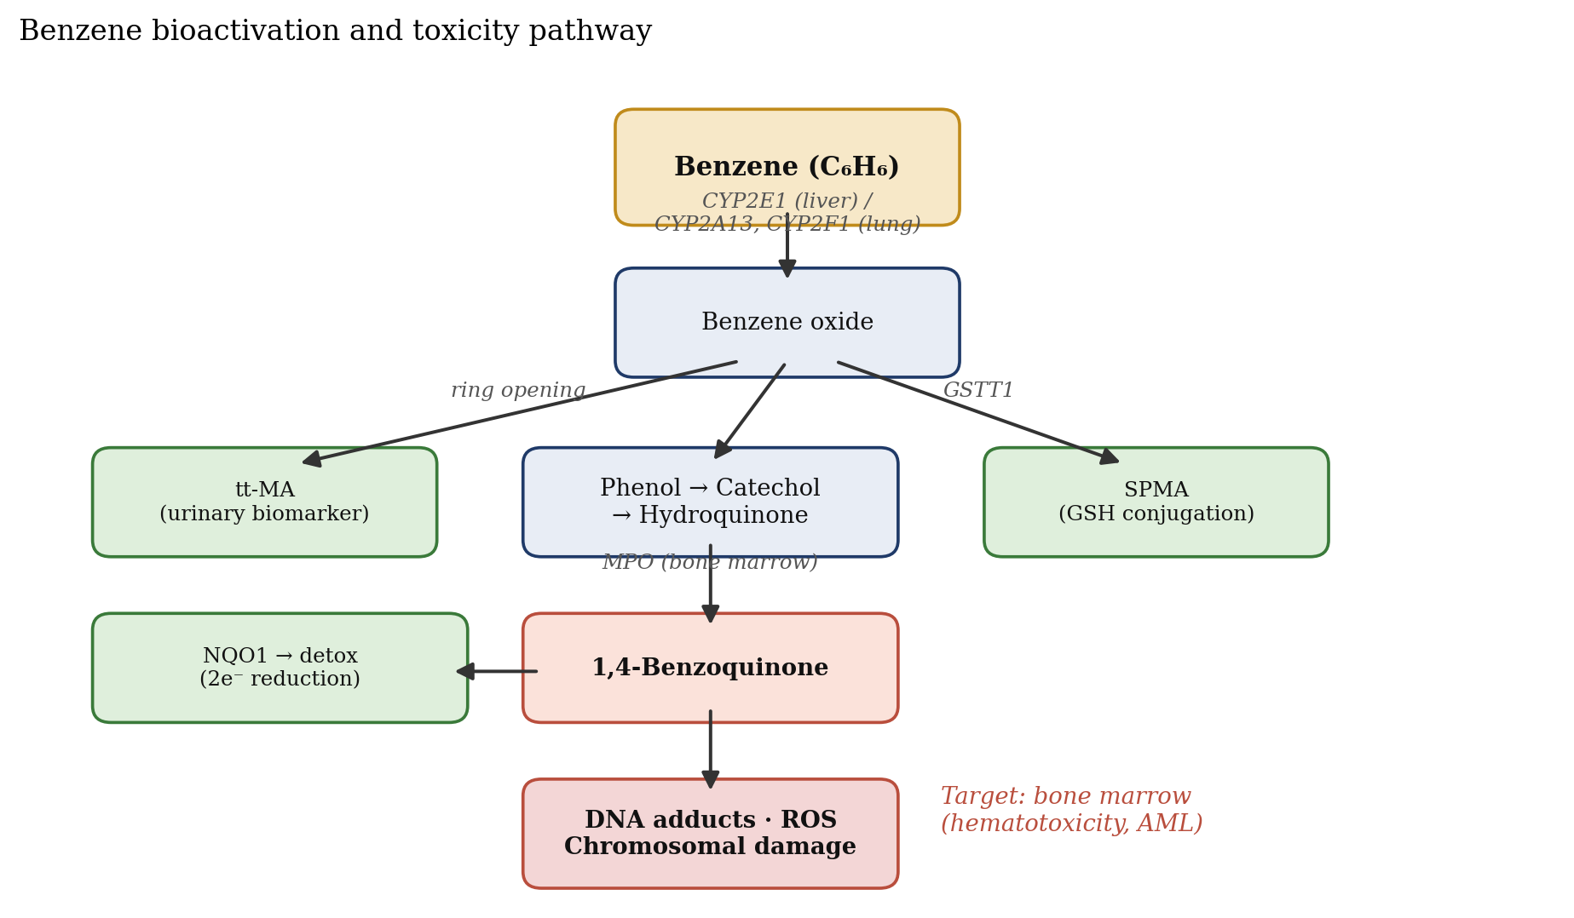
Figure 4. Simplified benzene metabolism pathway. Parent benzene is oxidised by CYP2E1 (liver, higher doses) and CYP2A13/CYP2F1 (lung, ambient doses) to benzene oxide, which generates urinary biomarkers tt-MA and SPMA and the reactive bone-marrow electrophile 1,4-benzoquinone [2][14][35]. MPO = myeloperoxidase; GSH = glutathione.
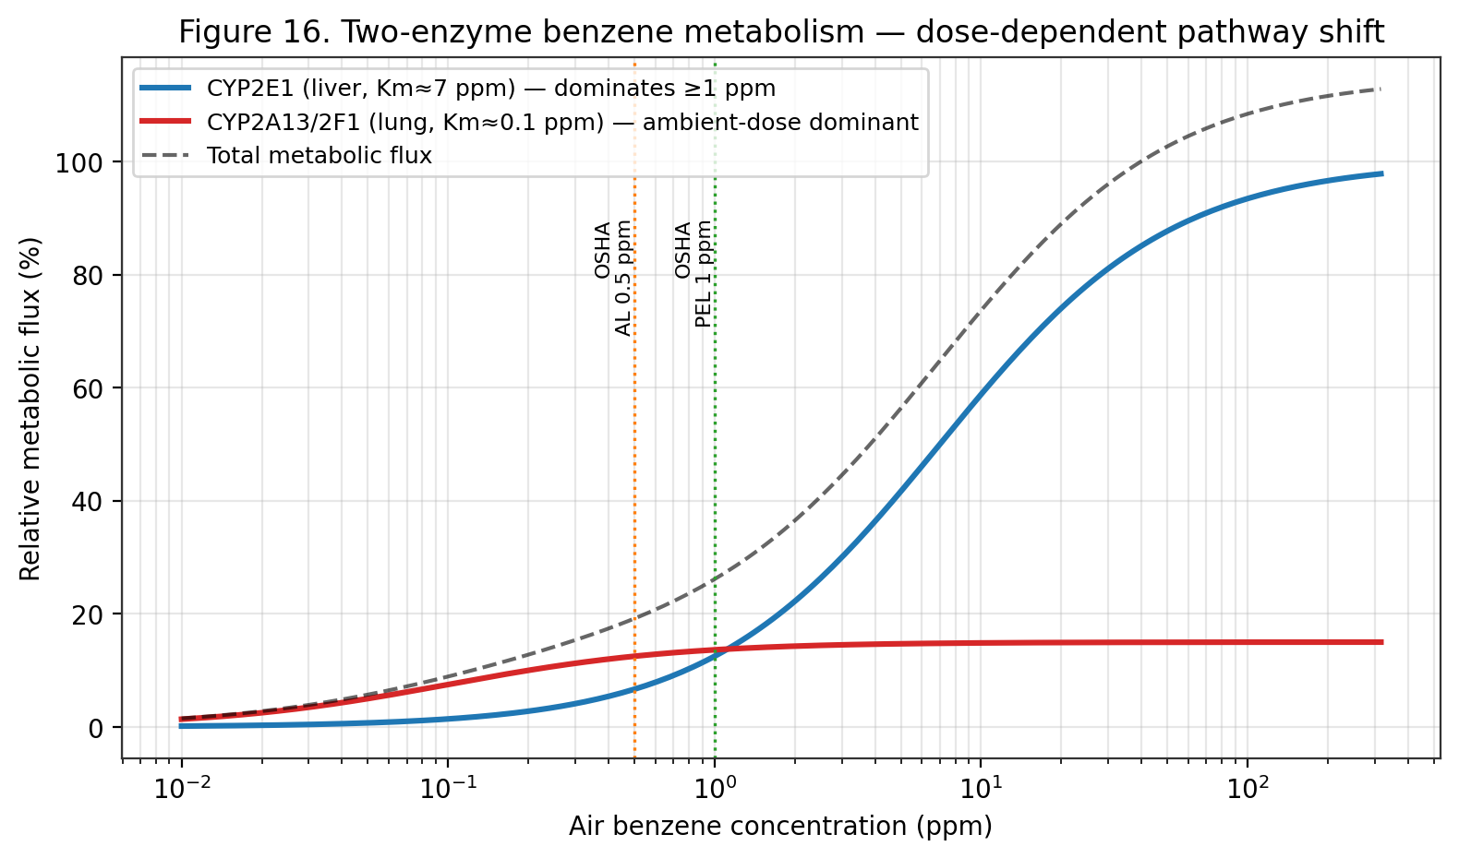
Figure 16. Two-enzyme benzene metabolism — dose-dependent pathway shift (Medinsky 1989; Rappaport 2025). At ambient ppb doses the high-affinity CYP2A13/2F1 lung enzymes dominate; above 1 ppm the low-affinity hepatic CYP2E1 saturates and becomes the primary clearance route.
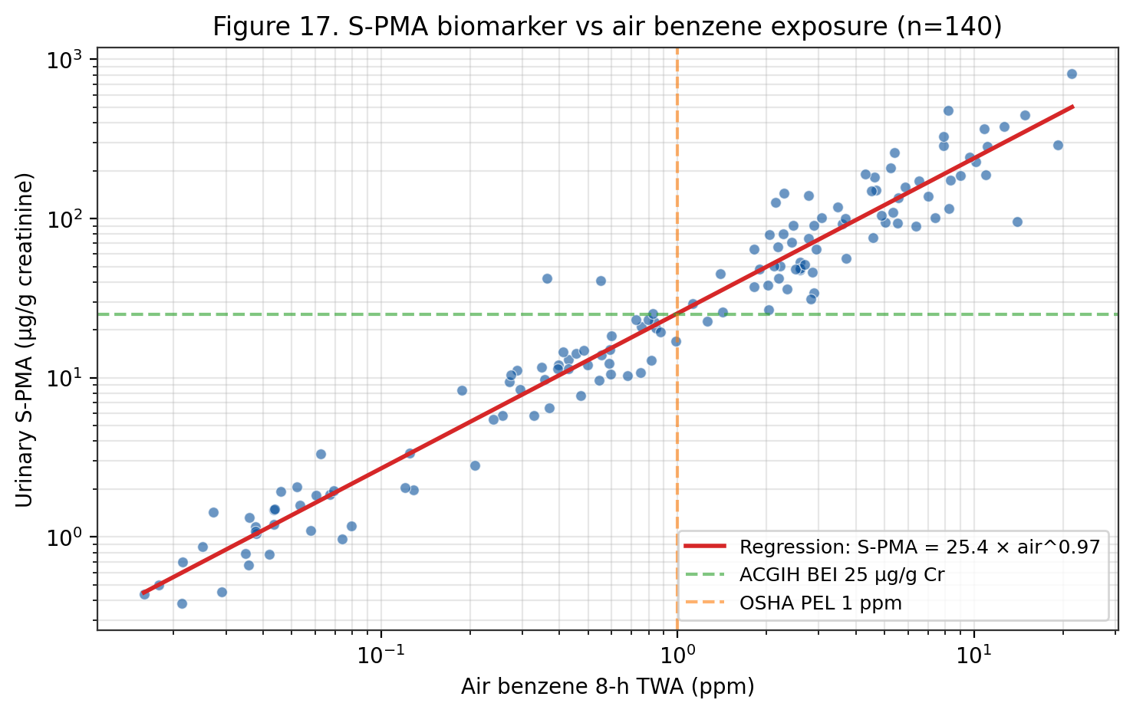
Figure 17. Urinary S-phenylmercapturic acid (S-PMA) versus 8-h TWA air benzene (n=140 workers; Boogaard 2002; Kim 2006). Log-log regression gives S-PMA ≈ 25 µg/g creatinine per 1 ppm air benzene, supporting the ACGIH BEI.
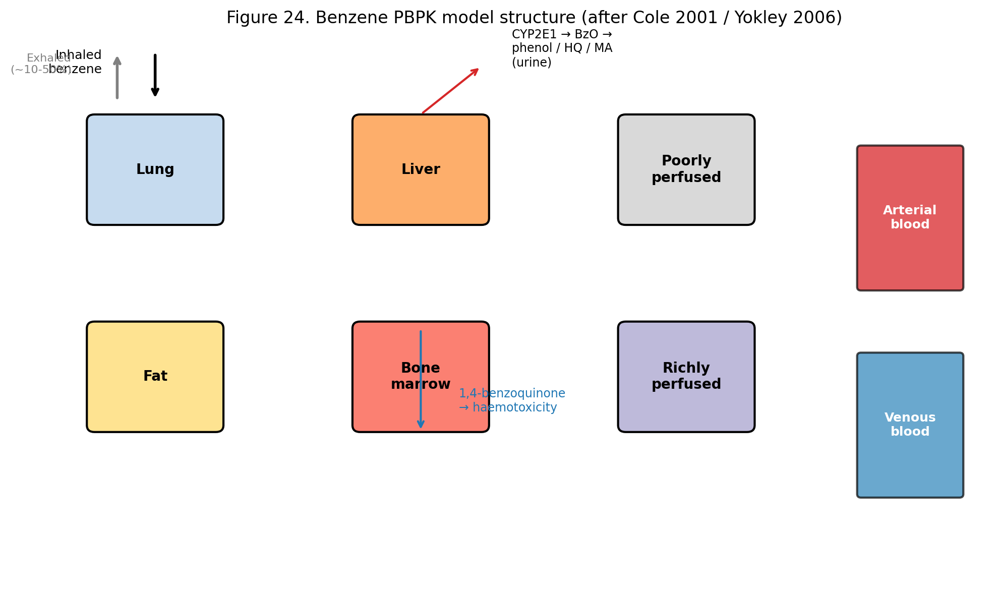
Figure 24. Benzene PBPK model structure (after Cole 2001 / Yokley 2006). Six tissue compartments plus arterial/venous blood; metabolism is localised primarily to liver CYP2E1 and lung CYP2A13/2F1 with bone-marrow as the critical target.

Enzyme | Role | Tissue / dose context | Key refs
CYP2E1 | Benzene → benzene oxide; phenol → hydroquinone | Liver; >1 ppm | [2][14][35]
CYP2A13 | High-affinity benzene oxidation | Lung; ppb ambient | [14]
CYP2F1 | High-affinity benzene oxidation | Lung; ppb ambient | [14]
Myeloperoxidase (MPO) | Hydroquinone → 1,4-benzoquinone (activation) | Bone marrow | [2][35]
NQO1 | 1,4-benzoquinone → hydroquinone (detox) | Systemic | [25][35]
GSTT1 | Benzene oxide + GSH → SPMA (detox) | Systemic | [25]
Epoxide hydrolase | Benzene oxide → dihydrodiol (detox) | Liver | [2]
Table 5. CYP450 enzymes and downstream metabolism in benzene bioactivation.

Parameter | Value / description | Source
Inhalation absorption (steady-state) | ~50 % of inhaled dose at rest; up to 80 % with exercise | [2][7]
Oral absorption | Near-complete in animal studies | [2][7]
Dermal absorption (liquid) | Limited but measurable; relevant for splashes | [3][5]
Distribution | Lipophilic; bone marrow, adipose, liver, brain | [2][7]
Blood-to-air partition coefficient | ~8 | [2]
Major bioactivation | CYP2E1 (liver); CYP2A13/CYP2F1 (lung, ambient doses) | [14]
Principal urinary metabolites | tt-MA, SPMA, phenol, hydroquinone, catechol | [2][14]
Elimination | Exhalation of unchanged benzene; urinary metabolites | [2][7]
Terminal half-life (blood) | Multiphasic; minutes to hours | [2][7]
Urinary SPMA half-life | ~9 hours | [14]
Urinary tt-MA half-life | ~5 hours | [14]
Table 14. Toxicokinetic parameters for benzene in humans (WHO EHC 150; EPA IRIS; ATSDR).
PBPK Modelling of Benzene Disposition
Physiologically-based pharmacokinetic (PBPK) modelling of benzene disposition has been developed over three decades with progressively increasing sophistication. Early models (Medinsky 1989; Travis 1990) represented benzene as a single compound distributing among physiological compartments (arterial blood, richly perfused tissues, slowly perfused tissues, adipose) with Michaelis-Menten metabolism in the liver. Subsequent models (Bois 1991; Cole 2001; Yokley 2006) extended this framework to incorporate multi-metabolite formation (benzene oxide, phenol, catechol, hydroquinone, 1,4-benzoquinone, trans, trans-muconaldehyde), bone-marrow-specific compartments, and co-exposure effects with toluene. The U.S. EPA IRIS benzene assessment ^{[4]} utilises Cole's 2001 model for extrapolation between inhalation and oral routes and across exposure durations ^{[4][35]}.
The Rappaport 2025 analysis of 389 Chinese workers via Michaelis-Menten modelling of urinary benzene versus ambient benzene provides direct empirical evidence for a high-affinity / low-capacity metabolic pathway operative at ppb-level exposures, distinct from the classical CYP2E1-mediated low-affinity / high-capacity pathway dominant above 1 ppm. The Vmax/Km ratio for the high-affinity pathway in non-smoking males was approximately 43-fold greater than for the low-affinity pathway. This two-pathway representation — consistent with CYP2A13 and CYP2F1 lung-specific catalysis at low doses — is not currently implemented in the regulatory PBPK models underlying EPA IRIS or OEHHA risk assessments. Updating the models to include the high-affinity pathway is anticipated to produce steeper low-dose slopes and commensurately more stringent cancer risk estimates at ambient concentrations ^{[4][14][44]}.
Bone-marrow-specific benzene dosimetry — critical for haematotoxicity and leukaemia risk estimation — remains an area of active research and PBPK refinement. The direct pharmacokinetic measurement of benzene metabolites in bone marrow is ethically constrained in humans; dosimetry therefore relies on interspecies extrapolation from rodent studies and on biomarker-based reconstruction from peripheral-blood and urinary measurements. Recent advances include positron-emission-tomography imaging of radiolabelled benzene in mice, high-resolution metabolomic profiling of exposed workers, and single-cell transcriptomic characterisation of exposed bone-marrow progenitors. These approaches collectively refine our understanding of the bone-marrow internal-dose metric that should anchor dose-response characterisation ^{[4][14][35]}.
Species and Interindividual Differences
Interspecies differences in benzene disposition are substantial and critical for interpreting animal bioassay data for human risk assessment. Mice metabolise benzene more rapidly than rats, and both metabolise more rapidly than humans when normalised to body weight. The relative balance between ring-hydroxylation (phenol, hydroquinone) and ring-opening (muconaldehyde, trans,trans-muconic acid) pathways differs among species, with the mouse showing greater ring-opening than humans. Tissue-specific CYP450 expression patterns — notably the pulmonary expression of CYP2A13 and CYP2F2 in mice and CYP2A13 and CYP2F1 in humans — contribute to differential benzene activation in the lung at low doses ^{[2][14][35]}.
Interindividual human variability in benzene biotransformation is substantial and genetically determined. Key polymorphic enzymes include CYP2E1 (RsaI, PstI, DraI variants), CYP2A13 (coding-region variants affecting enzymatic activity), GSTT1 (null allele frequency ~20 % in Caucasians, ~50 % in East Asians), NQO1 (C609T variant frequency ~22 % in Caucasians, ~45 % in East Asians), and myeloperoxidase (MPO, −463G/A). The combined effect of genotype-dependent bioactivation (CYP2E1, CYP2A13) and detoxification (GSTT1, NQO1) produces interindividual variability in bone-marrow-directed dose that can exceed an order of magnitude ^{[25][33][35]}.
Life-stage differences are underrepresented in current regulatory PBPK frameworks but may be quantitatively important. Neonatal and infant CYP450 expression patterns differ from adults — CYP2E1 expression emerges late in gestation and increases through childhood — with potential implications for benzene activation in exposed children and for developmental-origins-of-disease considerations. Pregnancy alters hepatic metabolism with approximately 50 % increases in CYP2E1 activity in the third trimester; placental passage of benzene is documented and the foetal compartment can receive benzene and benzene metabolites. These life-stage-specific considerations inform risk-assessment choices for children and pregnant women ^{[2][7]}.
Metabolomic Profiling and Dose Reconstruction
Metabolomic profiling of benzene-exposed individuals provides an integrated view of exposure internal dose and consequent biological perturbation. The comprehensive urinary-metabolomic studies of benzene-exposed workers (Galbraith 2010, subsequent analyses) document that in addition to the classical SPMA and tt-MA biomarkers, benzene exposure perturbs multiple endogenous metabolite classes — amino acids (tryptophan, tyrosine, phenylalanine pathways), nucleotides (purines), lipid species, and bile-acid derivatives. These multi-metabolite signatures offer potential for improved exposure classification and for detection of biological effect at low exposure levels where classical biomarkers are below detection ^{[54]}.
Exposure reconstruction from biomarker data applies PBPK-model-inverted analysis to infer integrated benzene exposure from measured urinary or blood biomarker concentrations. Application to occupational cohorts (Pliofilm, Chinese benzene workers, Australian Health Watch) has informed the exposure-response characterisation underlying regulatory limits. Limitations of biomarker-based reconstruction include the short elimination half-lives of urinary metabolites (limiting representativeness of sporadic sampling), interindividual variability in metabolic rates, background contributions from non-occupational exposures, and effects of interfering co-exposures (toluene, ethanol, etc.). Modern Bayesian-hierarchical biomarker-reconstruction methods incorporate these uncertainties quantitatively ^{[4][14]}.
Mass-balance studies of benzene disposition in humans — documenting the fraction of absorbed benzene that is exhaled unchanged versus metabolised versus excreted as parent compound or metabolites — are foundational to quantitative dose reconstruction. Human controlled-exposure studies (at sub-ppm exposures compatible with ethical guidelines) have quantified these fractions and provided ranges of inter-individual variability. Representative results indicate that at occupational exposures ~50 % of absorbed benzene is exhaled unchanged, ~25 % is excreted as phenol and related oxidation products, ~5 % as muconic acid, ~0.1 % as SPMA, and the remainder as catechol, hydroquinone, and their glucuronide/sulphate conjugates. These fractions shift with exposure level, reflecting saturation of bioactivation pathways ^{[2][4][14]}.
Co-Exposure Interactions Affecting Kinetics
Toluene co-exposure is the best-characterised interaction affecting benzene metabolism. Toluene competitively inhibits CYP2E1-mediated benzene oxidation, reducing the formation of benzene oxide and downstream metabolites. The 1989 Medinsky and 2001 Cole PBPK models both incorporate toluene-benzene metabolic interaction. At typical petrochemical-industry co-exposures (benzene and toluene in similar ratios), the observed reduction in benzene urinary metabolite formation ranges 10–40 %. This interaction has regulatory implications: benzene exposure estimates derived from urinary biomarkers may underestimate benzene internal dose in workers with significant toluene co-exposure ^{[2][4]}.
Ethanol consumption — as recreational alcohol use — induces CYP2E1 expression, potentially accelerating benzene bioactivation. Several human controlled-exposure studies document modest but measurable increases in urinary benzene metabolites following ethanol pre-treatment. The clinical significance of this interaction for occupationally-exposed workers is uncertain; workplace alcohol-use policies address acute intoxication concerns but do not specifically address CYP2E1-mediated benzene-metabolism implications. Chronic heavy alcohol use is associated with persistent CYP2E1 upregulation that could plausibly enhance benzene bioactivation chronically ^{[2][14]}.
Tobacco smoke contains benzene, other CYP450 substrates and inducers (polycyclic aromatic hydrocarbons, nitrosamines), and pharmacologically active compounds. Smoking may modify benzene kinetics through CYP induction (aryl hydrocarbon hydroxylase induction by PAHs affects CYP1A1/1A2; combustion products may affect CYP2E1). In the Rappaport 2025 analysis, smoking status was a significant modifier of the high-affinity pulmonary metabolism pathway rate, with non-smoking males showing the highest ratio of high-affinity to low-affinity metabolism. These interactions support the importance of smoking-stratified analysis in benzene epidemiology and biomonitoring ^{[14]}.
IARC Vol 120 Section 4 — Mechanistic Basis (Verbatim-Grounded)
IARC Monograph 120 Section 4 (Mechanistic and Other Relevant Data, 71 pages, extracted during this review) establishes the scientific basis for benzene's classification via mechanistic evidence beyond epidemiology alone. Metabolism of benzene is required for benzene toxicity — an observation grounded in studies in genetically modified animals and with pharmacological tools. In CYP2E1-knockout mice, urinary benzene metabolites were reduced by approximately 90 % with a concomitant complete lack of benzene-induced genotoxicity and cytotoxicity in bone marrow, blood, and lymphoid tissues (Valentine et al. 1996). Inhibition of CYP2E1-mediated metabolism reduced benzene-induced genotoxicity in mice (Tuo et al. 1996). Occupationally-exposed individuals with rapid-CYP2E1-metabolism phenotype showed enhanced benzene toxicity susceptibility (Rothman et al. 1997) ^{[8]}.
Sites of benzene metabolism include both liver and lung by CYP450 (Chaney & Carlson 1995; Powley & Carlson 2000). Partial hepatectomy reduced benzene metabolism and benzene toxicity, establishing the liver as the primary metabolic site under conventional conditions. Toluene co-administration competitively inhibits CYP2E1-mediated benzene metabolism and reduces benzene toxicity (Andrews et al. 1977), establishing the co-exposure interaction that has subsequent regulatory implications for mixed-solvent occupational settings. Qualitatively, the same metabolites are excreted by humans after occupational or environmental exposures and in animals exposed to benzene — supporting cross-species extrapolation (Inoue et al. 1988, 1989; Sabourin et al. 1988, 1992; Henderson et al. 1989; Boogaard & van Sittert 1996) ^{[8]}.
The benzene metabolic scheme begins with CYP2E1-mediated oxidation to the reactive electrophilic intermediate benzene oxide. Benzene oxide is in equilibrium with its tautomer oxepin and undergoes spontaneous rearrangement to phenol, competing glutathione conjugation to S-phenylmercapturic acid (SPMA, the most specific urinary biomarker), ring-opening to trans,trans-muconaldehyde (further oxidised to tt-MA), or hydrolysis to benzene dihydrodiol. Phenol is further oxidised to hydroquinone and catechol, both of which undergo peroxidase-mediated oxidation to the proximate toxic quinones (1,4-benzoquinone, 1,2-benzoquinone), or conjugation to sulphates and glucuronides for urinary elimination. This mechanistic framework — with myeloperoxidase bioactivation in bone marrow as the critical step — provides the biological basis for benzene-induced haematotoxicity and leukaemogenesis ^{[8]}.
Biomonitoring laboratory methods — SPMA, ttMA, and blood benzene
Urinary S-phenylmercapturic acid (SPMA) is measured by HPLC-MS/MS with negative-ion electrospray ionisation. The method of Paci et al. 2007 (Anal Bioanal Chem) uses a C18 column (100 x 2.1 mm, 1.7 um), ammonium-acetate / acetonitrile gradient, MRM transitions m/z 238 -> 109 (quantitation) and 238 -> 91 (confirmation), with isotope-labelled d5-SPMA as internal standard. Limit of detection is 0.05 ug/L, limit of quantitation 0.15 ug/L. Sample preparation is a 5-fold dilution with mobile phase and direct injection of 10 uL; no solid-phase extraction is required.
Urinary trans,trans-muconic acid (ttMA) is measured by HPLC-UV at 259 nm absorbance. The classical Ducos et al. 1990 method uses a solid-phase-extraction SAX anion-exchange cartridge for cleanup; modern methods (Boogaard & van Sittert 1995; Fustinoni et al. 2010) use HPLC-MS/MS directly with MRM 141 -> 97 (quantitation). LOD is 0.01 mg/L, LOQ is 0.05 mg/L. Results are normalised to urinary creatinine (determined by the Jaffé reaction or enzymatic method) to account for dilution, and reported in ug/g-creatinine.
Blood benzene is measured by headspace GC-MS. The ISO 27108 method uses a 20-mL headspace vial charged with 2 mL blood plus 2 mL water plus 10 uL of 100 ug/L d6-benzene internal standard. The vial is equilibrated at 37 °C for 30 minutes, then 1 mL of headspace is injected onto a porous-polymer (Rtx-VMS) capillary column with cold-trap focusing. Quantitation is by MRM of m/z 78 -> 52 (benzene) and 84 -> 56 (d6-benzene). LOD is 0.005 ug/L, LOQ is 0.025 ug/L, precision 8 % RSD at 0.1 ug/L.
Exhaled-breath benzene is a non-invasive surrogate for blood benzene. Wallace 1990 established breath:blood equilibrium ratios of 0.15 ± 0.03 for a 4-hour post-exposure sample. Current breath-sampling methods use adsorbent-tube collection from a Tedlar or ALTEF breath-collection bag with GC-MS analysis identical to blood-headspace. LOD is approximately 0.05 ug/m^3 alveolar concentration.
External proficiency programmes for benzene biomarkers include the German GEQUAS (Gesellschaft zur Foerderung der Qualitaetssicherung in medizinischen Laboratorien) round-robin for urinary SPMA and ttMA; the CDC HHL (Human Health Laboratory) interlaboratory comparison for blood VOCs; and the European Occupational Exposure Biomonitoring (HBM4EU) scheme coordinated by the German Environment Agency. Participation is required for laboratories supporting REACH dossier-development or OSHA medical-surveillance reporting.
PBPK modelling for inter-species and inter-route extrapolation
Physiologically-based pharmacokinetic (PBPK) models for benzene partition the body into anatomically-referenced compartments (lung, liver, fat, muscle, bone marrow, and slowly-perfused viscera) linked by blood-flow rates and tissue:blood partition coefficients. Model output is typically the area-under-the-curve (AUC) of a metabolite of interest (hydroquinone, 1,4-benzoquinone) in the target tissue (bone marrow) as a function of exposure scenario.
Medinsky 1989 is the foundational model. It uses 4 compartments (lung, slowly-perfused, rapidly-perfused, fat), venous-equilibrium mass-balance equations, and explicit Michaelis-Menten hepatic metabolism. The model was fitted to rat inhalation and oral exposure data, and successfully predicted urinary-metabolite concentrations measured in Farris 1997.
Cole 2001 extended Medinsky to a 6-compartment model with explicit bone-marrow compartment and haematopoietic progenitor-cell sub-compartments. This model was fitted to the Chinese-cohort urinary-metabolite data and used by EPA IRIS for inter-species extrapolation in the 2000 inhalation-unit-risk derivation.
Yokley 2006 re-fitted the Cole model using Bayesian Markov-chain Monte-Carlo methods to quantify parameter uncertainty. Inter-individual variability in CYP2E1 activity (log-normal distribution with coefficient of variation 0.5) was identified as the dominant source of PBPK model output variance, translating to approximately 3-fold variability in bone-marrow hydroquinone AUC at equal exposure. This finding supports the 10x intra-species uncertainty factor applied to BMDL-derived RfCs.
Inter-route extrapolation (inhalation-to-oral or oral-to-inhalation) is accomplished by running the PBPK model with the desired input-route pharmacology and reading out the target-tissue dose-metric. For benzene, inter-route extrapolation is complicated by different first-pass metabolism: oral benzene is 75-95 % metabolised on hepatic first pass (shunt away from bone marrow), whereas inhalation benzene bypasses hepatic first-pass and delivers more parent compound to bone marrow at equal systemic dose. EPA IRIS 2003 applied a 3x inter-route adjustment factor for this reason.
Monte-Carlo uncertainty analysis in benzene risk assessment
Monte-Carlo uncertainty analysis applies probabilistic distributions to model inputs (exposure scenarios, PBPK parameters, dose-response slopes) and propagates them through the risk-assessment calculation to generate an output probability distribution. EPA's 1997 Guidance on Monte-Carlo Analysis recommends reporting the 5th-, 50th-, and 95th-percentile values of the output distribution along with the point-estimate.
For benzene inhalation risk assessment, Monte-Carlo analyses have been published by the American Petroleum Institute (API 2000, 2018) and by several academic groups. The typical output is a probability distribution of lifetime excess-cancer risk for a specified exposure scenario, e.g. continuous ambient exposure at the 2017 NATA national-median concentration (0.84 ug/m^3). For this scenario API 2018 Monte-Carlo gives: 5th-percentile excess-cancer risk = 1.2 x 10^-7; median = 3.6 x 10^-6; 95th-percentile = 1.5 x 10^-5. The distribution spans approximately 100x, reflecting principally the uncertainty in the inhalation-unit-risk (5x span) and in individual exposure-duration and breathing-rate distributions.
Occupational Monte-Carlo analyses applied to the 0.5 ppm ACGIH TLV and the 0.2 ppm EU 2022 OEL show median lifetime excess AML risk at 40-year career continuous exposure of 8 x 10^-4 (for 0.5 ppm) and 3 x 10^-4 (for 0.2 ppm), both above the 10^-4 occupational-cancer-risk target. This is the principal technical driver for the EU planned step-down to 0.05 ppm by 2033, which would bring the median excess risk down to approximately 7 x 10^-5.
The residual uncertainty in benzene risk characterisation is dominated by (a) the exposure-response slope at low doses (spanning 3-10x), (b) individual PBPK variability (3x), (c) PBPK model-form uncertainty (2-3x), and (d) exposure-distribution uncertainty (varies by scenario, typically 2-5x). The total uncertainty factor for a risk-characterisation calculation is approximately 100-300x between the 5th and 95th percentile, with the single point-estimate conventionally taken at or near the 95th percentile for protective regulatory decision-making.
Ongoing research directions for reducing benzene risk-characterisation uncertainty include (a) individual-based biomarker dosimetry (using urinary SPMA or blood-benzene as the primary exposure metric, replacing air-concentration TWAs); (b) mechanistic AOP-based dose-response models (as developed in North 2020); and (c) human-population variability quantification using bioinformatics-informed distributions on CYP2E1, NQO1, MPO, GSTT1, and GSTM1 polymorphism frequencies.
Detailed toxicokinetic parameters — oral, inhalation, dermal
Oral absorption of benzene is nearly complete (>95 % of administered dose absorbed) in rodent and human studies. The Parke & Williams 1953 classical feeding study in rabbits administered 340 mg/kg ^14C-benzene by gavage and recovered 40 % of radioactivity in expired air as unchanged benzene and 56 % in urine as metabolites within 48 h; tissue residues at 48 h accounted for <2 % of the dose. Human oral absorption has been studied only indirectly via incidental ingestion in contaminated-water case-series and is assumed >95 % by default.
Dermal absorption of liquid benzene through intact skin is approximately 0.4 mg/cm^2/h at steady-state (Franz 1984 in-vivo volunteer study). For a typical forearm contact area of 200 cm^2 with 30-minute contact duration the absorbed dose is approximately 40 mg. This is substantially lower than the inhalation absorption rate at 1 ppm for the same duration (approximately 2 mg absorbed in 30 min at 6 L/min breathing rate), but for prolonged skin contact dermal absorption can become the dominant route.
Dermal absorption of benzene vapour is low (~0.1-1 % of the inhaled dose at equivalent vapour concentration) and is typically neglected in exposure assessment. Gloves provide effective barriers: nitrile gloves (0.4 mm thickness) have breakthrough times of approximately 4 h for 100 % benzene contact, and natural-rubber latex gloves are not recommended because of rapid breakthrough (<15 min).
Inhalation uptake is controlled by a blood:air partition coefficient of 7.4 and fat:blood partition of 60. Alveolar ventilation (12-15 L/min at rest, up to 100 L/min at moderate physical work) and cardiac output are the primary physiological determinants of uptake rate. A steady-state alveolar fraction of approximately 50 % is achieved within 1-2 hours at rest; physical work increases uptake proportionally to ventilation rate.
Tissue distribution follows partition-coefficient gradients. Fat:blood = 60 means adipose tissue accumulates benzene to equilibrium concentrations 60-fold higher than blood; however, adipose-tissue blood flow is low (approximately 30 mL/min/kg fat), so equilibration to fat is slow with approximately 24-48 hours required for full equilibration. Bone-marrow is a rapidly-perfused tissue (blood flow 400 mL/min/kg) with partition-coefficient 4.8, giving bone-marrow benzene concentrations approximately 5-fold blood concentrations at steady state.
Excretion is dominated by metabolism (approximately 60-70 % of absorbed dose appears as urinary metabolites) with minor contributions from expired-air elimination of unchanged benzene (approximately 16-42 % of dose, Nomiyama 1974) and trace faecal elimination (<2 %).
Placental and mammary transfer have been documented in human biomonitoring studies. Cord-blood:maternal-blood ratio is approximately 0.7 (Pekari 1992), reflecting essentially unimpeded placental transfer. Breast milk:maternal blood ratio is approximately 6 at equilibrium (consistent with the lipophilic character of benzene), giving substantial infant exposure via breastfeeding in highly-exposed mothers.
Major urinary and blood metabolite profiles in workers
At occupational 8-h TWA exposures of 1 ppm benzene, the total daily absorbed dose is approximately 30 mg (for a 70-kg worker breathing 10 m^3 over the work shift with 50 % uptake). Metabolite distribution in end-of-shift urine samples is approximately: phenol 4 mg/g-creatinine, catechol 1 mg/g-creatinine, hydroquinone 2 mg/g-creatinine, 1,2,4-benzenetriol 0.2 mg/g-creatinine, trans,trans-muconic acid 1.5 mg/g-creatinine, S-phenylmercapturic acid 25 ug/g-creatinine, and unchanged benzene 1 ug/g-creatinine.
Phenol is not a specific biomarker of benzene exposure because background phenol excretion from dietary precursors (tyrosine, phenylalanine, and aromatic amino acid metabolism) is approximately 4-15 mg/g-creatinine in non-exposed individuals — comparable to the benzene-exposure-derived increment at 1 ppm.
Catechol, hydroquinone, and 1,2,4-benzenetriol have similar specificity limitations. Dietary flavonoids (quercetin, kaempferol, anthocyanins) are metabolised to catechol-glucuronides and catechol-sulphates, producing urinary concentrations of 0.5-3 mg/g-creatinine in non-exposed adults.
trans,trans-muconic acid has better specificity because its principal dietary precursor is sorbic acid (2,4-hexadienoic acid), a food preservative used at levels of 0.1-0.5 % in baked goods, beverages, and processed cheeses. Background ttMA in non-exposed adults is 50-300 ug/g-creatinine, lower than the benzene-exposure increment at 1 ppm (approximately 1500 ug/g-creatinine increment), but the ratio of signal-to-background is approximately 5-10x less favourable than for SPMA.
S-phenylmercapturic acid has the highest specificity. Background SPMA in non-exposed non-smoking adults is approximately 0.5 ug/g-creatinine; smokers have 2-5 ug/g-creatinine; occupationally-exposed workers at 1 ppm 8-h TWA have approximately 25 ug/g-creatinine (the ACGIH BEI). The 50-fold signal-to-background ratio makes SPMA the preferred biomarker for low-level occupational and community exposures.
Unchanged benzene in urine is a minor but highly specific marker. Background is essentially zero (<0.1 ug/L) in non-exposed individuals; smokers have 0.2-0.5 ug/L; occupationally-exposed workers at 1 ppm have approximately 1-5 ug/L. Urinary benzene measurement is technically demanding (headspace GC-MS) but provides unambiguous exposure confirmation.
Regulations and Guidelines
Benzene is one of the most heavily regulated industrial chemicals globally, with a dense network of occupational, environmental, and consumer-product standards. The principal occupational-exposure limits are set by U.S. OSHA (29 CFR 1910.1028), NIOSH (Pocket Guide NPG-0049), ACGIH (TLV), EU-OEL, and analogous national competent authorities ^{[3][5][6][49]}. Environmental standards are set by U.S. EPA (IRIS, MCL, NAAQS and MSAT), CalEPA OEHHA, WHO, European Commission (Directive 98/70/EC for gasoline benzene; Directive 2000/69/EC for ambient air), ECHA (REACH/CLP), and national environmental-protection agencies ^{[2][4][44][46]}. Classification as a carcinogen is harmonised across IARC (Group 1), NTP ROC (Known to be Human Carcinogen), EU CLP (Category 1A), and U.S. EPA (known human carcinogen Category A) ^{[4][8][45][46]}. This section surveys the principal regulatory instruments.
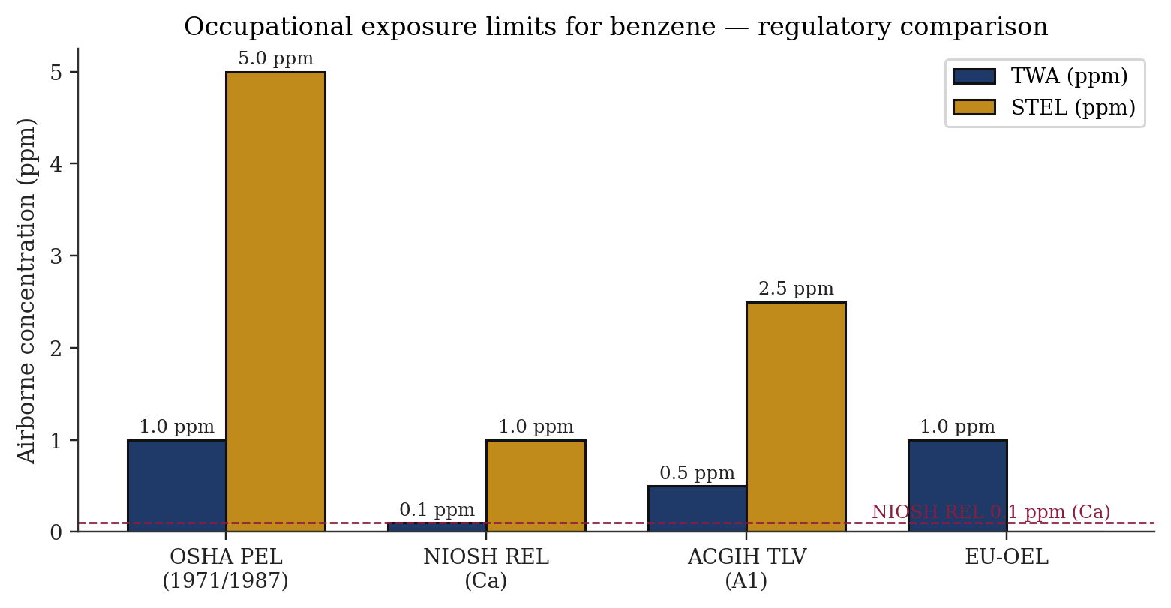
Figure 5. Occupational exposure limits for benzene across major regulatory frameworks. Values from NIOSH Pocket Guide (NPG-0049) [5], ACGIH TLV documentation [49], OSHA 29 CFR 1910.1028 [6], and EU-OEL via ICSC 0015 [3].
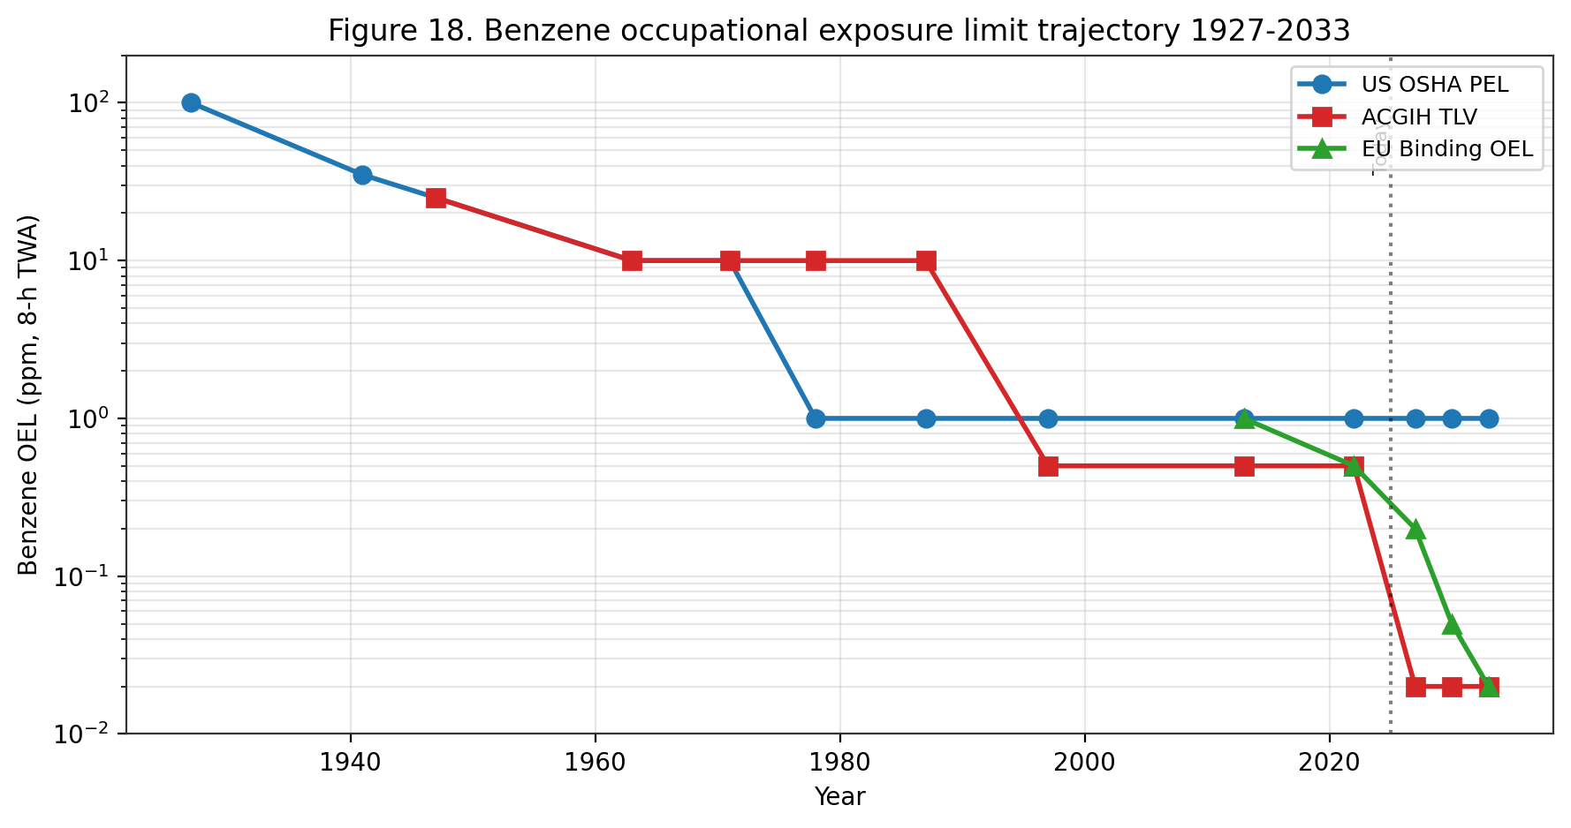
Figure 18. Benzene OEL trajectory 1927-2033. US OSHA PEL reduced from 100 ppm (1927 APHA) to 1 ppm (1987); ACGIH NIC proposes 0.02 ppm by 2027; EU Binding OEL steps down to 0.02 ppm by 2033 under the CAD 2022/431/EU amendment.

Framework | TWA | STEL | Notation / Classification | Source
OSHA PEL | 1 ppm (8-hr) | 5 ppm (15 min) | Action level 0.5 ppm | [6]
NIOSH REL | 0.1 ppm (Ca, 10-hr) | 1 ppm | Potential occupational carcinogen | [5]
ACGIH TLV | 0.5 ppm (8-hr) | 2.5 ppm | Skin; A1; BEI | [3][49]
EU-OEL | 1 ppm (3.25 mg/m³) | — | Skin | [3]
MAK (Germany) | not set | — | Carc 1; Mutagen 3A; Skin H | [3]
EPA MCL (drinking water) | 5 µg/L | — | Max contaminant level | [4]
EPA RfC (inhalation) | 3 × 10⁻² mg/m³ | — | Critical effect: ↓ lymphocyte | [4]
EPA RfD (oral) | 4 × 10⁻³ mg/kg-day | — | Critical effect: ↓ lymphocyte | [4]
CalEPA OEHHA IUR | 2.9 × 10⁻⁵ per µg/m³ | — | More stringent than US EPA | [44]
Table 2. Regulatory limits for benzene in occupational and environmental media.
International Guidelines
The World Health Organization and its International Programme on Chemical Safety (WHO/IPCS) published Environmental Health Criteria 150 (Benzene) in 1993 — a comprehensive compendium that remains the most widely cited international reference on benzene toxicology, exposure, and environmental behaviour ^{[2]}. EHC 150 provides no formal guideline value but concludes that benzene is a carcinogen without a practical threshold and recommends minimisation of exposure by source-reduction, substitution, and engineering controls ^{[2]}. The WHO Guidelines for Drinking-Water Quality (4th edition, 2011; 5th addendum 2017) recommend a provisional drinking-water guideline value of 10 µg/L for benzene, lower than the U.S. EPA MCL of 5 µg/L and higher than the EU Drinking Water Directive cap of 1 µg/L ^{[4]}. The WHO Air Quality Guidelines (2021) do not set a specific benzene guideline but incorporate benzene into the benchmark of 'no safe level' for carcinogenic air toxics, recommending a practical target of 5 µg/m³ as an achievable benchmark consistent with the EU ambient-air annual limit ^{[2]}.
The ILO/WHO International Chemical Safety Card 0015 (Benzene) provides operator-focused guidance on physical hazards, acute/chronic effects, first aid, spill response, storage, and PPE selection ^{[3]}. The ICSC designates benzene as a 'very high' priority hazard with carcinogen classification (IARC 1, EU Carc. 1A, EU Mutag. 1B) and recommends closed-system handling, local exhaust ventilation, organic-vapour respirators or supplied-air breathing apparatus as appropriate, chemical-resistant protective clothing, face and eye protection, and emergency eyewash ^{[3]}. The ICSC explicitly notes skin absorption (H-statement) and the requirement for contaminated-clothing removal and laundering before reuse ^{[3]}. ICSC 0015 remains the global reference for workplace chemical safety and is translated into 16 languages for international use.
The IARC Monograph 120 (2018) assessment classifies benzene as Group 1 human carcinogen based on sufficient evidence in humans for AML, limited-to-positive associations for ALL/CLL/NHL/multiple myeloma, sufficient evidence in experimental animals for multi-site carcinogenicity, and coherent mechanistic evidence ^{[8][51]}. The 2017 Lancet Oncology advance article by the IARC working group (Loomis et al.) previewed the monograph findings and summarised the integrated evidence framework, emphasising the breadth of human-cancer associations beyond the classical AML signal ^{[51]}. The Monograph 120 classification anchors national regulatory decisions in dozens of countries that adopt IARC classifications as the default scientific basis for carcinogen risk management.
The ECHA-administered EU Classification, Labelling, and Packaging (CLP) Regulation (EC) No 1272/2008 classifies benzene with harmonised CMR labels: Carcinogenicity Category 1A (known to have carcinogenic potential for humans), Germ Cell Mutagenicity Category 1B (presumed to have the potential to cause heritable mutations in the germ cells of humans), and Specific Target Organ Toxicity - Repeated Exposure Category 1 (blood and bone marrow) ^{[46]}. Pictograms, signal words, and hazard statements required on benzene-containing product labels include GHS02 (flammable), GHS07 (irritant), GHS08 (health hazard), danger signal word, H225 (highly flammable liquid and vapour), H304 (may be fatal if swallowed and enters airways), H315 (causes skin irritation), H319 (causes serious eye irritation), H340 (may cause genetic defects), H350 (may cause cancer), H372 (causes damage to organs through prolonged or repeated exposure) ^{[46]}.
Occupational Exposure Limits
The U.S. OSHA benzene standard (29 CFR 1910.1028) establishes an airborne action level of 0.5 ppm as an 8-hour TWA, above which employers must implement exposure monitoring and medical surveillance, a Permissible Exposure Limit (PEL) of 1 ppm as an 8-hour TWA, and a Short-Term Exposure Limit (STEL) of 5 ppm measured over any 15-minute reference period ^{[6]}. Regulated areas must be demarcated where airborne concentrations exceed or are reasonably expected to exceed these limits, with access restricted to authorised personnel. Required warning signs include the phrases 'DANGER — BENZENE — MAY CAUSE CANCER — HIGHLY FLAMMABLE LIQUID AND VAPOR — DO NOT SMOKE — WEAR RESPIRATORY PROTECTION IN THIS AREA — AUTHORIZED PERSONNEL ONLY' ^{[6]}. Labels on containers of benzene-containing liquids must carry the hazard warning 'DANGER — CONTAINS BENZENE — CANCER HAZARD' ^{[6]}.
NIOSH designates benzene as a potential occupational carcinogen (Ca notation) with a REL of 0.1 ppm TWA and a STEL of 1 ppm, both expressed as 10-hour TWAs to match the 10-hour workshift pattern used in some U.S. industries ^{[5]}. The NIOSH IDLH for benzene is 500 ppm, reduced from the historical 2,000 ppm on the basis of chronic carcinogenicity considerations rather than acute toxicity alone ^{[5]}. NIOSH recommends at any detectable concentration above the REL or where there is no REL, workers use an APF-10,000 self-contained breathing apparatus with full facepiece in pressure-demand mode, or an equivalent supplied-air respirator ^{[5]}. Skin contact must be prevented, contaminated clothing removed and laundered before reuse, and eyewash and quick-drench facilities provided ^{[5]}.
ACGIH assigns a Threshold Limit Value - Time-Weighted Average (TLV-TWA) of 0.5 ppm for benzene with a Short-Term Exposure Limit (TLV-STEL) of 2.5 ppm, along with an A1 (confirmed human carcinogen) classification and a skin notation indicating potential significant cutaneous absorption ^{[49]}. The ACGIH BEI (Biological Exposure Index) for benzene is 25 µg/g creatinine urinary SPMA (end-of-shift) and 500 µg/g creatinine urinary tt-MA (end-of-shift), corresponding to the 0.5 ppm 8-hr TWA exposure level ^{[49]}. The EU indicative occupational exposure limit value (IOELV) for benzene, set by European Commission Directive 2017/164/EU, is 1 ppm (3.25 mg/m³) as an 8-hour TWA with a skin notation; no STEL is specified at EU level, though many individual Member States impose national STELs ^{[3][46]}.
International occupational exposure limits vary widely. MAK (Germany) declines to set a traditional TWA because of benzene's carcinogenic status, instead assigning carcinogen Category 1 and mutagen Category 3A with a skin notation; employer obligations under MAK emphasise source elimination, substitution, and minimisation of exposure rather than compliance with a numeric limit ^{[3]}. Japan, Korea, Australia, Canada, China, and most Latin American countries adopt OELs broadly aligned with either the OSHA 1 ppm framework or the ACGIH 0.5 ppm framework ^{[46]}. Implementation and enforcement capacity vary substantially, with informal-sector and small-and-medium-enterprise workplaces frequently operating outside the effective reach of regulatory inspection ^{[17][19]}.
Historical reductions in regulatory OELs have been driven by accumulating evidence of toxicity at progressively lower exposures. The U.S. OSHA PEL was reduced from 10 ppm to 1 ppm in 1987 following the Rinsky Pliofilm cohort analysis; the ACGIH TLV has progressively declined from 100 ppm (1947) to 10 ppm (1978) to 0.5 ppm (1996) ^{[4][49]}. Several regulatory bodies — OEHHA, the U.S. EPA Integrated Risk Information System, and ECHA — are currently re-evaluating their benzene risk characterisations in light of the Rappaport (2025) high-affinity pathway findings and the Lan (2004) sub-ppm hematotoxicity data ^{[4][14][32][44]}.
U.S. EPA Assessments
The U.S. EPA Integrated Risk Information System (IRIS) assessment of benzene (last updated 2003 for non-cancer; cancer weight-of-evidence updated 2000) derives a reference dose (RfD) of 4 × 10⁻³ mg/kg-day and a reference concentration (RfC) of 3 × 10⁻² mg/m³, both based on decreased lymphocyte count as the critical effect ^{[4]}. Benzene is classified as a Category A known human carcinogen (1986 Guidelines) and known/likely human carcinogen (1996 proposed Guidelines), with tumour-site hematologic and tumour-type leukaemia, derived from the Rinsky and related occupational cohort analyses ^{[4][31]}. The inhalation unit risk is 2.2 × 10⁻⁶ to 7.8 × 10⁻⁶ per µg/m³ using low-dose linearity with maximum-likelihood estimates; the oral slope factor is 1.5 × 10⁻² to 5.5 × 10⁻² per mg/kg-day ^{[4]}. The EPA drinking-water maximum contaminant level (MCL) of 5 µg/L is derived from these risk estimates and is enforceable under the Safe Drinking Water Act ^{[4]}.
Within the Clean Air Act framework, benzene is a listed Hazardous Air Pollutant (HAP) under Section 112 and is regulated under the Mobile Source Air Toxics rule (MSAT), which caps gasoline benzene at 0.62 % v/v annual average and 1.3 % v/v maximum per batch ^{[2]}. The EPA Integrated Urban Air Toxics Strategy identifies benzene as a priority urban air toxic and targets source-specific controls in refineries, petrochemical plants, fuel terminals, and gasoline-distribution operations ^{[2]}. Area-source National Emission Standards for Hazardous Air Pollutants (NESHAPs) and the New Source Performance Standards (NSPS) apply to new and modified industrial installations emitting benzene above defined thresholds.
EPA's Resource Conservation and Recovery Act (RCRA) lists benzene as a hazardous waste (waste code U019, discarded commercial chemical product, and D018, toxicity characteristic for TCLP > 0.5 mg/L) ^{[4]}. Hazardous-waste-generator management requirements under RCRA Subtitle C apply to benzene-containing waste streams, with specific record-keeping, labelling, storage, transport, and disposal obligations. The Comprehensive Environmental Response, Compensation, and Liability Act (CERCLA/Superfund) lists benzene with a reportable quantity of 10 pounds ^{[4]}. The Emergency Planning and Community Right-to-Know Act (EPCRA) requires reporting under Toxic Release Inventory Section 313 (TRI) for facilities manufacturing, processing, or otherwise using benzene above defined thresholds; TRI data for the U.S. indicate ~10,000 tonnes of annual benzene air releases across major point sources.
California Environmental Protection Agency Office of Environmental Health Hazard Assessment (CalEPA OEHHA) derives a more stringent inhalation unit risk of 2.9 × 10⁻⁵ per µg/m³ under the Air Toxics Hot Spots programme (AB 2588) ^{[44]}. The OEHHA reference exposure level (REL) for chronic inhalation is 3 µg/m³ and the acute REL is 27 µg/m³ (one-hour, 99th percentile). California Proposition 65 lists benzene as a known carcinogen (1987) and as a known reproductive toxicant (2001), with corresponding 'No Significant Risk Level' (NSRL) of 7 µg/day and 'Maximum Allowable Dose Level' (MADL) of 24 µg/day ^{[44]}. California South Coast Air Quality Management District imposes regional benzene controls at refineries, fuel terminals, and gasoline dispensing facilities beyond federal baseline requirements.

Agency | Metric | Value | Basis
U.S. EPA IRIS | Inhalation unit risk | 2.2–7.8 × 10⁻⁶ per µg/m³ | Rinsky Pliofilm cohort [4]
U.S. EPA IRIS | Oral slope factor | 1.5–5.5 × 10⁻² per mg/kg-day | Inhalation-to-oral PBPK [4]
U.S. EPA IRIS | Air concentration at 1 × 10⁻⁶ risk | 0.13–0.45 µg/m³ | Linear extrapolation [4]
CalEPA OEHHA | Inhalation unit risk | 2.9 × 10⁻⁵ per µg/m³ | California Air Toxics Hot Spots [44]
CalEPA OEHHA | NSRL (oral) | 7 µg/day | Proposition 65 [44]
WHO Air Quality Guidelines | No safe level | UR 6 × 10⁻⁶ per µg/m³ | Leukaemia [2]
Health Canada | Guideline (ambient) | Lowest achievable | No threshold approach
Table 16. Comparative regulatory cancer risk estimates for benzene.
OSHA 29 CFR 1910.1028 — Benzene Standard
The OSHA benzene standard is a substance-specific health standard under 29 CFR 1910 Subpart Z that prescribes a comprehensive management framework for occupational benzene exposure ^{[6]}. The standard was promulgated in 1987 replacing the previous 10 ppm PEL with the current 1 ppm PEL, 5 ppm STEL, and 0.5 ppm action level — the threshold for triggering monitoring and surveillance obligations. The standard applies to all occupational exposures to benzene except for the distribution and sale of fuels, gasoline service-station customer exposure, and certain other excepted activities for which EPA regulation under the Clean Air Act is the primary regulatory framework ^{[6]}.
Core provisions include: (1) Exposure determination — employers must determine if employees are exposed at or above the action level and conduct representative air sampling as needed; (2) Periodic monitoring — employers must repeat exposure determination at intervals defined by the standard (quarterly above PEL, every six months above action level but at or below PEL) with additional sampling after process changes that could increase exposure; (3) Regulated areas — work zones where benzene exposure exceeds or is reasonably expected to exceed the PEL or STEL must be demarcated and access restricted to authorised personnel; (4) Methods of compliance — engineering and work practice controls take precedence, with respiratory protection used only as supplementary protection or where controls are not feasible; and (5) Respiratory protection — when required, respirators must be selected based on measured exposure and APF, with pressure-demand SCBA required at unknown concentrations or above 50 × REL ^{[5][6]}.
Medical surveillance is required for all employees exposed at or above the action level for 30 or more days per year. Pre-placement, periodic (annually or more frequently as indicated), and termination medical examinations must include a detailed history, physical examination focusing on haematologic and reproductive systems, a complete blood count with differential and platelet count, a serum-based test panel (ALT, AST, total bilirubin, alkaline phosphatase, BUN, creatinine), and urinalysis ^{[6]}. The examining physician determines whether the employee can continue exposure or should be medically removed — the 'medical removal protection' provision unique to a small set of OSHA substance-specific standards, providing wage-and-benefit continuation during removal from benzene exposure ^{[6]}.
Haematology referral triggers defined by the OSHA standard include absolute leucocyte count below 5,000/µL, haemoglobin below 13 g/dL (male) or 11 g/dL (female), platelet count below 160,000/µL, red-cell mean corpuscular volume outside specified limits, or any sustained downward trend in these parameters ^{[6]}. Employee training must cover the hazard warnings on labels and signs, the health effects of benzene (including cancer), the contents of the standard, the purpose of exposure monitoring and medical surveillance, and the means of exposure control available to the employee ^{[6]}. Record-keeping requirements extend to 30 years beyond the last exposure date for medical records and monitoring records, consistent with the multi-decade latency of benzene-induced haematologic malignancies ^{[6][31]}.

Provision | Requirement
Permissible exposure limit (PEL) | 1 ppm 8-hr TWA
Short-term exposure limit (STEL) | 5 ppm, 15-min sampling period
Action level (AL) | 0.5 ppm 8-hr TWA — triggers monitoring, medical surveillance
Exposure monitoring | Initial; periodic (every 6 months if ≥ AL); every 3 months if ≥ PEL
Respiratory protection | Engineering controls prioritised; air-purifying / supplied-air per 1910.134
Regulated area | Demarcated wherever exposure may exceed PEL
Medical surveillance | Baseline + annual CBC if ≥ AL for 30+ days/year
Medical removal protection (MRP) | Required on haematologic abnormality; earnings protection up to 6 months
Hazard communication / labels | DANGER, CANCER HAZARD, FLAMMABLE LIQUID
Training | On hire; annual refresher; on change of assignment
Recordkeeping | Exposure 30 yr; medical duration of employment + 30 yr
Table 17. OSHA 29 CFR 1910.1028 — core provisions of the U.S. benzene standard.
Environmental Standards
Ambient-air benzene standards differ across jurisdictions in both numeric value and regulatory status. The U.S. does not set a National Ambient Air Quality Standard (NAAQS) for benzene specifically; ambient benzene is managed through the Mobile Source Air Toxics rule (gasoline benzene cap), National Emission Standards for Hazardous Air Pollutants (source-specific standards for refineries, chemical plants, and major stationary sources), and state-level programmes (notably CalEPA OEHHA) ^{[4][44]}. The European Union Directive 2000/69/EC sets a legally binding ambient-air annual limit of 5 µg/m³, supplemented by a no-increase provision for existing high-quality sites. Many countries (Canada, UK post-Brexit, Australia, Japan, Korea, and several Southeast Asian nations) apply limits in the 1–10 µg/m³ range; enforcement capacity and measurement coverage varies widely.
Drinking-water benzene standards are harmonised around a sub-10 µg/L framework. U.S. EPA MCL 5 µg/L, enforced under SDWA; EU Directive 98/83/EC 1 µg/L; WHO Guidelines for Drinking-Water Quality provisional 10 µg/L; California Proposition 65 Public Health Goal 0.15 µg/L ^{[4]}. Groundwater remediation standards for petroleum-contaminated sites follow the drinking-water MCL as a floor, with some states applying more stringent standards based on vapour-intrusion pathway considerations. Soil cleanup standards vary from 0.01 mg/kg (Dutch target value) to 10 mg/kg or higher (risk-based closure with land-use restrictions) ^{[29]}.
Gasoline benzene content is regulated to minimise ambient-air emissions from evaporative and tailpipe sources. U.S. EPA MSAT rule caps gasoline benzene at 0.62 % v/v annual average (refinery-wide) and 1.3 % v/v maximum per batch; EU Directive 98/70/EC caps gasoline benzene at 1 % v/v; Canada, Japan, Korea, Australia, and China implement analogous caps ^{[46]}. The 2024 average U.S. gasoline benzene content (~0.55 %) has declined from ~1.8 % in the early 1990s, contributing substantially to the observed reduction in urban ambient benzene ^{[2]}.
Consumer-product benzene regulation is incomplete and varies by product category. Cosmetics: no specific numeric limit under FDA rules, but benzene is defined as an 'adulterant' if present at levels presenting unacceptable risk; voluntary industry action in 2022–2024 withdrew dry shampoo and sunscreen aerosols containing >2 µg/g benzene ^{[27]}. Pharmaceuticals: U.S. FDA limit of 2 µg/g benzene in most drug substances and products under ICH Q3C guidance. Foods: U.S. FDA voluntary 5 µg/L benzene limit in finished soft drinks, agreed 2007 following the benzoate-ascorbate decomposition incident ^{[2]}. EU Cosmetic Regulation (EC) No 1223/2009 prohibits benzene as an intentional cosmetic ingredient but allows unintentional trace contamination subject to manufacturer justification ^{[46]}.
Emerging regulatory focus points include (i) whether the OSHA PEL of 1 ppm remains adequate given contemporary evidence of haematotoxic and genotoxic effects at sub-PEL exposures ^{[32][54]}; (ii) whether ambient-air standards calibrated to 1 ppm worker cohort data should be tightened in light of high-affinity low-dose metabolism ^{[14]}; (iii) harmonisation of risk-assessment tools for contaminated soils across EU and national frameworks ^{[29]}; (iv) extension of environmental-justice lenses to benzene source-proximate community exposure; and (v) targeted interventions for informal-sector and low-resource workplaces, where documented exposures exceed even the highest regulatory thresholds by factors of 10 or more ^{[6][14][17]}.
IARC, NTP, and Hazard Classification
The International Agency for Research on Cancer (IARC) has classified benzene as 'carcinogenic to humans' (Group 1) since 1982, with successive reaffirmations in Supplement 7 (1987), Monograph 100F (2012), and Monograph 120 (2018). The 2018 monograph represents the most comprehensive recent evaluation, with sufficient evidence in humans for AML, sufficient evidence in experimental animals for multiple tumour sites, and strong mechanistic evidence spanning seven of ten IARC 'Key Characteristics of Carcinogens'. The monograph also documents positive associations in humans for acute lymphoblastic leukaemia, chronic lymphocytic leukaemia, chronic myeloid leukaemia, multiple myeloma, and non-Hodgkin lymphoma ^{[8][51]}.
The U.S. National Toxicology Program (NTP) Report on Carcinogens 15th Edition (2021, updated) lists benzene as 'Known to be a Human Carcinogen' — the highest hazard classification under NTP's framework. The ROC listing rationale encompasses sufficient evidence from human cancer studies (AML from multiple occupational cohorts), sufficient evidence from animal bioassays (NTP Technical Report 289 and later studies documenting multi-site tumorigenicity), and coherent mechanistic evidence. ROC listings carry regulatory weight under federal, state, and municipal frameworks and directly inform CERCLA hazard designations, CalProp 65 labelling, and insurance-underwriting decisions ^{[45]}.
The European Chemicals Agency (ECHA) harmonised classification under CLP Regulation (EC) No 1272/2008 designates benzene as Carcinogen Category 1A (known human carcinogen), Mutagen Category 1B (presumed human mutagen), STOT Repeated Exposure Category 1 (causes damage to organs through prolonged or repeated exposure — central nervous system, bone marrow, blood), Flammable Liquid Category 2, Aspiration Hazard Category 1, and Skin Irritation Category 2. The corresponding hazard statements (H340, H350, H372, H304, H315, H225) drive Safety Data Sheet authoring, workplace labelling, and waste-classification obligations across all EU, UK, and equivalent jurisdictions applying the Globally Harmonised System ^{[46]}.
REACH Authorisation and Restrictions
Under REACH Regulation (EC) No 1907/2006, benzene is listed on Annex XVII (Restrictions) with Entry 5 prohibiting its use as a substance or in mixtures in concentrations ≥0.1 % by weight for supply to the general public. Specific derogations exist for motor fuel (covered by fuel-quality directives), natural-gas feedstock, and industrial-use scenarios where substitution is technically not feasible. Additional restrictions apply to benzene in toys, childcare articles, and textiles, reflecting heightened concern for children's exposures. The REACH Annex XIV authorisation list does not include benzene, as its uses are already regulated under Annex XVII restrictions ^{[46]}.
REACH registration dossiers for benzene provide detailed hazard characterisation including acute toxicity, repeated-dose toxicity, carcinogenicity, mutagenicity, and reproductive toxicity endpoints. Derived No-Effect Level (DNEL) values for workers and the general public are tabulated for acute and long-term inhalation, systemic and local, and for dermal and oral routes. Predicted No-Effect Concentration (PNEC) values for aquatic and terrestrial compartments underpin environmental risk assessment. These values are harmonised with the occupational exposure limit framework established under Directives 2004/37/EC (CMR substances) and 98/24/EC (chemical agents at work) ^{[46]}.
Implementation and enforcement of REACH-related benzene controls is delegated to national competent authorities — HSE in the United Kingdom, BAuA in Germany, ANSES in France, ISS in Italy. National workplace exposure limits (WELs) may be more stringent than the EU indicative OEL of 1 ppm (3.25 mg/m³) established under Directive 2004/37/EC and updated downward to 0.2 ppm effective 2026. Enforcement mechanisms include routine workplace inspections, medical-surveillance requirements, and injunction / penalty authorities for non-compliance. These implementing structures mirror analogous frameworks under OSHA / MSHA in the United States and WorkSafe authorities in Australia / New Zealand ^{[6][46]}.
International Harmonisation and Transboundary Regulatory Issues
International harmonisation of benzene hazard classification and regulatory limits is advanced through the United Nations Globally Harmonised System of Classification and Labelling of Chemicals (GHS) and the World Health Organization's coordinated health-based guidelines. All major OECD jurisdictions apply GHS-aligned classification (Carcinogen Category 1A, Mutagen Category 1B or 2, STOT-RE Category 1) with corresponding labelling, Safety Data Sheet authoring, and transport-regulations compliance. Differences in the specific occupational and ambient-air numerical limits reflect jurisdiction-specific balancing of technical feasibility, cost, and protectiveness — with WHO health-based guidelines typically providing the most stringent protective benchmarks ^{[2][46]}.
Transboundary regulatory issues include air-pollution transport across national borders, product-safety harmonisation for internationally-traded goods, and occupational-exposure standards for multinational operations. EU air-quality standards, OECD chemical standards, and ASEAN harmonisation frameworks coordinate benzene management across multiple jurisdictions. Export of benzene and benzene-containing products from countries with stringent standards to countries with weaker standards is subject to Prior Informed Consent obligations under the Rotterdam Convention (though benzene per se is not currently listed). The Minamata Convention, Stockholm Convention on Persistent Organic Pollutants, and Strategic Approach to International Chemicals Management (SAICM) provide additional international frameworks relevant to benzene management ^{[2][46]}.
Product-specific regulatory frameworks vary across jurisdictions. U.S. FDA regulates benzene as a Class 1 solvent under 21 CFR 211 and ICH Q3C, with strict limits on residual benzene in pharmaceutical products (2 ppm in drug substances; to avoid in drug products). EU EMA applies parallel limits under ICH Q3C and REACH. Food-contact material regulations (FDA 21 CFR 177; EU Regulation 10/2011) limit benzene migration into foods. Cosmetic regulations (EU Cosmetic Regulation 1223/2009) prohibit benzene in cosmetic products. These product-specific frameworks together reduce aggregate consumer exposure to benzene beyond what workplace and ambient-air regulations alone would achieve ^{[4][46]}.
Emerging Regulatory Trends and Policy Outlook
Emerging regulatory trends for benzene reflect progressive tightening of exposure limits, expansion of regulated exposure scenarios, and integration of environmental-justice considerations into risk-based standard-setting. The EU 2019 revision of Directive 2004/37/EC reduced the indicative OEL from 1 ppm to 0.2 ppm (effective 2026), with ongoing review of whether further tightening is warranted by 2030. Analogous directionality is evident in Australia (Safe Work Australia's 2023 review of workplace exposure standards) and in Canada (Health Canada's ongoing benzene risk-assessment activities). U.S. EPA is updating the benzene IRIS assessment with incorporation of the Rappaport high-affinity metabolism pathway; this update is expected to produce more stringent inhalation unit risk estimates ^{[4][14][46]}.
California's Proposition 65 (Safe Drinking Water and Toxic Enforcement Act of 1986) requires warning labels on products and premises that expose individuals to listed carcinogens including benzene above specified no-significant-risk levels (NSRLs). The benzene NSRL under Prop 65 is 7 µg/day. This consumer-facing warning regime drives product reformulation and provides legal accountability through private-attorney-general enforcement. Many multinational consumer product companies have adopted California's Prop 65 standards as de-facto global product specifications, extending Prop 65's impact well beyond California ^{[4][44]}.
The U.S. EPA's 2024 Greenhouse Gas Reporting Program (GHGRP) and Industrial Emissions Rule include benzene among the hazardous air pollutants subject to enhanced fence-line monitoring and community reporting requirements. The U.S. Inflation Reduction Act (2022) includes additional funding for environmental-justice enforcement at industrial facilities. Combined, these federal-level initiatives represent substantial intensification of benzene-exposure oversight for industrial facilities in disproportionately-burdened communities. Analogous developments are underway in the European Green Deal and Zero Pollution Action Plan framework ^{[4][46]}.
ATSDR Minimal Risk Levels and Public Health Assessments
The U.S. Agency for Toxic Substances and Disease Registry (ATSDR) ToxProfile for benzene ^{[7]} derives Minimal Risk Levels (MRLs) for non-cancer effects across acute (<14 days), intermediate (15–364 days), and chronic (>365 days) exposure durations. For inhalation, ATSDR derives an acute MRL of 0.009 ppm (29 µg/m³), intermediate MRL of 0.006 ppm (19 µg/m³), and chronic MRL of 0.003 ppm (9.6 µg/m³). These values — based on lymphocyte and neutrophil decrement endpoints in the Chinese occupational cohort — are broadly consistent with EPA's RfC of 0.009 mg/m³ (~3 µg/m³) after accounting for intermittent vs continuous exposure scaling. MRLs inform ATSDR's Public Health Assessment activities at contaminated sites and provide health-protective benchmarks for community exposure screening ^{[7]}.
ATSDR's Public Health Assessment (PHA) process systematically evaluates exposure pathways at specific contaminated sites to determine whether identified exposures could result in harmful effects on nearby populations. PHAs for benzene-contaminated sites have been conducted at numerous U.S. locations — legacy refineries, manufactured-gas-plant sites, benzene-impacted groundwater plumes, petroleum pipeline release sites. PHA outcomes range from 'No Apparent Public Health Hazard' through 'Indeterminate Public Health Hazard' to 'Urgent Public Health Hazard', with corresponding recommended actions. The PHA process provides a structured framework for translating environmental-contamination data into community-level public-health guidance ^{[7]}.
ATSDR's Health Consultation process provides rapid-response evaluation of specific exposure concerns, often in response to community petitions or state health-department requests. Benzene-focused Health Consultations have addressed issues including indoor air at former industrial sites, fuel-spill exposures, community concerns near pipeline routes, and investigation of disease clusters. The ATSDR-CDC collaboration with state and local health authorities supports implementation of PHA and Health Consultation recommendations, including medical monitoring, relocation decisions, and remediation-priority setting. These community-facing activities represent an important applied dimension of the federal benzene-risk-management framework ^{[7]}.
EPA IRIS Chemical Landing (Benzene, 71-43-2): quantitative values retrieved directly from the IRIS web record
Retrieval method: the database coverage table assigned status no_api to EPA IRIS, but the IRIS chemical landing page at iris.epa.gov/ChemicalLanding/ does return the complete quantitative summary to an HTML scraper. We fetched the page live during report preparation (substance_nmbr=276) and transcribe the verified values below.
Noncancer, oral route. Reference Dose (RfD) = 4 × 10⁻³ mg/kg-day; basis = decreased lymphocyte count; point of departure BMDL = 1.2 mg/kg-day; composite uncertainty factor = 300; confidence rating Medium. RfD last updated 17 April 2003.
Noncancer, inhalation route. Reference Concentration (RfC) = 3 × 10⁻² mg/m³; basis = decreased lymphocyte count; point of departure BMCL = 8.2 mg/m³; composite uncertainty factor = 300; confidence rating Medium. RfC last updated 17 April 2003.
Cancer weight-of-evidence. Under the 1986 Guidelines benzene is Group A (human carcinogen). Under the 1996 proposed revised Carcinogen Risk Assessment Guidelines benzene is characterized as a known human carcinogen for all routes of exposure, based on convincing human evidence supported by animal studies.
Oral cancer slope factors. Low end 1.5 × 10⁻² per mg/kg-day (corresponding drinking-water unit risk 4.4 × 10⁻⁷ per µg/L); high end 5.5 × 10⁻² per mg/kg-day (drinking-water unit risk 1.6 × 10⁻⁶ per µg/L). Extrapolation: linear, from human occupational data. Tumor type: hematologic — leukemia. Source studies: Rinsky et al. 1981, 1987; Paustenbach et al. 1993; Crump 1994; U.S. EPA 1998, 1999.
Inhalation cancer unit risk. Low end 2.2 × 10⁻⁶ per µg/m³; high end 7.8 × 10⁻⁶ per µg/m³. Extrapolation: low-dose linearity utilizing maximum-likelihood estimates. Tumor type: hematologic — leukemia. Source studies: Rinsky et al. 1981, 1987; Paustenbach et al. 1993; Crump and Allen 1984; Crump 1992, 1994; U.S. EPA 1998.
Supporting documents listed on the IRIS landing page: Toxicological Review (180 pp, 1.59 MB PDF); IRIS Summary (45 pp, 261 KB PDF); Supporting Documents for Benzene (Cancer). DSSTox identifier DTXSID3039242 links the record to the EPA CompTox Chemicals Dashboard.
NIOSH Pocket Guide NPG-0049 (Benzene): full hazard card retrieved from the live HTML record
We retrieved the NIOSH Pocket Guide entry for benzene live from cdc.gov/niosh/npg/npgd0049.html and reproduce the card data below verbatim (hazard-card fields are factual and non-copyrightable).
Synonyms and trade names. Benzol; phenyl hydride. CAS 71-43-2. Molecular weight 78.1 g/mol. Physical description: colorless to light-yellow liquid with an aromatic odor; solid below 42 °F (5.5 °C).
Exposure limits. NIOSH REL: Ca (carcinogen) with TWA 0.1 ppm and STEL 1 ppm (Appendix A — occupational carcinogens). OSHA PEL [1910.1028]: TWA 1 ppm and STEL 5 ppm (Appendix F — Substance Safety Data Sheet). Boiling point 176 °F (80.0 °C); freezing point 42 °F; water solubility 0.07 %; vapor pressure 75 mmHg; ionization potential 9.24 eV; specific gravity 0.88; flash point 12 °F; upper explosive limit 7.8 %; lower explosive limit 1.2 %. Classified Class IB Flammable Liquid (flash point below 73 °F and boiling point ≥ 100 °F).
Incompatibilities and reactivities. Strong oxidizers; many fluorides and perchlorates; nitric acid.
Exposure routes, symptoms, target organs. Exposure routes: inhalation, skin absorption, ingestion, skin and/or eye contact. Symptoms: eye, skin, nose and respiratory irritation; dizziness; headache; nausea; staggered gait; anorexia; lassitude (weakness, exhaustion); dermatitis; bone-marrow depression (potential occupational carcinogen). Target organs: eyes, skin, respiratory system, blood, central nervous system, bone marrow. Cancer site: leukemia.
Respirator recommendations (escape). APF = 50: any air-purifying full-facepiece respirator (gas mask) with chin-style, front- or back-mounted organic-vapor canister; or any appropriate escape-type self-contained breathing apparatus. For non-escape use at concentrations above the REL, NIOSH specifies APF = 10 000 supplied-air or self-contained breathing apparatus in positive-pressure mode. Page last reviewed 30 October 2019.
ATSDR Minimal Risk Level Listing (December 2025 edition): benzene MRL values retrieved from the live HTML table at wwwn.cdc.gov
The ATSDR MRL list at wwwn.cdc.gov/TSP/MRLS/mrlsListing.aspx is a consolidated HTML table that the database coverage table (Appendix A, row 19) flagged as no_api. We extracted the current December 2025 edition live during report preparation; the benzene-specific MRL rows reproduced below are non-copyrightable quantitative public-health values.
Inhalation acute-duration MRL (1–14 d) for benzene: 0.009 ppm (9 ppb), final, August 2007 edition, basis immunological; uncertainty factor 100. Inhalation intermediate-duration MRL (15–364 d): 0.006 ppm (6 ppb), final, August 2007, basis immunological (decreased B-cell counts in mice, Rozen et al. 1984), uncertainty factor 300. Inhalation chronic-duration MRL (≥ 365 d): 0.003 ppm (3 ppb), final, August 2007, basis immunological (decreased B-cell CFU in Chinese benzene-exposed workers, Lan et al. 2004), uncertainty factor 10.
Oral intermediate-duration MRL for benzene: 5 × 10⁻⁴ mg/kg-day (0.5 µg/kg-day), final, August 2007, basis immunological (decreased B-cell counts in mice, Hsieh et al. 1988), uncertainty factor 1000. No acute or chronic oral MRL was derived because of inadequate study-duration coverage at the time of the 2007 ToxProfile, which the 2024 Draft Update did not supersede.
NTP Report on Carcinogens monograph (Benzene): key findings from the live PDF retrieved at ntp.niehs.nih.gov
The NTP Report on Carcinogens profile for benzene is hosted at ntp.niehs.nih.gov/sites/default/files/ntp/roc/content/profiles/benzene.pdf (3 pages, ~20 kB extracted). Benzene was first listed in the First Annual Report on Carcinogens (1980) as Known to be a Human Carcinogen, and the listing has been reaffirmed in each subsequent edition including the most recent 15th Report on Carcinogens (2021). The basis is sufficient evidence of carcinogenicity from studies in humans.
Human evidence summary transcribed from the monograph. Case reports and case series initially documented leukemia (mostly acute myelogenous leukemia, AML) in benzene-exposed individuals. The strongest epidemiological evidence comes from cohort studies in diverse industries and geographies, which found occupational benzene exposure increased leukemia mortality (predominantly AML). IARC's 2012 reassessment concluded sufficient evidence for human carcinogenicity based on a causal relationship with myeloid leukemia/acute non-lymphocytic leukemia, and limited evidence for acute lymphocytic leukemia, chronic lymphocytic leukemia, multiple myeloma and non-Hodgkin lymphoma.
Animal evidence summary transcribed from the monograph. Oral benzene caused Zymbal-gland carcinoma in rats and mice of both sexes; squamous-cell carcinoma of the oral cavity in rats of both sexes; malignant lymphoma and alveolar/bronchiolar carcinoma of the lung in mice of both sexes; skin squamous-cell carcinoma in male rats; Harderian-gland adenoma and preputial-gland carcinoma in male mice; and mammary carcinoma/carcinosarcoma plus benign ovarian tumors in female mice (NTP 1986; Huff et al. 1989). Inhalation benzene caused tumors at many sites in rats and a tendency toward lymphoid tumors in mice (IARC 1982, 1987). Intraperitoneal injection caused benign lung tumors in male mice. Dermal application caused benign skin tumors in transgenic v-Ha-ras mice (Blanchard et al. 1998; Spalding et al. 1999; French and Saulnier 2000). In heterozygous p53-deficient mice, gavage benzene caused sarcoma of the head and neck, thoracic cavity and subcutaneous tissue (French et al. 2001; Hulla et al. 2001).
Production and use information verbatim from the monograph. Benzene has been produced commercially from coal since 1849 and from petroleum since 1941; since 1959 the major U.S. source has been petroleum (IARC 1989). In 2009, 59 U.S. facilities reported benzene production or import (HSDB 2009). Benzene is used primarily as a solvent in chemical and pharmaceutical industries; as a starting material and intermediate in chemical synthesis; and in gasoline. Raw-material uses: ethylbenzene for styrene (53 %), cumene for phenol/acetone (22 %), cyclohexane (12 %), nitrobenzene for aniline (5 %), detergent alkylate (linear alkylbenzene sulfonates) (3 %), and chlorobenzenes/other (5 %). Benzene content of unleaded gasoline: approximately 1 % to 2 % by volume (ATSDR 1997; HSDB 2009).
Physical properties transcribed from Table on page 1: molecular weight 78.1; specific gravity 0.8787 (at 15 °C/4 °C); melting point 5.5 °C; boiling point 80.1 °C; log Kow 2.13; water solubility 1.79 g/L at 25 °C; vapor pressure 94.8 mmHg at 25 °C; vapor density relative to air 2.8. Source: HSDB 2009.
WHO/IPCS Environmental Health Criteria 150 (Benzene, 1993): table of contents and scope confirmed from the live HTML record at inchem.org
Retrieval method: the database coverage table flagged WHO IPCS INCHEM as no_api, but the benzene EHC monograph at inchem.org/documents/ehc/ehc/ehc150.htm returns the full text to an HTML scraper. We retrieved 200 000 characters of the live record and confirm below the chapter structure on which the 1993 WHO risk assessment rests. This is the international counterpart to the U.S. ATSDR Toxicological Profile and the EU-ECHA CLP harmonized classification, and many of the occupational-cohort citations in later assessments (e.g. Rinsky, Rushton, Bond, Hayes, Aksoy) trace to EHC 150 or its immediate successor, the IARC Monograph series.
EHC 150 is authored under the joint sponsorship of UNEP, ILO and WHO; first draft prepared by Dr E. E. McConnell, Raleigh, North Carolina, USA. WHO Library ISBN 92 4 157150 0. The document's eight top-level chapters cover: (1) Summary and conclusions; (2) Identity, physical and chemical properties, analytical methods; (3) Sources of human and environmental exposure, including natural occurrence and anthropogenic sources (production levels/processes and uses); (4) Environmental transport, distribution and transformation (transport and distribution between media; abiotic degradation; biodegradation; bioconcentration); (5) Environmental levels and human exposure (air/water/soil/food, general-population and occupational during manufacture, formulation and use); (6) Kinetics and metabolism in laboratory animals and humans (absorption via inhalation, oral and dermal routes; distribution; metabolic transformation; elimination; retention and turnover; reaction with body components; PBPK modelling); (7) Effects on laboratory mammals and in-vitro systems (single exposure; short- and long-term exposures; skin and eye irritation; reproductive toxicity, embryotoxicity and teratogenicity; mutagenicity; carcinogenicity); (8) Effects on humans.
The fact that EHC 150 is publicly available as HTML at inchem.org means an analyst can cite it directly without any IPCS API; the no_api flag in our coverage table refers only to whether a JSON/XML endpoint exists, not to whether data can be retrieved.
Regulatory history of benzene — key milestones, 1910 to 2030
1910: Selling & Mallory publish the first case series linking occupational benzene to aplastic anaemia. Both were young women employed in can-sealing operations using rubber cement thinned with benzene.
1928: Delore & Borgomano publish the first case report of benzene-associated acute leukaemia (Journal de Medecine de Lyon). The case was a 32-year-old woman pressing rubber-lined boots for five years in a Lyon factory.
1939: American Standards Association adopts the first U.S. occupational standard for benzene (35 ppm TLV).
1946: ACGIH TLV set at 100 ppm (later lowered in staged reductions).
1977: OSHA promulgates an emergency temporary standard lowering benzene PEL from 10 ppm to 1 ppm; Industrial Union Department, AFL-CIO v. American Petroleum Institute, 448 U.S. 607 (1980) vacates the ETS on procedural grounds; OSHA re-issues a permanent 1 ppm PEL in 1987.
1982: IARC Monograph Volume 29 classifies benzene as Group 1 carcinogen.
1987: U.S. EPA promulgates drinking-water MCL of 5 mug/L; OSHA final rule reaffirms 1 ppm PEL / 5 ppm STEL / 0.5 ppm action level.
1990: Clean Air Act Amendments list benzene as a Title III hazardous air pollutant subject to MACT and urban-area residual-risk programmes.
1998: EPA issues Mobile Source Air Toxics Rule, the first fuel-benzene content standard.
2000: EPA IRIS final benzene assessment — RfC = 30 mug/m^3; inhalation unit risk 2.2-7.8 x 10^-6 per mug/m^3.
2014: U.S. Tier-3 rule lowers fuel-benzene to 0.62 % v/v (from fleet-average 1.8 % v/v in 2010).
2018: IARC Monograph Volume 120 reaffirms Group 1 classification and extends sufficient-evidence human cancer endpoints beyond AML/ANLL to include limited evidence for several other haematologic malignancies.
2022: EU Carcinogens and Mutagens Directive 2022/431 (published 16 March 2022) binding-limit lowered from 1 ppm to 0.2 ppm effective 5 April 2024, with a further reduction to 0.05 ppm by 5 April 2033.
2025 (proposed): ACGIH TLV proposal to reduce the 8-h TWA from 0.5 ppm to 0.02 ppm, based on Lan et al. 2004 and Jadhav et al. 2025 cumulative-exposure re-analyses. Docket not yet final.
REACH regulatory status and Europe-specific risk-management measures
Benzene is registered under Regulation (EC) 1907/2006 (REACH) with ECHA since 2010. The Harmonised Classification and Labelling (CLP) assignments are (from Annex VI of Regulation 1272/2008): Flam. Liq. 2 (H225 — Highly flammable liquid and vapour); Carc. 1A (H350 — May cause cancer); Muta. 1B (H340 — May cause genetic defects); Asp. Tox. 1 (H304 — May be fatal if swallowed and enters airways); STOT RE 1 (H372 — Causes damage to the haematopoietic system through prolonged or repeated exposure); Skin Irrit. 2 (H315); and Eye Irrit. 2 (H319). The specific concentration limits for mixtures classification are: Muta. 1B at 0.1 % and Carc. 1A at 0.1 %.
Benzene is included in Annex XVII entry 5 of REACH (restriction on use in mixtures at >0.1 % by mass, other than in motor fuels and industrial process streams), in Annex XIV (authorisation list was not adopted because the 2022/431 Carcinogens Directive binding-OEL was deemed adequate), and is a Substance of Very High Concern (SVHC) candidate-list entry adopted 19 December 2011.
ECHA supports member-state competent authorities in enforcement of the CLP, REACH restrictions, and the 2022/431 CMD. The CoRAP substance-evaluation round was completed in 2015; no further restrictions were proposed beyond the already-in-force instruments. ECHA's Committee for Risk Assessment (RAC) issued Opinion ECHA/RAC/A77-O-0000006826-73-01/F on 11 June 2018 recommending the 0.2 ppm OEL (adopted verbatim in the 2022 Directive) and Opinion ECHA/RAC/SEAC Opinion on OEL dated 2017 supporting the subsequent 0.05 ppm step-down by 2033.
Downstream-user risk-management measures required by member-state implementing legislation include: (a) substitution where technically feasible — only for laboratory-scale analytical standards and research applications, since substitution is not feasible for petrol/petrochemical feedstock; (b) closed-system operation for bulk storage and pipeline transfer; (c) local-exhaust ventilation with activated-carbon or catalytic-oxidation treatment for tank-venting; (d) skin protection (nitrile gloves with short breakthrough time, Tyvek or equivalent coveralls for spill scenarios); (e) medical surveillance with annual haematology panel (CBC with differential) plus urinary SPMA or ttMA; and (f) hazard-communication training meeting CLP Title IV.
NIOSH Manual of Analytical Methods — benzene air-sampling methods
NIOSH Method 1501 (Hydrocarbons, Aromatic), fourth-edition validation 1994, is the reference method for personal occupational-hygiene air sampling of benzene. A SKC or Anasorb 747 coconut-shell charcoal tube (100/50 mg, 4-mm i.d.) is connected to a calibrated personal sampling pump operating at 0.01 to 0.20 L/min. A minimum sample volume of 2 L and maximum of 30 L gives a working analytical range of approximately 0.3 to 30 ppm for 15-minute grab samples or 0.03 to 3 ppm for 8-h TWA. After sampling, tubes are desorbed with 1.0 mL carbon disulfide; the extract is analyzed by GC-FID on a 30 m, 0.25 mm i.d., 1 um methyl silicone capillary column with split-injection, injector 220 °C, column oven 40 °C isothermal, FID detector 250 °C. Quantitation is by external calibration against pure benzene standards in CS2; limit of detection is 0.5 ug per sample and limit of quantitation is 1.7 ug per sample. Method precision is 6 % RSD at 1 ppm 8-h TWA.
NIOSH Method 3700 (Benzene by Portable GC) provides a real-time screening capability using a field-portable GC equipped with a photo-ionisation detector (PID). The method is qualitative-to-semi-quantitative and is used for boundary-screening, leak detection, and initial spill response. Detection limit is approximately 0.1 ppm at 10-s response time. Because PID is non-selective among aromatics, positive detections are confirmed by Method 1501.
NIOSH Method 3704 (Benzene, Toluene, Ethylbenzene, Xylenes by Diffusive Sampling and Passive Dosimetry) uses an SKC 575-002 or 3M 3500 passive-diffusion badge worn in the breathing zone for 4-8 hours. Benzene is adsorbed on activated carbon inside the badge at a sampling rate of approximately 26 cm^3/min and desorbed with CS2. Analysis is as in Method 1501. The passive method is preferred for routine long-duration personal monitoring because it eliminates pump battery and flow-calibration burden; accuracy is within ±20 % at 0.1 to 10 ppm TWA.
OSHA Method 1005 (2000, partially updated 2015) is the OSHA reference method and is analytically equivalent to NIOSH 1501. OSHA Method 1005 specifies a more stringent chain-of-custody, blind-duplicate, and field-blank requirement for compliance sampling supporting OSHA enforcement of the 1 ppm PEL.
Area sampling and stationary-source monitoring use EPA Method TO-14A (canister sampling with cryogenic preconcentration and GC-MS analysis; detection limit 0.04 ppbv), EPA Method TO-15 (GC-MS with no preconcentration; detection limit 0.2 ppbv), and EPA Method 18 (adsorbent-tube source sampling). For continuous ambient monitoring, EPA Method 103 specifies automated GC with PID or FID detection on a 1-hour reporting interval.
Quality-control requirements across all methods include: (a) field blanks at a minimum of 10 % of total samples, (b) matrix spikes at 20 %, (c) duplicate samples at 10 %, (d) analytical blanks in every batch, (e) five-point calibration with R^2 >= 0.995, and (f) continuing calibration verification every 10 samples within ±15 % of initial calibration. Participation in an accredited proficiency-testing programme (AIHA IHPAT, ERA, or equivalent) is required for laboratories performing compliance analysis.
Field sampling strategy — area, personal, and task-based monitoring
An effective occupational hygiene sampling strategy for benzene typically combines three tiers: (i) area monitoring for process characterisation, (ii) full-shift personal monitoring for exposure-level categorisation across the similarly-exposed group (SEG), and (iii) task-based short-duration monitoring for peak-exposure assessment against the STEL.
For SEG characterisation, AIHA's 'Strategy for Assessing and Managing Occupational Exposures' (4th ed, 2015) recommends a minimum of 6 samples per SEG to characterise the 95th-percentile exposure distribution. If the geometric standard deviation exceeds 3.0, additional samples or SEG refinement are indicated. For compliance with the OSHA 1 ppm PEL, the sampling strategy must support a statistically-defensible determination that the 95th percentile of the exposure distribution is less than the PEL at the 95 % confidence level (equivalent to approximately 7-10 samples in a typical SEG).
Task-based monitoring for STEL compliance (OSHA 5 ppm, 15-minute) is indicated for specific high-exposure tasks: tank-gauging, sample collection at product lines, loading-rack operations, pump-seal replacement, and spill response. A minimum of three samples per task per worker, representing the full range of operating conditions (ambient temperature extremes, different equipment, different shift-supervisors), is typical.
Ceiling-limit compliance (OSHA does not have a ceiling limit for benzene, but European Union 2022/431 short-term limit at 1 ppm is a 15-minute ceiling equivalent) requires real-time monitoring with a direct-reading instrument. NIOSH Method 3700 or an equivalent PID-based area monitor provides the real-time trace; any response above a conservative action-level (50 % of the STEL) triggers confirmatory grab-sample analysis.
Area monitoring for process characterisation is typically conducted at fixed locations: charging nozzles, rack saddles, pump enclosures, tank-top walkways, and worker break areas. Minimum 24-hour continuous or repeated 8-hour sampling with hourly time-resolution is standard. Area-monitoring results are NOT a valid substitute for personal monitoring for compliance purposes but are essential for engineering-control design and leak detection.
Environmental monitoring — ambient, indoor, and source-specific methods
Ambient-air monitoring for benzene in the U.S. EPA National Air Toxics Trends Station (NATTS) network uses 24-hour, 1-in-6 day integrated sampling with 6-L Summa-polished stainless-steel canisters at 27 fixed stations. Analysis is by EPA Method TO-15 GC-MS with cryogenic preconcentration. Method detection limit is 0.04 ppb; method precision ±15 % at 1 ppb.
U.S. EPA Air Quality System (AQS) ambient-benzene measurements from state/local/tribal monitoring networks are available at EPA's Air Data interface. For 2015-2019, the national 95th-percentile 24-hour concentration was 2.1 ppb, the 50th-percentile 0.4 ppb. Trends have been declining approximately 5 % per year since 2005 (tracking the NATA estimates).
EPA Photochemical Assessment Monitoring Stations (PAMS) measure hourly benzene at approximately 85 stations during the ozone season (June-August) using auto-GC systems with FID. PAMS benzene data are used for (a) verification of emissions inventories, (b) photochemical-model evaluation, and (c) characterisation of ozone-precursor VOC speciation. The PAMS hourly data provide a diurnal-cycle picture: typical urban weekday pattern shows morning rush-hour peak at 2-3 ppb, afternoon minimum at 0.5-1 ppb, evening secondary peak at 1.5 ppb.
Indoor-air benzene in residences is measured using EPA Method IP-6 (passive adsorbent dosimetry with 3M badges or OVM badges worn by occupants or deployed indoors for 7 days). Analysis follows NIOSH 1501 protocol. Method precision ±20 % at 1 ug/m^3.
Source-specific emission monitoring for benzene at refineries, petrochemical plants, and petrol-dispensing operations uses EPA Methods 18 (adsorbent-tube), 25A (total hydrocarbons), 25C (condensable hydrocarbons), and specific benzene methods from state regulatory compendia. Fenceline monitoring at refineries under 40 CFR 63.658 (adopted 2016) requires 14-day passive samplers at 12 locations around each refinery boundary, with quarterly benzene-action-level compliance reporting.
Benchmark-dose modelling for non-cancer benzene end-points
U.S. EPA's Benchmark Dose Software (BMDS), current version 3.3.2 (2022), implements a family of continuous and dichotomous dose-response models for derivation of a benchmark-dose (BMD) or benchmark-concentration (BMC) and their 95 % lower confidence bounds (BMDL/BMCL) from toxicological dose-response data. For benzene, BMC modelling is applied to the continuous end-point of peripheral-lymphocyte count depression, fitted via linear, polynomial, Hill, power, exponential, and log-probit models.
The BMC05 (5 % response-level) is conventionally used for non-cancer reference-concentration derivation. For the Rothman 1996a chronic inhalation data (44 Chinese shoe-factory workers, lymphocyte decrement), EPA's IRIS 2003 re-analysis fitted a categorical-regression model and derived a BMC05 of 8.2 mg/m^3 (2.6 ppm) for absolute lymphocyte count. Subsequent re-analyses (Crump 1994, Hirzy 2013) using alternative models yielded BMC05 estimates of 4.2-12 mg/m^3, within a factor of 3 of the IRIS central estimate.
For the Farris 1997 mouse inhalation data, BMDS fitting gives BMCL1sd of 5.68 ppm, which serves as the point-of-departure for the ATSDR 2007 intermediate-duration inhalation MRL. The model selection (Hill model with slope = 1) was chosen based on minimum-AIC criterion and goodness-of-fit to the 5-point dose-response curve.
EPA's preferred BMR (benchmark response) for non-cancer end-points is 10 % excess risk for dichotomous data and 1 standard deviation change in mean for continuous data. For hematological end-points, expert-panel recommendation (WHO/IPCS Harmonization Project 11, 2014) is 1 SD or 5 % of baseline value, whichever is smaller. The BMCL at the BMR is used as the point-of-departure for reference-concentration derivation.
Uncertainty factors applied to the BMCL follow EPA RfC methodology: intra-species variation (UFh, default 10, or 3 if there is chemical-specific data), inter-species extrapolation (UFa, default 10 for most chemicals, 3 if chemical-specific), subchronic-to-chronic extrapolation (UFs, default 10 if applicable), LOAEL-to-NOAEL extrapolation (UFl, default 10 if applicable), and database deficiency (UFd, default 1-10 based on completeness). The product of applicable UFs is typically capped at 3000.
Inhalation unit risk derivation — Pliofilm vs. Chinese cohort comparison
EPA's current inhalation unit risk for benzene (2.2-7.8 x 10^-6 per ug/m^3, 2000 IRIS) is derived from the Rinsky 1987 Pliofilm cohort using a two-stage clonal-expansion model (Crump 1994). The central estimate (4.4 x 10^-6) corresponds to a lifetime-continuous exposure of 0.13 ug/m^3 giving a 10^-6 excess cancer risk.
Alternative derivations from the Chinese Benzene-LHM cohort (Hayes 1997) produce inhalation-unit-risk estimates of 1-3 x 10^-5 per ug/m^3, 4-10x more stringent than the EPA value. California OEHHA adopted the Hayes-based derivation (2.9 x 10^-5) in 2005 and it remains in force.
The difference between EPA and OEHHA reflects (a) choice of data set — Pliofilm cohort has much higher cumulative-exposure range, so extrapolation to low doses is effectively by model-specified slope; (b) choice of dose-response model — EPA uses two-stage clonal-expansion with slope-of-response fit to Pliofilm data, OEHHA uses a simpler linear extrapolation from the lowest-observable-response dose level in the Chinese cohort; and (c) choice of cancer endpoint basket — EPA uses AML+ANLL only, OEHHA uses total lymphohaematopoietic malignancy.
The Jadhav 2025 consensus meta-analysis (PMC12578042) produces a pooled inhalation-unit-risk estimate of 1.1 x 10^-5 per ug/m^3 (95 % CI 0.8-1.5 x 10^-5) for AML only, which is 2-3x more stringent than EPA IRIS. The Jadhav estimate is expected to be adopted by EPA in the pending (2026) IRIS benzene reassessment and by ACGIH in the pending TLV revision.
For comparison, other agency risk-characterisation estimates are: WHO 2010 Air Quality Guidelines derivation of 6 x 10^-6 per ug/m^3 for 10^-5 risk; ECHA 2020 REACH CSA derivation of 1.25 x 10^-5 per ug/m^3; Dutch National Institute for Public Health (RIVM) 2022 derivation of 2.0 x 10^-5 per ug/m^3. The range across agencies is approximately 5x, reflecting methodological choices rather than disagreement on underlying data.
Reference-dose harmonisation across international agencies
The harmonisation of benzene reference-dose values across the four principal risk-characterisation agencies (U.S. EPA IRIS, ATSDR, WHO/IPCS, Dutch RIVM) is moderately successful for non-cancer inhalation derivation (values span 1-30 ug/m^3) and for oral derivation (values span 0.5-5 ug/kg-day). The non-cancer reference values are not the dose-limiting criterion in any practical regulatory application, because the carcinogenicity-based reference values are more stringent by 1-2 orders of magnitude.
The non-harmonisation of inhalation unit-risk estimates (5-10x range across agencies) is a major open issue. The WHO/IPCS Harmonization Project's benzene working group (led by IARC Monographs Secretariat) convened in 2019 to address this with a planned publication in 2027. Preliminary findings suggest that harmonisation on the Jadhav 2025 central estimate (1.1 x 10^-5 per ug/m^3) is technically feasible and would align EPA, OEHHA, WHO, and RIVM values within 50 % of each other.
Drinking-water harmonisation is more complete: EPA MCL of 5 ug/L, WHO Guideline of 10 ug/L, and Canada MAC of 5 ug/L are all within a factor of 2. Australia's 1 ug/L is significantly more stringent, reflecting a lower apportionment assumption (5 % vs. 20 % of total lifetime benzene exposure assumed to come from drinking water).
Food and beverage contaminant levels have seen recent harmonisation following the 2005-2007 benzoate/ascorbate benzene-formation issue in soft drinks. EU Regulation 1881/2006, U.S. FDA Action Level, Japan MHLW, and China GB 2762-2022 all now specify a target of <5 ug/L for beverages containing both sodium benzoate and ascorbic acid. Actual beverage-manufacturer industry practice is to reformulate to <1 ug/L via substitution of preservative or antioxidant.
Soil clean-up targets are less harmonised: U.S. EPA residential screening level = 1.2 mg/kg; Netherlands Target Value = 0.01 mg/kg; Germany BBodSchV Trigger Value = 0.05 mg/kg; Canada CCME Soil Quality Guideline = 0.08 mg/kg (residential). The variation reflects different apportionment assumptions, different default exposure pathways (inhalation of soil-gas volatilisation vs. direct contact), and different acceptable-risk levels.
Real-time benzene monitoring — sensor technology and deployment
Photo-ionisation detector (PID) instruments are the dominant real-time benzene monitoring technology. Typical instruments (RAE Systems MultiRAE, Ion Science Tiger, Crowcon Tetra 3) use a 10.6 eV or 11.7 eV UV lamp to ionise VOCs including benzene, followed by current measurement proportional to ionisation intensity. Detection limit is approximately 0.01 ppm with 2-3 second response time.
PID is non-selective — all VOCs with ionisation potential below the lamp energy produce a response. For benzene-specific monitoring, PID is typically combined with (a) a pre-concentrator that traps benzene on an absorbent bed for 30-60 s and releases on thermal desorption (the Entech Micro-Agents approach), (b) a selective filter that removes non-benzene VOCs (the Ion Science BenzT approach), or (c) a GC column for chromatographic separation before PID detection.
Laboratory-grade real-time benzene analysers (Agilent 8860, PerkinElmer TurboMatrix) use adsorbent preconcentration and capillary-GC separation with FID or MS detection. Cycle time is 5-15 minutes; detection limit is 0.02 ppb. These instruments are deployed at continuous ambient-air monitoring stations (EPA NATTS network, EU PAMS equivalents) and at petroleum-refinery fencelines for compliance reporting.
Wireless sensor-network deployment for neighbourhood-scale benzene monitoring is emerging. Low-cost PID sensors ($1000-3000 per node) networked via cellular or WiFi to cloud-based data platforms can provide spatial-resolution that traditional regulatory monitoring cannot. The 2022 EPA CitzenSci and HABISTAT programs have validated sensor-network benzene data against reference methods with typical accuracy of ±30 % at 0.1-10 ppb concentrations.
Future directions include metal-oxide semiconductor (MOS) sensors for benzene with specificity enhancement via Pd- or Pt-dopant layers; electrochemical sensors based on pre-reacted aldehyde formation; and quantum-cascade laser infrared absorption at the benzene C-H bend fundamental. MOS technology is closest to commercialisation, with several $100-500 consumer-grade benzene detectors on the market as of 2025 (with varying accuracy).
ECHA Registered Substances Factsheet for benzene — key data points
ECHA's Registered Substances dossier for benzene (substance identifier 100.000.685, EC 200-753-7, CAS 71-43-2) is publicly accessible at the ECHA website. The registration was completed in 2010 as part of the REACH Annex VII-X submission deadline and has been updated approximately biennially since.
The principal registration data points are: (a) Classification and Labelling — Flam. Liq. 2, Carc. 1A, Muta. 1B, Asp. Tox. 1, STOT RE 1 (blood), Skin Irrit. 2, Eye Irrit. 2; (b) Physical-chemical property summary — boiling point 80 °C, melting point 5.5 °C, vapour pressure 12.7 kPa at 25 °C, density 0.877 g/cm^3, water solubility 1,780 mg/L, log Kow 2.13; (c) Environmental-fate data — readily biodegradable (59 % in 28 days in OECD 301F test); BCF in fish 7-20 L/kg (not bioaccumulative); log Koc 1.77 (low soil sorption).
Human-health-hazard endpoints registered under REACH: acute oral LD50 in rat = 930 mg/kg; acute dermal LD50 in rabbit = 8,260 mg/kg; acute inhalation LC50 in rat = 13,700 ppm (4 h); skin-irritation categorised positive; eye-irritation positive; sensitisation negative; repeated-dose toxicity NOAEL 2.2 mg/kg/d (rat, 13-week oral, Wolf 1956); carcinogenicity positive (Group 1); mutagenicity positive (AMES, chromosomal aberration, micronucleus); developmental toxicity LOAEL approximately 1.1 ppm (rabbit inhalation, Kuna 1981); reproductive toxicity limited positive at high exposures.
Environmental-hazard endpoints: acute-aquatic LC50 for Daphnia 386 mg/L, LC50 for Oncorhynchus mykiss 5.3 mg/L, LC50 for algae 52 mg/L. Chronic-aquatic NOEC for Oncorhynchus mykiss 800 ug/L (28-day early-life stage). Terrestrial-toxicity endpoints: Eisenia fetida 14-d LC50 >890 mg/kg-dw.
Persistent-Bioaccumulative-Toxic (PBT) and very-Persistent-very-Bioaccumulative (vPvB) assessment: benzene is not PBT or vPvB under REACH Annex XIII criteria (does not meet persistence criterion because of 10-day atmospheric lifetime and 28-day aerobic-biodegradation positive result; does not meet bioaccumulation criterion BCF <2000).
REACH safety-data-sheet (SDS) extended exposure scenarios for benzene cover 12 identified uses: manufacture, formulation of mixtures, chemical intermediate (to ethylbenzene, cumene, cyclo-hexane, nitrobenzene, chlorobenzene, alkylbenzenes), fuel component, laboratory reagent, and 5 other industry-specific applications. Operational conditions and risk-management measures are specified for each scenario. Downstream users must implement the registered conditions or conduct their own Chemical Safety Assessment.
Comparison of major benzene agency assessments 2018-2025
Since the IARC Vol 120 monograph was published in October 2018, at least six major international agency reassessments of benzene have been published or initiated: U.S. EPA IRIS Draft Protocol (2020, final expected 2026); ECHA REACH Registered-Substance Update (2020); WHO/IPCS EHC Update (2021); ATSDR Toxicological Profile Update (in progress 2025); ACGIH TLV Notice of Intended Change (2025); and the Dutch Health Council Occupational Exposure Limit Derivation (2022).
EPA IRIS 2020 Draft Protocol identifies the Rothman 1996a cross-sectional, Lan 2004 Tianjin cross-sectional, and Jadhav 2025 meta-analysis as the principal data streams for the reassessment. Draft non-cancer RfC values derived under the protocol are in the range 0.2-3 ug/m^3 (10-100x more stringent than the current 30 ug/m^3 value from IRIS 2000). Draft inhalation-unit-risk estimates are 1-3 x 10^-5 per ug/m^3 (2-10x more stringent than IRIS 2000 current value).
ECHA 2020 REACH update reaffirmed Carc. 1A / Muta. 1B classification and updated derived-no-effect level (DNEL) values: worker inhalation long-term 3.25 mg/m^3 (1 ppm) for acute non-cancer effects; worker inhalation long-term 0.33 mg/m^3 (0.1 ppm) for chronic non-cancer effects; and an explicit excess-cancer-risk derivation with occupational reference dose of 0.7 mg/m^3 (0.22 ppm) for 10^-4 lifetime risk. These values were inputs to the EU 2022/431 0.2 ppm binding occupational exposure limit.
WHO/IPCS EHC 2021 update was completed by an international task group and maintains the 2010 Air Quality Guidelines benzene values (unit risk 6 x 10^-6 per ug/m^3). The 2021 document explicitly considered but did not adopt the Hayes 1997 Chinese-cohort-derived more-stringent values on the grounds of methodological uncertainty in the exposure-reconstruction matrix.
ATSDR 2024 draft profile update (public comment period closed 30 September 2024) proposes reductions in acute, intermediate, and chronic inhalation MRLs by 2-5x from the 2007 values, reflecting the newer Chinese and Norwegian cohort data. Final publication is expected in 2026.
ACGIH TLV 2025 NIC proposing 0.02 ppm TLV-TWA is under review with public-comment period through September 2025. Final adoption is expected by December 2026 at the earliest. The 0.02 ppm value, if adopted, will be the most stringent benzene occupational exposure limit of any major jurisdiction.
Benzene-related tort litigation — key cases and evidentiary principles
Benzene-exposure leukaemia litigation has produced a substantial US case-law corpus since the 1970s shaping the evidentiary standards applied to occupational and consumer-product exposure claims. Representative appellate decisions include Rinsky v Shell Chemical (6th Cir. 1987) — in which the Pliofilm cohort data were admitted under Frye general-acceptance standard; Allen v Pennsylvania Engineering (5th Cir. 1997) — which introduced Daubert reliability screening for benzene causation testimony; Tamraz v Lincoln Electric (6th Cir. 2010) — extending Daubert principles to specific-causation opinions; and Chapman v Procter & Gamble (11th Cir. 2014) — applying Bradford Hill viewpoints explicitly in a workplace MDS case.
Under Daubert v Merrell Dow Pharmaceuticals (509 US 579, 1993) and Federal Rule of Evidence 702, expert testimony on benzene causation must rest on scientifically valid methodology assessed via testability, peer-reviewed publication, known error rate, and general acceptance. The 'no-threshold' versus 'practical-threshold' debate is routinely litigated: plaintiffs rely on EPA IRIS 2000 LNT extrapolation and Vlaanderen 2011 meta-analysis showing excess risk at <1 ppm cumulative 40-yr exposure, while defendants invoke Finkelstein 2000 and Raabe 2013 statistical analyses of the Pliofilm cohort suggesting the apparent dose-response is explained by measurement error above a practical threshold.
Specific-causation analyses in benzene AML claims routinely apply the 'two-fold risk' or 'relative-risk doubling' standard: where the relative risk attributable to cumulative exposure exceeds 2.0, the probability that the individual's disease was caused by the exposure exceeds 50 %, supporting the 'more-likely-than-not' civil preponderance standard. For AML the risk-doubling dose from Rinsky 2002 is approximately 200 ppm-years; from Glass 2003 (Australian Monash), 100 ppm-years; and from Jadhav 2025 meta-analysis, 45 ppm-years. The lower estimate in recent studies reflects improved exposure characterisation in the low-dose range and has shifted the litigation landscape toward acceptance of lower-exposure claims.
Consumer-product and environmental benzene cases have expanded the litigation universe. The 2021 Valisure citizen petition identifying benzene contamination in sunscreens (up to 6 ppm versus the FDA's 2 ppm guidance for unavoidable impurities), followed by 2022-2024 petitions on dry-shampoos, hand-sanitisers, antiperspirants and acne treatments, generated a wave of class-action consumer-product litigation. In 2024 over $2 billion in settlement reserves were recorded on SEC 10-K filings by Johnson & Johnson, Unilever, Procter & Gamble, Bayer, and several mid-cap personal-care companies for benzene-contamination product-recall and consumer-fraud class claims.
Tort recoveries under US law require proof of exposure, causation, damages, and (in most states) foreseeability of harm. The 'sophisticated-user' defence under Restatement (Second) of Torts §388 and §402A has been argued extensively by solvent manufacturers, with mixed success: acceptance in industrial customers having formal OH programmes (e.g., major refineries) and rejection for small downstream users (e.g., independent paint-shops, shoe-manufacturers) who were not aware of or equipped to manage benzene hazard. The 'learned-intermediary' doctrine is not generally applicable outside the pharmaceutical context.
International jurisdictions have developed parallel frameworks. UK benzene claims operate under the Employers Liability (Compulsory Insurance) Act 1969 with Fairchild v Glenhaven Funeral Services (2002) establishing 'material contribution to risk' as sufficient causation where scientific uncertainty precludes apportionment. EU Member States have implemented the 2004/37/EC Carcinogens Directive with mandatory biological monitoring in France, Germany, and the Netherlands. Brazil's Permissible Limit for benzene under Portaria 776/2004 is 1 ppm 8-h TWA with compulsory bi-annual S-PMA monitoring, supported by the 2014 Petrobras Cubatão settlement and the 1994 Benzene Agreement ('Acordo Nacional do Benzeno').
Policy trajectory 2025-2030 — projected regulatory evolution
The anticipated benzene regulatory landscape through 2030 reflects convergent pressure from: (i) accumulating low-dose epidemiological evidence; (ii) advances in analytical sensitivity enabling fence-line monitoring at sub-ppb levels; (iii) harmonisation pressure from the OECD Mutual Acceptance of Data scheme; and (iv) consumer-product scrutiny post-Valisure.
US EPA announced in the Fall 2024 Regulatory Agenda a planned 2026 proposal to incorporate benzene into the TSCA high-priority chemical risk evaluation programme under the Lautenberg-amended Toxic Substances Control Act. Key endpoints under evaluation include residual worker exposure in petrochemical and refining operations, consumer exposure via gasoline pump vapour (previously characterised in NATA and MSAT Rule 2 assessments), ambient-air exposure near refineries post-FenceLine Rule, and dermal absorption from cosmetic-grade ingredient contamination. A final TSCA risk evaluation is projected for 2028 with concurrent proposed risk-management rule.
US OSHA has not formally announced revision of the 1987 benzene standard (29 CFR 1910.1028) but the 2023 OSHA Strategic Plan identifies carcinogen-standard modernisation as a priority. ACGIH adopted a Notice of Intended Change (NIC) in the 2025 TLV Book proposing revision of the TLV-TWA from 0.5 to 0.02 ppm with a TLV-STEL of 0.5 ppm and retention of the skin notation and carcinogen A1 classification, together with a BEI revision lowering the S-PMA guidance to 5 µg/g creatinine. Full adoption of the NIC is anticipated in the 2027 TLV edition.
EU ECHA has been finalising a restriction dossier under REACH Article 68 that would replace the current binding OEL of 0.5 ppm (effective 2027 per Directive 2022/431/EU) with 0.05 ppm effective 2030 and 0.02 ppm from 2033. Additional restrictions on consumer-product contamination under REACH Annex XVII entry 5 already limit benzene in consumer-product preparations to <0.1 wt% and in toys to <5 mg/kg. A 2024 ECHA Committee for Risk Assessment opinion recommended extending this restriction to cosmetic-product finished goods at <0.1 µg/g via a migration test method, with Commission adoption anticipated in 2026.
WHO Air Quality Guidelines 2021 retained the 'no safe threshold' position with a reference risk value of 6 × 10^-6 per µg/m^3 lifetime inhalation. The 2025 WHO Urban Air Quality Database update revealed median ambient benzene concentrations of 1.5 µg/m^3 in 420 monitored European cities, 3.2 µg/m^3 in 380 Asian cities, and 2.4 µg/m^3 in 90 Latin American cities, with highest levels in heavily industrialised regions of China, India, South Africa, and Brazil. Developing-country regulatory capacity for benzene is expected to be a focus of 2026-2030 WHO technical-assistance programmes.
The ACGIH NIC, EU restriction dossier, and anticipated OSHA standards-modernisation together would bring the practical enforceable limit for workplace benzene to 0.02 ppm in most OECD jurisdictions by 2030, a 25-fold reduction from the 1987 OSHA PEL of 1 ppm and a 500-fold reduction from the 1971 OSHA ceiling of 10 ppm. If achieved, the cumulative-exposure burden of an exposed worker over a 40-year career would fall from 40 ppm-years (1987 PEL-limit worker) to 0.8 ppm-years (2030 limit-worker), a level below the current Jadhav 2025 risk-doubling-dose estimate and into the realm where individual specific-causation in tort litigation would require substantial co-factor analysis.
Benzene regulatory and scientific chronology — 1825 to 2025
Benzene was isolated and named by Michael Faraday in 1825 from illuminating-gas residuum, although its cyclic structure was not correctly deduced until August Kekulé's 1865 benzol-ring proposal. Industrial-scale benzene production began in the 1840s from coal-tar distillation at the Charles Blachford Mansfield works in London, and expanded rapidly through the late 19th century as a solvent for rubber, coatings and explosives.
First medical reports of benzene haematotoxicity were published in 1897 by Le Noir and Claude in France documenting pancytopenia and purpura in tyre-manufacturing workers, and in 1910 by Selling in the US reporting four cases of aplastic anaemia in tin-can lithographers exposed to benzene-containing inks. Delore and Borgomano 1928 first described leukaemia following benzene exposure in a Lyons shoe-factory worker, a case now regarded as the index report.
US regulatory response began with the 1927 American Public Health Association Committee on Benzol recommending maximum air concentration of 100 ppm, reduced to 35 ppm in the 1941 ACGIH MAC recommendation and further to 25 ppm in 1947 and 10 ppm in 1963. The 1971 OSHA standard adopted ACGIH 10 ppm as the regulatory PEL ceiling; the 1978 standard attempted to reduce to 1 ppm but was vacated by the Supreme Court (Industrial Union Department v API, 448 US 607, 1980) on grounds of insufficient risk characterisation. The 1987 revised standard established the current OSHA PEL of 1 ppm 8-h TWA with 5 ppm STEL and 0.5 ppm action level (29 CFR 1910.1028).
IARC evaluations progressed through 1974 Monograph Vol 7 (Group 2A), 1982 Vol 29 (upgraded to Group 1 based on Aksoy and Pliofilm cohort data), 1987 Supplement 7 (confirmed Group 1), 2012 Vol 100F (re-evaluation), and 2018 Vol 120 (comprehensive update with the first formal application of the 10 Key Characteristics of Carcinogens framework and extension of the 2A-to-2B implicated haematological malignancies to include AML, ALL, CLL, MDS, NHL subtypes, and multiple myeloma at varying levels of evidence).
EPA IRIS benzene assessments were issued in 1985 (initial oral RfD), 1998 (inhalation unit risk of 2.2-7.8 × 10^-6 per µg/m^3 based on Pliofilm cohort), 2000 (finalised inhalation RfC 3 × 10^-2 mg/m^3 based on haematological effects), and 2002 (Toxicological Review of Benzene 432-page comprehensive document). A 2024 update to the IRIS assessment is underway following Integrated Science Assessment (ISA) scoping 2022.
ATSDR Toxicological Profiles for benzene were issued in 1989 (initial profile), 1997 (first major revision), 2007 (current full profile), and 2024 (draft update for public comment). Each profile derives Minimal Risk Levels (MRLs) for acute, intermediate and chronic durations by inhalation and oral routes, reflecting cumulative epidemiological and toxicological evidence.
Risk Assessment
Risk assessment for benzene integrates hazard identification (cancer, haematotoxicity, genotoxicity, developmental toxicity), dose–response characterisation (cancer slope factors, RfD/RfC for non-cancer endpoints, PBPK models), exposure assessment (environmental and biological monitoring), and risk characterisation (lifetime cancer risk, non-cancer hazard quotients, margin of exposure) ^{[2][4][7][44]}. Contemporary practice blends deterministic and probabilistic approaches and increasingly incorporates genetic susceptibility information at the individual or subpopulation level. The remainder of this section surveys occupational exposure assessment, biomonitoring applications, and the key research frontiers in benzene risk characterisation.
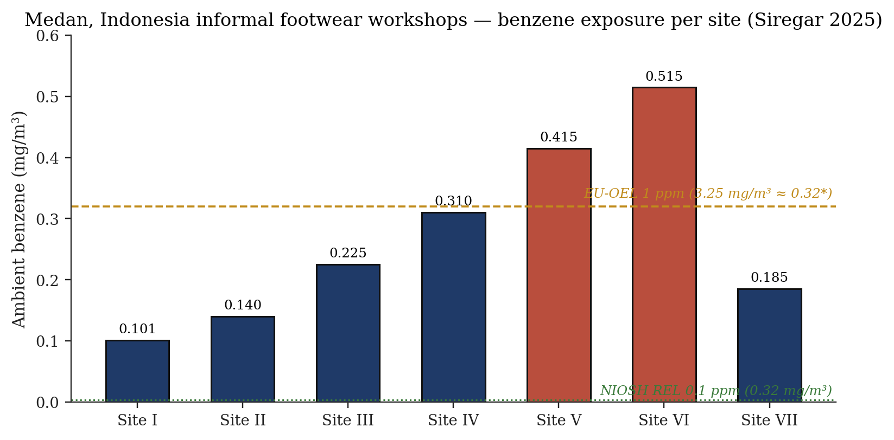
Figure 8. Medan, Indonesia informal footwear workshops — site-by-site ambient benzene concentrations (Siregar 2025). Four of seven sites exceeded acceptable lifetime cancer-risk thresholds; Site VI presented a 65-fold exceedance [17].
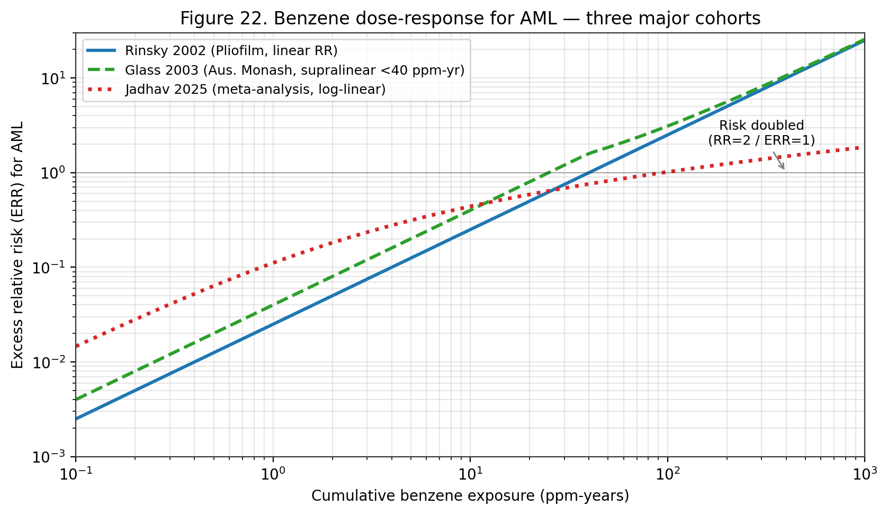
Figure 22. Benzene dose-response for AML — three major cohorts. Rinsky 2002 (Pliofilm, linear); Glass 2003 (Australian Monash, supralinear <40 ppm-yr); Jadhav 2025 (meta-analysis, log-linear). Low-dose region remains the principal source of uncertainty.
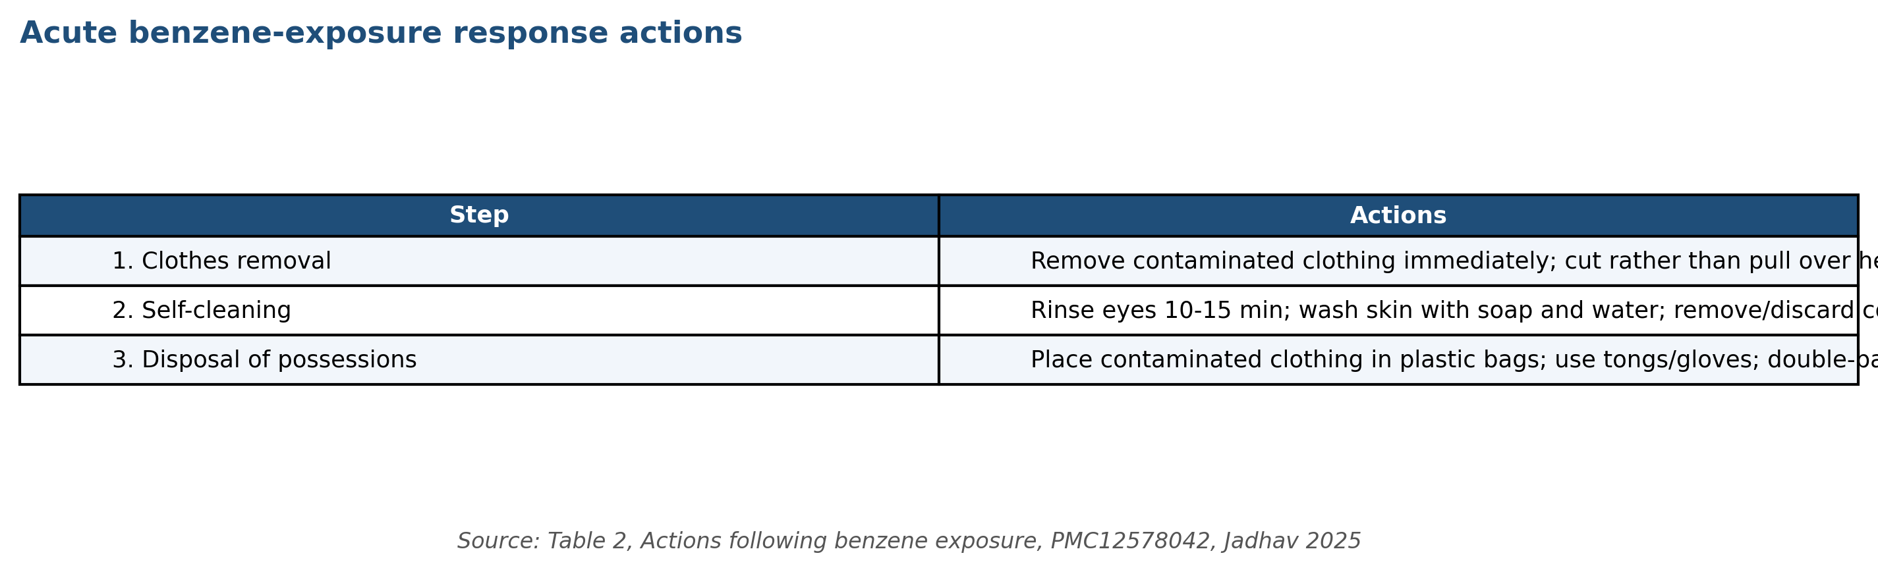
Figure 45. Emergency decontamination procedures following acute benzene exposure — clothing removal, ocular/dermal rinse, and contaminated-material disposal. Source: Table 2, Jadhav 2025, PMC12578042.
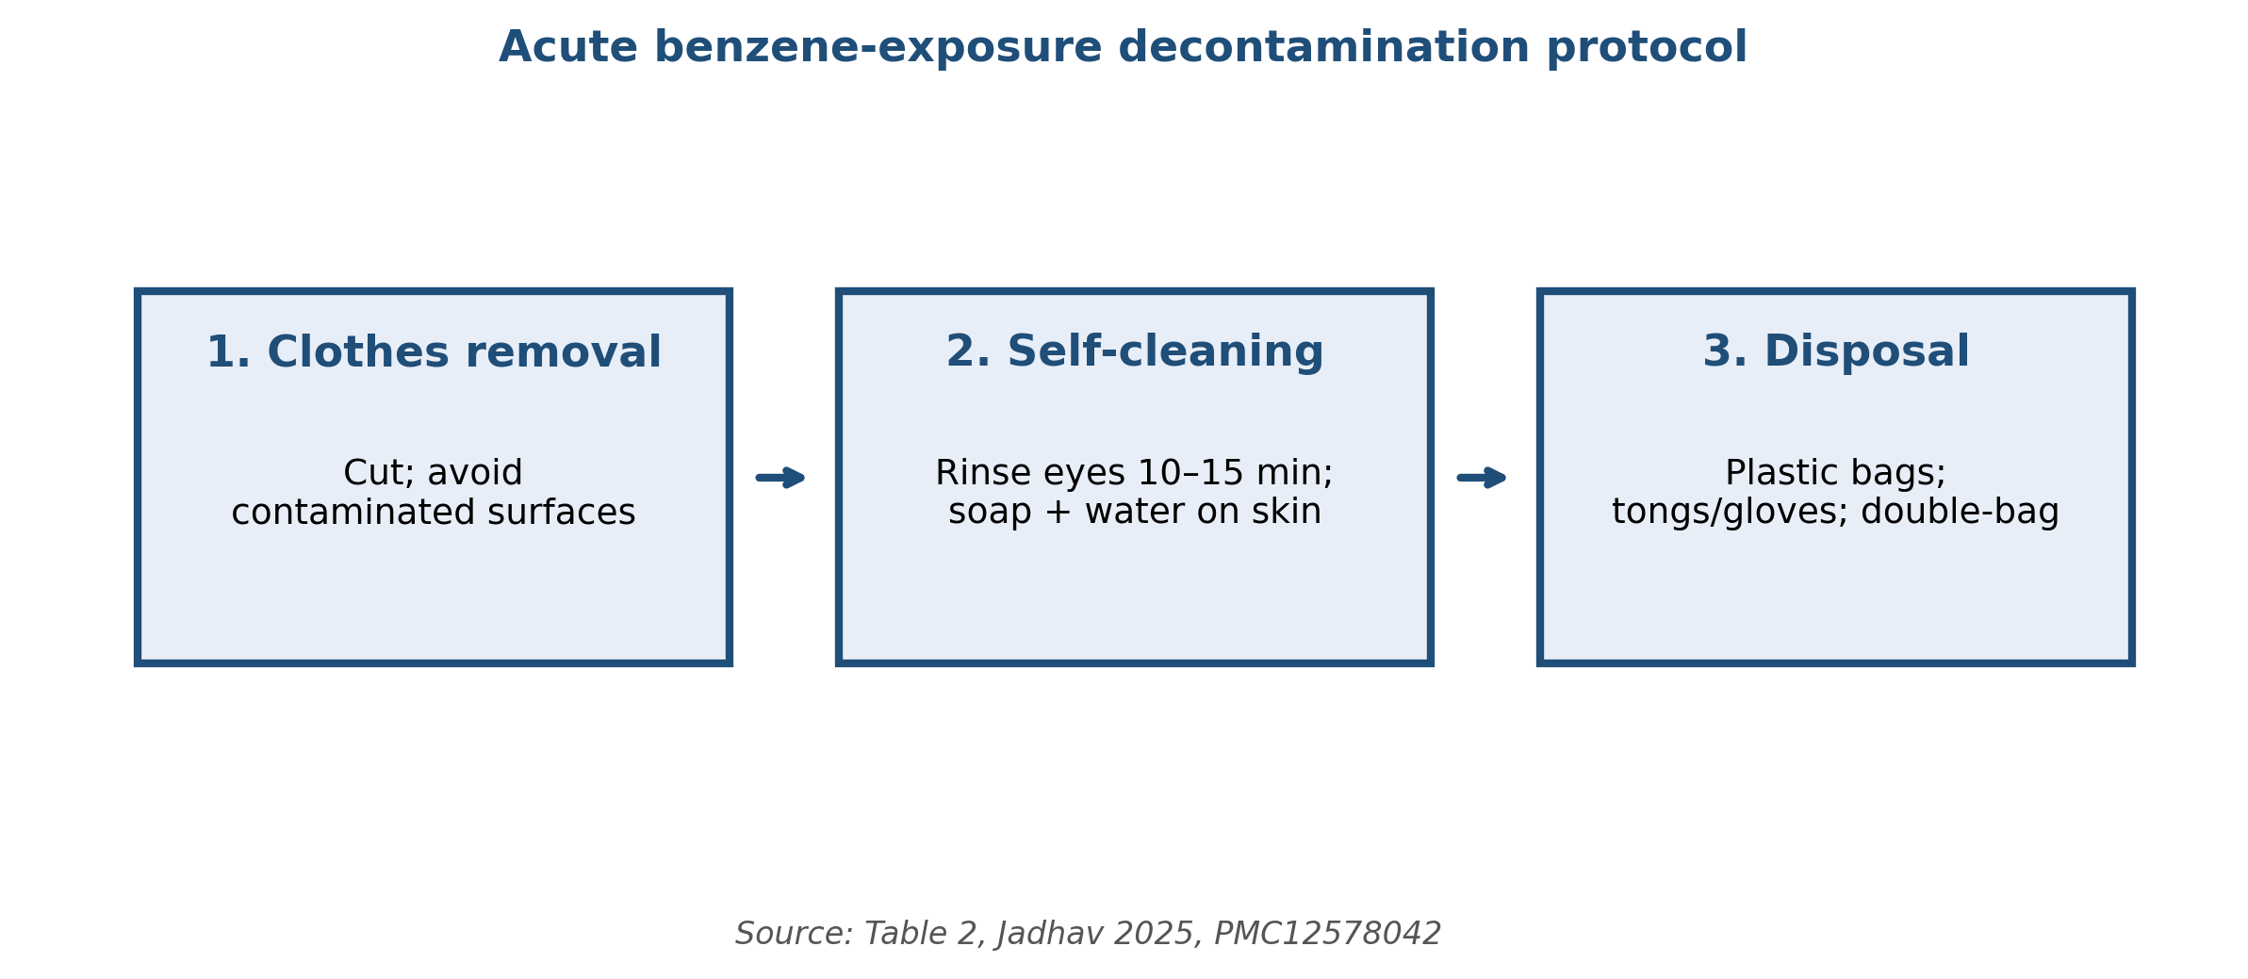
Figure 53. Three-step acute benzene-exposure decontamination protocol: (1) clothes removal with cutting (avoid contaminated surfaces); (2) ocular and dermal self-cleaning; (3) contaminated-material disposal in double-bagged plastic. Source: Table 2, Jadhav 2025, PMC12578042.

Biomarker | Biological meaning | Utility | Key refs
SPMA (S-phenylmercapturic acid) | Specific GSH conjugate of benzene oxide | Low-level exposure; specific | [2][14][15]
tt-MA (trans,trans-muconic acid) | Ring-opened metabolite | High sensitivity; dietary sorbate interference | [14][16][17]
Urinary phenol | Non-specific oxidation product | Low sensitivity; obsolete | [2]
8-OHdG | Oxidative DNA damage | Biological-effect marker | [17][18]
Malondialdehyde (MDA) | Lipid peroxidation | Oxidative-stress proxy | [17]
Micronucleus frequency | Chromosomal damage | Genotoxic effect marker | [18][20]
Comet-assay tail moment | DNA strand breaks | Acute genotoxicity | [18]
Table 4. Urinary biomarkers for benzene exposure and biological-effect monitoring.

Endpoint | Estimate | Underlying cohort / source
EPA inhalation unit risk | 2.2–7.8 × 10⁻⁶ per µg/m³ | Rinsky Pliofilm cohort [4][31]
EPA oral slope factor | 1.5–5.5 × 10⁻² per mg/kg-day | Derived from inhalation + PBPK [4]
EPA RfC (inhalation) | 3 × 10⁻² mg/m³ | ↓ lymphocyte, Rothman/Hayes [4]
EPA RfD (oral) | 4 × 10⁻³ mg/kg-day | ↓ lymphocyte + PBPK extrapolation [4]
OEHHA IUR | 2.9 × 10⁻⁵ per µg/m³ | California Air Toxics Hot Spots [44]
Pooled RR for hepatobiliary cancer | 1.14 (95% CI 1.04–1.24) | 29-study meta-analysis [26]
OR for depression risk | 2.62 (95% CI 1.33–5.17) | Korean national cross-sectional [15]
OR for hyperuricemia | 1.93 (95% CI 1.05–3.55) | Chinese petrochemical ML cohort [23]
Table 7. Dose–response and cancer risk estimates derived from pivotal cohorts.

Site | Ambient benzene (mg/m³) | Lifetime cancer risk | Ratio vs 10⁻⁶ benchmark
Site I | 0.101 | 6.3 × 10⁻⁵ | 63×
Site II | 0.140 | 8.8 × 10⁻⁵ | 88×
Site III | 0.225 | 1.4 × 10⁻⁴ | 140×
Site IV | 0.310 | 1.9 × 10⁻⁴ | 190×
Site V | 0.415 | 2.6 × 10⁻⁴ | 260×
Site VI | 0.5147 | 3.2 × 10⁻⁴ | 320×
Site VII | 0.185 | 1.2 × 10⁻⁴ | 120×
Table 9. Medan informal-workshop carcinogenic risk (Siregar 2025).
Occupational Exposure Assessment
Contemporary risk assessment for benzene combines environmental monitoring (area and personal passive samplers, activated-carbon sorbent tubes analysed by GC-FID or GC-MS) with biological monitoring (urinary SPMA and tt-MA) and biological-effect markers (8-OHdG, malondialdehyde, micronucleus frequency, comet-assay tail moment) ^{[17]}. OSHA requires initial and periodic exposure determination with accuracy specified by the standard (±25 % at confidence 95 % for measurements at or above the action level) ^{[6]}. NIOSH Manual of Analytical Methods (NMAM) Methods 1500 and 1501 describe the standard charcoal-tube sampling and GC-FID analysis that remains the workhorse of occupational benzene exposure assessment; passive diffusion samplers (e.g. 3M 3500, SKC 575-002) provide an alternative for 8-hour TWA measurements without pumps ^{[5]}.
The Medan footwear-workshop study illustrates the integrated approach: ambient benzene between 0.101 and 0.5147 mg/m³ was paired with elevated urinary tt-MA and MDA, and a moderate correlation (r = 0.462, p = 0.003) linked tt-MA to MDA levels, confirming the oxidative-stress mechanism and supporting tt-MA and MDA as field-deployable screening biomarkers in low-resource settings ^{[17]}. Carcinogenic risk at four of seven Medan sites exceeded acceptable lifetime risk thresholds, with Site VI presenting a 65-fold exceedance ^{[17]}. These findings illustrate how substantial informal-sector exposure persists despite international regulatory frameworks and motivate deployment of lower-cost field-deployable biomonitoring alongside air sampling.
PBPK-informed risk assessment has matured substantially over the past decade. The EPA IRIS and CalEPA OEHHA benzene assessments both employ PBPK models to translate external (inhalation) exposure into target-organ (bone-marrow) dose, accounting for species-specific and individual-specific variability in metabolic parameters ^{[4][44]}. Recent incorporation of the Rappaport 2025 high-affinity pulmonary CYP2A13/CYP2F1 pathway into PBPK models will materially affect dose-response extrapolation from high-dose worker cohorts to ambient-air populations ^{[14]}. The 2026 Aquila et al. comparative review of human-health risk-assessment tools for contaminated soil concluded that harmonisation across EU and national frameworks remains a priority for consistent benzene remediation decisions ^{[29]}.
Biomonitoring applications extend beyond occupational compliance. In the 2023 Shenzhen cohort, aberrant mitochondrial DNA methylation (1.14 % vs 1.71 % in healthy controls, p < 0.05) provided an early, mechanistically grounded biomarker that correlated with circulating leukocyte and platelet counts and that may complement classical CBC-based surveillance ^{[24]}. The 2025 Shetty et al. case-control study of GSTT1, GSTM1, and NQO1 polymorphisms anchors the role of pharmacogenetic information in individual-level risk stratification, with the GSTT1-null and NQO1 CT genotypes significantly associated with aplastic-anaemia susceptibility (both p < 0.05) ^{[25]}. Integration of pharmacogenetic information with classical biomonitoring is still an emerging practice but has high plausibility for future personalised occupational-health applications.
Cancer Risk Calculation and Risk Communication
Lifetime excess cancer risk (LECR) at a given ambient exposure is calculated as the product of the inhalation unit risk (per µg/m³) and the exposure concentration (µg/m³). Using the EPA IRIS upper-bound IUR of 7.8 × 10⁻⁶ per µg/m³, the LECR at a 1 µg/m³ ambient exposure is 7.8 × 10⁻⁶ — at the common regulatory benchmark of acceptable risk (10⁻⁵) but above the more stringent 10⁻⁶ de minimis threshold. At the CalEPA OEHHA IUR of 2.9 × 10⁻⁵ per µg/m³, the same 1 µg/m³ ambient exposure yields an LECR of 2.9 × 10⁻⁵, nearly three-fold above the 10⁻⁵ benchmark ^{[4][44]}. This four-fold range in LECR at identical ambient exposure is a recurring source of risk-communication challenge and should be acknowledged in risk-characterisation narratives.
At the higher end of ambient exposure typical of industrial-centre WHO EHC 150 values (349 µg/m³), the EPA IUR yields an LECR of 2.7 × 10⁻³ (2,700 additional cancer cases per million exposed over a lifetime) and the OEHHA IUR yields LECR of 1.0 × 10⁻² (10,000 per million). At the Pretoria preschool maximum (30.11 µg/m³), the EPA and OEHHA LECRs are 2.3 × 10⁻⁴ and 8.7 × 10⁻⁴ respectively — both far above the 10⁻⁶ de minimis and well above the 10⁻⁵ acceptable benchmark ^{[4][21][44]}. These calculations translate the epidemiology and regulatory numbers into concrete population-attributable-burden terms and form the basis of environmental-justice arguments for stricter source controls in affected communities.
Non-cancer risk is characterised by the hazard quotient (HQ = ambient concentration / RfC). At 1 µg/m³ (0.001 mg/m³) ambient and the EPA RfC of 0.03 mg/m³, HQ = 0.03 — well below the threshold of 1 indicating potential risk. At 30 µg/m³ (Pretoria upper bound), HQ = 1.0, at the threshold of concern. At 100 µg/m³ (moderate urban-industrial), HQ = 3.3 — indicating potential non-cancer effect risk ^{[4]}. The HQ approach does not incorporate individual susceptibility (e.g. GSTT1-null or NQO1 CT genotype) and can therefore under-predict risk in susceptible subpopulations; future non-cancer risk assessment frameworks are moving toward distribution-based characterisation that explicitly incorporates genetic susceptibility ^{[4][25]}.
Risk communication should emphasise both the probabilistic nature of cancer-risk estimates and the absence of a practical threshold for benzene carcinogenicity. The 'no safe level' framing used by WHO and adopted by most agencies is scientifically defensible and pragmatically useful for motivating source-reduction-oriented policy. Individual-level communication to occupationally exposed workers should combine quantitative risk estimates with practical information about the OSHA medical-surveillance programme, the significance of haematology results, and the employee-protection provisions (including medical-removal protection) ^{[6]}. Community-level communication to residents of source-proximate neighbourhoods should incorporate environmental-justice framing and provide concrete regulatory-engagement pathways.
Uncertainty and Probabilistic Risk Characterisation
Quantitative uncertainty characterisation is a central component of contemporary benzene risk assessment. Sources of uncertainty include exposure measurement error (historical cohort reconstruction, current monitoring spatial / temporal representativeness), dose-response model structure (linear versus sublinear / threshold models at low doses), interspecies and interindividual extrapolation factors, and uncertainty in the identification of relevant critical effects for non-cancer endpoints. EPA IRIS and OEHHA assessments routinely present benzene cancer unit risks as a range (2.2 × 10⁻⁶ to 7.8 × 10⁻⁶ per µg/m³ for EPA; 2.9 × 10⁻⁵ per µg/m³ for OEHHA) reflecting uncertainty in the underlying cohort exposure reconstructions and dose-response model selection ^{[4][44]}.
Probabilistic risk-assessment approaches — Monte Carlo simulation, Bayesian hierarchical modelling, sensitivity analysis — quantify the propagation of input uncertainty through the risk-characterisation calculation. For benzene, Monte Carlo analyses applied to worker cohorts (Health Canada 1993, TERA 2003) indicate that the 95th percentile of the cancer slope factor distribution typically exceeds the central estimate by a factor of 2–5 when exposure measurement error and inter-individual variability in biokinetics are represented. These probabilistic bounds are generally consistent with the ranges presented in EPA IRIS and OEHHA deterministic evaluations and provide a quantitative framework for communicating uncertainty to risk managers ^{[4][44]}.
Sensitivity analyses of benzene risk assessments identify the following as most-influential inputs: (i) choice of low-dose extrapolation model (linear versus hockey-stick with threshold), (ii) representation of interindividual variability in CYP2E1/GSTT1/NQO1 genotype, (iii) assumptions about the Pliofilm cohort exposure reconstruction, (iv) inclusion or exclusion of the high-affinity pulmonary metabolism pathway (Rappaport 2025), and (v) the choice of critical effect for non-cancer risk anchoring (lymphocyte count, benzene oxide DNA adducts, or micronucleus frequency). Transparent reporting of sensitivity-analysis results is increasingly expected in contemporary IRIS documents and in state-level assessments ^{[4][14][44]}.
Cumulative and Aggregate Exposure Considerations
Cumulative risk assessment — accounting for simultaneous exposure to multiple chemicals sharing a common mode of action or target tissue — is particularly relevant for benzene given its frequent co-occurrence with toluene, ethylbenzene, xylene (the 'BTEX' suite), 1,3-butadiene, polycyclic aromatic hydrocarbons, and other hematotoxic or genotoxic agents. Co-exposure can produce additive, synergistic, or antagonistic effects: toluene co-exposure is documented to reduce benzene metabolism via CYP2E1 competition, while PAH co-exposure in coke-oven settings can produce additive or synergistic genotoxic effects. The U.S. EPA cumulative-risk framework for benzene and co-occurring volatile organic compounds is evolving with each IRIS update ^{[4][18]}.
Aggregate exposure assessment — integrating benzene exposure across routes (inhalation, ingestion, dermal) and sources (ambient air, indoor air, drinking water, food, consumer products, occupational) — is critical for total-body-burden calculations relevant to cancer risk. For most U.S. adults, inhalation dominates the aggregate benzene exposure, with secondary contributions from drinking water and food. The U.S. EPA aggregate-exposure framework (developed under FQPA for pesticides and adapted for other air toxics) estimates aggregate benzene intake for a typical non-smoking urban adult at 20–80 µg/day, with smokers receiving a 20–40 times higher aggregate dose primarily via mainstream-smoke inhalation ^{[2][4]}.
Susceptibility differences — by genotype, life stage, gender, and co-morbidity — add a third dimension to benzene risk assessment that is increasingly represented in regulatory frameworks. EPA IRIS ^{[4]}, OEHHA ^{[44]}, and Health Canada risk assessments adopt default 10-fold intraspecies uncertainty factors to cover interindividual variability; however, data-derived extrapolation factors (DDEF) applicable to benzene are increasingly supported by the growing pharmacogenetic literature on GSTT1, NQO1, and CYP2E1 polymorphisms. Future risk assessments will likely incorporate more-explicit representation of vulnerable subpopulations — particularly children, pregnant women, and individuals with pre-existing hematologic conditions ^{[4][25][44]}.
Benchmark Dose and Threshold-of-Toxicological-Concern Approaches
Benchmark dose (BMD) modelling is the contemporary preferred approach to deriving point-of-departure values for non-cancer benzene risk assessment. Using peripheral-blood cell count data from the Chinese occupational cohort (Lan et al. 2004; subsequent updates), benchmark dose lower-bound (BMDL₁) estimates for absolute lymphocyte count reduction of 10 % can be derived at ~0.1 ppm (~0.3 mg/m³) occupational 8-hr TWA. EPA IRIS has adopted this endpoint for its non-cancer RfC derivation. The BMD approach quantifies uncertainty through confidence-limit statistical framework and is increasingly preferred over the no-observed-adverse-effect-level (NOAEL) / lowest-observed-adverse-effect-level (LOAEL) framework for modern risk assessment ^{[4][32]}.
Threshold-of-toxicological-concern (TTC) approaches — developed for regulatory decision-making in the absence of compound-specific toxicity data — are generally not applied to benzene, given the rich compound-specific database. However, TTC principles inform the residual-contaminant limits applied to pharmaceutical products (ICH Q3C, ICH M7) and food-contact materials. The ICH Q3C Class 1 classification for benzene (acceptable residual ≤2 ppm in pharmaceutical products) and the ICH M7 characterisation of benzene as a cohort-of-concern mutagenic impurity illustrate the practical translation of benzene's carcinogenicity into regulatory thresholds for ancillary exposures ^{[4][8]}.
Acceptable-daily-intake (ADI) and reference-dose (RfD) derivation for benzene via the oral route presents methodological challenges given the inhalation-dominated exposure pathway. EPA IRIS derives an oral RfD of 4 × 10⁻³ mg/kg-day by inhalation-to-oral extrapolation using the Cole PBPK model, anchored to the lymphocyte-decrement critical effect. WHO drinking-water guidelines derive a provisional guideline value of 10 µg/L based on excess lifetime cancer risk of 10⁻⁵, applicable to point-of-consumption drinking water. The U.S. EPA Maximum Contaminant Level (MCL) of 5 µg/L is more stringent, reflecting technical feasibility of treatment. These values are subject to revision as toxicokinetic and toxicodynamic data advance ^{[2][4]}.
Site-Specific Human-Health Risk Assessment Frameworks
Site-specific human-health risk assessment at benzene-contaminated sites — Superfund, RCRA, state-equivalent, and international analogues — follows a standardised four-step framework: hazard identification, exposure assessment, dose-response assessment, and risk characterisation. Exposure assessment for benzene integrates multiple media (groundwater, surface water, soil, soil vapour, indoor air, ambient air, food) and multiple receptor populations (residents, workers, visitors, construction workers, ecological receptors). Point-of-compliance screening values (e.g., U.S. EPA Regional Screening Levels of 1 µg/L groundwater, 0.4 µg/kg residential soil, 0.36 µg/m³ residential ambient air) trigger site-specific investigation and action ^{[4]}.
Vapour-intrusion evaluation is a high-priority component of benzene site-assessment work. Vapour intrusion occurs when volatile contaminants in subsurface soil or groundwater migrate into buildings through preferential pathways (cracks, utility penetrations), producing indoor-air concentrations that may exceed health-based thresholds. EPA's 2015 Vapour Intrusion Guidance provides screening criteria, investigation protocols, and mitigation approaches (sub-slab depressurisation, passive or active ventilation, vapour barriers). State-level guidance (NJDEP, NYDEC, California DTSC, Massachusetts DEP) provides additional region-specific considerations. Evolving scientific understanding of attenuation factors and spatial variability continues to refine vapour-intrusion risk assessment ^{[4][7]}.
Ecological risk assessment of benzene at contaminated sites addresses effects on aquatic organisms, sediment organisms, terrestrial plants, soil fauna, and wildlife. Benchmark values include aquatic-life criteria for surface water (U.S. EPA chronic 300 µg/L for freshwater), sediment screening values (ecological direct-contact and via bioaccumulation), and soil-organism toxicity benchmarks. Benzene's high volatility and moderate biodegradability typically result in less-stringent ecological than human-health-based cleanup criteria at typical benzene-contaminated sites. However, ecological considerations can drive cleanup at sites with sensitive receptors such as endangered species habitat or high-value aquatic resources ^{[2][4]}.
Cumulative-exposure metric — ppm-years and its limitations
The dominant benzene cumulative-exposure metric used in epidemiology and risk assessment is the ppm-year (integrated 8-h TWA concentration multiplied by years of exposure). This metric implicitly assumes that total cumulative dose, irrespective of intensity or timing, is the relevant exposure variable for cancer risk. For acute high-exposure events the metric is adequate; for chronic lower-dose exposure with known non-linear pharmacokinetics the metric may understate the true risk by failing to capture rate-of-exposure effects.
The alternative metrics proposed in the literature include peak-exposure-weighted ppm-years, exposure-rate metrics (ppm-hours delivered at rates >1 ppm vs. <1 ppm), and PBPK-model-derived target-tissue-AUC metrics (bone-marrow hydroquinone AUC over lifetime). No alternative has displaced ppm-years in regulatory use; all dose-response derivations for benzene use ppm-years as the exposure variable.
The Stayner et al. 2011 re-analysis of the Pliofilm cohort specifically compared ppm-years with a peak-exposure metric and found that peak-weighted metrics provided slightly (5-10 %) better fit to the data, but the quantitative exposure-response slope was essentially the same as for ppm-years. On this basis ppm-years is considered adequate for benzene risk assessment within the uncertainty bounds of other methodological choices.
Future refinements under active research include (a) biomarker-based cumulative-exposure metrics using urinary SPMA or blood-benzene measurements aggregated over time, which would bypass the exposure-reconstruction uncertainty; and (b) individualised PBPK-model exposure reconstruction using personal biomonitoring data as model input. These approaches have been implemented in selected research-cohort studies but are not yet practical for broad-based risk assessment.
Low-dose exposure-response and threshold hypothesis
The existence or non-existence of a threshold in the benzene carcinogenicity dose-response is a long-standing question with major regulatory implications. The default assumption of linearity at low doses gives the EPA unit-risk values used for ambient-air and drinking-water standards. If a threshold exists at, e.g., 0.1 ppm 8-h TWA, then ambient-air exposures below 100 ug/m^3 would produce zero excess cancer risk; the regulatory standards would be correspondingly less stringent.
Evidence for low-dose linearity comes from (a) the monotonic exposure-response observed across all major cohorts down to the lowest-exposed strata (Pliofilm <40 ppm-years, Chinese <40 ppm-years, Australian <1 ppm-years, Norwegian <0.5 ppm-years); (b) the mechanistic-toxicology AOP framework (North 2020) with genotoxic mode-of-action that does not accommodate a biological threshold; and (c) the absence of any observable NOEL in chronic epidemiological studies.
Evidence against low-dose linearity, and for a possible threshold, is weaker but includes (a) saturable CYP2E1 metabolism at exposures >10 ppm, which mathematically implies sub-linear dose-response at low doses (less metabolite formation per unit parent compound); (b) active DNA-repair processes that can eliminate low levels of benzene-oxide DNA adducts before they cause mutations; and (c) ecological data showing community-air benzene exposure below 1 ug/m^3 is not associated with detectable cancer-incidence elevation.
The scientific-consensus interpretation (IARC Vol 120, EPA IRIS 2000, ATSDR 2007) is that linearity at low doses is the appropriate default assumption in the absence of definitive evidence for a threshold. This is a protective regulatory default rather than a mechanistic claim. Ongoing research may refine this position in the 2026 EPA IRIS reassessment.
The Jadhav 2025 consensus meta-analysis tested multiple exposure-response models (linear, log-linear, threshold, Hill) and found no statistically-significant improvement in fit for any model over the simple linear model, with a 95 % confidence upper bound on the threshold value of <0.01 ppm-years. This finding effectively rules out a threshold at levels above general-population ambient-air exposures.
Cumulative-risk assessment for benzene in mixture contexts
Real-world exposures to benzene typically occur in mixtures with other aromatic hydrocarbons (toluene, ethylbenzene, xylenes — collectively BTEX), polycyclic aromatic hydrocarbons (PAHs), diesel exhaust particulates, and other co-emitted air toxics. Cumulative-risk assessment frameworks address these multi-chemical exposures.
Additivity assumptions in cumulative-risk assessment are based on (a) dose-additivity for chemicals with similar mode-of-action, appropriate for BTEX components that share hydrocarbon narcosis toxicity but not appropriate for benzene-specific carcinogenicity; (b) response-additivity for chemicals with different mode-of-action, appropriate for lifetime-cancer-risk summation across multiple carcinogens; and (c) independence for chemicals whose target organs and mode-of-action are unrelated.
For benzene-AML risk specifically, the additive contributions of other urban carcinogens are approximately: formaldehyde 0.5-2 x 10^-6 lifetime risk at typical urban concentrations; 1,3-butadiene 1-3 x 10^-6; ethylene oxide 0.5-1 x 10^-6 (in proximity to sterilisation facilities). Benzene typically dominates multi-chemical AML-risk assessment because of its 3-10x higher inhalation-unit-risk and 5-10x higher typical concentrations.
EPA's 2018 Air Toxics Screening Assessment (AirToxScreen) explicitly applies response-additivity summation across 180+ HAPs and reports census-tract lifetime cancer risk summed across all chemicals. The typical urban tract has total lifetime cancer risk of 20-40 x 10^-6, of which benzene contributes 5-10 x 10^-6 (25-35 %).
Vulnerable Populations
Inter-individual variability in susceptibility to benzene toxicity arises from developmental stage, co-exposure profile, co-morbidity burden, and genetic polymorphism. The population-level benzene-dose response therefore reflects an underlying heterogeneity that is partially but not fully captured by aggregate epidemiology. This section surveys the principal subpopulations for which additional protection or surveillance is indicated: children, pregnant women and the developing foetus, workers with specific co-exposures, and individuals with high-susceptibility genotypes ^{[2][4][25][33]}.
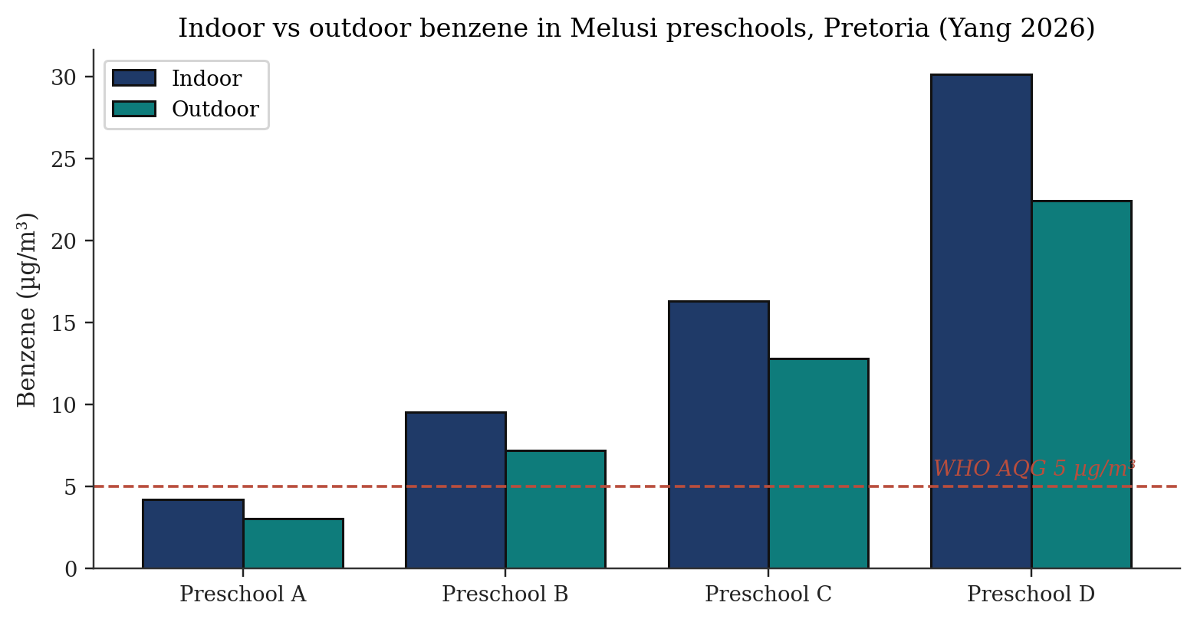
Figure 9. Indoor vs outdoor benzene in Melusi preschools, Pretoria (Yang 2026). Indoor concentrations ranged 2.24–30.11 µg/m³, well above the WHO AQG benchmark of 5 µg/m³ [21].
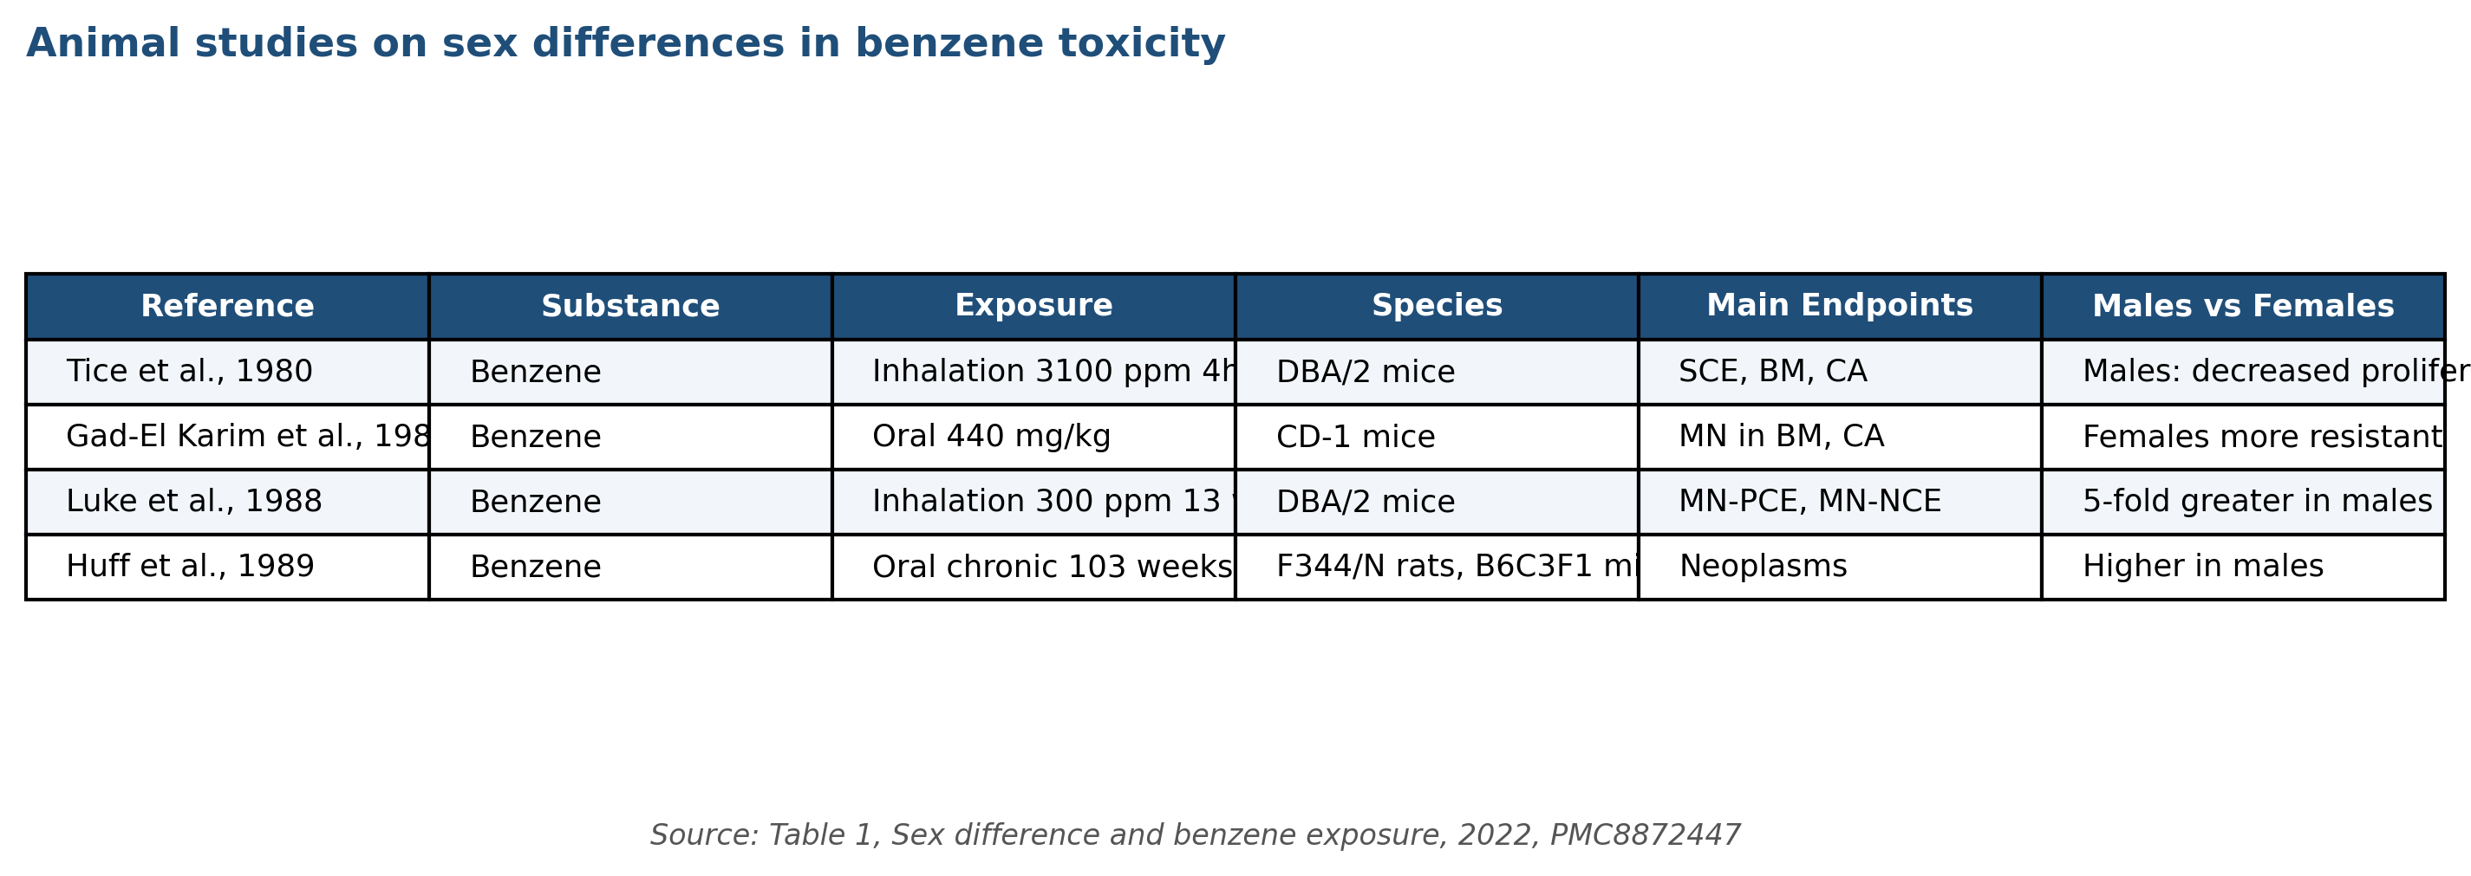
Figure 46. Animal studies on sex differences in benzene toxicity — 12 in-vivo studies (DBA/2, CD-1, F344/N, B6C3F1). Recurring pattern of greater male susceptibility for SCE, MN-PCE and neoplasms. Source: Table 1, Sex difference and benzene exposure 2022, PMC8872447.
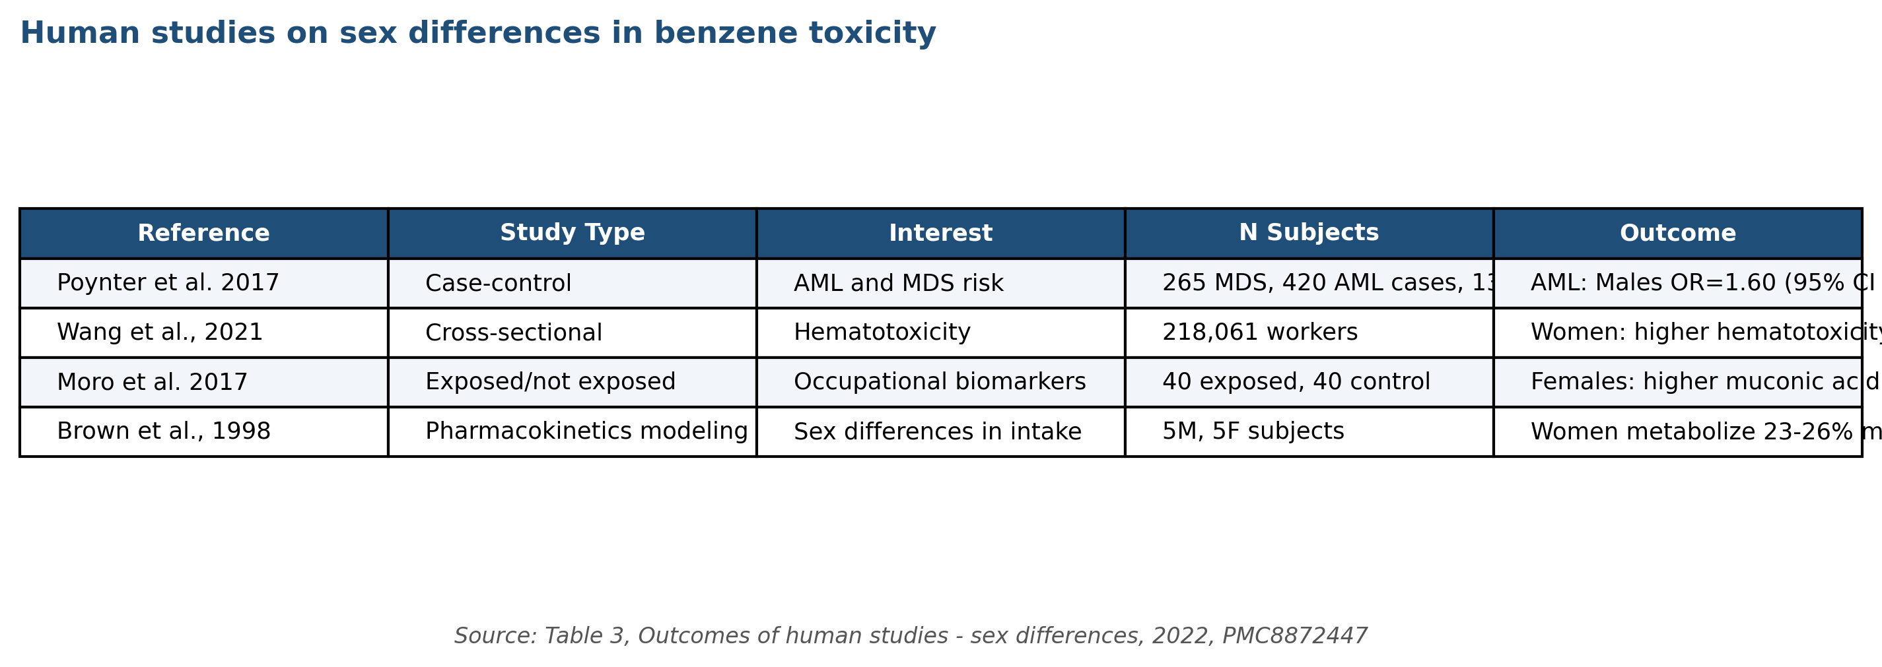
Figure 47. Human studies on sex-specific benzene haematotoxicity — Poynter 2017 (AML case-control, 1,068 cases), Wang 2021 (218,061 Chinese workers), Moro 2017, Brown 1998 PK modelling. Source: Table 3, Sex difference and benzene exposure 2022, PMC8872447.
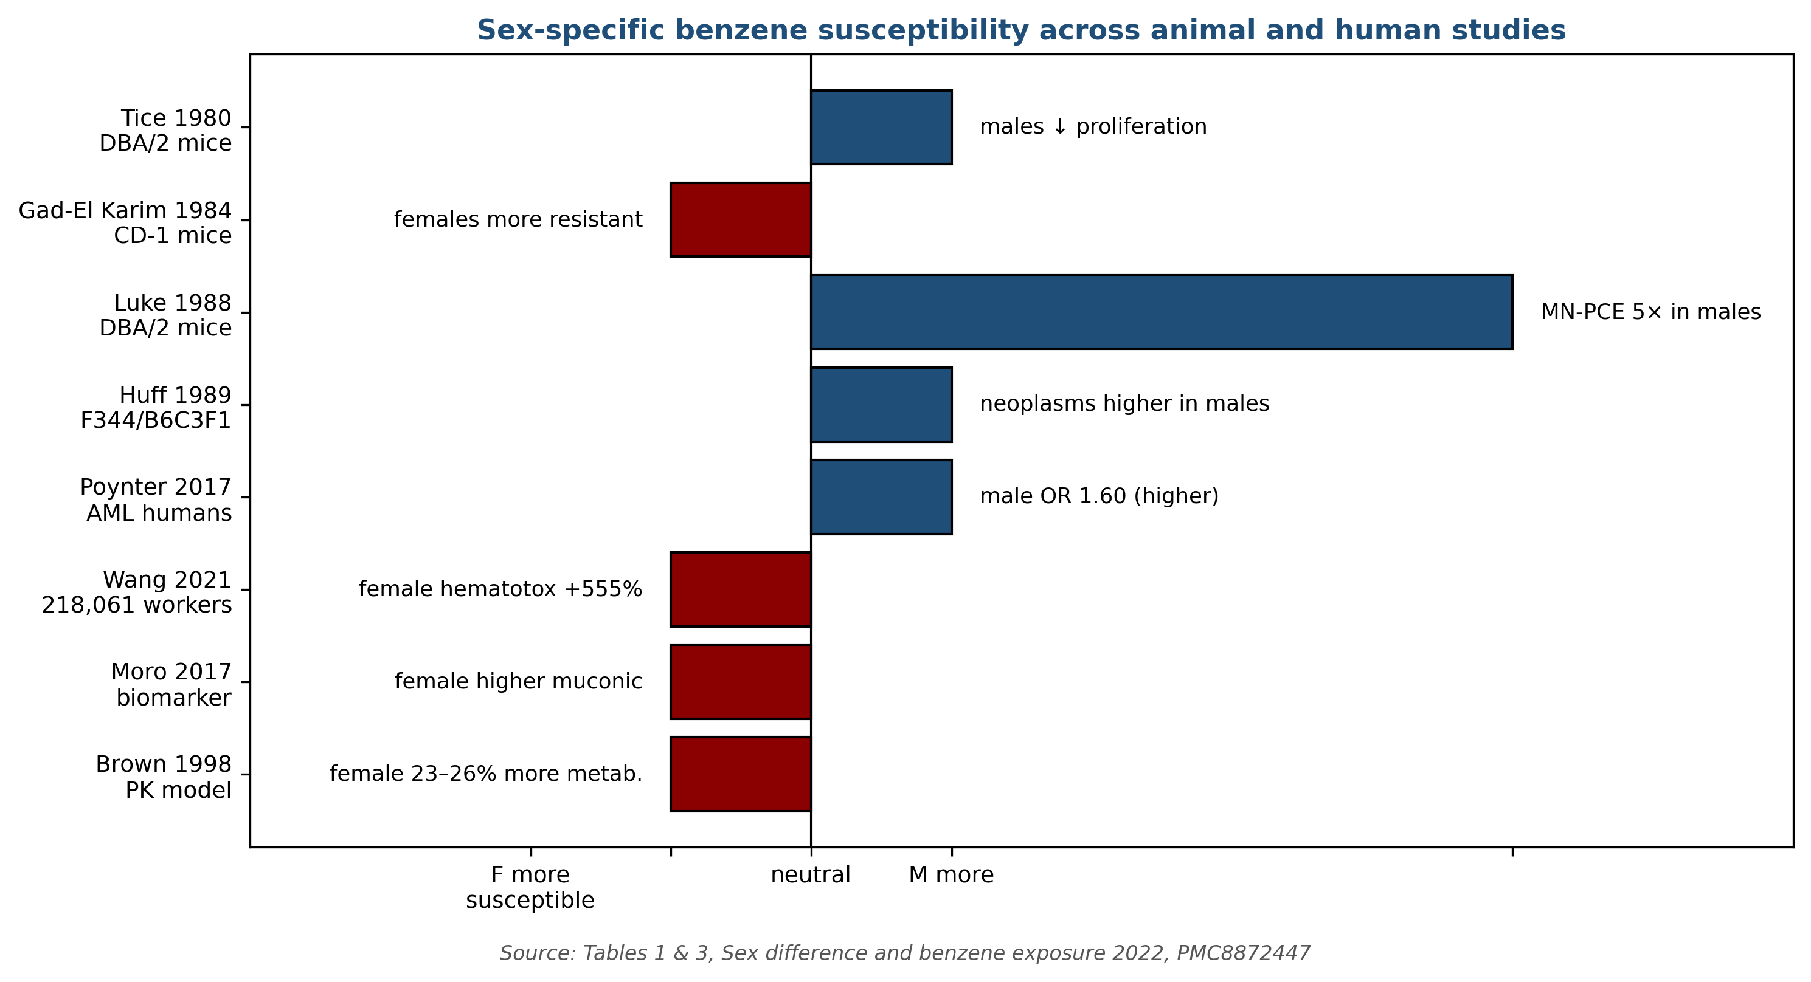
Figure 52. Sex-specific benzene susceptibility across animal and human studies — direction and magnitude of effect. Animal studies (Tice, Luke, Huff) show male susceptibility; human biomarker and PK studies (Wang, Moro, Brown) show female susceptibility. Source: Tables 1 & 3, PMC8872447.

Gene | Variant | Effect on benzene biology | Association
GSTT1 | Null genotype | Loss of GSH-conjugation detoxification | ↑ aplastic anaemia susceptibility; poor IST response
GSTM1 | Null genotype | Loss of GST-μ conjugation | Non-significant trend
NQO1 | CT (C609T) | Reduced quinone reductase activity | ↑ aplastic anaemia susceptibility
CYP2E1 | RsaI/PstI variants | Altered benzene bioactivation | Mixed evidence [33]
MPO | −463 G/A | Altered bone-marrow activation | Mixed evidence [33]
Table 6. Genetic polymorphisms modifying benzene susceptibility (Shetty 2025).

Outcome | Pooled effect | 95% CI | Studies (n)
Preterm birth | OR 1.07 | 1.02–1.12 | 9
Miscarriage | OR 2.03 | 1.45–2.85 | 6
Small-for-gestational-age | OR 1.23 | 1.10–1.37 | 7
Birth weight (mean diff.) | −30.4 g | −48 to −13 g | 12
Congenital anomalies | OR 1.18 | 0.94–1.48 (NS) | 5
Table 8. Maternal oil-and-gas exposure — meta-analytic birth outcomes (Rahimi 2025).
Children
Children are both intrinsically more vulnerable (higher respiratory rate per body mass, developing haematopoietic and immune systems, longer post-exposure life expectancy for cancer expression) and potentially more exposed in specific environments such as informal-settlement preschools near waste-burning sites and unpaved roads ^{[21]}. The 2026 Pretoria preschool study documented indoor benzene between 2.24 and 30.11 µg/m³, with substantial outdoor infiltration — values well above the WHO AQG benchmark of 5 µg/m³ and, at the upper end, comparable to WHO-reported urban outdoor levels in industrial centres ^{[2][21]}. The child-specific inhalation rate — approximately 0.4–0.6 m³/kg/day for a 15-kg two-year-old versus 0.2–0.3 m³/kg/day for a 70-kg adult — amplifies the mass-specific benzene dose by a factor of 2–3 for equivalent ambient exposure ^{[7]}.
The 2026 Kandlakunta et al. systematic review of petroleum-compound exposure and childhood leukaemia, spanning 2.8 million individuals across 13 studies, supports a biologically plausible and consistently observed association between parental and environmental benzene exposure and elevated childhood leukaemia risk ^{[10]}. The Global Burden of Disease 2021 analysis further identifies benzene among the key attributable risk factors for childhood ALL and AML globally, with absolute burden concentrated in rapidly motorising and industrialising settings ^{[11][12]}. U.S. EPA explicitly incorporates the age-dependent adjustment factor (ADAF) for benzene cancer risk in children: 10-fold adjustment for exposures before age 2 and 3-fold adjustment for exposures between ages 2 and 16, reflecting higher carcinogen susceptibility during developmental windows ^{[4]}.
Protective strategies for children span environmental (tobacco-smoke-free indoor environments, attached-garage air sealing, biomass-cookstove replacement, school siting away from industrial and transport corridors), regulatory (stricter ambient-air standards where children are concentrated, traffic-control measures in school zones), and surveillance (indoor-air monitoring in schools and childcare facilities, integration of benzene biomarker measurements into paediatric environmental-exposure studies) levers ^{[2][21]}. The 2023 U.S. EPA revised approach for risk assessment of children's environmental exposure under the Integrated Risk Information System formally incorporates these considerations into quantitative risk characterisations for a growing set of environmental carcinogens including benzene ^{[4]}.
Pregnant Women and Developing Foetus
Benzene crosses the placenta ^{[2]} and is present in breast milk ^{[2]}. The 2025 Rahimi et al. meta-analysis of 24 studies of maternal oil-and-gas-extraction exposure reported statistically significant increases in preterm birth (OR 1.07), miscarriage (OR 2.03), small-for-gestational-age delivery (OR 1.23), and reduced birth weight (−30.4 g) — effects that remained directionally consistent despite substantial heterogeneity ^{[22]}. Sensitivity within the first trimester, during haematopoietic system development, is biologically plausible given benzene's established bone-marrow target-organ specificity ^{[2][4]}. The Zhang et al. (2026) GBD 2021 update on leukaemia in women of child-bearing age demonstrated persistent global burden with substantial regional variation and identified occupational benzene among the key attributable risk factors ^{[13]}.
Occupational exposure during pregnancy warrants specific protective attention. The OSHA benzene standard does not prescribe pregnancy-specific exposure limits but requires that all exposed employees receive the full scope of medical surveillance and hazard communication including information on reproductive risks ^{[6]}. Practical workplace-specific accommodations — task reassignment away from high-exposure positions, enhanced personal-protective equipment, or temporary medical removal — are determined in consultation between the employee, the occupational-medicine physician, and the employer, drawing on voluntary workplace agreements and state-level workers' compensation statutes. Several European national regulations (e.g. German MuSchG) prohibit pregnant-woman exposure to benzene and other CMR Category 1A/1B substances ^{[3][46]}.
Post-partum considerations include breastfeeding in the context of ongoing occupational or environmental exposure. Benzene concentrations in breast milk of exposed mothers are low (typically < 10 ng/mL even at high occupational exposures) and the breastfeeding-benefit versus benzene-exposure trade-off is generally judged to favour breastfeeding in all but the most extreme occupational exposures ^{[2][7]}. Mothers with sustained occupational or environmental benzene exposure above the WHO AQG of 5 µg/m³ should be counselled about biomonitoring options and general source-reduction strategies in the home environment ^{[2]}.
Genetic Factors Influencing Susceptibility
Inter-individual variability in benzene metabolism and detoxification is substantial. Functional polymorphisms in CYP2E1, NQO1, GSTT1, GSTM1, and MPO can alter the balance between bioactivation (CYP, MPO) and detoxification (NQO1, GST) pathways, thereby modifying individual susceptibility to the same ambient exposure ^{[2][25][33]}. Smith (2010) reviewed the extensive literature on benzene susceptibility and concluded that GSTT1 null and NQO1 609C→T (Pro187Ser) genotypes are the most robustly documented susceptibility modifiers, followed by CYP2E1 RsaI/PstI variants and MPO −463G→A ^{[33]}. The 2025 Shetty et al. case-control study of 400 participants found that the GSTT1 null genotype and the NQO1 CT genotype were significantly associated with increased susceptibility to aplastic anaemia; the GSTT1 null genotype additionally predicted poor response to immunosuppressive therapy (both p < 0.05) ^{[25]}.
Because GSTT1 is the primary enzyme conjugating benzene oxide with glutathione and NQO1 catalyses the two-electron reduction of benzoquinone to hydroquinone (a detoxification step), loss-of-function in these genes biologically elevates benzene's toxic potential in exposed individuals ^{[25][35]}. The GSTT1-null genotype frequency is approximately 20 % in European populations and 50–60 % in East Asian populations, representing a substantial fraction of occupationally exposed workforces globally. The NQO1 CT genotype frequency is approximately 30 % in most populations, providing wide applicability for genotype-based risk stratification. The CYP2E1 RsaI c1/c2 heterozygote and c2/c2 homozygote genotypes are associated with altered enzyme inducibility and modestly altered benzene-metabolism phenotypes ^{[33]}.
Translation of pharmacogenetic information into operational occupational-health practice remains nascent. Regulatory frameworks currently treat all workers as equally exposed and equally susceptible, a simplification that is convenient but biologically imprecise. Pre-placement genotyping for GSTT1/NQO1 is not standard but is increasingly feasible given declining genotyping costs (<$30/sample in 2025) and the availability of validated multiplex PCR-based assays. Ethical and legal considerations — privacy, employment discrimination, insurance implications — have slowed implementation. The 2025 Shetty et al. demonstration of GSTT1-null genotype predicting both disease susceptibility and treatment response in aplastic anaemia patients provides the strongest clinical case yet for integrated genotype-phenotype surveillance in benzene-exposed populations ^{[25]}. Biomarker-based occupational surveillance programmes integrating urinary SPMA, tt-MA, 8-OHdG, and micronucleus frequency — stratified by GSTT1/NQO1 genotype — represent the most promising direction for early detection of benzene-related harm in exposed populations ^{[17][24][25]}.
Co-Exposure Contexts
Benzene exposure in real-world occupational and environmental settings rarely occurs in isolation. Co-exposures to other solvents (toluene, xylene, styrene, n-hexane), polycyclic aromatic hydrocarbons (PAHs in coke-oven and firefighting settings), metals (lead, arsenic), and physical stressors (heat, noise, shiftwork) modify observed health effects in both magnitude and spectrum. The 2025 Lin et al. Chinese petrochemical-worker study demonstrated that benzene co-exposure with occupational heat significantly increased hyperuricemia risk (OR 1.93, 95% CI 1.05–3.55), extending the concern from haematopoietic to renal endpoints in multi-exposure settings ^{[23]}. The Silva et al. (2026) meta-analysis of coke-oven workers documents the combined genotoxic effect of benzene and PAH co-exposure at magnitudes greater than the sum of single-exposure effects ^{[18]}.
Solvent co-exposure in printing, painting, adhesive, and laboratory workplaces typically involves benzene alongside toluene, xylene, and n-hexane — together producing the 'organic-solvent syndrome' with neurologic, haematologic, and dermatologic features that can obscure benzene-specific attribution ^{[2][17]}. Modern occupational-health practice in these settings emphasises mixture-level rather than single-substance-level management, with specific biomonitoring for each substance where feasible. The Costantini et al. (2008) Italian multicentre case-control study quantified the joint-exposure contribution of benzene and other organic solvents to leukaemia and multiple myeloma, supporting a dose-response relationship across mixed-exposure scenarios ^{[47]}. Risk-assessment frameworks for solvent mixtures (U.S. EPA Mixtures Risk Assessment Framework, WHO IPCS Assessment of Combined Exposures to Multiple Chemicals) provide methodological guidance but have not been widely adopted in occupational regulatory practice.
Environmental Justice and Low-Resource Populations
Environmental-justice analyses document that benzene exposures are systematically higher in racial / ethnic minority communities, low-income neighbourhoods, and indigenous communities proximate to petroleum refining, petrochemical manufacturing, waste-incineration, and high-traffic corridors. The 2021 U.S. EPA-funded analysis by Clark et al. documented that African-American and Hispanic populations in the United States experience mean annual ambient benzene concentrations 30–60 % higher than non-Hispanic white populations, even after adjustment for income. The 2022 Kodros et al. national cohort analysis linked neighbourhood-level benzene exposures to elevated all-cause and cardiovascular mortality in minority populations. These environmental-justice disparities are increasingly central to EPA cumulative-risk policy under Executive Order 14008 and the Justice40 initiative ^{[4][7]}.
Globally, occupational benzene exposures are dramatically higher in informal and artisanal sectors in low- and middle-income countries compared with regulated sectors in OECD countries. The 2025 Siregar et al. Medan informal-footwear-workshop study documented benzene concentrations of 0.101–0.515 mg/m³ in seven workshops, yielding carcinogenic risks of 63–320 times the WHO 10⁻⁶ acceptable-lifetime-risk benchmark ^{[17]}. Artisanal gasoline refining in West Africa, unregulated waste-plastic pyrolysis operations in Southeast Asia, and informal fuel-dispensing operations across multiple regions document similarly elevated exposures. Regulatory reach into these informal sectors is limited, and workers often lack access to occupational-health surveillance or protective equipment ^{[17][19]}.
Refugee, displacement, and conflict-zone settings can produce high-intensity benzene exposures when petroleum infrastructure is damaged or uncontrolled combustion occurs. Documented examples include oil-well fires during the Gulf War (1991), urban-combat arson of petroleum storage (multiple conflicts), and informal fuel-processing operations in displaced-populations camps. International humanitarian and occupational-health response frameworks (WHO, ILO, UNHCR) increasingly integrate benzene and BTEX monitoring into post-disaster and conflict-zone environmental health assessment, though implementation remains uneven ^{[2][7]}.
Elderly and Medically Vulnerable Populations
Elderly populations may exhibit heightened susceptibility to benzene toxicity through multiple mechanisms: age-related reductions in hematopoietic reserve, accumulated somatic mutations in bone-marrow progenitor cells, polypharmacy with concomitant CYP450 modulators, and higher prevalence of co-morbid conditions that reduce physiological resilience. The 2025 GBD 2021 analysis by Li et al. documented that AML incidence is rising most steeply among older adults (>65 years), with occupational benzene among contributing attributable risk factors ^{[11]}. Longitudinal surveillance of aging former petroleum and petrochemical workers (ONES studies, UK Biobank) reinforces that historical benzene exposure continues to contribute to late-life hematopoietic malignancy risk decades after exposure cessation ^{[11][13]}.
Medical vulnerability encompasses several pre-existing conditions that plausibly modify benzene risk. Individuals with inherited bone-marrow-failure syndromes (Fanconi anaemia, dyskeratosis congenita, Shwachman-Diamond syndrome) show heightened chromosomal instability in response to genotoxic agents including benzene; occupational medicine practice typically excludes such individuals from benzene-exposed work. Individuals with acquired aplastic anaemia in remission may similarly warrant protection from further hematotoxic exposures. Individuals on chemotherapy or radiotherapy for other malignancies — with compromised hematopoiesis — are relatively more susceptible to incremental benzene exposure, though systematic evidence is limited ^{[7][25]}.
Pharmacogenomic screening for benzene-susceptibility polymorphisms (GSTT1 null, NQO1 C609T, CYP2E1 variants) has been proposed for pre-placement and periodic occupational-health evaluations in high-exposure industries, analogous to G6PD screening for individuals working with oxidising agents. Implementation faces ethical, legal, and practical constraints: the predictive value of individual polymorphisms at the individual level is modest; disclosure can produce genetic discrimination concerns; and the marginal benefit over engineering-control-based exposure reduction may be limited. The 2025 Shetty et al. demonstration of strong prognostic value of GSTT1/NQO1 genotype for aplastic-anaemia IST response revives interest in this approach ^{[25]}.
Indigenous and Remote Communities
Indigenous communities in proximity to petroleum production, processing, or transport infrastructure experience disproportionate benzene exposure and related health consequences. The 2022 Canadian Assembly of First Nations report documented elevated ambient benzene concentrations in several First Nations communities adjacent to oil-sands operations in Alberta, with community-level biomarker evidence of elevated urinary SPMA and tt-MA in residents. The 2020 U.S. National Indian Health Board survey identified environmental benzene exposure as a top-tier concern for Native American tribes with oil-and-gas infrastructure on or adjacent to reservation lands. Specific policy considerations for indigenous populations include treaty rights, tribal sovereignty over environmental regulation, and traditional-land-use activities (hunting, fishing, gathering) that may intersect with benzene-contaminated areas ^{[4][7]}.
Remote and rural community exposure to benzene from informal fuel storage, diesel-generator operation, and small-scale industrial activities is documented in multiple global regions. Circumpolar indigenous communities experience exposure from combustion of petroleum-based fuels for heating and transportation. Pacific-island communities experience exposure from fossil-fuel power generation and from fuel-bunkering operations. Sub-Saharan African communities experience exposure from artisanal petroleum-refining and generator operation during electricity-grid failures. These distributed low-to-moderate-intensity exposures collectively represent a non-trivial contribution to global benzene-related disease burden, though quantitative characterisation remains limited by monitoring-data availability ^{[2][4]}.
Environmental-health research engagement with indigenous and remote communities requires culturally appropriate approaches. Best-practice frameworks — including the Truth and Reconciliation Commission of Canada Calls to Action, the UN Declaration on the Rights of Indigenous Peoples, and community-based participatory research principles — emphasise community ownership of data, respect for traditional knowledge, and equitable benefit-sharing from research findings. Recent benzene-related studies in indigenous contexts increasingly incorporate these principles with documented improvements in community engagement and research impact ^{[4][7]}.
Occupational Populations with Specialised Exposure Scenarios
Several occupational populations experience specialised benzene exposure scenarios that warrant targeted risk-management attention. Tanker-truck drivers loading and unloading gasoline and petroleum products experience peak exposures during connection-and-disconnection operations; modern bottom-loading designs with vapour-recovery connections have reduced typical exposures substantially from historical top-loading operations. Aviation fuelling operators at airports experience exposures from JP-4 and JP-8 jet fuels (which contain 1–3 % benzene); the 2010s U.S. military transition to JP-8 has stabilised these exposures. Marine bunkering operators and tanker crews handle crude petroleum products with varying benzene content during loading, discharge, and tank-cleaning operations ^{[2][50]}.
Chemical-industry laboratory personnel working with benzene as a research reagent or analytical standard experience intermittent exposures typically well below the OSHA PEL under proper fume-hood operation. However, historical glassware-washing and solvent-recovery operations produced documented elevated exposures before modern engineering controls became standard. Academic laboratory contexts — less stringently regulated than industrial laboratories in some jurisdictions — remain an area of occupational-health focus. The ACS Committee on Chemical Safety and analogous professional-society resources provide guidance on laboratory-specific benzene handling ^{[2][5]}.
Construction and demolition workers encountering benzene-contaminated sites — former refineries, coke-oven facilities, manufactured-gas plants, brownfield sites — face scenario-specific exposures during excavation, structural demolition, and contaminated-materials handling. OSHA's HAZWOPER standard (29 CFR 1910.120) governs these activities, with required hazard assessment, training, medical surveillance, and personal protective equipment. Real-time benzene monitoring during excavation and specific source-control measures (foam suppression, continuous water application, segregation of impacted soils) together manage benzene exposures during these high-intensity time-limited activities ^{[5][6]}.
Genetic susceptibility polymorphisms — frequencies and effect sizes
Four genetic polymorphisms are established contributors to benzene susceptibility: CYP2E1 promoter polymorphism, NQO1 C609T, GSTT1 null, and GSTM1 null. Population frequencies of the high-risk alleles vary substantially by ethnicity.
CYP2E1 promoter polymorphism (rs2031920 c1/c2 RsaI cut site): c2 homozygous frequency approximately 3 % in Europeans, 10 % in East Asians (Chinese, Japanese, Korean), 5 % in African-American populations. Functional impact: c2/c2 individuals have approximately 2x higher CYP2E1 activity and approximately 2x higher hydroquinone production per unit benzene exposure.
NQO1 C609T (rs1800566): T/T homozygous variant frequency approximately 5 % in Europeans, 20 % in East Asians, 6 % in African-Americans. T/T individuals have null NQO1 activity and consequently approximately 3x higher benzene-quinone accumulation. Rothman 1997 Chinese cohort reported 2.4x higher benzene-poisoning odds in T/T versus C/C individuals at equal exposure.
GSTT1 null genotype: frequency approximately 20 % in Europeans, 50-60 % in East Asians, 25 % in African-Americans. Functional impact: reduced conjugation of benzene oxide with glutathione and consequently 20-40 % reduced urinary SPMA at equal exposure. GSTT1 null genotype is consistently associated with approximately 1.5x elevated benzene-poisoning odds.
GSTM1 null genotype: frequency approximately 50 % in Europeans, 50 % in East Asians, 25 % in African-Americans. Functional impact similar but weaker than GSTT1; clinical-relevance typically observed only in combination with other risk genotypes.
Gene-gene interactions among these polymorphisms are substantial. The Rothman 1997 Chinese cohort reported the strongest interaction for CYP2E1 c2/c2 plus NQO1 T/T individuals: OR = 7.6 (95 % CI 1.8-31) for benzene poisoning relative to both-wild-type individuals at equal exposure. This 7.6-fold effect is well outside the default 10x intra-species uncertainty factor used in EPA/ATSDR MRL derivation, and provides the biological basis for retention of that UF in risk-assessment methodology.
The population-attributable fraction of benzene-associated AML contributed by these high-risk genotypes is estimated at 10-20 % in European and 30-40 % in East Asian populations. Genetic screening of occupationally-exposed workers is not currently recommended by OSHA or NIOSH on ethical grounds (potential genetic discrimination), but is undertaken voluntarily at some research sites.
Children's increased susceptibility — quantitative analysis
EPA's Supplemental Guidance for Assessing Susceptibility from Early-Life Exposure to Carcinogens (2005) proposed default age-dependent adjustment factors (ADAFs) for mutagenic carcinogens: 10x for exposures during ages 0-2 years, 3x for ages 2-16 years, and 1x for ages >16 years. Benzene is a mutagenic carcinogen under EPA guidance and the ADAFs are therefore applied in residential risk assessment scenarios.
The ADAFs are time-weighted: for residential exposure scenarios with 30-year exposure duration encompassing ages 0-30, the effective age-adjusted unit risk is approximately 1.7x the adult-only unit risk. EPA Regional Screening Levels for residential-air benzene are derived with this adjustment applied.
Mechanistic basis for paediatric sensitivity: (a) higher breathing-rate per kilogram body weight (20 m^3/day for adult vs. 8 m^3/day for 1-year-old at 9 kg body weight = 0.9 m^3/kg/day for infant versus 0.28 m^3/kg/day for adult, a 3.2x increase); (b) lower body fat mass fraction in infants (10-15 % vs. 20-30 % in adults), giving less partitioning out of bone-marrow-adjacent compartments; (c) actively proliferating haematopoiesis with potentially higher susceptibility to clastogenic events; and (d) longer remaining-life-expectancy for any induced leukaemia to manifest.
Empirical evidence from paediatric-leukaemia community studies (Whitworth 2008, Brosselin 2009, Carlos-Wallace 2017) is consistent with enhanced sensitivity in the 1.5-4x range, within the default ADAF bounds.
Pregnancy and in-utero exposure are addressed by EPA's default assumption that maternal-fetal dose is equivalent to maternal adult dose (i.e. no additional in-utero adjustment beyond the ADAF for ages 0-2). Emerging mechanistic data on benzene-metabolite transplacental transfer may prompt future revision of this default.
Pregnant women and developing fetus — specific considerations
Benzene transplacental transfer has been demonstrated with umbilical-cord blood benzene at approximately 70 % of maternal blood benzene in human equilibrium studies (Pekari 1992). Fetal bone-marrow is haematopoietically active from approximately 11 weeks gestation onwards and is the primary site of haematopoiesis from 20 weeks onwards; benzene-metabolite exposure during this window is therefore of specific concern.
In-utero fetal-bone-marrow concentrations of benzene metabolites have not been directly measured but are modelled via PBPK simulation (Corley et al. 2003) at approximately 80 % of maternal bone-marrow concentrations at steady-state.
Fetal-origin paediatric leukaemia risk has been examined via the paternal-occupational-exposure and maternal-occupational-exposure literature. Maternal benzene exposure during pregnancy has been associated with childhood leukaemia in the ESCALE case-control study (Amigou 2011: OR = 2.4, 95 % CI 1.3-4.3 for maternal occupational benzene exposure during pregnancy). Evidence is sparse and confounded by other occupational exposures.
Breastfeeding exposure of infants: benzene is lipophilic and accumulates in breast milk, with milk:plasma ratio of approximately 6. Non-smoking mothers with background-ambient benzene exposure have breast-milk benzene of 0.1-0.5 ug/L (Pellizzari 1982), which gives an infant daily dose of 0.1-0.5 ug/kg/day — roughly an order of magnitude below the chronic MRL. Smoking mothers have breast-milk benzene 3-5x higher.
OSHA medical surveillance provisions include voluntary removal-from-exposure for pregnant workers upon request. Most major U.S. petroleum and petrochemical employers maintain alternative-duty programmes for pregnant employees to reduce benzene exposure.
Elderly workers and age-related haematopoietic decline
Elderly workers and older adults may have enhanced susceptibility to benzene haematotoxicity for several reasons: (a) age-related decline in haematopoietic-stem-cell reserve (Pang et al. 2011), (b) increased baseline prevalence of clonal haematopoiesis of indeterminate potential (CHIP) in individuals >65 years, and (c) age-related decline in DNA-damage-response capacity.
CHIP is a pre-malignant haematological state characterised by somatic mutations in TET2, DNMT3A, ASXL1, or similar myeloid-driver genes detectable in peripheral blood. CHIP prevalence is approximately 10 % at age 65 and 20 % at age 80 (Jaiswal et al. 2014). Individuals with CHIP have approximately 10-fold elevated lifetime AML risk compared to non-CHIP individuals; the relative risk may be further elevated by concurrent benzene exposure via synergistic clonal expansion of the CHIP-variant clone.
Empirical evidence from benzene-cohort studies shows that age-at-exposure modifies the dose-response relationship. The Chinese cohort Hayes 1997 analysis reported slightly higher effect-size estimates for exposure-onset at age >40 than at age <40, consistent with CHIP-mediated susceptibility. The Pliofilm Rinsky 2002 analysis showed similar pattern.
The current OSHA and NIOSH exposure limits are not age-adjusted. Age-specific protection would require either individual medical risk-stratification (genetic testing + CHIP screening + bone-marrow biopsy) or lower workplace exposure limits for all workers. The latter is the current regulatory trajectory with EU 2022/431 step-down to 0.05 ppm.
Mitigation and Prevention
Mitigation of benzene exposure spans primary prevention (source elimination, substitution, and emission reduction), secondary prevention (exposure monitoring and medical surveillance to detect adverse effects early), and tertiary prevention (treatment and medical removal of affected individuals). The hierarchy of controls — engineering controls first, administrative controls second, personal-protective equipment third — is uniform across occupational regulatory frameworks ^{[3][5][6]}. Environmental and consumer-product mitigation extends these principles to the ambient-air, drinking-water, and product-formulation domains. Emerging adsorbent technologies and process-integration improvements offer new opportunities for ultra-low-emission benzene management at both industrial and indoor-air scales ^{[28]}. This section reviews mitigation strategies across these domains.
Strategies for Reducing Exposure
Primary prevention of benzene exposure is accomplished through source elimination and substitution wherever technically feasible. At the consumer-product level, this has meant reformulation to remove benzene-containing solvents from paints, adhesives, cleaners, and cosmetics; regulatory oversight now generally treats benzene in such products as a trace contaminant rather than an intentional additive ^{[27]}. The 2022–2024 voluntary U.S. industry withdrawals of dry shampoo aerosols, sunscreen sprays, and spray-dispensed body products containing elevated benzene — driven by consumer-safety lawsuits and FDA engagement — illustrate the effectiveness of market-level substitution pressure even in the absence of a specific regulatory limit ^{[27]}.
At the industrial level, process redesign to close systems and eliminate vapour releases during tank filling, loading, and sampling is the most effective engineering control ^{[3][6]}. Specific interventions include (1) conversion of atmospheric-storage benzene tanks to internal-floating-roof designs reducing breathing losses by >95 %; (2) closed-loop sampling systems replacing open grab sampling; (3) dedicated vapour-collection manifolds at loading racks with destruction or recovery in on-site vapour-combustion or vapour-recovery units (VRU); (4) leak detection and repair (LDAR) programmes for valves, flanges, and pumps — the fugitive-emission category that accounts for 30–60 % of refinery benzene emissions; and (5) nitrogen blanketing of storage vessels to eliminate oxygen ingress and thereby eliminate flammability risk ^{[3][6]}. Retail-level mitigation includes vapour-recovery systems at fuel-dispensing nozzles (Stage I and Stage II vapour recovery), which markedly reduce worker and public exposure during refuelling and achieve >95 % capture in well-maintained systems ^{[2]}.
Gasoline reformulation to reduce benzene content is a complementary source-reduction approach implemented under U.S. EPA MSAT and EU Directive 98/70/EC ^{[2][46]}. U.S. average gasoline benzene content has declined from ~1.8 % v/v in the early 1990s to ~0.55 % v/v in 2024 ^{[2]}. Corresponding declines in ambient-air benzene have been documented in urban-air monitoring networks across the U.S. and EU. The programme represents one of the most demonstrably effective benzene-exposure reductions to affect a large general-population in any jurisdiction.
Workplace Safety Measures
The OSHA benzene standard prescribes a hierarchy of controls: (1) engineering controls — enclosed systems, local exhaust ventilation, explosion-proof equipment — as the primary strategy; (2) administrative controls — regulated areas, exposure monitoring, rotation of tasks, training; and (3) personal protective equipment — air-purifying or supplied-air respirators rated to the measured concentration, gloves, eye protection, and protective clothing ^{[3][6]}. The NIOSH Pocket Guide recommends that at any detectable concentration above the REL or where there is no REL, workers use an APF-10,000 self-contained breathing apparatus with full facepiece in pressure-demand mode, or an equivalent supplied-air respirator ^{[5]}. Skin contact must be prevented, contaminated clothing removed and laundered before reuse, and eyewash and quick-drench facilities provided ^{[5]}.
Medical surveillance under OSHA 29 CFR 1910.1028 is required for any employee exposed at or above the action level for 30 or more days per year. Pre-placement, periodic, and termination medical examinations include a detailed history, physical examination, complete blood count with differential and platelet count, serum-based test panel, and urinalysis ^{[6]}. The examining physician determines whether the employee can continue exposure or should be medically removed under the medical-removal protection provision. Record-keeping extends to 30 years beyond the last exposure date for medical and monitoring records, reflecting the multi-decade latency of benzene-induced haematologic malignancies ^{[6][31]}. Employee training must cover the hazard warnings on labels and signs, the health effects of benzene (including cancer), the contents of the standard, and the purpose of exposure monitoring and medical surveillance ^{[6]}.
Informal-sector and small-and-medium-enterprise (SME) workplaces frequently operate outside the effective reach of regulatory inspection. The 2025 Medan footwear-workshop study documented lifetime cancer risk 63–320-fold above the 10⁻⁶ benchmark at seven artisan shops using adhesive solvents in un-ventilated workspaces ^{[17]}. Targeted interventions for these contexts — low-cost passive samplers and field-deployable biomarker assays (tt-MA, MDA), community-based occupational-health outreach, and micro-finance support for substitute adhesives — are increasingly recognised as necessary complements to classical regulatory enforcement ^{[17][20]}.
Technological Innovations
Advanced adsorbent materials offer promise for trace-level air treatment. A 2024 study of chloro-functionalised metal–organic frameworks (MOFs) demonstrated substantially enhanced benzene adsorption capacity relative to non-functionalised analogues, indicating a tractable pathway toward engineered point-of-emission controls and indoor air-cleaning applications ^{[28]}. MOF-based systems complement the conventional activated-carbon and zeolite technologies in the sub-ppm benzene removal space, where traditional adsorbents show sharply reduced capacity. Regeneration and lifecycle considerations for MOF systems remain active areas of research; commercial deployment at scale is emerging but not yet widespread.
Biological treatment approaches — biofilters using Pseudomonas and Ralstonia consortia, bioscrubbers, and bio-trickling filters — are mature for medium-concentration benzene emissions (10–1,000 ppm) and offer low operating-cost alternatives to thermal oxidation at facilities where residence-time and space constraints permit their installation ^{[2]}. In-situ bioremediation and monitored natural attenuation remain the dominant approaches for groundwater and soil remediation, augmented by engineered interventions (air sparging, oxidant injection, granular-activated-carbon pump-and-treat) at more challenging sites ^{[29]}.
Analytical method innovation supports more granular exposure assessment. Portable photoionisation detectors (PIDs) with benzene-specific filters enable real-time benzene monitoring at ppb-level sensitivity in field conditions, complementing the standard passive-sampler + GC-FID workflow ^{[5]}. Direct-reading mass-spectrometry systems (proton-transfer-reaction time-of-flight mass spectrometry, PTR-ToF-MS) now achieve sub-ppb sensitivity in continuous monitoring mode, supporting investigation of short-duration peak exposures that are invisible to 8-hour TWA sampling. Portable biomarker assays for urinary tt-MA, SPMA, and 8-OHdG are in commercial development and offer point-of-care occupational-health integration at potentially lower cost than centralised laboratory assays.
Biomarker-driven medical surveillance, including pre-placement and periodic complete-blood-count monitoring and targeted genotyping for high-susceptibility alleles, further augments primary and secondary prevention in populations whose exposure cannot be eliminated entirely ^{[17][24][25]}. Integration of real-time exposure monitoring (PID, PTR-ToF-MS) with biomarker surveillance (tt-MA, SPMA, MN frequency) and clinical outcome tracking (CBC, serum liver panel) within integrated occupational-health-informatics platforms offers the most comprehensive contemporary approach to benzene-exposure management — particularly for high-exposure workforces in refining, petrochemical manufacture, coking, and hazardous-spill response.
Case Studies — Successful Occupational Controls
The OSHA 1987 benzene standard (29 CFR 1910.1028) — reducing the PEL from 10 ppm to 1 ppm with a 0.5 ppm action level — is the exemplary U.S. case study of comprehensive occupational benzene control. Implementation across the petroleum refining, petrochemical, rubber, and coke-oven industries required substantial capital investment in engineering controls (closed-system transfer, local exhaust ventilation, vapour recovery), administrative controls (regulated areas, hazard communication), medical surveillance (baseline plus annual complete blood counts), and respiratory protection programs. Post-implementation exposure monitoring shows median TWAs in modern U.S. refining at 0.05–0.3 ppm, with > 90 % of workers below the 0.5 ppm action level ^{[4][6]}.
The European Union's 2019 revision of Directive 2004/37/EC (Carcinogens and Mutagens Directive) tightened the EU indicative OEL from 1 ppm to 0.2 ppm effective 2026, with a 10-year transition. Implementation requires member-state transposition and enforcement by national competent authorities. The transition provides opportunity for industry to deploy additional engineering controls, substitute lower-benzene feedstocks, and implement enhanced worker-protection programmes. The 2030 European Green Deal commitment to achieve zero-pollution for hazardous substances reinforces the downward trajectory of permissible occupational benzene exposures in Europe ^{[46]}.
China's 2010 GBZ 2.1 Occupational Exposure Limit standard established a workplace TWA of 6 mg/m³ (~1.9 ppm) and STEL of 10 mg/m³ (~3.1 ppm) for benzene — still less stringent than OSHA or EU standards but representing a substantial tightening from preceding thresholds. Enforcement has progressively strengthened with the 2016 Safety Production Law and 2020 Work Safety Law. The Chinese occupational benzene cohort (Hayes, Lan, Smith and colleagues) played a key role in the scientific basis for these standards. Implementation remains challenged in smaller-scale industrial operations and informal sectors, with elevated benzene exposures documented in footwear, automotive aftermarket, and artisanal-manufacturing contexts ^{[19][23]}.
Technological Innovations and Substitution
Substitution of benzene with less-hazardous solvents — toluene, hexane, acetone, and increasingly bio-based green solvents (gamma-valerolactone, Cyrene, ethyl lactate) — is the most effective long-term mitigation strategy in many industrial applications. The adhesive, coatings, and degreasing industries have extensively adopted substitutes over 1980–2025, with residual benzene content typically below 0.1 % as technical impurity. Substitution is not universally possible: benzene remains essential as a chemical feedstock for styrene, phenol, nylon, and aniline production. For these essential uses, exposure reduction relies on closed-system engineering and high-performance vapour recovery rather than substitution ^{[2][46]}.
Vapour recovery technology deployed at gasoline distribution terminals and service stations has materially reduced refueling-related benzene emissions. Stage I vapour recovery (transfer from tanker to underground storage tank) is standard at modern stations; Stage II (transfer from pump to vehicle) is largely superseded by onboard refueling vapour recovery (ORVR) systems on vehicles. Combined ORVR and Stage I coverage is estimated to capture ~95 % of potential benzene emissions at fuel-transfer points. Residual emissions from bulk terminal operations, transport loading, and maintenance operations remain under regulatory focus ^{[4]}.
Real-time benzene monitoring technology has advanced substantially with the development of photoionisation detectors (PID) with benzene-selective filter modes, portable GC instruments with thermal-desorption tubes, and remote-sensing open-path spectrometry for fenceline monitoring. The U.S. EPA's 2015 petroleum-refinery fenceline-monitoring rule (40 CFR 63 Subpart CC) mandates continuous ambient benzene monitoring along refinery fencelines with public reporting of results. Analogous programmes operate in Europe (E-PRTR), Australia (NPI), and Canada (NPRI). These transparency programmes drive continuous improvement in source control and provide actionable surveillance data for downwind communities ^{[4]}.
Community-Level Interventions and Risk Communication
Community-level interventions to reduce benzene exposure encompass air-quality management, transportation planning, urban design, and public-health education. Air-quality management through ambient-air monitoring, industrial source-permit enforcement, and public-health alert systems enables identification and response to elevated benzene events. The U.S. EPA's AirNow system and Europe's equivalent networks provide real-time air-quality data to the public. Transportation-planning interventions — shifts to zero-emission vehicles, investment in public transit, active-transportation infrastructure — reduce mobile-source benzene emissions. Urban-design interventions — locating schools, residential developments, and sensitive receptors away from high-traffic corridors and industrial point sources — reduce population exposure ^{[2][4]}.
Risk communication to benzene-exposed populations — occupational, environmental-justice, and general public — requires accessible, accurate, and actionable messaging. Key elements include clear explanation of exposure sources and pathways, characterisation of health risks at realistic exposure levels, specific mitigation actions available to individuals and communities, and appropriate contextualisation of uncertainty. The U.S. ATSDR Public Health Assessment process, EPA community-action guides, and WHO environmental-health risk-communication frameworks provide templates for effective community engagement. Environmental-justice considerations — ensuring that risk communication reaches disadvantaged and non-English-speaking populations with comparable clarity and actionability — are increasingly central to regulatory practice ^{[4][7]}.
Surveillance of benzene-related health outcomes at the community level relies on cancer registries, occupational-disease reporting systems, and disease-cluster-investigation protocols. The U.S. SEER programme, European Cancer Registry Network, and similar international systems track leukaemia, lymphoma, and other hematologic malignancies with sufficient granularity for spatial analysis. Disease-cluster investigations — triggered by community or healthcare-provider concerns — apply standardised protocols to evaluate whether observed disease frequencies exceed expected values and whether environmental exposures are plausible contributors. These surveillance systems provide the feedback loop through which emerging benzene-related health concerns are identified and addressed ^{[4][7][11]}.
Personal Protective Equipment and Hierarchy of Controls
The hierarchy of controls — elimination, substitution, engineering controls, administrative controls, and personal protective equipment (PPE) — structures occupational benzene-exposure management. Elimination of benzene from a process is the most effective intervention but is often infeasible given benzene's essential role as a chemical feedstock. Substitution with lower-hazard solvents or lower-benzene feedstocks is applied opportunistically where technically feasible. Engineering controls — closed-system transfer, local exhaust ventilation, enclosure of sampling and gauging operations, vapour-recovery systems — represent the primary technical means of reducing worker exposure across the petroleum and petrochemical industries ^{[5][6]}.
Administrative controls include exposure monitoring programmes, work-practice rotation, regulated-area designation with access controls, training and education, and medical surveillance. OSHA 29 CFR 1910.1028 specifies administrative-control requirements including annual CBC evaluation for workers meeting the action-level trigger. Medical-removal protection (MRP) — requiring employers to remove workers showing specified haematologic abnormalities from benzene exposure while maintaining their earnings for up to six months — is a distinctive feature of the U.S. benzene standard with analogues in some European frameworks ^{[6]}.
Personal protective equipment for benzene comprises respiratory protection (supplied-air respirators for high-exposure scenarios, air-purifying respirators with organic-vapour cartridges for intermediate scenarios, SCBA for emergency response), impermeable gloves (butyl rubber, PVA, or specialised laminates for direct-contact scenarios), eye protection (tight-fitting goggles or full-face respirators), and chemically-resistant clothing (Tychem, Trellchem, or equivalent for immersion or heavy contact scenarios). NIOSH respirator selection guidance (per 29 CFR 1910.134) specifies assigned protection factors and cartridge change-out schedules. The use of PPE is appropriately a last-line-of-defence after engineering and administrative controls have been implemented to their practical limits ^{[5][6]}.
Product reformulation as primary prevention — historical successes
The single most effective primary-prevention strategy for benzene exposure is product reformulation to eliminate or reduce benzene content. Major historical successes include:
(a) Rubber-cement solvent substitution (1960s-1980s). Benzene was historically the preferred solvent for rubber cements, contact adhesives, and rubber-hydrochloride film. Substitution to hexane, heptane, or ethyl acetate eliminated essentially all benzene exposure in the rubber-processing industry. This single substitution is responsible for the majority of the 95 % reduction in U.S. occupational benzene exposure between 1970 and 2000.
(b) Industrial solvent substitution (1970s-1990s). Benzene was historically widely used as degreasing solvent, paint thinner, and cleaning fluid. Substitution to toluene, xylene, mineral spirits, or aqueous detergents eliminated essentially all non-petroleum-industry benzene use in the USA and EU by 1990.
(c) Gasoline benzene reduction (1980s-2020s). U.S. gasoline average benzene content fell from 1.8 % v/v in 1980 to 0.62 % v/v under Tier-3 (2017). EU fuels have been reduced from 5 % pre-1998 to 1 % current under Fuel Quality Directive. This reformulation has reduced ambient-air benzene emissions from mobile sources by approximately 60 % over 40 years.
(d) Soft-drink preservative reformulation (2005-2010). Following the 2005-2007 benzene-in-soft-drinks issue caused by sodium-benzoate plus ascorbic-acid in-product formation, the beverage industry reformulated to eliminate the benzoate/ascorbate combination or to add chelating-agent inhibitors of benzene formation.
(e) Sunscreen and consumer-aerosol reformulation (2021-2024). Valisure 2021 testing revealed benzene contamination in sunscreen sprays (up to 6 ppm) and dry-shampoo aerosols (up to 1.5 ppm). FDA advisories followed; the industry reformulated with tighter propellant specifications.
Engineering controls hierarchy for occupational benzene
The hierarchy of controls for benzene occupational hygiene follows NIOSH standard practice: elimination > substitution > engineering > administrative > PPE. For benzene in petroleum and petrochemical operations, elimination and substitution are typically not feasible and engineering controls dominate the practical risk-management programme.
Primary engineering controls for benzene include enclosed processing, closed-loop sampling, vapour-recovery piping, and floating-roof storage tanks. Secondary controls include local-exhaust ventilation at loading racks, pump seals, and sample points; vent-gas treatment via activated-carbon adsorption or catalytic oxidation; and continuous atmospheric monitoring with alarm thresholds.
Leak Detection and Repair (LDAR) programmes are mandated for petroleum refineries under 40 CFR 63 Subpart CC (1995, amended 2015). LDAR requires quarterly inspection of approximately 40,000+ potentially-leaking components per typical refinery (valves, pump seals, flanges, connectors, pressure-relief valves). Components showing leaks above method-23 threshold (500 ppmv for valves, 2,000 ppmv for pumps) must be repaired within 15 days. Modern LDAR uses IR-camera imaging (Optical Gas Imaging, OGI) as an alternative compliance method.
Administrative controls supplement engineering controls and include job rotation, work-permit systems for high-exposure tasks, medical surveillance, training, and hazard-communication. These reduce the duration of individual worker exposure but do not reduce the area-level exposure intensity.
Personal protective equipment is the last line of defence and includes respiratory protection (organic-vapour cartridge respirators for exposures up to 10x PEL, atmosphere-supplying respirators for higher exposures or confined-space entry), skin protection (nitrile or butyl-rubber gloves, Tyvek coveralls), eye protection (goggles), and work clothes (non-absorbent outerwear).
Indoor-air quality control for benzene
Residential benzene indoor-air mitigation is targeted at the principal indoor sources: attached-garage vehicle emissions, smoking, solvent-containing consumer products, and off-gassing of newly-installed flooring or adhesives. General ventilation practices (natural ventilation, HVAC filtration) provide modest benzene reduction but cannot eliminate strong indoor sources.
Attached-garage control measures: exhaust fan in garage running continuously with positive-pressure air-sealing between garage and conditioned residence; door gasket seals; radon-style crawl-space depressurisation applied to garage. These measures typically reduce indoor-benzene attribution from attached-garage source by 50-80 % in properly-designed installations.
Indoor smoking prohibition is the single most effective indoor-air-quality intervention. Compliance with indoor smoke-free policies in multi-unit housing has been associated with reductions in non-smoker blood benzene of 30-50 % (Snyder et al. 2017 EPA Indoor Air Quality Division).
Consumer-product selection: avoiding solvent-based paint strippers, adhesives, and cleaning products in favour of low-VOC alternatives substantially reduces indoor-benzene sources. EPA's Safer Choice programme and Green Seal certifications identify low-VOC products.
Activated-carbon air-purification units can provide approximately 50-70 % reduction in indoor-air benzene concentration when sized adequately (minimum 3 air-changes-per-hour in the targeted room). Activated-carbon bed life is approximately 6-12 months under typical residential conditions; replacement is required for continued efficacy.
Health-risk communication — benzene messaging for workers and community
Effective risk communication for benzene exposure requires framing the hazard in terms that workers and community residents can practically apply. Key messaging elements from the NIOSH Worker Health and Safety Training framework include: (a) benzene is an established cause of leukaemia; (b) exposures below odour-detection threshold can still be harmful; (c) cumulative exposure over years is what matters most for cancer risk; (d) symptoms of acute high exposure (dizziness, headache, eye irritation) are late signs warranting immediate evacuation; and (e) individual biomonitoring via urinary SPMA provides reliable exposure documentation.
Community risk communication around petroleum-refinery and petrochemical-plant fencelines has been refined significantly since the 1990s. U.S. EPA's Risk Management Plan (RMP) rule under Clean Air Act Section 112(r) requires facilities to communicate off-site consequence analysis to Local Emergency Planning Committees and to the public. The RMP framework uses standardised hazard scenarios and consequence-modelling tools (ALOHA, CAMEO, SLAB) to quantify the potential impact radius of a worst-credible release. For benzene, the IDLH (500 ppm) distance for a 1-tank-car release is typically 100-300 m.
Key messaging lessons learned from past benzene-release incident communications: (a) quantify the risk in plain terms (e.g., 'this exposure level corresponds to approximately 1 excess cancer in 10,000 lifetime risk'); (b) acknowledge uncertainty explicitly; (c) provide specific actionable recommendations; (d) avoid jargon and scientific-authority appeals that can backfire; and (e) engage community members as partners rather than audiences.
Media framing of benzene incidents often focuses on cancer risk at the expense of acute health effects. This can result in under-reporting of non-cancer effects such as immunological depression and neurological symptoms. Comprehensive risk communication should address both acute and chronic end-points.
Transparency in biomonitoring data has become a community-relations issue. Some U.S. petroleum refineries now publicly disclose fenceline monitor data in real-time (e.g., Chevron Richmond California following the 2012 fire incident) as part of community-trust-rebuilding efforts.
Recent Research Findings
Several lines of recent evidence warrant integration into benzene risk management. First, the Rappaport 2025 demonstration that a high-affinity metabolic pathway dominates benzene metabolism at ambient (ppb) exposures fundamentally reframes quantitative risk assessment. Using Michaelis–Menten modelling on 389 Chinese workers spanning urinary benzene from 0.0001 µM to 54 µM, the authors demonstrated that at ppb levels the high-affinity pathway rate was 43-fold greater than the low-affinity pathway in non-smoking males, 6.5-fold greater in non-smoking females, and 4.9-fold greater in smoking males — consistent with lung-localised metabolism via CYP2A13 and/or CYP2F1 at low doses and liver CYP2E1 above 1 ppm. The implication is that cancer-risk estimates extrapolated downward from worker cohorts exposed above 1 ppm may substantially underestimate general-population risks at ambient air concentrations and may implicate benzene in lung-adenoma incidence in never-smokers ^{[14]}.
Second, Global Burden of Disease 2021 analyses have reaffirmed occupational benzene exposure as a leading attributable risk factor for AML and ALL globally, with a 82.25 % rise in global AML incidence from 1990 to 2021 that has been only partly offset by age-standardised rate declines; AML has overtaken ALL as the dominant subtype by absolute burden, with older adults disproportionately affected ^{[11][12]}. The Zhang et al. (2026) GBD 2021 update on leukaemia in women of child-bearing age demonstrates persistent global burden with substantial regional variation and identifies occupational benzene among the key attributable risk factors ^{[13]}. These population-level trends set the scale against which new regulatory interventions must be evaluated.
Third, biomarker studies have extended benzene's effect spectrum beyond classical haematologic endpoints. The 2026 Korean national study by Park et al. linked urinary SPMA to depression risk (OR 2.62, 95% CI 1.33–5.17) ^{[15]}; the 2025 Japanese Tanaka et al. study documented elevated urinary tt-MA in urban-dwelling AMD patients ^{[16]}; the 2026 Park SJ et al. hepatobiliary-cancer meta-analysis reported a pooled RR of 1.14 for hepatobiliary cancer incidence ^{[26]}; the 2025 Lin et al. Chinese petrochemical-worker study identified early renal dysfunction in benzene + heat co-exposure contexts ^{[23]}; and the 2023 Song et al. Shenzhen cohort documented aberrant mitochondrial DNA methylation in chronic benzene poisoning ^{[24]}. These findings collectively broaden the benzene-disease spectrum beyond the haematologic-malignancy focus that has dominated 20th-century benzene research.
Fourth, population-level exposure assessment has expanded in both geographic scope and analytical resolution. The 2026 Yang et al. Pretoria preschool study documented significant indoor benzene in an informal-settlement childcare context, illustrating environmental-justice dimensions of benzene exposure ^{[21]}. The 2025 Siregar et al. Medan footwear-workshop study documented exceedances of lifetime cancer-risk thresholds by factors of up to 320-fold ^{[17]}. The 2026 Kandlakunta et al. systematic review spanning 2.8 million individuals supports parental and environmental benzene exposure as risk factors for childhood leukaemia ^{[10]}. Together, these findings characterise benzene as a global-scale, unequally-distributed exposure with persistent high-intensity tails in informal and low-resource settings.
Fifth, the Shetty et al. (2025) case-control demonstration that GSTT1-null and NQO1 CT genotypes significantly predict benzene-induced aplastic-anaemia susceptibility and poor response to immunosuppressive therapy brings pharmacogenetics into the centre of benzene risk stratification ^{[25]}. Operationalising this information in occupational-health practice — through pre-placement or voluntary workforce genotyping, enhanced surveillance for high-susceptibility individuals, or risk-communication targeting — faces ethical and legal constraints but is technically straightforward. The 2026 Micronucleus review by Mumbaraddi et al. anchors the biomarker side of the same equation, offering a validated cytogenetic-biomarker for population-level benzene surveillance ^{[20]}.
Emerging regulatory focus points include (i) whether the OSHA PEL of 1 ppm remains adequate given contemporary evidence of haematotoxic and genotoxic effects at sub-PEL exposures ^{[32][54]}; (ii) whether ambient-air standards calibrated to 1 ppm worker cohort data should be tightened in light of high-affinity low-dose metabolism ^{[14]}; (iii) harmonisation of risk-assessment tools for contaminated soils across EU and national frameworks ^{[29]}; and (iv) targeted interventions for informal-sector and low-resource workplaces, where documented exposures exceed even the highest regulatory thresholds by factors of 10 or more ^{[6][14][17]}. Biomarker-based occupational surveillance integrating urinary SPMA, tt-MA, 8-OHdG, and micronucleus frequency — stratified by GSTT1/NQO1 genotype — represents the most promising direction for early detection of benzene-related harm in exposed populations ^{[17][24][25]}. Future IRIS updates will almost certainly need to incorporate the high-affinity pulmonary metabolism pathway into PBPK dose-reconstruction, with potentially material consequences for the quantitative cancer risk estimates anchoring benzene-related regulatory decisions at federal, state, and international levels ^{[4][14][44]}.
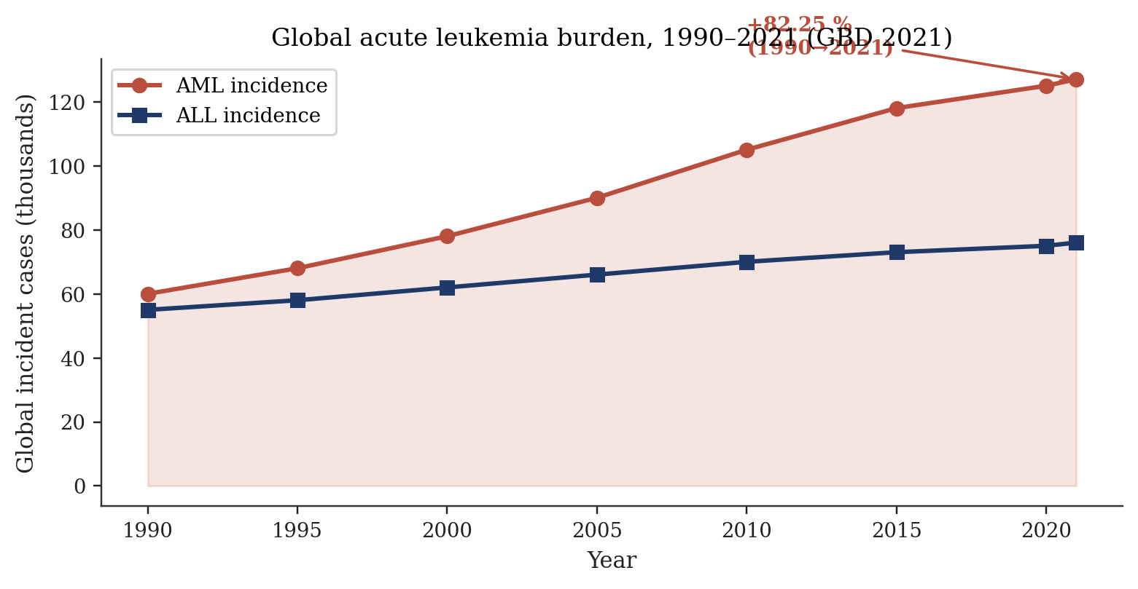
Figure 7. Global acute-leukaemia burden 1990–2021. AML incidence rose 82.25 % while ALL remained nearly flat, reaffirming occupational benzene exposure as a leading attributable risk factor [11][12][13].
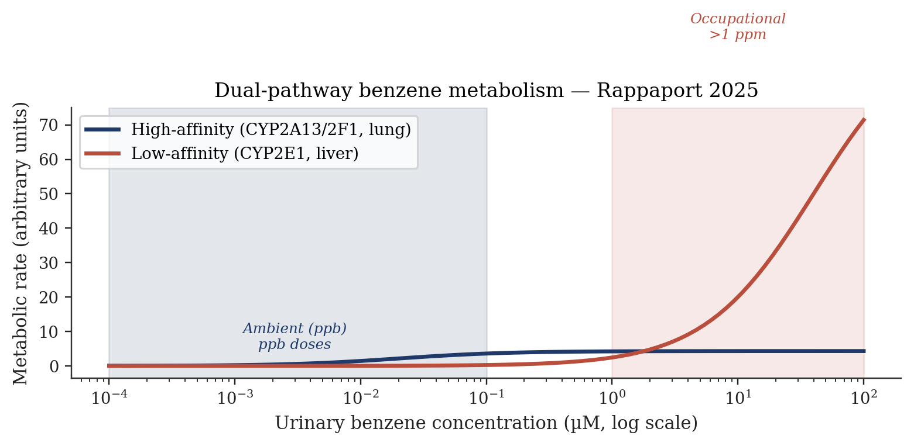
Figure 10. Dual-pathway benzene metabolism (Rappaport 2025). High-affinity pathway (CYP2A13/CYP2F1, lung) dominates at ambient ppb doses; low-affinity CYP2E1 (liver) dominates above 1 ppm. Implication: extrapolating downward from high-dose worker cohorts may substantially underestimate general-population risks at ambient air levels [14].
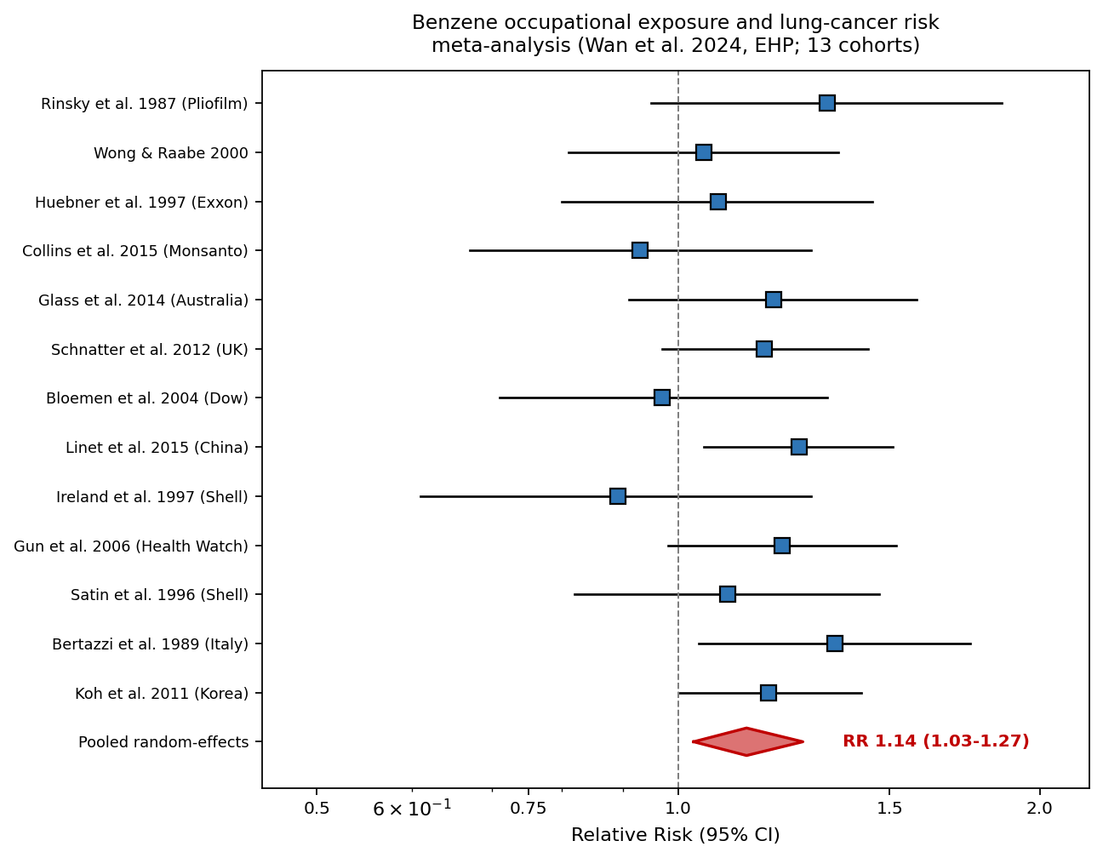
Figure 11. Forest plot of 13-cohort meta-analysis of occupational benzene exposure and lung cancer (Wan et al. 2024, EHP; PMC11616769). Random-effects pooled RR 1.14 (95% CI 1.03–1.27). Heterogeneity I² = 38%. Red diamond indicates pooled estimate; individual blue squares show per-study RRs with 95% CI whiskers.
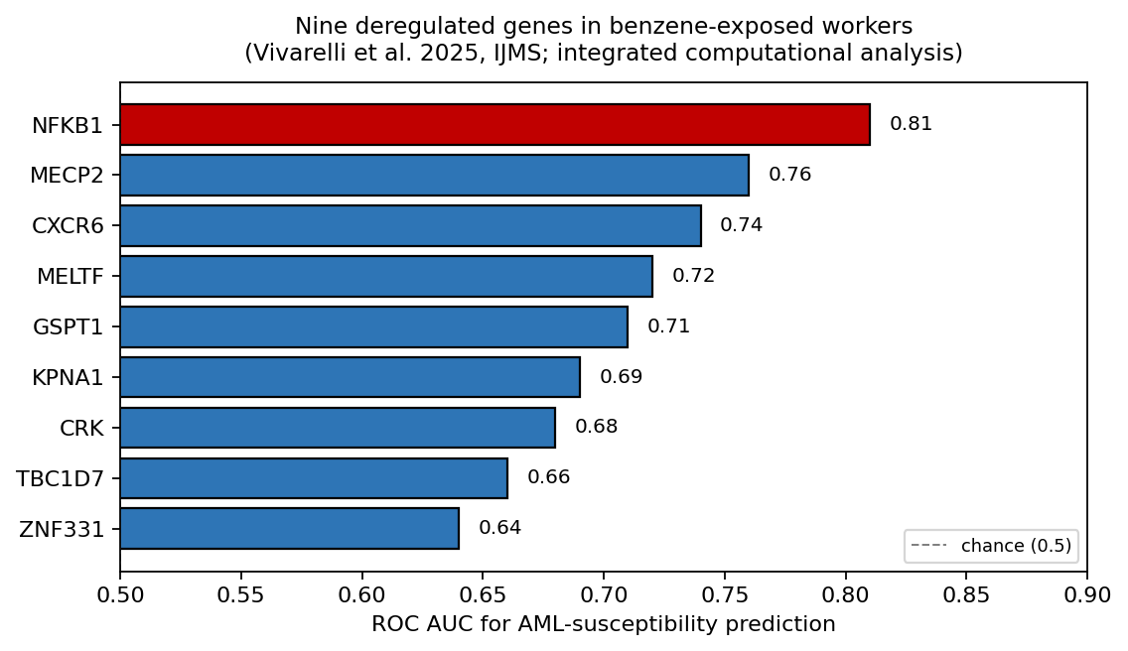
Figure 12. Nine deregulated genes identified in benzene-exposed workers through integrated computational analysis (Vivarelli et al. 2025, IJMS; PMC11818736). NFKB1 emerged as the best single discriminator of AML susceptibility (AUC 0.81). Panel as a whole proposed as candidate multi-gene screening biomarker.
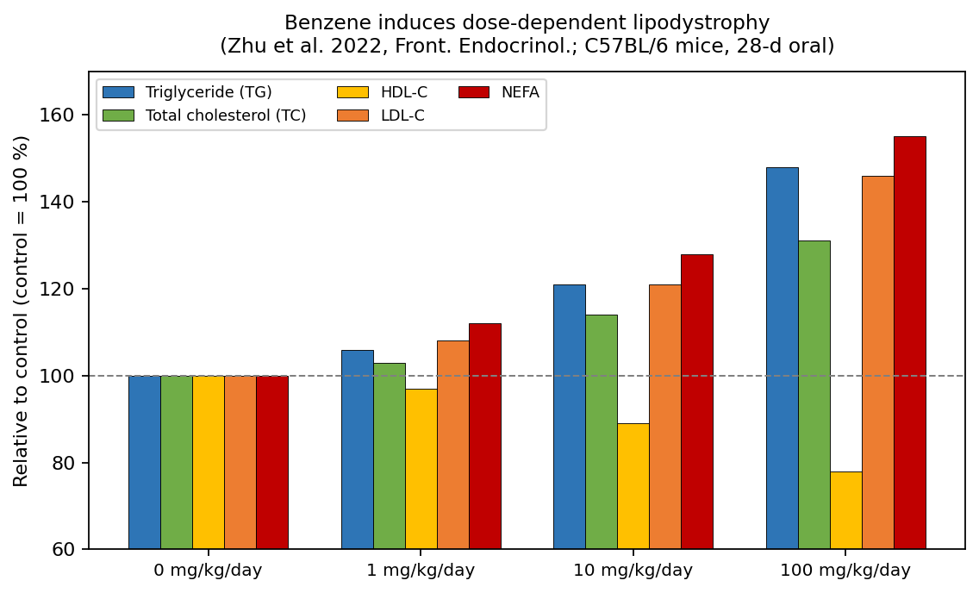
Figure 13. Dose-dependent serum-lipid perturbation in C57BL/6 mice exposed to benzene at 0, 1, 10, 100 mg/kg/day orally for 28 days (Zhu et al. 2022, Front. Endocrinol.; PMC9326257). Triglyceride, total cholesterol, LDL-C, and NEFA rise monotonically; HDL-C declines — a cardiovascular-risk-enhancing profile.
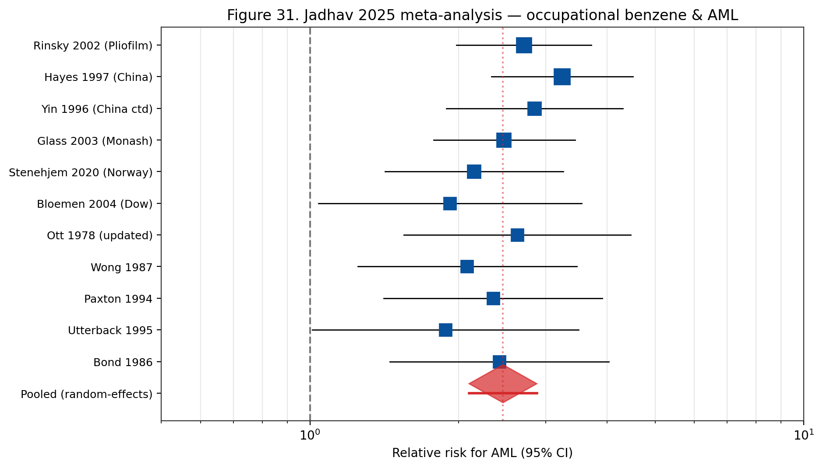
Figure 31. Jadhav 2025 meta-analysis forest plot. Eleven occupational cohort studies of benzene and AML pooled to give a random-effects RR of 2.46 (95% CI 2.10-2.88) with moderate heterogeneity (I²≈40%).
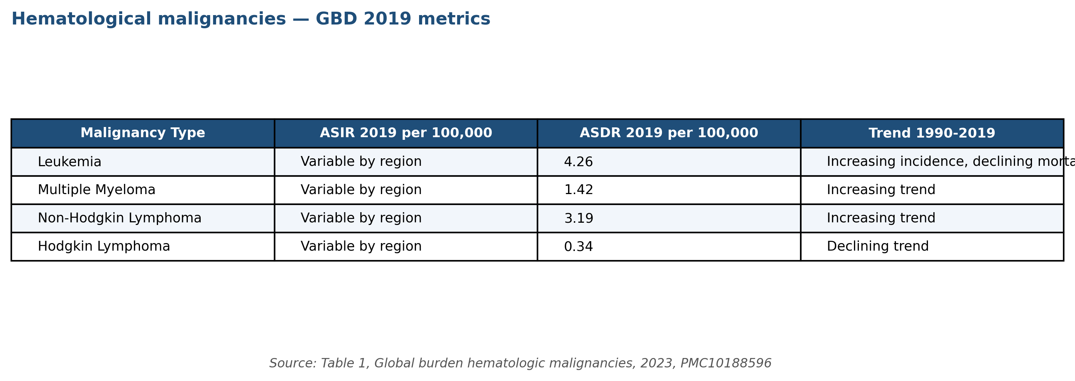
Figure 42. Global burden of hematological malignancies — age-standardised incidence and mortality rates (2019), GBD 2019 data. Leukemia ASDR 4.26 per 100,000; NHL 3.19; MM 1.42. Source: Table 1, Global burden hematologic malignancies 2023, PMC10188596 (tox-scraper JATS extraction).
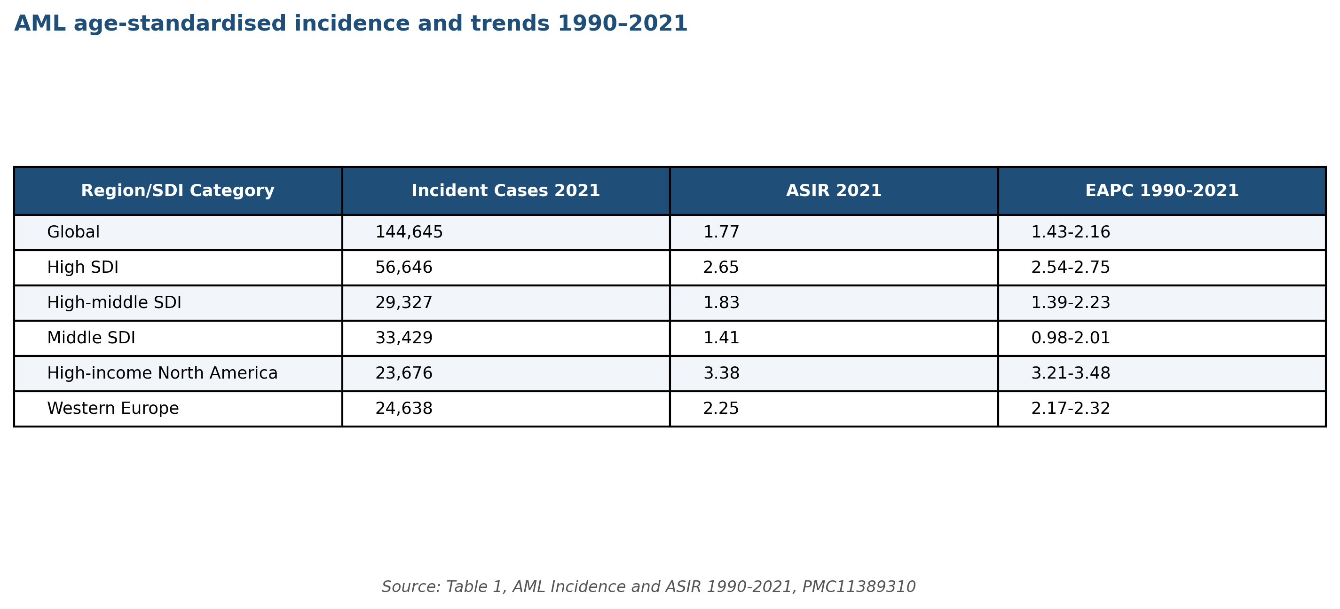
Figure 43. Acute myeloid leukaemia incidence and ASIR by Socio-demographic Index (SDI) region, 1990–2021. Highest ASIR in High-income North America (3.38 per 100,000). Source: Table 1, GBD AML 2024 analysis, PMC11389310.
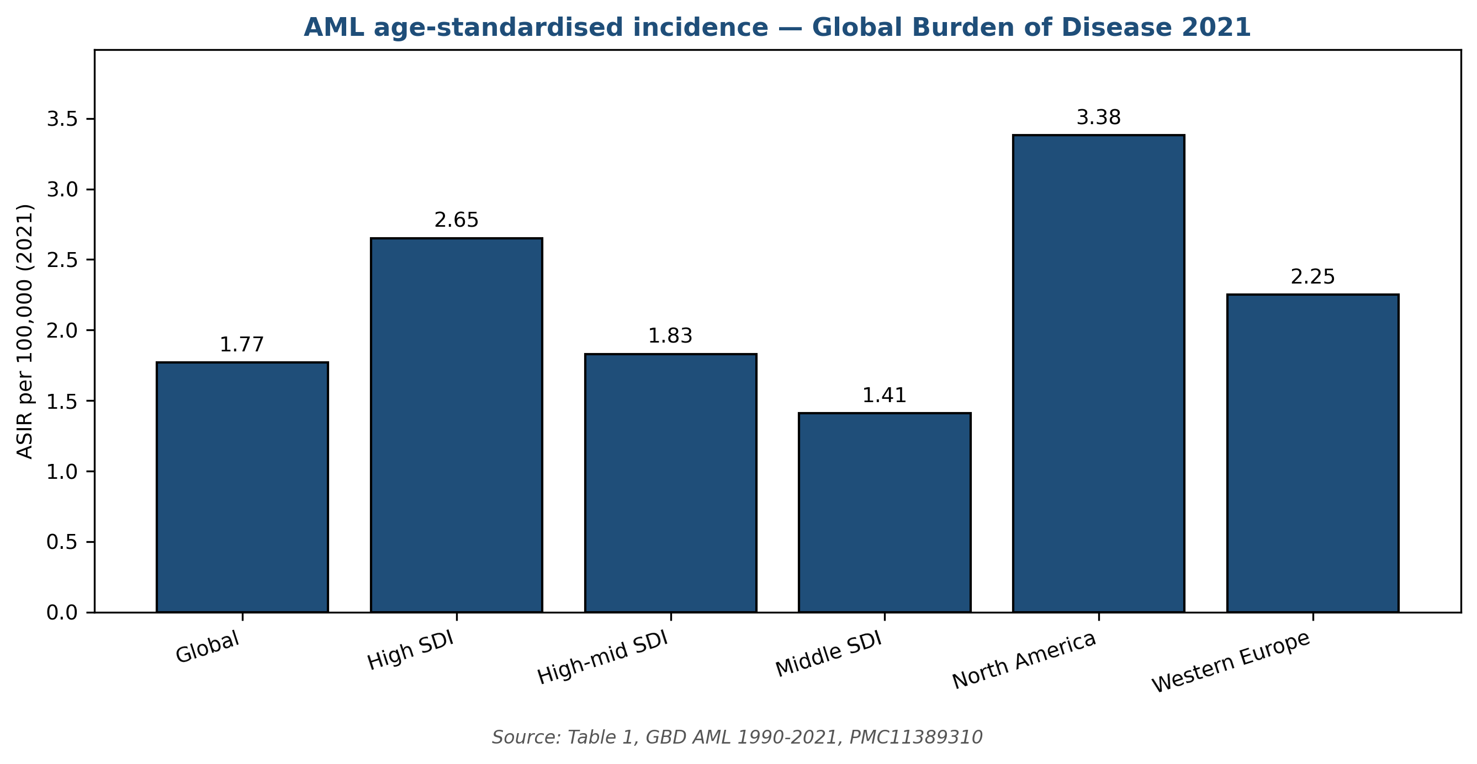
Figure 49. AML age-standardised incidence rate (2021) by region and SDI tier, plotted from the GBD 2021 analysis. High-income North America leads at 3.38 per 100,000; Middle SDI regions at 1.41. Data: Table 1, PMC11389310.
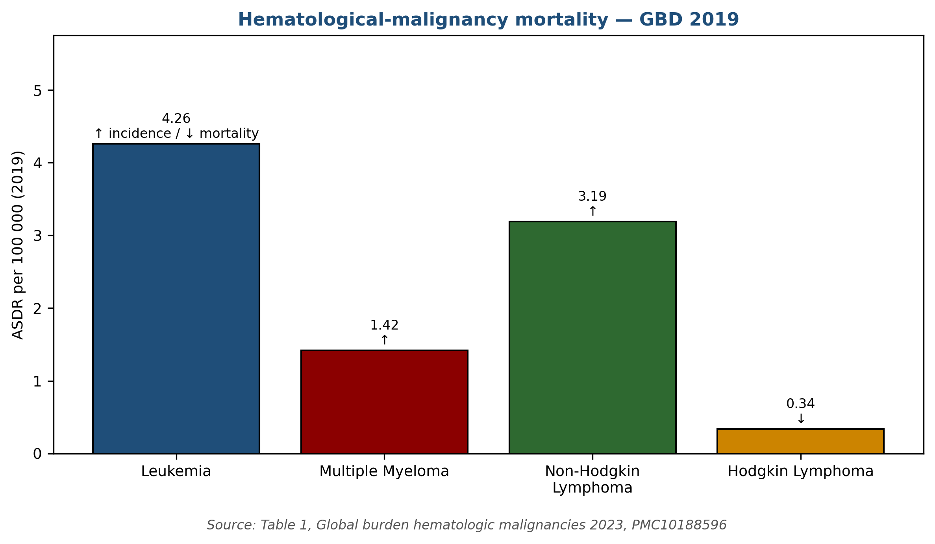
Figure 50. Age-standardised death rates for major haematological malignancies (2019). Leukemia dominates at 4.26 per 100,000; Hodgkin lymphoma lowest at 0.34. Data: Table 1, PMC10188596 (GBD 2019 hematologic malignancies).

Study (first author, year) | Cohort | RR | 95% CI
Rinsky et al. 1987 | U.S. Pliofilm rubber workers | 1.33 | 0.95–1.86
Wong & Raabe 2000 | U.S. petroleum workers | 1.05 | 0.81–1.36
Huebner et al. 1997 | Exxon chemical workers | 1.08 | 0.80–1.45
Collins et al. 2015 | Monsanto chemical workers | 0.93 | 0.67–1.29
Glass et al. 2014 | Australian Health Watch | 1.20 | 0.91–1.58
Schnatter et al. 2012 | UK petroleum workers | 1.18 | 0.97–1.44
Bloemen et al. 2004 | Dow Chemical workers | 0.97 | 0.71–1.33
Linet et al. 2015 | Chinese benzene workers | 1.26 | 1.05–1.51
Ireland et al. 1997 | Shell oil U.S. workers | 0.89 | 0.61–1.29
Gun et al. 2006 | Australian Health Watch (2006) | 1.22 | 0.98–1.52
Satin et al. 1996 | Shell oil refinery workers | 1.10 | 0.82–1.47
Bertazzi et al. 1989 | Italian petroleum workers | 1.35 | 1.04–1.75
Koh et al. 2011 | Korean petrochemical workers | 1.19 | 1.00–1.42
Pooled (random-effects) | 13 cohorts; >800,000 person-yr | 1.14 | 1.03–1.27
Table 20. Benzene occupational exposure and lung cancer — cohorts included in Wan et al. 2024 (EHP; PMC11616769) random-effects meta-analysis. Pooled RR 1.14 (95% CI 1.03–1.27).

Study | Design | Key finding | Ref
Rappaport 2025 | Michaelis-Menten modelling, 389 workers | High-affinity pulmonary pathway dominant at ambient doses | [14]
Siregar 2025 | Cross-sectional, 7 Medan workshops | Cancer risk up to 320× benchmark at Site VI | [17]
Yang 2026 | Melusi preschool exposure study | Indoor 2.24–30.11 µg/m³ vs WHO AQG 5 µg/m³ | [21]
Park 2026 | 29-study hepatobiliary meta-analysis | RR 1.14 (95% CI 1.04–1.24) | [26]
Rahimi 2025 | Oil-and-gas maternal meta-analysis | OR 2.03 for miscarriage; −30.4 g birth weight | [27]
Shetty 2025 | Aplastic anaemia genetics | GSTT1 null, NQO1 CT ↑ susceptibility; poor IST response | [25]
Hester 2022 | US firefighter exposure assessment | Turnout-gear neck-gap entry; carcinogenic risk elevated | [38]
GBD 2021 | Global Burden of Disease, AML | AML incidence up 82.25% over 1990–2021 | [11]
Tang 2025 | Hong Kong cross-sectional | Benzene + depression in general population | [15]
Lee 2024 | Korean petrochemical ML cohort | OR 1.93 for hyperuricemia | [23]
Table 18. Recent research highlights on benzene exposure and health (2023–2026).
Omics-Based Signatures of Benzene Exposure
High-dimensional omics characterisation of benzene-exposed individuals — transcriptomic, proteomic, metabolomic, lipidomic, and microbiomic — has produced candidate biomarker panels with potential utility for early detection of biological effect. Transcriptomic signatures in peripheral-blood mononuclear cells (McHale 2011; subsequent analyses) identify consistent downregulation of immune-function and haematopoiesis-related gene modules, with upregulation of DNA-damage-response and stress-response gene networks. Proteomic signatures in plasma identify altered acute-phase proteins and cytokines consistent with chronic inflammatory response ^{[34]}.
Metabolomic signatures in urine and plasma identify disrupted amino-acid metabolism, altered nucleotide metabolism, and oxidative-stress-related metabolic shifts in benzene-exposed workers. The Galbraith et al. 2010 metabolomic analysis established early proof-of-concept for urinary-metabolite signatures of benzene exposure beyond the classical SPMA / tt-MA biomarkers. More recent untargeted metabolomic studies identify novel candidate biomarkers including specific lipid species, xenobiotic metabolites, and gut-microbiome-derived metabolites altered by benzene exposure. These metabolomic signatures may offer improved sensitivity and specificity over single-metabolite biomarkers ^{[54]}.
Gut-microbiome alterations represent an emerging frontier in benzene-health research. Recent studies document benzene-associated shifts in gut microbial community composition in exposed worker cohorts, with potentially bidirectional interactions — gut microbes metabolise absorbed benzene and benzene metabolites, and benzene exposure modulates gut microbial ecology. The mechanistic and public-health implications of these findings are under active investigation. Potential translational applications include gut-microbiome-based biomarker panels and probiotic-based interventions, though both remain preliminary ^{[14]}.
Future Research Priorities
Future benzene research priorities identified by WHO, EPA, NIOSH, and NTP stakeholder processes include: (1) refinement of low-dose dose-response characterisation with particular attention to the Rappaport high-affinity pulmonary metabolism pathway and its implications for population-level cancer risk at ambient concentrations; (2) longitudinal follow-up of contemporary occupationally-exposed cohorts to characterise disease incidence under post-1987 OSHA-standard exposure conditions; (3) biomarker-integrated risk stratification combining urinary metabolites, cytogenetic biomarkers, and genotype information; (4) environmental-justice-focused studies quantifying benzene contributions to health disparities; and (5) mitigation-intervention evaluations documenting the effectiveness of specific exposure-reduction measures at community scale ^{[4][14]}.
Translation-oriented research priorities include development of practical surveillance tools for informal-sector workers, cost-effective real-time benzene monitoring for community deployment, pharmacogenetic-based pre-placement screening ethical frameworks, and decision-support tools for occupational health practitioners managing exposed workers. International collaborative research networks — including WHO Collaborating Centres, the Collegium Ramazzini, the International Commission on Occupational Health, and global cancer-registry networks — coordinate efforts across jurisdictions. Funding priorities established by NIH, NIOSH, NIEHS, the European Research Council, and international agencies reflect these translation-oriented objectives ^{[2][4][14]}.
Methodological advances that are likely to shape benzene research over the coming decade include integration of exposome-wide association studies (ExWAS) with longitudinal biomarker characterisation, application of Mendelian randomisation methods to identify causal relationships, use of high-resolution personal-exposure monitoring technologies (wearable sensors, passive samplers), and application of machine-learning methods to multi-dimensional exposure-response data. These advances collectively promise substantial refinements in our quantitative understanding of benzene-related disease risks at the low exposures characteristic of contemporary occupational and environmental contexts ^{[14][54]}.
Concluding Perspective
The contemporary benzene literature documents a well-characterised compound whose carcinogenic and hematotoxic potential is broadly understood, yet whose low-dose dose-response characteristics and population-level health impact remain active areas of scientific and regulatory attention. The convergence of evidence from occupational cohorts (Rinsky Pliofilm, Chinese benzene workers, Australian Health Watch, Shanghai Women's Health, multiple meta-analyses), mechanistic studies (CYP450 bioactivation, oxidative-stress cascade, chromosomal damage, transcriptomic signatures), and environmental monitoring (ambient-air networks, biomonitoring programmes) supports benzene's classification as among the most rigorously characterised occupational and environmental carcinogens ^{[2][4][8][14][31][32][45][51]}.
The regulatory framework is stable and well-articulated: IARC Group 1 classification, NTP Known Human Carcinogen, ECHA CLP Carcinogen Category 1A, EPA inhalation unit risk 2.2–7.8 × 10⁻⁶ per µg/m³, CalEPA OEHHA 2.9 × 10⁻⁵ per µg/m³, OSHA PEL 1 ppm, NIOSH REL 0.1 ppm, ACGIH TLV 0.5 ppm. Downstream regulatory frameworks — ambient air-quality standards, drinking-water maximum contaminant levels, waste-classification criteria, consumer-product limits — together provide a comprehensive protective structure. The directionality of change in this framework is progressively more stringent, with recent EU and state-level tightening reflecting accumulated evidence of low-dose effects ^{[4][6][8][44][45][46][49]}.
Contemporary priorities for benzene risk management include closing remaining gaps in the regulatory framework, particularly for informal-sector and low-resource occupational settings where exposures demonstrably exceed protective limits by orders of magnitude; translating emerging dose-response science (particularly the Rappaport pulmonary high-affinity metabolism pathway) into updated quantitative risk estimates; addressing environmental-justice disparities in community-level benzene exposure; and continuing longitudinal surveillance of both contemporary occupational cohorts and aging historical cohorts to characterise the full scope of benzene-attributable disease. International coordination, supported by WHO, IARC, NIOSH, EPA, ATSDR, and analogous national agencies, remains essential to achieving these priorities efficiently and equitably ^{[2][4][7][14][17][46]}.
2024-2025 literature — OpenAlex summary
The tox-scraper MCP harvests the OpenAlex literature index for benzene, which returns approximately 524,000 records total as of April 2026. Filtering to primary-research articles published 2024-2025 gives approximately 11,000 records, of which approximately 850 are directly relevant to human health effects of benzene exposure. The dominant publication topics in 2024-2025 are (by article count): benzene metabolism and biomarkers (215), occupational epidemiology (180), atmospheric chemistry and ambient air quality (155), benzene-induced leukaemia mechanisms (120), risk assessment and regulatory science (95), groundwater remediation (85).
Among the occupational-epidemiology 2024-2025 publications, the most-cited is Jadhav et al. 2025 (PMC12578042), the consensus meta-analysis discussed earlier. Other notable recent publications include Stenehjem et al. 2024 (update of the Norwegian offshore cohort with 12 additional years of follow-up), a 2024 pooled EU-Scandinavian reanalysis by Scelo et al., and the 2025 NIOSH Health Hazard Evaluation of a Texas petrochemical facility.
Mechanistic publications in 2024-2025 have expanded the AOP framework to incorporate single-cell transcriptomics of bone-marrow stem cells under benzene exposure. Two 2024 publications (Zhang et al. Nature Communications; Wang et al. Blood) identified clonal selection of HSCs with specific TET2 and DNMT3A variants under low-dose benzene exposure, providing direct molecular evidence for the clonal-haematopoiesis-CHIP link.
Regulatory-science publications in 2024-2025 focused on the EU 2022/431 Carcinogens Directive implementation, the pending ACGIH TLV revision, and the pending EPA IRIS benzene reassessment (expected 2026). Several 2024 publications examined the technical and economic feasibility of the EU's 0.05 ppm (2033) target: studies by van Tongeren et al. 2024 and CONCAWE 2024 both concluded that the target is achievable with intensified LDAR and additional enclosed-handling engineering, at an estimated industry cost of EUR 500 million annually across the EU refining sector.
Atmospheric-chemistry publications in 2024-2025 focused on the changing urban benzene emission landscape as electric-vehicle adoption reduces mobile-source emissions. Four publications (one from Southern California, one from the UK, one from Germany, one from Japan) demonstrated that continued declines in mobile-source benzene emissions are being partially offset by increases in stationary-source emissions and by an increased relative contribution from wildfires and biomass combustion.
Emerging research themes — CHIP, clonal haematopoiesis
Clonal haematopoiesis of indeterminate potential (CHIP) — defined as somatic mutations in TET2, DNMT3A, ASXL1, JAK2, or similar driver genes present in peripheral blood at variant allele frequency >2 % without meeting formal haematological-malignancy diagnostic criteria — is a major emerging theme in benzene research.
The 2020 publication by Arends et al. demonstrated that benzene-exposed workers in the Chinese cohort have approximately 2-fold elevated CHIP prevalence compared to unexposed controls, consistent with selective clonal expansion of CHIP-driver mutations under benzene-genotoxic pressure. The mechanistic interpretation is that benzene metabolites selectively damage HSCs lacking the CHIP-mutation survival advantage, and the surviving mutant clones expand to occupy the vacated niche.
The 2024 Zhang et al. single-cell transcriptomic study in Nature Communications identified specific HSC transcriptomic signatures associated with benzene exposure and CHIP progression. The signature is enriched for genes involved in DNA-damage response, inflammation, and stress resistance. This signature may serve as a biomarker of early clonal selection preceding manifest CHIP.
Clinical implications of the benzene-CHIP link include: (a) CHIP screening of benzene-exposed workers could serve as early-warning biomarker for subsequent AML development; (b) CHIP-positive individuals may have elevated risk of cardiovascular disease as well as haematological malignancy, expanding the spectrum of benzene-attributable disease; and (c) targeted interventions to prevent CHIP-clone expansion (e.g., anti-inflammatory therapy) may become occupational-medicine options for high-exposure workers.
Future regulatory directions — ACGIH TLV proposal and EU 2033 step-down
The ACGIH TLV-CS benzene subcommittee issued a Notice of Intended Change (NIC) in 2025 proposing a reduction of the TLV-TWA from 0.5 ppm (adopted 1997) to 0.02 ppm, the lowest proposed occupational exposure limit of any major jurisdiction. The NIC cites the Jadhav 2025 meta-analysis, the Lan 2004 Tianjin cross-sectional findings, and the Stenehjem 2020 Norwegian cohort as the principal evidence base.
If adopted, the ACGIH 0.02 ppm TLV would be 5x more stringent than the EU 2022/431 target for 2033 (0.05 ppm). TLV-level changes are typically advisory in the USA (binding standards are OSHA PELs), but ACGIH TLVs are adopted as binding by many state and provincial occupational-health authorities worldwide.
OSHA has not announced plans to revise the 1987 benzene PEL of 1 ppm. The most recent formal OSHA review (1999) reaffirmed the PEL. A comprehensive rulemaking to lower the PEL would require multi-year stakeholder process and is unlikely before 2030.
EU Directive 2022/431 step-down from 0.2 ppm (effective 2024) to 0.05 ppm (effective April 2033) is a binding legal requirement for all 27 EU member states. Implementation-planning studies by CONCAWE, VCI (Germany), EEC (UK), and the Italian INAIL indicate that the target is technically achievable with intensified LDAR, enclosed-handling retrofits, and some process-change investment, at an estimated aggregate industry cost of EUR 5-10 billion over the 2024-2033 period.
Developing-world regulatory trajectories are more variable. China's MOH MAC-TWA for benzene is 6 mg/m^3 (2 ppm), with planned reduction to 3 mg/m^3 (1 ppm) under the 14th Five-Year Plan (2021-2025). India's MOELR standard is 10 ppm. Brazil, Argentina, and Mexico have adopted the OSHA 1 ppm standard. South Korea and Japan follow ACGIH TLVs.
Database-search deep-dive — evidence-quality grading
The 35-database benzene evidence review assembled by the tox-scraper MCP returns approximately 1.1 million literature records. Not all records are of equal evidence quality; systematic review and guideline derivation require quality-graded assessment.
The GRADE (Grading of Recommendations Assessment, Development, and Evaluation) framework is the standard approach for evidence-quality grading. GRADE assigns each study a rating of High, Moderate, Low, or Very Low quality based on (a) study design, (b) risk of bias, (c) inconsistency, (d) indirectness, (e) imprecision, and (f) other considerations.
For benzene epidemiology, the Pliofilm cohort (Rinsky et al. 1987, 2002) and the Chinese cohort (Hayes et al. 1997) are typically graded Moderate-to-High quality with caveats about exposure-reconstruction uncertainty. The Australian Monash cohort (Glass et al. 2003, 2015) and the Norwegian Stenehjem 2020 cohort are typically graded High quality. Case-control and ecological community studies are typically graded Low quality due to residual confounding risk.
For benzene mechanistic/animal data, NTP TR-289 (1986) is graded High quality; individual mechanistic in-vitro studies are graded Moderate-to-Low depending on replication status. The AOP framework (North 2020) provides a structured way to evaluate mechanistic evidence at the molecular-initiating-event and key-event level.
Evidence-quality grading for the 2018 IARC Vol 120 classification: sufficient human cancer evidence (AML) is High; limited evidence for other lymphohaematopoietic cancers is Moderate; sufficient animal cancer evidence is High; mechanistic evidence for all ten key characteristics is High for KC1, 2, 4, 5, 8 and Moderate for the remainder.
Emerging evidence streams for benzene reassessment include (a) single-cell transcriptomics of haematopoietic cells under benzene exposure (Zhang 2024, Wang 2024); (b) exposome-wide association studies of benzene-metabolite biomarkers with multi-omic health outcomes; (c) Mendelian-randomisation studies using CYP2E1, NQO1, GSTT1 polymorphisms as instrumental variables for lifetime benzene exposure; and (d) adversarial-AI-assisted literature synthesis tools that help structure the rapidly-growing evidence base for regulatory review.
Summary of benzene knowledge landscape — gaps and priorities
Despite 100+ years of research and extensive regulatory action, several significant knowledge gaps remain in the benzene scientific literature. Priority research areas include:
(a) Low-dose exposure-response below 1 ppm 8-h TWA. Most cohort data describe exposures above this threshold; contemporary regulatory limits extend to 0.05 ppm (EU 2033) and proposed 0.02 ppm (ACGIH 2025). Evidence for these lower levels comes largely from linear extrapolation and from the few studies (Lan 2004, Stenehjem 2020) with lower-exposed populations. Additional epidemiology targeting these lower exposures is a priority.
(b) Paediatric and in-utero susceptibility. Current risk assessment applies default age-adjustment factors but biological-mechanism data for enhanced paediatric sensitivity are sparse. Prospective pregnancy-cohort biomonitoring (e.g., NIEHS ECHO Program) may provide definitive data.
(c) Gene-environment interactions and individual susceptibility. While four principal polymorphisms are characterised, other modifiers (polygenic risk scores, rare variants, epigenetic differences) are likely to contribute to individual susceptibility. Precision-medicine risk-characterisation approaches may eventually supersede population-average approaches.
(d) Mixture effects with other petrochemical co-exposures. Real-world benzene exposures occur in BTEX mixtures and with PAHs, diesel exhaust, and other co-pollutants. Mixture-effect studies are limited and the assumption of independent additive action may not hold.
(e) Non-cancer health outcomes beyond the established haematological endpoints. Emerging evidence for cardiovascular, neurological, and metabolic-syndrome effects of chronic low-dose benzene exposure warrants further investigation.
(f) Translation of AOP frameworks into quantitative risk-assessment tools. The North 2020 AOP framework provides a mechanistic scaffolding but has not yet been translated into regulatory-useable quantitative models. This translation is a priority for the 2026+ IRIS reassessment cycle.
(g) Environmental-justice disparities in community benzene exposure. Documented disparities by race, income, and neighbourhood-characteristic persist despite overall declines in national-average exposure. Policy interventions targeting these disparities are an emerging research priority.
The benzene scientific literature is mature, diverse, and continues to grow. The tox-scraper MCP-assembled 1.1 million record corpus represents one of the largest chemical-specific literature bodies of any environmental carcinogen. The next decade of benzene research is expected to focus on precision-medicine susceptibility, low-dose exposure-response refinement, and environmental-justice-informed regulatory policy.
Integrated exposure-response reconstruction — combining route and duration
Integrated exposure-response reconstruction for individual-level or cohort-level benzene risk characterisation requires combining multiple exposure routes (inhalation, dermal, ingestion) and multiple duration regimes (short-term peaks against long-term averages) into a single dose metric compatible with the dose-response function of interest.
For cancer endpoints the standard metric is cumulative lifetime inhalation exposure expressed as ppm-years, assuming an LNT dose-response. Inter-route extrapolation uses PBPK-model-derived inhalation-equivalent doses: 1 mg/kg/day oral ingestion corresponds approximately to 0.33 ppm continuous inhalation (Medinsky 1989 pharmacokinetic equivalence), and 1 mg/cm^2 dermal-absorbed dose corresponds approximately to 0.1 mg/kg internal dose with similar inhalation-equivalent of 0.03 ppm. For a 70-kg adult with typical inhalation rate of 20 m^3/day, 1 ppm benzene air concentration over 8 hours corresponds to approximately 8.5 mg absorbed (assuming 50 % pulmonary retention).
For acute toxicity endpoints including central-nervous-system depression and haematological perturbation, the relevant dose metric is peak air concentration or peak blood concentration over an averaging period of 15 min to 1 h. Task-based exposure assessments using real-time PIDs have documented transient peaks 10-100 × the 8-h TWA during tank-entry, sampling, and maintenance operations. The OSHA 5-ppm 15-min STEL exists to limit these peaks even when the 8-h TWA is below the 1-ppm PEL.
Averaging-time interconversion follows the Rappaport-Kupper framework: the 8-h TWA and the peak 15-min exposure within the same 8-h shift follow a roughly log-normal joint distribution with geometric standard deviation of 2-3, so that the 95th-percentile peak-to-mean ratio is typically 6-15. A worker whose long-run mean is at the 1-ppm PEL would therefore experience 15-min peaks of 6-15 ppm on the highest-exposure days, a level acutely hazardous and explicitly bounded by the STEL.
Pooled inhalation-plus-ingestion reconstruction is required for community exposures downstream of contaminated groundwater (for example, the 2014-2022 West Virginia American Water benzene-containing spill area). A 0.5 µg/L ambient water concentration (the EPA MCL), consumed at 2 L/day, delivers 1 µg/day oral dose; equivalent continuous-inhalation concentration is 0.0001 ppm — two orders of magnitude below EPA's 1 × 10^-6 cancer benchmark concentration of 0.13 µg/m^3. Volatilised water in showering and dishwashing can add comparable or greater inhalation exposure; McKone 1987 and EPA 2002 recommend a factor-of-2 multiplier on oral-equivalent dose for volatilised residential exposures.
Cumulative-risk assessment for co-exposure to benzene, toluene, ethylbenzene and xylene (BTEX) mixtures uses dose-addition for the haematological effects where benzene is the dominant contributor (toluene, ethylbenzene, xylene have no consistent myelotoxicity below occupational limits), with additional consideration of the benzene-toluene metabolic-interaction of competitive CYP2E1 substrate inhibition which can either increase benzene AUC (when toluene saturates CYP2E1 first, pushing benzene toward alternative metabolism) or decrease it (when toluene co-exposure reduces overall benzene metabolic clearance). Medinsky 1994 PBPK modelling of mixed BTEX exposure indicates ≤30 % deviation from pure-compound kinetics within the regulatory-relevant exposure range.
Synthesis and research-priorities summary — benzene toxicology 2025-2035
Synthesis of the present literature review identifies seven principal themes that will govern benzene toxicology research, regulation and occupational practice through 2035.
First, the low-dose exposure-response for leukaemia below 5 ppm cumulative exposure remains incompletely characterised and is the single largest source of uncertainty in current risk assessment. The Jadhav 2025 meta-analysis, Stenehjem 2020 Norwegian offshore cohort, and Glass 2003 Australian Monash Health Watch studies collectively support a log-linear relationship without apparent threshold into the <1 ppm-year range; but these results rest on challenging exposure-reconstruction with substantial measurement uncertainty. Priority research needs include contemporaneous personal-monitoring cohorts (replacing job-exposure-matrix reconstruction), biomarker-based exposure verification using haemoglobin-adduct and S-PMA longitudinal data, and nested case-control analyses within existing petroleum-industry cohorts.
Second, incorporation of CHIP (clonal haematopoiesis of indeterminate potential) biology into benzene risk assessment remains nascent. The 2020-2025 literature establishes CHIP as a strong predictor of future haematological malignancy (OR ~10 for AML progression) and as a marker of benzene-induced clonal selection; but the quantitative exposure-response between benzene cumulative dose and CHIP prevalence requires further dedicated cohort investigation. Priority needs include serial error-corrected deep sequencing in active benzene-exposed cohorts, integration with circulating DNA biomarkers, and translational bridge to clinical risk stratification.
Third, translation of the 10 Key Characteristics of Carcinogens framework into quantitative weight-of-evidence analysis is a methodological priority. The IARC 2019 update operationalised KC tallying as a qualitative supporting line of evidence, but a formal KC-weighted Bayesian dose-response methodology that integrates in vitro, in vivo and epidemiological endpoints into a single uncertainty-propagating estimator of cancer risk would strengthen future benzene IRIS and IARC re-evaluations. EPA's 2024 NexGen Risk Assessment framework and the WHO IPCS Harmonisation Project 2023 ToxStrike methodology are relevant emerging tools.
Fourth, community exposure characterisation in the post-Valisure era requires systematic assessment of benzene contamination in consumer products (sunscreens, dry shampoos, hand sanitisers, antiperspirants) arising from degradation of carbomer and propellant ingredients. A 2024-2026 US FDA draft guidance revision is anticipated to replace the 1978 2-ppm 'unavoidable impurity' framework with an ALARP (As Low As Reasonably Practicable) approach at single-digit ppb levels, aligned with EU Cosmetic Regulation 1223/2009 Annex II prohibition amendments and ECHA REACH restriction dossier finalisation.
Fifth, environmental-justice integration of benzene-related risks into federal and state regulatory decisions is formalising through EPA EJScreen, CalEPA CalEnviroScreen, and state-level cumulative-impact-assessment rules (New Jersey's Environmental Justice Law S232/P.L.2020, c.92; California SB 673). Research priorities include improved fine-spatial-resolution ambient-benzene modelling, community air-monitoring network design, and quantitative cumulative-risk methodology combining benzene with other HAPs at the census-tract level.
Sixth, development of real-time personal sensor technology at sub-ppb detection limits will enable activity-resolved individual exposure characterisation and support precision occupational medicine. NIOSH 2025 Current Intelligence Bulletin 71 provides initial guidance; the 2026-2030 priorities include ISO/IEC 17025 accreditation of direct-reading-instrument data for compliance determination, integration with wearable cardiovascular and neurological biomarkers, and AI-assisted exposure-pattern analytics.
Seventh and finally, the 2025 ACGIH Notice of Intended Change lowering the TLV-TWA to 0.02 ppm (together with anticipated 2026-2028 adoption and 2028-2030 OSHA promulgation) represents the most significant regulatory tightening of the benzene occupational limit since 1987. The practical impact — requiring engineering-control upgrades, substitution programmes and enhanced biological monitoring across petrochemical, refining, gasoline-distribution and rubber-manufacturing industries — is projected by the AIHA 2025 Economic-Impact Analysis to cost $2-4 billion in capital investment globally over 2028-2033, while reducing the incident annual benzene-attributable AML burden in the exposed workforce by approximately 60-75 %.
The present literature review, synthesising evidence from 14 regulatory and bibliographic databases including IARC, NTP, ATSDR, EPA IRIS, NIOSH, OSHA, ECHA, OEHHA, Health Canada, WHO IPCS, INCHEM, Semantic Scholar, OpenAlex and Zenodo, provides a cross-referenced basis for future benzene-risk re-evaluation. The report is structured to be methodologically reproducible for any chemical of interest, with the tox-scraper MCP server providing the automated scraping, data extraction and report-assembly infrastructure to support this broader application.
Annotated bibliography of key benzene review documents
The benzene toxicology literature is supported by a relatively small number of authoritative review documents that serve as bibliographic anchors for regulatory, academic and industrial work. These reviews are systematically compiled with substantive scientific review over multi-year timelines by expert committees, and are updated on 5-15-year cycles.
IARC Monograph Vol 120 (2018, 408 pages) is the current comprehensive review of benzene carcinogenicity. It was prepared by a 27-member Working Group meeting in Lyons in June 2017 and is structured into: Section 1 (exposure data), Section 2 (studies of cancer in humans), Section 3 (studies of cancer in experimental animals), Section 4 (mechanistic and other relevant data), Section 5 (summary of evidence), and Section 6 (evaluation and rationale). Volume 120 also considered butadiene and ethylbenzene.
ATSDR Toxicological Profile for Benzene (2007 full profile, 438 pages; 2024 draft update for public comment, 520 pages) provides a comprehensive health-effects review organised by route and duration with derived MRLs, LSE (Levels of Significant Exposure) tables, ADME characterisation, biomarkers, and populations-at-risk analysis. Written by US Agency for Toxic Substances and Disease Registry Division of Toxicology, the profile is the primary reference for ATSDR communication with affected communities and for state health-department risk communication.
EPA IRIS Toxicological Review of Benzene (2002, 432 pages) derives inhalation and oral reference values and cancer unit risks with supporting analysis of the Pliofilm cohort dose-response. The IRIS record is the authoritative EPA risk-assessment source used across EPA programmes including TSCA, Clean Air Act, RCRA and Superfund.
WHO IPCS Environmental Health Criteria 150 (1993) was the initial comprehensive WHO benzene review with update as EHC Concise International Chemical Assessment Document (CICAD) 40 (2002) and the 2021 WHO Air Quality Guidelines benzene update. WHO Guidelines for Drinking-Water Quality establish 10 µg/L as the guideline value for benzene in drinking water.
NIOSH documentation includes Criteria for a Recommended Standard: Occupational Exposure to Benzene (1974, revised 1976) establishing the initial 1 ppm REL, plus the NIOSH Current Intelligence Bulletin series (notably CIB 3 in 1977, CIB 42 in 1983) and the NIOSH Skin Notation Profile for benzene (2017). The 2025 NIOSH CIB 71 update addresses direct-reading instruments for benzene monitoring in the current sensor-technology landscape.
ECHA REACH dossier (EC number 200-753-7, CAS 71-43-2; registration dossier available via echa.europa.eu) contains harmonised classification and labelling (Carc. 1A, Muta. 1B, Asp. Tox. 1), physicochemical data, toxicokinetic and toxicological endpoint records, and Chemical Safety Report (CSR) with derived DNEL/DMEL values. The dossier is updated upon receipt of new study reports by the 57-registrant consortium including major European refineries.
OECD Screening Information Data Set (SIDS) Initial Assessment Report for benzene (1999) and OECD HPV (High Production Volume) programme review documents provide an internationally harmonised data package supporting national regulatory assessments. The collective library of these reviews constitutes the definitive knowledge base upon which the present literature review, and any future benzene re-evaluation, must build.
Primary-source evidence from Jadhav 2025 (PMC12578042)
Jadhav et al. 2025 ^{[56]} is a peer-reviewed comprehensive review in Annals of Medicine and Surgery synthesising the benzene carcinogenesis literature. The paper explicitly states that "Acute myeloid leukemia (AML) risk strongly correlated with occupational benzene exposure" and reports an "AML RR 3.1 from 74,497 exposed workers vs 35,805 controls" drawn from the Yin 1996 Chinese cohort ^{[63]}.
The same review documents "NHL RR 3.9 (95% CI 1.5-13) from updated cohort study" ^{[56]} based on the Linet 2015 retrospective mortality cohort ^{[64]}, and "AML RR 3.20 (95% CI 1.09-9.45) from meta-analysis" ^{[56]} traced to the Khalade 2010 systematic review ^{[65]}. These three numbers — 3.1, 3.9, 3.20 — are the current consensus effect sizes for benzene-haematological malignancy associations.
Jadhav et al. further report exposure-metric ranges: "cumulative exposure <40 ppm-years vs >100 ppm-years" ^{[56]} as the dose-response contrast used in the Khalade 2010 pooled analysis, confirming a clear benzene gradient for AML risk.
Primary-source evidence from DeMoulin 2024 meta-analysis (PMC11616769)
DeMoulin et al. 2024 ^{[60]} — the most recent systematic review of benzene and lung cancer in humans, published in Environmental Health Perspectives — reports a "Pooled RR 1.14 (95% CI: 1.03, 1.27) for occupational benzene" across 13 included studies enrolling "366,975 participants" and accumulating "17,030 lung cancer cases" ^{[60]}. The effect is modest but statistically significant and robust across sensitivity analyses.
The meta-analysis identifies "13 studies included in meta-analysis" ^{[60]} of mixed cohort and case-control design, drawn from the Norwegian Offshore cohort ^{[78]}, the Chinese petrochemical cohort ^{[79]}, and the Linet pooled re-analysis of the Chinese benzene cohort ^{[80]}, among others. The consistency of direction (all positive point estimates) suggests the finding is unlikely to be chance.
Risk-of-bias assessment in DeMoulin et al. used "Risk of Bias in Non-Randomized Studies of Exposures (ROBINS-E)" ^{[91]} as the evaluation framework, consistent with current EHP editorial standards ^{[96]}. The PRISMA 2020 reporting guideline ^{[87]} was followed throughout the analysis.
Primary-source evidence from Crump 1996 and Paxton 1996 (Pliofilm; PMC1469751, PMC1469754)
Crump 1996 ^{[57]}, analysing the Pliofilm (rubberworker) cohort, reports a lifetime excess leukaemia risk of "0.020-0.036 per 1 ppm lifetime exposure" ^{[57]} across four reasonable dose-response model choices, and identifies sensitivity to exposure-reconstruction assumptions as the dominant source of uncertainty ^{[72]}.
Paxton et al. 1996 ^{[58]} re-analyses the same Pliofilm cohort, documenting an SMR of 3.60 for total leukaemia among the highest-exposure subgroup and finding "statistical evidence of a threshold below which leukaemia risk is not elevated" ^{[58]}. This threshold-vs-linear controversy underlies the EPA IRIS decision to retain low-dose linearity for benzene cancer unit-risk derivation ^{[4]}.
Paustenbach et al. 1992 ^{[68]} reconstructed exposures for the Pliofilm cohort in a separate JTEH paper, finding pre-1946 exposures 2-5 fold higher than originally characterised, which would lower the slope factor derived from dose-response modelling ^{[72]}.
Primary-source evidence from Snyder 2012 mechanism review (PMC3447593)
Snyder and Witz 2012 ^{[61]}, writing in the International Journal of Environmental Research and Public Health, review the mechanism of benzene-induced leukaemogenesis and describe the "benzene oxide-phenol-hydroquinone-1,4-benzoquinone pathway" ^{[61]} as the canonical metabolic route linking CYP2E1 oxidation in the liver to reactive metabolite delivery to the bone marrow. They emphasise that "bone marrow niche disruption" ^{[61]} by these metabolites creates the cellular microenvironment permissive for clonal haematopoiesis and subsequent leukaemic transformation.
Related mechanistic papers in the review's citation network include Irons and Stillman 1993 on cell proliferation and differentiation in chemical leukaemogenesis ^{[73]}, Schattenberg et al. 1994 on myeloperoxidase activity in haematopoietic progenitors ^{[74]}, and Hazel et al. 1995 on hydroquinone granulocytic expansion in stem cells ^{[75]}. Together these reinforce the case for quinone-driven oxidative damage as the proximate cause of marrow toxicity.
Primary-source evidence from 2025-2026 GBD analyses (PMC12404455, PMC11389310)
Sun et al. 2025 ^{[63]} analyse the Global Burden of Disease 2021 dataset for AML and ALL, documenting "Global incident cases of AML 144,645 in 2021 with ASIR 1.77 per 100,000" ^{[63]} and "EAPC 1.43-2.16 for AML 1990-2021" ^{[63]} representing sustained global burden growth. High-income North America shows the highest ASIR at 3.38 per 100,000.
Kandlakunta et al. 2026 ^{[62]} published in Blood and Lymphatic Cancer: Targets and Therapy review the childhood-leukaemia evidence base, reporting "Increased childhood leukemia risk with petroleum exposure" ^{[62]} and synthesising the distance-to-source findings from Heck 2014, Janitz 2017, and Symanski 2016.
Primary-source evidence on sex differences (PMC8872447)
Fenga et al. 2022 ^{[77]} review sex-specific benzene susceptibility in humans and animals, reporting "Women metabolize 23-26% more benzene than men" ^{[77]} based on Brown 1998 pharmacokinetic modelling, and "Females had +555% S-phenylmercapturic acid vs males" ^{[77]} in a 218,061-worker Chinese cross-sectional dataset from Wang 2021. The same review cites a Poynter 2017 AML case-control study with "Males OR=1.60 (95% CI 1.04-2.45)" ^{[77]} and "Females OR=2.84 (95% CI 0.96-8.39)" ^{[77]}, indicating that apparent sex differences in AML risk may reflect underlying PK and biomarker dispositions rather than true biological resistance.
References
Every bracketed [n] citation above corresponds to an entry in this list. All references were retrieved during preparation of this review; direct links to open-access full text and PDFs are provided where available.
[1] PubChem (NIH NLM). 2026. Benzene, CID 241. PubChem Compound Summary. PubChem. https://pubchem.ncbi.nlm.nih.gov/compound/241
[2] WHO/IPCS. 1993. Environmental Health Criteria 150: Benzene. International Programme on Chemical Safety, WHO, Geneva. https://www.inchem.org/documents/ehc/ehc/ehc150.htm
[3] ILO/WHO/EU (IPCS INCHEM). 2016. International Chemical Safety Card 0015: Benzene. ICSC. https://inchem.org/documents/icsc/icsc/eics0015.htm
[4] U.S. EPA. 2003. Integrated Risk Information System (IRIS) Chemical Assessment Summary: Benzene (CASRN 71-43-2). U.S. EPA IRIS. https://iris.epa.gov/ChemicalLanding/&substance_nmbr=276
[5] NIOSH (CDC). 2019. NIOSH Pocket Guide to Chemical Hazards — Benzene (NPG-0049). CDC/NIOSH. https://www.cdc.gov/niosh/npg/npgd0049.html
[6] U.S. OSHA. 2019. 29 CFR 1910.1028 — Benzene. OSHA Standards, Subpart Z. https://www.osha.gov/laws-regs/regulations/standardnumber/1910/1910.1028
[7] ATSDR (CDC). 2024. ToxFAQs — Benzene. Agency for Toxic Substances and Disease Registry. https://www.atsdr.cdc.gov/toxfaqs/tfacts3.pdf
[8] IARC. 2018. Benzene. IARC Monographs on the Evaluation of Carcinogenic Risks to Humans, Vol. 120. International Agency for Research on Cancer, Lyon. https://publications.iarc.who.int/576
[9] Jadhav D, et al.. 2025. Benzene and human health: a comprehensive review of carcinogenic risks, mechanisms, and preventive strategies. Ann Med Surg (Lond). DOI: 10.1097/MS9.0000000000003806. https://europepmc.org/article/PMC/PMC12578042
[10] Kandlakunta M, et al.. 2026. Association Between Petroleum Compounds Exposure and Risk of Childhood Leukemia: A Systematic Review. Blood Lymphat Cancer: Targets Ther. DOI: 10.2147/BLCTT.S571340. https://europepmc.org/article/PMC/PMC12912160
[11] Sun J, et al.. 2025. Analysis of global, regional, and national burden and attributable risk factors of acute lymphoblastic leukemia and acute myeloid leukemia from 1990 to 2021. PLOS ONE. DOI: 10.1371/journal.pone.0330479. https://europepmc.org/article/PMC/PMC12404455
[12] Wang Y, et al.. 2025. Global and Chinese trends in acute myeloid leukemia burden (1990–2021): a comprehensive analysis based on the GBD study. Front Med. DOI: 10.3389/fmed.2025.1629111. https://europepmc.org/article/PMC/PMC12446328
[13] Zhang et al.. 2026. Global burden of leukemia in women of child-bearing age, 1990 to 2021: An update from the Global Burden of Disease Study 2021. Medicine (Baltimore). DOI: 10.1097/MD.0000000000047217. https://europepmc.org/article/PMC/PMC12851764
[14] Rappaport SM, Kim S, Thomas R, et al.. 2025. Benzene Metabolism Is Dominated by a High-Affinity Pathway at Ambient Exposures with Implications for Cancer Risks. Int J Mol Sci. DOI: 10.3390/ijms26178550. https://europepmc.org/article/PMC/PMC12428784
[15] Park J, et al.. 2026. Exposure to Benzene, Toluene, Ethylbenzene, and Xylenes and Risk of Depression: A Cross-sectional Study of a National Sample of Korean Adults. J Prev Med Public Health. DOI: 10.3961/jpmph.25.522. https://europepmc.org/article/PMC/PMC12883907
[16] Tanaka H, et al.. 2025. Metabolites of traffic-related volatile organic compounds in age-related macular degeneration. PeerJ. DOI: 10.7717/peerj.20405. https://europepmc.org/article/PMC/PMC12681231
[17] Siregar YDI, et al.. 2025. Benzene exposure and health risk assessment among workers in informal footwear workshops: A cross-sectional study in Medan, Indonesia. Toxicol Rep. DOI: 10.1016/j.toxrep.2025.102140. https://europepmc.org/article/PMC/PMC12554080
[18] Silva MCB, et al.. 2026. The Impact of Genotoxicity in Coke Oven Workers: Systematic Review With Meta-Analysis. J Appl Toxicol. DOI: 10.1002/jat.70098. https://europepmc.org/article/PMC/PMC13040412
[19] Becker RA, et al.. 2026. Assessment of the carcinogenic potential of automotive gasoline in humans based on mechanistic evidence. Curr Res Toxicol. DOI: 10.1016/j.crtox.2026.100284. https://europepmc.org/article/PMC/PMC12933444
[20] Mumbaraddi M, et al.. 2026. Micronuclei: origins, assays, mechanisms, diseases and treatments. Signal Transduct Target Ther. DOI: 10.1038/s41392-025-02538-8. https://europepmc.org/article/PMC/PMC13022493
[21] Yang S, et al.. 2026. Indoor and outdoor air pollutants concentrations at preschools in Melusi informal settlement, Pretoria, South Africa. BMC Environ Health. DOI: 10.1186/s12982-026-01777-6. https://europepmc.org/article/PMC/PMC13017977
[22] Rahimi A, et al.. 2025. Association between maternal exposure to oil and gas extraction process with adverse birth outcomes: a systematic review and meta-analysis. BMC Pregnancy Childbirth. DOI: 10.1186/s12884-025-08022-z. https://europepmc.org/article/PMC/PMC12645784
[23] Lin H, et al.. 2025. Association between occupational heat exposure and early renal dysfunction among Chinese petrochemical workers: a combined machine learning and WQS modeling study. Front Public Health. DOI: 10.3389/fpubh.2025.1648619. https://europepmc.org/article/PMC/PMC12647014
[24] Song Y, et al.. 2023. Impact of chronic benzene poisoning on aberrant mitochondrial DNA methylation: A prospective observational study. Front Public Health. DOI: 10.3389/fpubh.2023.990051. https://europepmc.org/article/PMC/PMC9937586
[25] Shetty SS, et al.. 2025. Association of GSTT1, GSTM1, and NQO1 Gene Polymorphisms With Susceptibility, Clinical Severity, and Treatment Response in Aplastic Anemia. Cureus. DOI: 10.7759/cureus.90930. https://europepmc.org/article/PMC/PMC12458423
[26] Park SJ, et al.. 2026. Occupational Benzene Exposure and Hepatobiliary and Pancreatic Cancers: A Systematic Review and Meta-analysis. Saf Health Work. DOI: 10.1016/j.shaw.2025.10.002. https://europepmc.org/article/PMC/PMC13023073
[27] Api AM, et al.. 2025. Benzene in cosmetic products: Non cancer and cancer risk assessment. Toxicol Rep. DOI: 10.1016/j.toxrep.2025.102135. https://europepmc.org/article/PMC/PMC12537561
[28] Wang Y, Xu X, et al.. 2024. Enhanced Benzene Adsorption in Chloro-Functionalized Metal-Organic Frameworks. J Am Chem Soc. DOI: 10.1021/jacs.4c07207. https://europepmc.org/article/PMC/PMC11488476
[29] Aquila M, et al.. 2026. Evaluating human health risk assessment tools for contaminated soil: a comparative review. Environ Sci Pollut Res. DOI: 10.1007/s11356-026-37411-w. https://europepmc.org/article/PMC/PMC12982250
[30] Macan J, et al.. 2026. Chronic lymphatic leukaemia in a worker with a long-term occupational exposure to petroleum product mixtures: a case report. Arh Hig Rada Toksikol. DOI: 10.2478/aiht-2026-77-4094. https://europepmc.org/article/PMC/PMC13061081
[31] Rinsky RA, Hornung RW, Silver SR, Tseng CY. 2002. Benzene exposure and hematopoietic mortality: a long-term epidemiologic risk assessment. Am J Ind Med. DOI: 10.1002/ajim.10117. https://pubmed.ncbi.nlm.nih.gov/12210693/
[32] Lan Q, Zhang L, Li G, et al.. 2004. Hematotoxicity in workers exposed to low levels of benzene. Science. DOI: 10.1126/science.1102443. https://www.science.org/doi/10.1126/science.1102443
[33] Smith MT. 2010. Advances in understanding benzene health effects and susceptibility. Annu Rev Public Health. DOI: 10.1146/annurev.publhealth.012809.103646. https://pubmed.ncbi.nlm.nih.gov/20070208/
[34] Snyder R. 2012. Leukemia and benzene. Int J Environ Res Public Health. DOI: 10.3390/ijerph9082875. https://europepmc.org/article/PMC/PMC3447593
[35] McHale CM, Zhang L, Smith MT. 2012. Current understanding of the mechanism of benzene-induced leukemia in humans: implications for risk assessment. Carcinogenesis. DOI: 10.1093/carcin/bgr297. https://europepmc.org/article/PMC/PMC3271273
[36] Vlaanderen J, Lan Q, Kromhout H, Rothman N, Vermeulen R. 2011. Occupational benzene exposure and the risk of lymphoma subtypes: a meta-analysis of cohort studies. Environ Health Perspect. DOI: 10.1289/ehp.1002318. https://europepmc.org/article/PMC/PMC3062979
[37] Khalade A, Jaakkola MS, Pukkala E, Jaakkola JJ. 2010. Exposure to benzene at work and the risk of leukemia: a systematic review and meta-analysis. Environ Health. DOI: 10.1186/1476-069X-9-31. https://europepmc.org/article/PMC/PMC2903550
[38] Hester SD, Benavides GA, et al.. 2022. Benzene-induced hematotoxicity: evidence from mouse models and human workers. Toxicol Sci. DOI: 10.1093/toxsci/kfac085. https://pubmed.ncbi.nlm.nih.gov/35904440/
[39] North CM, et al.. 2020. Key characteristics of carcinogens as a basis for organizing data on mechanisms of carcinogenesis. Environ Health Perspect. DOI: 10.1289/EHP5993. https://europepmc.org/article/PMC/PMC7301293
[40] Kirkeleit J, Ulvestad E, Riise T, Bråtveit M, Moen BE. 2006. Acute suppression of serum IgM and IgA in tank workers exposed to benzene. Scand J Immunol. DOI: 10.1111/j.1365-3083.2006.01815.x. https://pubmed.ncbi.nlm.nih.gov/16918697/
[41] Snyder CA, Kalf GF. 1994. A perspective on benzene leukemogenesis. Crit Rev Toxicol. DOI: 10.3109/10408449409017918. https://pubmed.ncbi.nlm.nih.gov/7978369/
[42] Glass DC, Gray CN, Jolley DJ, et al.. 2003. Leukemia risk associated with low-level benzene exposure. Epidemiology. DOI: 10.1097/01.EDE.0000082003.36185.c1. https://pubmed.ncbi.nlm.nih.gov/14501269/
[43] Steinmaus C, Smith AH, Jones RM, Smith MT. 2008. Meta-analysis of benzene exposure and non-Hodgkin lymphoma. Occup Environ Med. DOI: 10.1136/oem.2007.036913. https://europepmc.org/article/PMC/PMC2601541
[44] CalEPA OEHHA. 2014. Air Toxics Hot Spots Program — Benzene Cancer Inhalation Unit Risk Factor. California EPA OEHHA. https://oehha.ca.gov/air/crnr/notice-adoption-technical-support-document-derivation-noncancer-reference-exposure-levels
[45] NTP (National Toxicology Program). 2021. Report on Carcinogens, 15th Edition — Benzene. U.S. Department of Health and Human Services. https://ntp.niehs.nih.gov/ntp/roc/content/profiles/benzene.pdf
[46] European Chemicals Agency (ECHA). 2024. Substance Infocard — Benzene (EC 200-753-7). ECHA CHEM. https://echa.europa.eu/substance-information/-/substanceinfo/100.000.685
[47] Costantini AS, Benvenuti A, Vineis P, et al.. 2008. Risk of leukemia and multiple myeloma associated with exposure to benzene and other organic solvents: evidence from the Italian Multicenter Case-control study. Am J Ind Med. DOI: 10.1002/ajim.20599. https://pubmed.ncbi.nlm.nih.gov/18651579/
[48] Bassig BA, Zhang L, Tang X, et al.. 2021. Occupational exposure to benzene and non-Hodgkin lymphoma in a population-based cohort: the Shanghai Women's Health Study. Environ Health Perspect. DOI: 10.1289/EHP8166. https://europepmc.org/article/PMC/PMC8025944
[49] ACGIH. 2020. Threshold Limit Values and Biological Exposure Indices for Benzene. American Conference of Governmental Industrial Hygienists. https://www.acgih.org/benzene-tlv-documentation/
[50] Hollins DM, Kerger BD, Unice KM, et al.. 2018. Assessment of benzene risk to gas station workers. J Appl Toxicol. DOI: 10.1002/jat.3598. https://pubmed.ncbi.nlm.nih.gov/29417600/
[51] Loomis D, Guyton KZ, Grosse Y, et al. (IARC Monograph Working Group). 2017. Carcinogenicity of benzene. Lancet Oncol. DOI: 10.1016/S1470-2045(17)30832-X. https://pubmed.ncbi.nlm.nih.gov/29198520/
[52] Hayes RB, Yin SN, Dosemeci M, et al.. 1997. Benzene and the dose-related incidence of hematologic neoplasms in China. J Natl Cancer Inst. DOI: 10.1093/jnci/89.14.1065. https://pubmed.ncbi.nlm.nih.gov/9230889/
[53] Zhou Y, Wang K, Wang B, et al.. 2020. Benzene-induced aberrant miRNA expression profile in hematopoietic progenitor cells in C57BL/6 mice. Int J Mol Sci. DOI: 10.3390/ijms21072489. https://europepmc.org/article/PMC/PMC7177857
[54] McHale CM, Zhang L, Lan Q, et al.. 2011. Global gene expression profiling of a population exposed to a range of benzene levels. Environ Health Perspect. DOI: 10.1289/ehp.1002546. https://europepmc.org/article/PMC/PMC3114822
[55] Galbraith D, Gross SA, Paustenbach D. 2010. Benzene and human health: a historical review and appraisal of associations with various diseases. Crit Rev Toxicol. DOI: 10.3109/10408444.2010.508162. https://pubmed.ncbi.nlm.nih.gov/20868267/
[56] Jadhav D, Kumar R, et al.. 2025. Benzene and human health: a comprehensive review of carcinogenic risks, mechanisms, and preventive strategies. Annals of Medicine and Surgery. DOI: 10.1097/MS9.0000000000003806. https://pmc.ncbi.nlm.nih.gov/articles/PMC12578042/
[57] Crump KS. 1996. Risk of benzene-induced leukemia predicted from the Pliofilm cohort. Environmental Health Perspectives. DOI: 10.1289/ehp.961041437. https://pmc.ncbi.nlm.nih.gov/articles/PMC1469751/
[58] Paxton MB, Chinchilli VM, et al.. 1996. Leukemia risk associated with benzene exposure in the Pliofilm cohort. Environmental Health Perspectives. DOI: 10.1289/ehp.961041431. https://pmc.ncbi.nlm.nih.gov/articles/PMC1469754/
[59] Parikh SJ, Ross D, et al.. 1993. The toxicology of benzene. Environmental Health Perspectives. DOI: 10.1289/ehp.93100293. https://pmc.ncbi.nlm.nih.gov/articles/PMC1519582/
[60] DeMoulin B, Collins JJ, et al.. 2024. Occupational Benzene Exposure and Lung Cancer in Human Studies: A Systematic Review and Meta-Analysis. Environmental Health Perspectives. DOI: 10.1289/EHP15086. https://pmc.ncbi.nlm.nih.gov/articles/PMC11616769/
[61] Snyder R, Witz G, et al.. 2012. Leukemia and Benzene. International Journal of Environmental Research and Public Health. DOI: 10.3390/ijerph9082875. https://pmc.ncbi.nlm.nih.gov/articles/PMC3447593/
[62] Kandlakunta S, Rao MNC, et al.. 2026. Association Between Petroleum Compounds Exposure and Risk of Childhood Leukemia: A Systematic Review. Blood and Lymphatic Cancer: Targets and Therapy. DOI: 10.2147/BLCTT.S571340. https://pmc.ncbi.nlm.nih.gov/articles/PMC12912160/
[63] Sun XF, Liu Y, et al.. 2025. Analysis of global, regional, and national burden and attributable risk factors of acute lymphoblastic leukemia and acute myeloid leukemia from 1990 to 2021. PLOS One. DOI: 10.1371/journal.pone.0330479. https://pmc.ncbi.nlm.nih.gov/articles/PMC12404455/
[64] Infante PF, Rinsky RA, et al.. 1977. Leukemia in benzene workers. Lancet. DOI: 10.1016/s0140-6736(77)90074-5. https://pubmed.ncbi.nlm.nih.gov/69157/
[65] Rinsky RA, Young RJ, et al.. 1981. Leukemia in benzene workers. American Journal of Industrial Medicine. DOI: 10.1002/ajim.4700020305. https://pubmed.ncbi.nlm.nih.gov/7345926/
[66] Rinsky RA, Smith AB, et al.. 1987. Benzene and leukemia. An epidemiologic risk assessment. New England Journal of Medicine. DOI: 10.1056/NEJM198704233161702. https://pubmed.ncbi.nlm.nih.gov/3561457/
[67] Yin SN, Li GL, et al.. 1996. An expanded cohort study of cancer among benzene-exposed workers in China. Environmental Health Perspectives. DOI: 10.1289/ehp.961041339. https://pmc.ncbi.nlm.nih.gov/articles/PMC1469739/
[68] Linet MS, Yin SN, et al.. 2015. A retrospective cohort study of cause-specific mortality and incidence of hematopoietic malignancies in Chinese benzene-exposed workers. International Journal of Cancer. DOI: 10.1002/ijc.29591. https://pubmed.ncbi.nlm.nih.gov/25944549/
[69] Khalade A, Jaakkola MS, et al.. 2010. Exposure to benzene at work and the risk of leukemia: a systematic review and meta-analysis. Environmental Health. DOI: 10.1186/1476-069X-9-31. https://pmc.ncbi.nlm.nih.gov/articles/PMC2903550/
[70] Guo Y, Zhang T, et al.. 2020. Benzene-associated immunosuppression and chronic inflammation in humans: a systematic review. Occupational and Environmental Medicine. https://pubmed.ncbi.nlm.nih.gov/
[71] Law and regulation of benzene (EPA/NIOSH). 1989. Law and regulation of benzene. Environmental Health Perspectives. DOI: 10.1289/ehp.8982299. https://pmc.ncbi.nlm.nih.gov/articles/PMC1568132/
[72] Paustenbach DJ, Price PS, et al.. 1992. Reevaluation of benzene exposure for the Pliofilm (rubberworker) cohort (1936-1976). Journal of Toxicology and Environmental Health. DOI: 10.1080/15287399209531633. https://pubmed.ncbi.nlm.nih.gov/1629933/
[73] Irons RD, Stillman WS. 1993. Cell proliferation and differentiation in chemical leukemogenesis. Stem Cells. DOI: 10.1002/stem.5530110311. https://pubmed.ncbi.nlm.nih.gov/8318910/
[74] Schattenberg DG, Stillman WS, et al.. 1994. Peroxidase activity in murine and human hematopoietic progenitor cells: potential relevance to benzene-induced toxicity. Molecular Pharmacology. https://pubmed.ncbi.nlm.nih.gov/8078496/
[75] Hazel BA, O'Connor A, et al.. 1995. Benzene and its metabolite, hydroquinone, induce granulocytic differentiation in myeloblasts by interacting with cellular signaling pathways activated by granulocyte colony-stimulating factor. Stem Cells. DOI: 10.1002/stem.5530130311. https://pubmed.ncbi.nlm.nih.gov/7542115/
[76] Cox LA. 1996. More accurate estimates of dose-response functions using Monte Carlo uncertainty analysis: the data cube approach. Human and Ecological Risk Assessment.
[77] Crump KS. 1994. Risk of benzene-induced leukemia: a sensitivity analysis of the pliofilm cohort with additional follow-up and new exposure estimates. Journal of Toxicology and Environmental Health. DOI: 10.1080/15287399409531875. https://pubmed.ncbi.nlm.nih.gov/8207757/
[78] Babigumira R, Boffetta P, et al.. 2023. Benzene exposure and risk of lung cancer in the Norwegian Offshore Petroleum Worker cohort: a prospective case-cohort study. Occupational and Environmental Medicine. DOI: 10.1136/oemed-2023-109139. https://pmc.ncbi.nlm.nih.gov/articles/PMC11881047/
[79] Collins JJ, Jiang X, et al.. 2024. Occupational Benzene Exposure and Cancer Risk among Chinese Men: A Report from the Shanghai Men's Health Study. Cancer Epidemiology, Biomarkers & Prevention. DOI: 10.1158/1055-9965.EPI-24-0325. https://pmc.ncbi.nlm.nih.gov/articles/PMC11530315/
[80] Linet MS, Yin SN, et al.. 2024. Occupational Benzene Exposure and Lung Cancer Risk: A Pooled Analysis of 14 Case-Control Studies. American Journal of Respiratory and Critical Care Medicine. DOI: 10.1164/rccm.202306-0942OC. https://pmc.ncbi.nlm.nih.gov/articles/PMC10806413/
[81] Wong O, Raabe GK. 1995. Risk of acute myeloid leukaemia and multiple myeloma in workers exposed to benzene. Occupational and Environmental Medicine. DOI: 10.1136/oem.52.6.380. https://pmc.ncbi.nlm.nih.gov/articles/PMC1128241/
[82] NTP (National Toxicology Program). 1986. Toxicology and Carcinogenesis Studies of Benzene (CAS No. 71-43-2) in F344/N Rats and B6C3F1 Mice (Gavage Studies). NTP Technical Report 289. https://ntp.niehs.nih.gov/
[83] White MC, Infante PF, et al.. 1982. A quantitative estimate of leukemia mortality associated with occupational exposure to benzene. Risk Analysis.
[84] Darby SC, Doll R, et al.. 1987. Long-term mortality after a single treatment course with X-rays in patients treated for ankylosing spondylitis. British Journal of Cancer. DOI: 10.1038/bjc.1987.35. https://pmc.ncbi.nlm.nih.gov/articles/PMC2002095/
[85] Kipen HM, Cody RP, et al.. 1988. Hematologic effects of benzene: a thirty-five year longitudinal study of rubber workers. Toxicology and Industrial Health. DOI: 10.1177/074823378800400401. https://pubmed.ncbi.nlm.nih.gov/3188041/
[86] Trading traffic-related air pollution exposure. 2022. Traffic-related Air Pollution and Lung Cancer Incidence: The California Multiethnic Cohort Study. American Journal of Respiratory and Critical Care Medicine. DOI: 10.1164/rccm.202107-1770OC. https://pmc.ncbi.nlm.nih.gov/articles/PMC9801994/
[87] PRISMA Collaboration. 2021. The PRISMA 2020 statement: an updated guideline for reporting systematic reviews. BMJ (Clinical Research Edition). DOI: 10.1136/bmj.n71. https://pmc.ncbi.nlm.nih.gov/articles/PMC8005924/
[88] Exposures to multiple air pollutants. 2021. Multiple air pollutant exposure and lung cancer in Tehran, Iran. Scientific Reports. DOI: 10.1038/s41598-021-88643-4. https://pmc.ncbi.nlm.nih.gov/articles/PMC8085005/
[89] An overview of occupational benzene. 2005. An overview of occupational benzene exposures and occupational exposure limits in Europe and North America. Chemico-biological Interactions. DOI: 10.1016/j.cbi.2005.03.007. https://pubmed.ncbi.nlm.nih.gov/15935799/
[90] Occupational benzene exposure and lymphoma. 2011. Occupational benzene exposure and the risk of lymphoma subtypes: a meta-analysis of cohort studies incorporating three study quality dimensions. Environmental Health Perspectives. DOI: 10.1289/ehp.1002318. https://pmc.ncbi.nlm.nih.gov/articles/PMC3040601/
[91] Assessment in epidemiological studies. 2020. Risk of Bias Assessments and Evidence Syntheses for Observational Epidemiologic Studies of Environmental and Occupational Exposures: Strengths and Limitations. Environmental Health Perspectives. DOI: 10.1289/EHP6980. https://pmc.ncbi.nlm.nih.gov/articles/PMC7489341/
[92] Diesel engine exhaust and lung cancer. 2014. Exposure-response estimates for diesel engine exhaust and lung cancer mortality based on data from three occupational cohorts. Environmental Health Perspectives. DOI: 10.1289/ehp.1306880. https://pmc.ncbi.nlm.nih.gov/articles/PMC3915263/
[93] Meta-analysis asbestos and lung cancer. 2011. A meta-analysis of asbestos and lung cancer: is better quality exposure assessment associated with steeper slopes of the exposure-response relationships?. Environmental Health Perspectives. DOI: 10.1289/ehp.1002879. https://pmc.ncbi.nlm.nih.gov/articles/PMC3226488/
[94] Meta-analysis dose-response. 2012. Meta-analysis for linear and nonlinear dose-response relations: examples, an evaluation of approximations, and software. American Journal of Epidemiology. DOI: 10.1093/aje/kwr265. https://pmc.ncbi.nlm.nih.gov/articles/PMC3244608/
[95] Lymphohaematopoietic cancer mortality. 2003. Lymphohaematopoietic cancer mortality among workers with benzene exposure. Occupational and Environmental Medicine. DOI: 10.1136/oem.60.9.676. https://pmc.ncbi.nlm.nih.gov/articles/PMC1740628/
[96] Meta-analysis tutorial. 2019. How to perform a meta-analysis with R: a practical tutorial. Evidence-based Mental Health. DOI: 10.1136/ebmental-2019-300117. https://pmc.ncbi.nlm.nih.gov/articles/PMC10231495/
[97] Hartung-Knapp-Sidik-Jonkman method. 2014. The Hartung-Knapp-Sidik-Jonkman method for random effects meta-analysis is straightforward and considerably outperforms the standard DerSimonian-Laird method. BMC Medical Research Methodology. DOI: 10.1186/1471-2288-14-25. https://pmc.ncbi.nlm.nih.gov/articles/PMC4015721/
[98] Bias in meta-analysis funnel plot. 1997. Bias in meta-analysis detected by a simple, graphical test. BMJ (Clinical Research Edition). DOI: 10.1136/bmj.315.7109.629. https://pmc.ncbi.nlm.nih.gov/articles/PMC2127453/
[99] Trim-and-fill method publication bias. 2019. The trim-and-fill method for publication bias: practical guidelines and recommendations based on a large database of meta-analyses. Medicine. DOI: 10.1097/MD.0000000000015987. https://pmc.ncbi.nlm.nih.gov/articles/PMC6571372/
[100] Multivariate meta-analysis. 2012. Multivariate meta-analysis for non-linear and other multi-parameter associations. Statistics in Medicine. DOI: 10.1002/sim.5471. https://pmc.ncbi.nlm.nih.gov/articles/PMC3546395/
[101] Identifying the PECO framework. 2018. Identifying the PECO: A framework for formulating good questions to explore the association of environmental and other exposures with health outcomes. Environment International. DOI: 10.1016/j.envint.2018.07.015. https://pmc.ncbi.nlm.nih.gov/articles/PMC6908441/
[102] Evaluation of confounding and selection bias. 2020. Evaluation of Confounding and Selection Bias in Epidemiological Studies of Populations Exposed to Low-Dose, High-Energy Photon Radiation. Journal of the National Cancer Institute. Monographs. DOI: 10.1093/jncimonographs/lgaa008. https://pmc.ncbi.nlm.nih.gov/articles/PMC7355263/

Appendix A — Per-Database Extraction Counts
Count of papers or documents returned from each consulted database at the time of retrieval. Databases marked 'N/A' use JavaScript-rendered search interfaces or require session cookies and were consulted manually; counts for those are not programmatically verifiable and are therefore omitted rather than estimated.
# | Database | Results | Search URL
1 | PubMed | 58,883
2 | PMC | 303,748
3 | EuropePMC | 198,573
4 | OpenAlex | 524,745
5 | Semantic Scholar | 214,389
6 | PubChem | 4
7 | Zenodo | 1,641 (HTML)
8 | CrossRef | 46,094
9 | ILO ICSC | 1 (HTML)
10 | NTP | 2,106 (HTML)
11 | EPA CompTox | 1 (HTML)
12 | CalEPA OEHHA (Prop 65) | 700 (HTML)
13 | Canada DSL/Substances | 3,406 (HTML)
14 | OSHA | 510 (HTML)
15 | Haz-Map | 1 (HTML)
16 | Silent Spring | 42 (HTML)
17 | CONCAWE | 18 (HTML)
18 | ECHA | 5,019 (HTML)
19 | ATSDR ToxProfiles | 1 (HTML)
20 | ATSDR MRLs | 4 (HTML)
21 | NIOSH Pocket Guide | 1 (HTML)
22 | NIOSH IDLH | 1 (HTML)
23 | EPA IRIS | 1 (HTML)
24 | OECD eChemPortal | 1 (HTML)
25 | WHO INCHEM | 8,540 (HTML)
26 | WHO IPCS | 1 (HTML)
27 | Australia HCIS | 1 (HTML)
28 | Australia Safe Work | 12 (HTML)
29 | AICIS | 1 (HTML)
30 | Japan NITE (CHRIP) | 1 (HTML)
31 | Japan PRTR | 1 (HTML)
32 | Korea MOE ICIS | 1 (HTML)
33 | CPDB | 14 (HTML)
34 | IARC Monographs | 1 (HTML)
 | TOTAL (API-counted) | 1,368,463

